PROJECT 29 — SMART IRRIGATION SYSTEM
Enclosure Design Report
Name | Index No. | Course | Date
Calvin | 8985323 | Embedded Systems | 11 June 2026

1. Design Overview
The enclosure is a benchtop instrument case that houses the complete Smart Irrigation controller. The display and all user controls sit on the front panel for easy reading and operation, while the ESP32, DHT11 and relay module mount on internal standoffs above a dedicated battery bay. A removable lid gives full access for assembly and debugging. This layout was chosen over a sealed weatherproof box because the unit is operated and graded on a desk, and every component must remain visible and serviceable.
2. Overall Dimensions
All dimensions are stated in centimetres (cm), as required.
Parameter | Value (cm)
Overall width | 15.0
Overall depth | 12.0
Overall height | 6.0
Wall thickness | 0.3
Corner radius | 0.6
Lid clearance | 0.04
3. Dimensioned Drawing
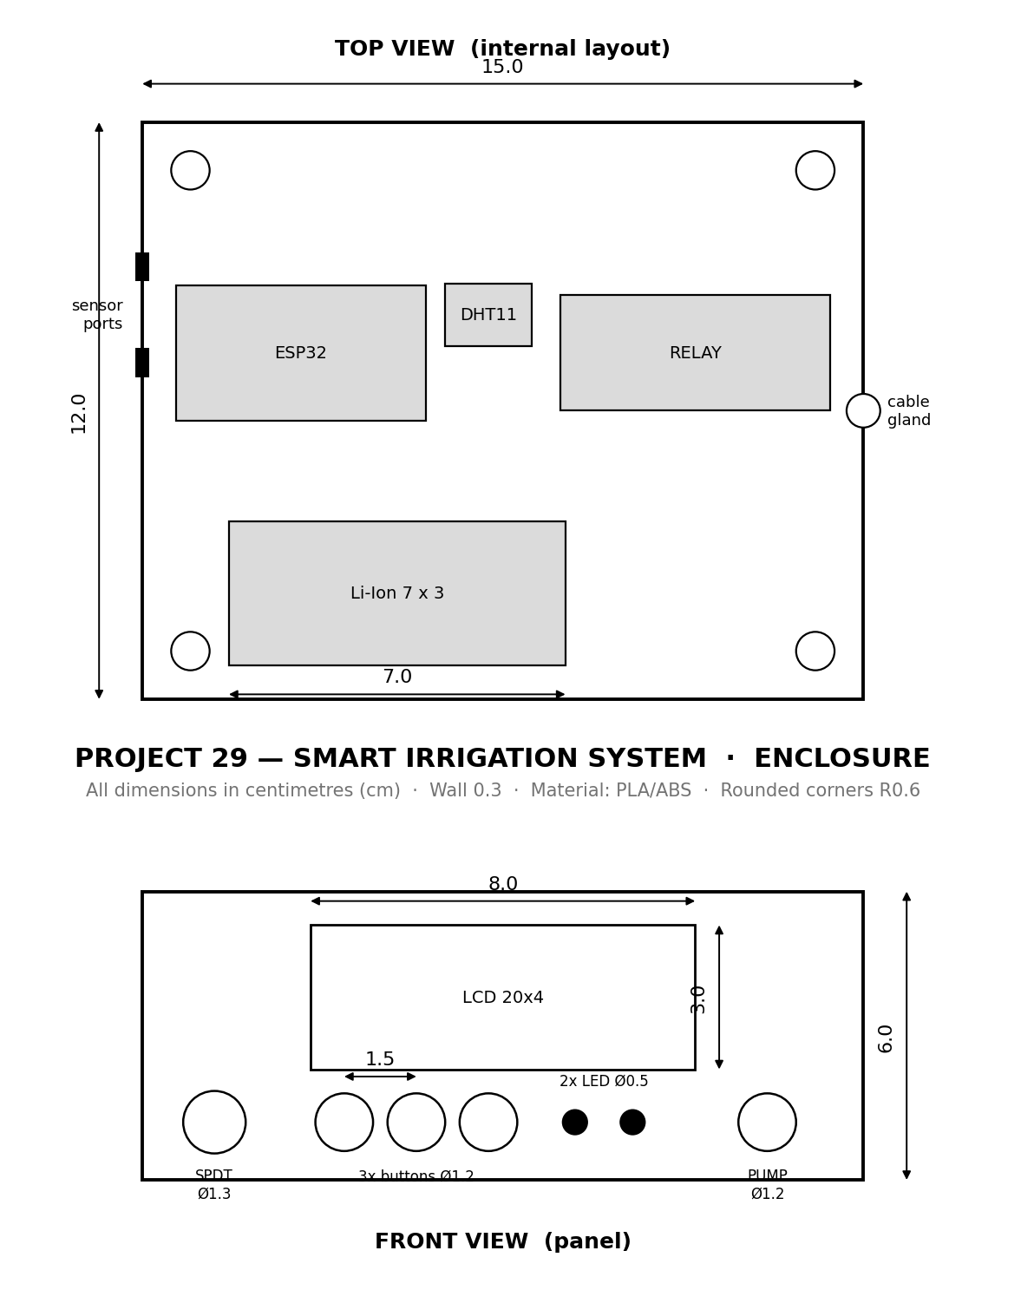
Figure 1 — Top view (internal layout) and front view (panel). Dimensions in cm.
4. Front Panel Layout
Feature | Size (cm) | Qty
LCD 20x4 window | 8.0 x 3.0 | 1
Tactile buttons | Ø1.2 (1.5 spacing) | 3
Indicator LEDs | Ø0.5 | 2
SPDT power switch | Ø1.3 | 1
Pump output jack | Ø1.2 | 1
5. Internal Layout & Component Mounting
Every component from the Project 29 brief maps to a physical feature of the enclosure:
Component | Mounting / feature
ESP32 dev module | 4 standoffs, left bay
DHT11 sensor | 2 standoffs, centre
LDR module | left-side sensor port
Soil-sensor wiring | left-side sensor ports
Relay module (2-ch) | 4 standoffs, right bay
LCD 20x4 + I2C | 8 x 3 cm front window
Tactile buttons | 3 x Ø1.2 cm holes @ 1.5 cm
Indicator LEDs | 2 x Ø0.5 cm holes
SPDT switch | Ø1.3 cm hole
Li-Ion battery + case | 7 x 3 cm battery bay
Water pump output | Ø1.2 cm jack + cable gland
6. Ports, Access & Ventilation
Location | Feature
Left side | 3 sensor-port slots (soil probe + LDR wiring)
Right side | Cable gland Ø1.2 cm + 4 ventilation slots
Top | Removable lid, 4 corner screws (self-locating lip)
7. Materials & Manufacturing
The enclosure is designed for FDM 3D printing in PLA or ABS with 0.3 cm walls. The body prints open-side-up with no supports; the lid prints flat. The four corner bosses accept M2.5 self-tapping screws to secure the lid. Rounded R0.6 cm corners improve strength and finish.
8. Rendered Assembly
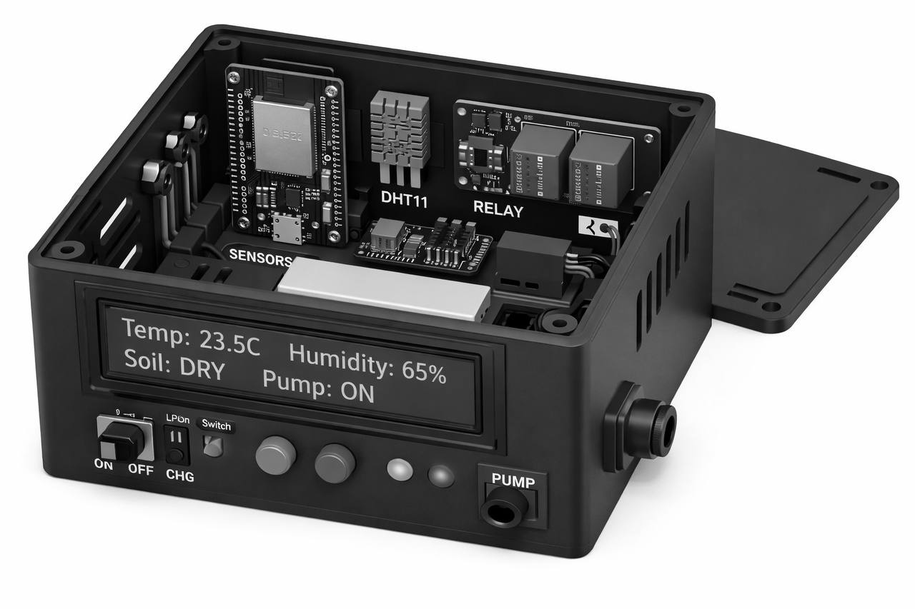
Figure 2 — Assembled concept render (grayscale) showing the populated panel.
9. CAD Files Delivered
File | Purpose
irrigation_body_cm.step | Import into OnShape (centimetre units)
irrigation_lid_cm.step | Lid — import into OnShape
irrigation_body_mm.step / lid | Millimetre backup for other CAD tools
irrigation_body.stl / lid | 3D printing (slicer)
build_final_cm.py | Editable parametric source (all cm parameters)
10. Model Generation & Verification
The geometry was produced from a parametric CadQuery (Python) script in which every dimension is a named centimetre parameter. The STEP files were verified by re-importing and measuring the bounding box: the centimetre file imports at exactly 15.0 x 12.0 x 6.0 cm, confirming the unit and scale are correct before any CAD or print work.

