Calvin Chen

605.445

Self Check 2

1. Tic tac toe heuristic:
   1. Win: +inf
   2. Lose: -inf
   3. Neutral move: +0
   4. One in line w/ empty cell: + 10
   5. Two in line w/ empty cell: + 100
   6. Opponent one in line w/ empty cell: -10
   7. Opponent two in line w/ empty cell: -100
2. See below

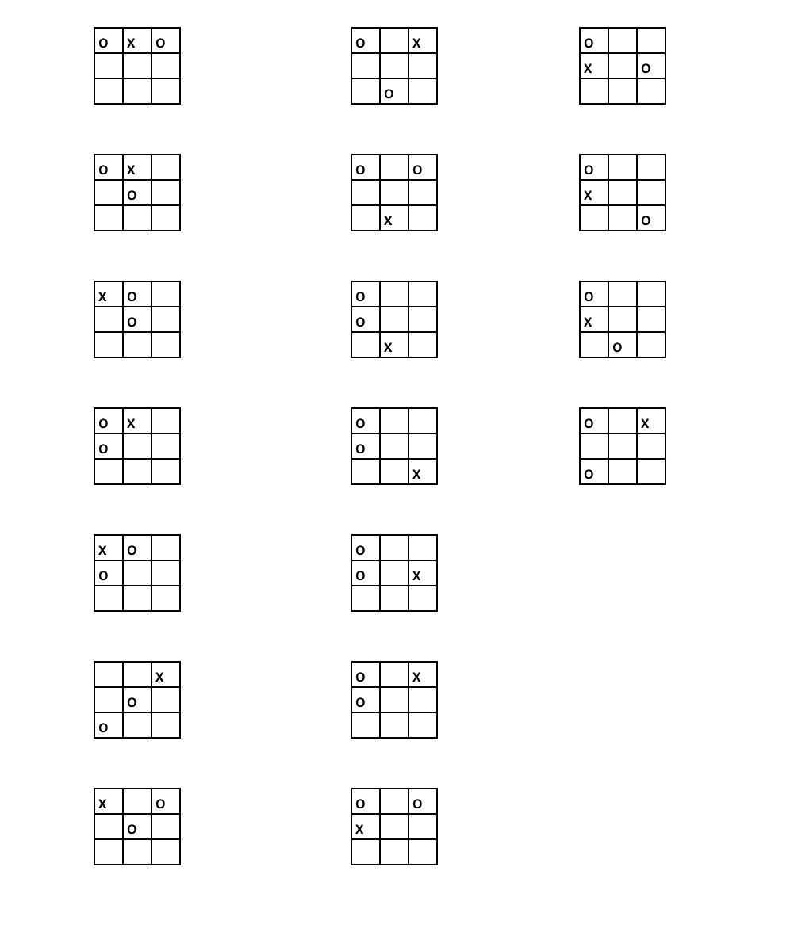

1. The Nash Equilibrium is defined as a state where no player can achieve a better outcome by switching to a different strategy if all other players’ strategies are fixed. That is, it’s a situation where a player can maximize their profit and minimize their opponents such that the opponent has no better solution. Typically, this is expressed in the situations where the players have equal payoffs.

Let’s evaluate the following situations where the players have equal payoffs, expressed in (Bar1, Bar2): ($2, $2), ($4, $4), and ($5, $5)

($2, $2): Moving outside of this point can increase the payoff of both Bar1 and Bar2 if the other party plays optimally (Bar1: ($5, $2), Bar2: ($2, $5)), so it is not at equilibrium

($4, $4): Moving out of this point will only decrease the payoff of both Bar1 and Bar2. For example, if Bar1 moves to either ($2, $4) or ($5, $4), payoff will drop from 20 to 14 or 15 respectively. Bar2 is in a similar situation. Therefore, ($4, $4) is a Nash Equilibrium.

($5, $5): Moving outside of this point can increase the payoff of both Bar1 and Bar2. If Bar1 moves to ($4, $5), the payoff increases from 25 to 28. The inverse is true for Bar2. Therefore, this is not an equilibrium point since there is a more optimal move for each player.

($4, $4) is the only Nash Equilibrium point.