50 MHz GaN Based Power Amplifier with Digital Resonant Gate Drive

Calvin H Lin

Zhechi Ye

**Abstract**

We present a 50 MHz power amplifier capable of delivering 11 W CW using a GaN transistor in a class Φ2 design. To drive the GaN device, we utilize a resonant gate drive with digital inverters, an auxiliary inductor, and freewheeling diodes to minimize gate loss.

**Schematic: Primary Power Stage**

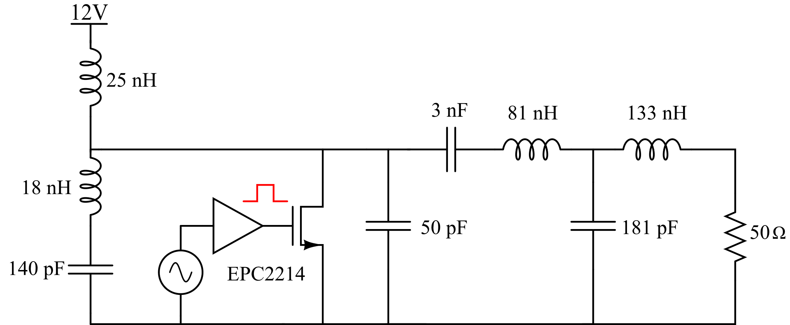

**Schematic: Resonant Gate Drive**

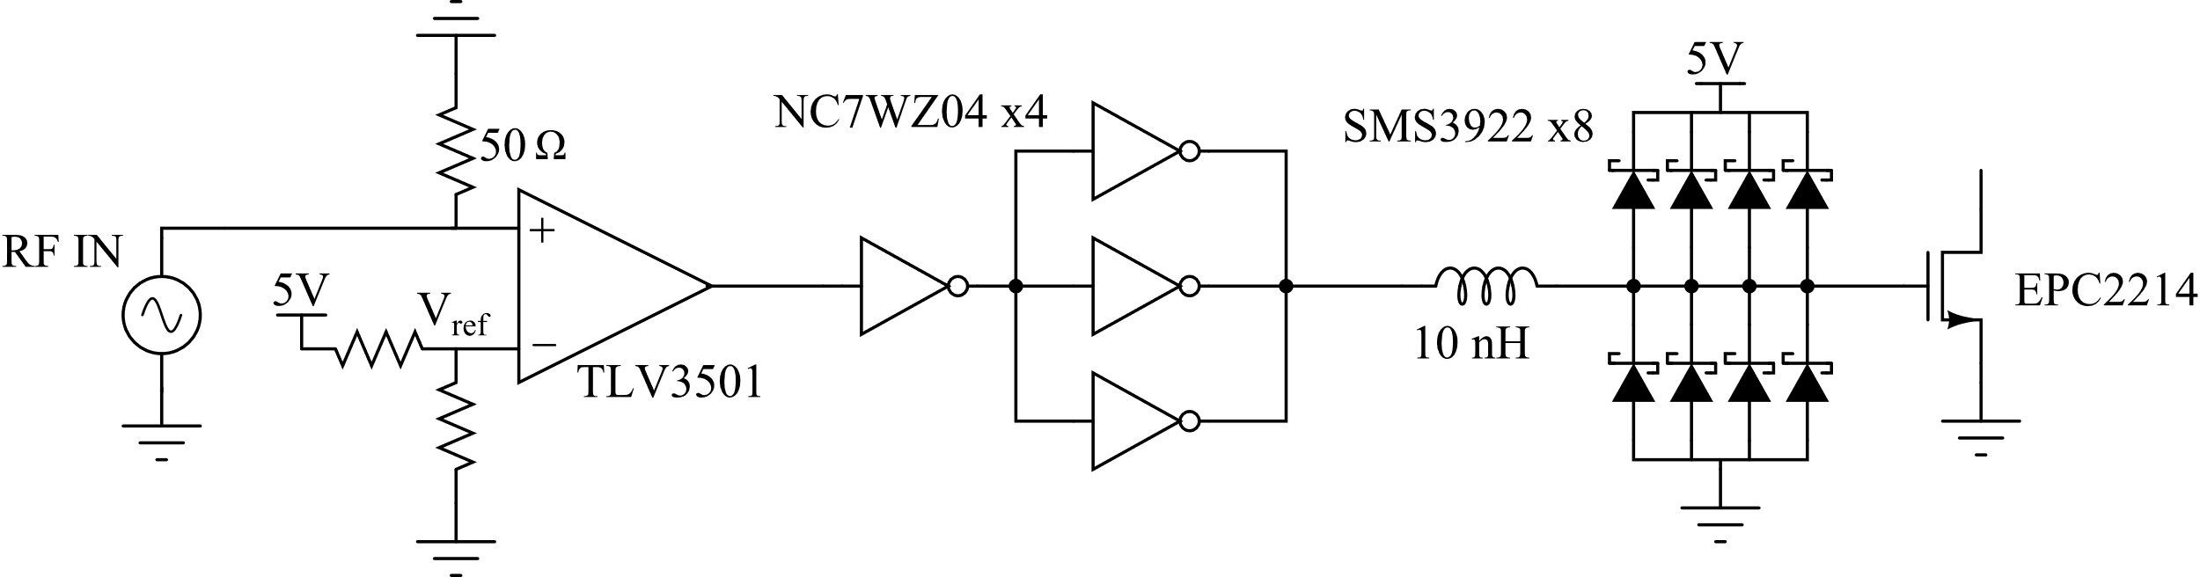

**Parts List**

|  |  |  |
| --- | --- | --- |
| **Part Number** | **Description** | **Quantity** |
| EPC2214 | 80 V 47 A GaN Transistor | 1 |
| TPS563203 | 12V to 5V Buck Converter IC | 1 |
| NC7WZ04 | Digital Buffer Inverter IC | 4 |
| TLV3501 | Comparator IC | 1 |
| SMS3922 | 50 mA RF Schottky Diode | 8 |
| Capacitors | Ceramic, 0603, 0805, 1206, Electrolytic | 28 |
| Inductors | Coilcraft, Handwound | 6 |
| Resistors | 0402, 0603 | 7 |

**Constructed Circuit**

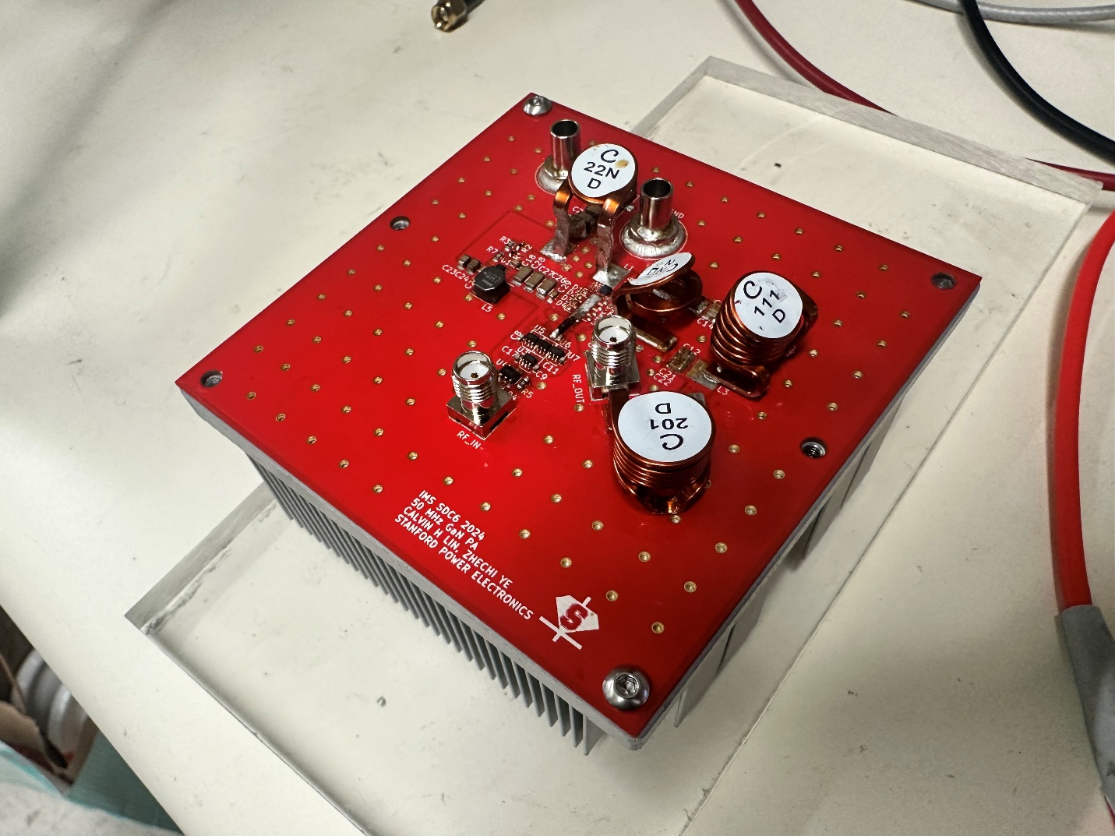

We are still in the process of tuning the power stage, and will update this report with results as soon as they are complete.