SheetMusicViewer – User Guide (2025 Edition)
  - A cross-platform PDF sheet music viewer by Calvin Hsia
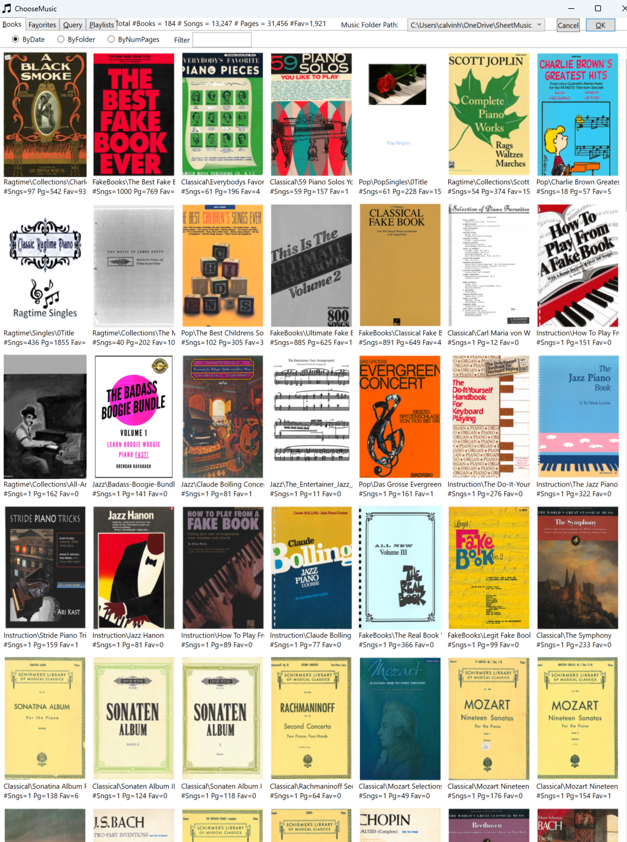

Table of Contents
Contents
SheetMusicViewer – User Guide (2025 Edition) 1
Table of Contents 2
Welcome 3
Getting Started 4
Multi-Volume PDF Support 5
Singles Folders 6
Display Modes & Navigation 7
Display Modes 7
Navigation 7
Instant Page Turns (Predictive Caching) 8
Inking & Annotations 9
PDF Table of Contents (TOC) 10
About SheetMusicViewer 11
About the Author 11

Welcome
SheetMusicViewer helps musicians browse, annotate, and navigate PDF music collections with speed and ease.
- Display 1 or 2 pages at a time
- Mark pages as Favorites
- Add ink annotations with stylus/finger
- Table of Contents support
- Supports multi-volume PDF sets
- In Show2Pages mode, allows a right hand page to be on the left, minimizing page turning
This guide will help you learn how to use the application.

Getting Started
- Run the program and choose a path to a root folder containing PDF music files.
- PDFs can contain any number of pages.
- The PDFs are never altered by the program. All auxiliary data (TOC, Favorites, Inking, LastPageNumberViewed) is stored in JSON files (automatically created).
- You can use the JSON files to store Composer name, Date, Notes, etc.
Tip: Click the Image Icon in the toolbar above to view/edit the JSON for the current PDF.
- The program needs write permission to write the JSON metadata files alongside your PDFs.
- Press Alt+C or use the Menu to open the Music Chooser dialog. Choose “New…” Music Folder from the dropdown.
- Run the program and choose a path to a root folder containing PDF music files.
- PDFs can contain any number of pages.
- The PDFs are never altered by the program. All auxiliary data (TOC, Favorites, Inking, LastPageNumberViewed) is stored in JSON files (automatically created).
- You can use the JSON files to store Composer name, Date, Notes, etc.
Tip: Click the Image Icon in the toolbar to view/edit the JSON for the current PDF.
- The program needs write permission to write the JSON metadata files alongside your PDFs.
- Press Alt+C or use the Menu to open the Music Chooser dialog.

Multi-Volume PDF Support
Large works can be split into multiple PDFs. All PDFs sharing the same root name are treated as one continuous book.
The icon for the volume is the first page as a thumbnail.
Naming Convention
File Name | Description
book.pdf (or book0.pdf) | First volume
book1.pdf | Second volume
book1a.pdf | Insert after book1
book2.pdf | Third volume
Example: SonatenI.pdf and SonatenI1.pdf form one book, while SonatenII.pdf is separate.
This allows rescanning or inserting pages without renumbering later volumes.

Singles Folders
A subfolder ending with “Singles” (e.g., GershwinSingles) treats each PDF as an individual song.
- Alphabetical ordering
- First page of the first song becomes the thumbnail
- Automatically updates when items change
- TOC adjusts dynamically
A subfolder called “Hidden” is not searched.
Tip: Add a custom PDF title page that alphabetically sorts first.

Display Modes & Navigation

Display Modes
- Single Page Mode – one page per screen
- Two-Page Mode – two pages side by side

Navigation
- Thumb arrows: move by screenful or jump to next/previous favorite
- Arrow keys: move by screenful
- Bottom quarter of screen: tap to turn pages

In Two-Page Mode:
- Bottom outer quarters: advance 2 pages
- Bottom inner quarters: advance 1 page
- Top ¾: zoom/pan with two fingers
You can rotate the screen; auto-rotation adjusts the layout.
You can mark any page as a Favorite.

Instant Page Turns (Predictive Caching)
PDFs use a lot of memory.
PDF rendering normally takes 100–500 ms — too slow for live performance. SheetMusicViewer solves this with predictive caching.
Cache management is automatic.
Result: Page turns feel like real sheet music.
You can choose from many Bluetooth Page turning pedals to advance pages with your foot.

Inking & Annotations
Inking is off by default.
- Check the Ink box (each page has its own in two-page mode)
- Draw with mouse, stylus, or finger
- Right-click menu to change color (black, red, yellow)
- Uncheck Ink to save
Tip: Zoom in for precise marking.
All ink data is stored in the PDF’s accompanying JSON.

PDF Table of Contents (TOC)
A PDF might contain hundreds of pages
Open TOC editor:
- Click the thumbnail beside the slider
- or press Alt+E

Features:
- Import/export TOC in Excel format
- Add composer, date, and notes
- OCR support for scanned TOCs

Page Number Offset
Compensates for mismatches between physical pages and PDF pages (covers, intros, etc.).

About SheetMusicViewer
Created by Calvin Hsia
Email: calvin_hsia@alum.mit.edu
Source code: https://github.com/calvinhsia/SheetMusicViewer
Website: http://calvinhsia.com
Licensed under MIT License

About the Author
I have hundreds of piano music books collected over decades, kept on OneDrive. I digitized 30,000+ pages of my music using a Xerox WorkCentre scanner. I really love Ragtime! There's something so binary about it: powers of 2, 16 measures per verse, 2/4 time, syncopation.
I started this project in 2019 using Windows Presentation Foundation (WPF)
Enjoy your music!
– Calvin

