Is There a Correlation Between Age and Party of Governors Elected Since 2000?

1. Introduction
The mean age of the 118th congress is 58 years old, and that is younger than the one that preceded it, but Americans express majority interest across the partisan divide for an age ceiling on elected officials. This view has practically become conventional wisdom, but this axiom may only be meant for Congress. Therefore, it might be helpful to consider the age of governors when elected of each party. In a multi-variate analysis, one could see if, as time has gone on, governors have been younger on average and which of the two parties is more likely to consistently hold these views across elections. Therefore, the relationship has been investigated using a boxplot and ANOVA.
If it is that there is a relationship between party and age, it can usefully provide a model for how mounting dialogue about ‘gentocracy’ has edified voting behaviors. There is, of course, a ratio discrepancy between the number of Democrat and Republican states. By understanding and visualizing these patterns, however, we begin to see whether the noise about age is gnomic or statistically effectuated, and whether or not certain policy priorities give themselves to certain candidates. It may altogether abolish the notion that age is seriously considered, especially if, controlling for the years in which they were elected, there is no or little change in the mean age of either party in recent years when the discourse has reached its most intense pitch.

2. Data and Methods
The variables “gov_party”, and “gov_age” have been selected for review, which reflect the party alignment and age when elected of all governors since 2000. These were accessed through Wikipedia. The data-collection process was simple. Wikipedia lists governors by state including when they were elected, their party, their name and photograph, and their lieutenant governor. Extracting the correct information was a matter of subtracting their birth year from the year in which they were originally elected. Party affiliation was self-evident.
Party affiliation is standardized using dummy values of 1, 2, and 3, being Democrat, Republican, and ‘other’ respectively. There are only three governors, who received ‘other’ categorization. Two of those three, Bill Walker of Alaska and Lincoln Chaffee of Rhode Island, successfully achieved gubernatorial victories as independents, and the third, Jim Justice of West Virginia, changed party affiliations between his first and second term in 2016 and 2020. Justice is the only former or sitting governor to have won the governorship since 2000 running with both major parties and therefore seemed suitable for ‘other’, rather than receiving his own fourth value. Age needed no recoding. It is continuous and represented by numeric values. Each of those values was recorded in the year the governor was elected. The table represents a column for every listed age, which ranges from 35 and 72. The single 35-year old who has assumed the governorship since 2000 was a Republican, and three of those who were inaugurated at 72 were Democrats. The table reflects a wider range of ages for Republican than Democratic governors.
The research question which motivated the study was, “Is there a correlation between party affiliation of governor and age?” which will be assessed by comparing the continuous and nominal variables against one another to look for trends or overlap. Party affiliation serves as the independent variable, and age as the dependent variable.

3. Results
The results reflect a wider range of outliers for Republicans than Democrats, with a greater magnitude of age among Republicans with a higher significance and more upwards direction than compared to Democrats. Although ‘other’ candidates reflected the highest ages on average, those being 63, 58, and 66, among major parties with similar sample sizes and therefore those results which are more comparable, Republicans are older than Democrats. Figure 1 illustrates the difference with the median being somewhat lower in the Democratic box than the Republican box, and also including a smaller range especially concerning the youngest of those governors. Figure 2, however, reflects a p-value of 0.9, which is significantly higher than the standard alpha of 0.5 and suggests a lack of statistical significance in the results, underpinned by an f-value of 0.015, which suggests the variation between and within groups are similar.
To test this, I used ANOVA, of which there are seven assumptions. The first, that the independent variable is categorical and that the dependent variable is quantitative needs no proof, beyond that the elected governors have only belonged to any one party at a time, if any, making their alignment categorical and age, being discrete, fulfills the obligation of a dependent variable. Normality, the assumption of normally distributed residuals throughout the data visualization, is here defied as exemplified by Figure 3. If the distribution of residuals were normal, so too the histogram would have a bellcurve, but the balance is skewed. Homogeneity of variances is evinced by the length of the boxplots which are roughly the same among Democrat and Republican in Figure 1. The variances are heavily skewed for ‘Other’ which is to be expected given the meaningfully smaller sample size. As for the values of observations, while it is technically possible for one governor to influence another of their own party to run, especially in states preferential to the party and where the subsequent governor is a member of the previous state government, generally speaking they can believed to be independent and certainly, the age of one cannot have an effect on the age of another. Finally, random sampling cannot necessarily occur because the collection of all governors since 2000 is a narrow list, and all of those are included in the results here and there are no particular outliers.

4. Discussion
Understanding the role of age in party is essential, more now than in previous American political cycles. Younger and older voters alike are chafing at an increasingly septuagenarian establishment. While not statistically significant, the basic knowledge of voting trends against age can usefully spell a story about whether this cultural discourse has spilled into electoral habits. It can also serve as a predictor for future elections, candidates, and likelihood of success in the primaries.
I wish I might have also done a multivariate analysis of the data, including chronology as a measure of when these governors were elected and whether or not there is a more recent, significant shift. It might dispel these ideas or prove a reverse effect, that governors have only gotten older over time which would itself pose a slew of questions. Party and age do not suggest statistical significance but controlling for a time variable might change that.
The process of research was not itself too much of a challenge. Data collection was a bit tedious, as data collection tends to be, but all of the information was easily viewable through wikipedia. The most strenuous part of the technical process was the coding, and that wasn’t highly challenging either. I enjoyed getting to see my data go from bits and pieces of disparate information to a single source, then become visualized and customizable to evoke a sense of narrative.

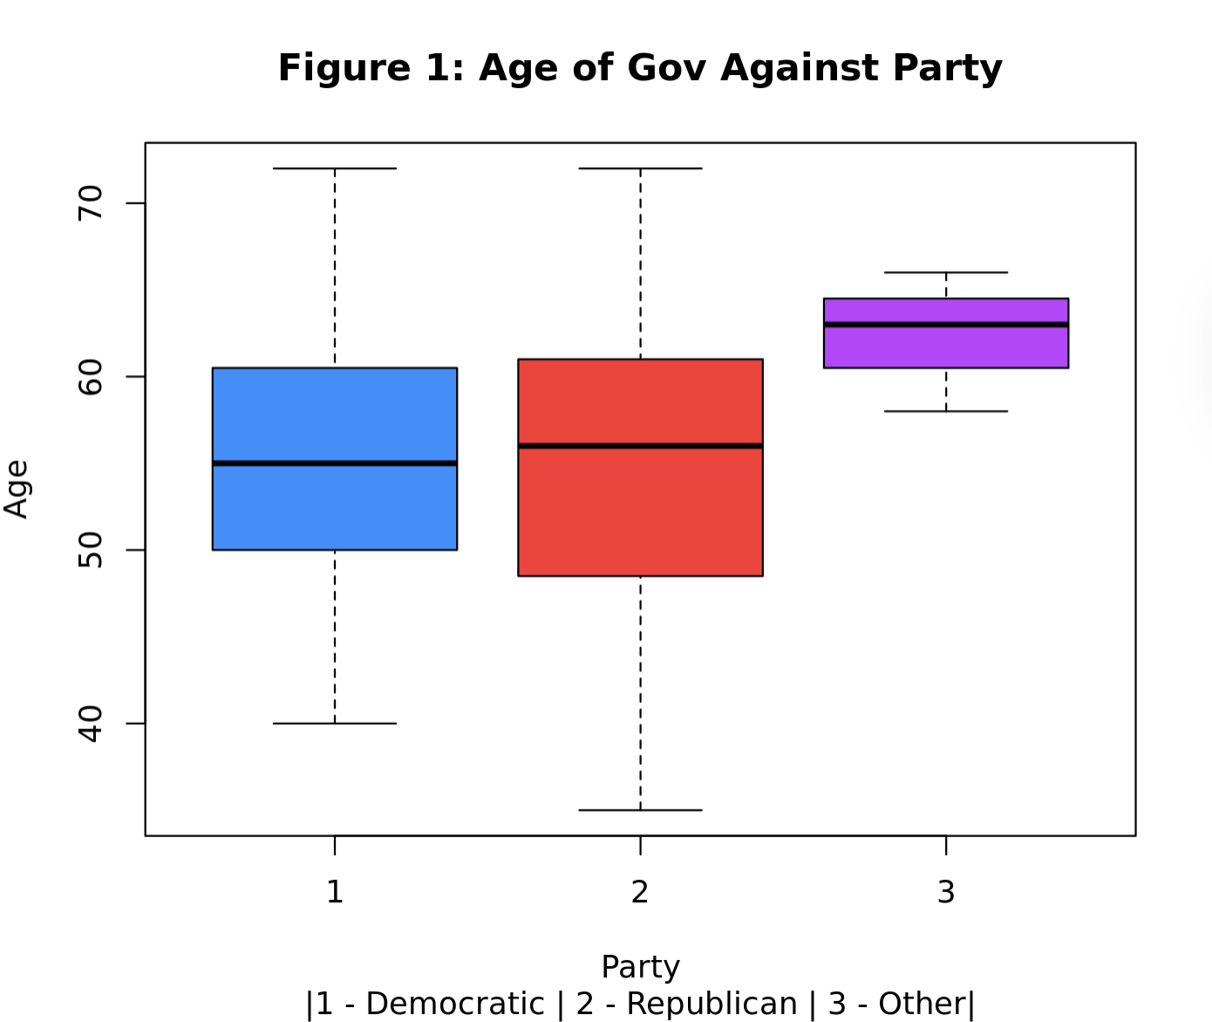
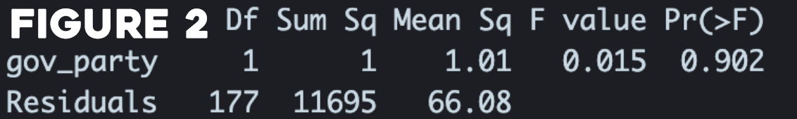
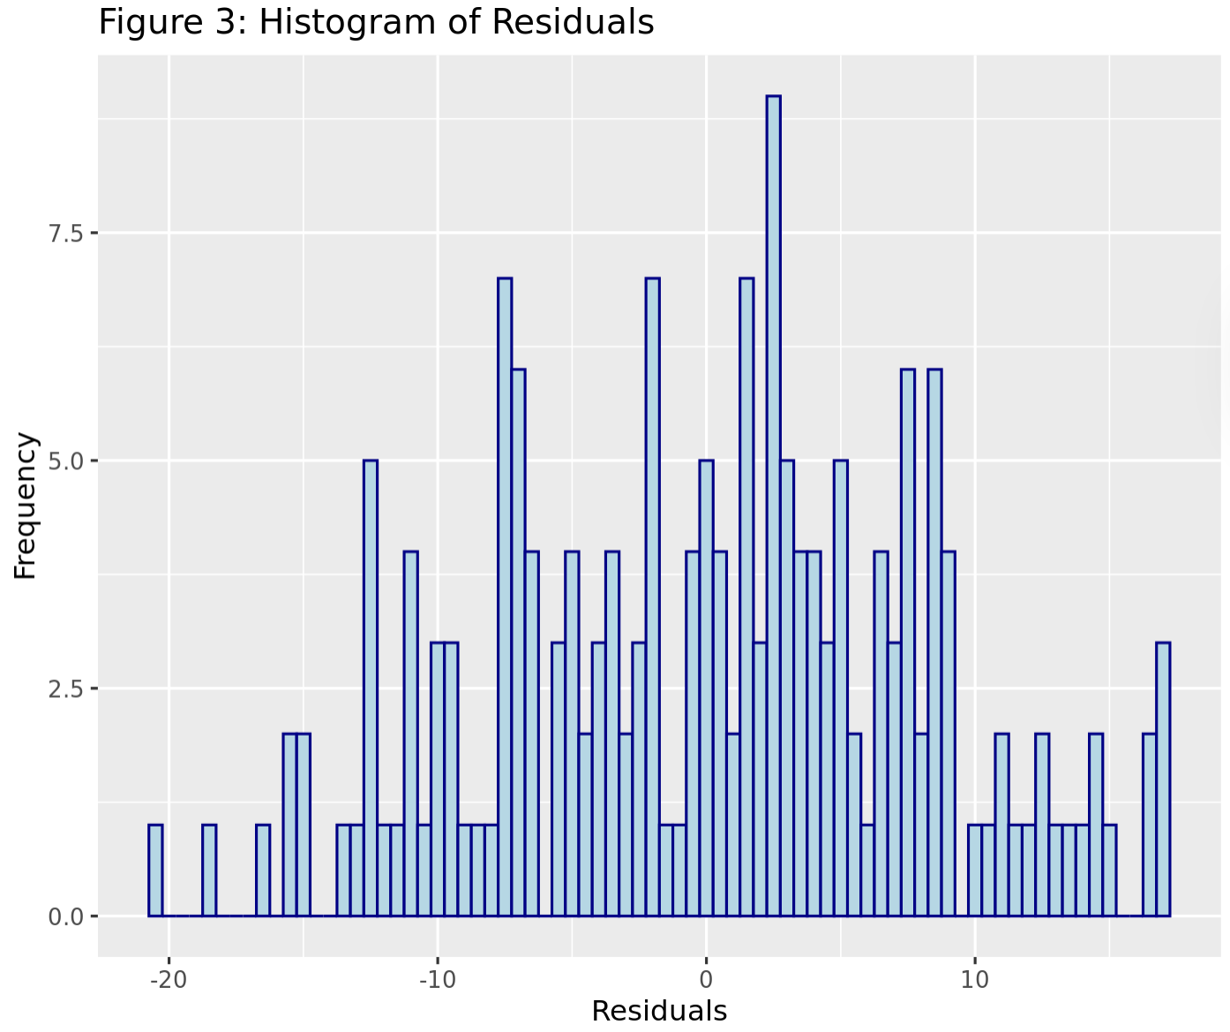

Stowe, Lydia. “Age of Members of 118th Congress (& Averages).” FiscalNote, 6 Feb. 2023, fiscalnote.com/blog/how-old-118th-congress.
Gramlich, John. “Most Americans Favor Maximum Age Limits for Federal Elected Officials, Supreme Court Justices.” Pew Research Center, Pew Research Center, 4 Oct. 2023, www.pewresearch.org/short-reads/2023/10/04/most-americans-favor-maximum-age-limits-for-federal-elected-officials-supreme-court-justices/.

