Topologi:

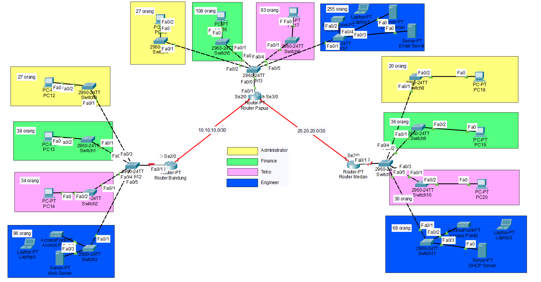

Tabel Pembagian IP address

| **Cabang** | **Divisi** | **Jumlah Pegawai** | **VLAN** | **Subnet** | **IP Range** |
| --- | --- | --- | --- | --- | --- |
| Papua | Engineer | 255 | 40 | 192.168.10.0/23 | 192.168.10.1 - 192.168.11.254 |
| Papua | Finance | 108 | 20 | 192.168.12.0/25 | 192.168.12.1 - 192.168.12.126 |
| Papua | Telco | 93 | 30 | 192.168.12.128/25 | 192.168.12.129 - 192.168.12.254 |
| Papua | Administrator | 27 | 10 | 192.168.13.0/27 | 192.168.13.1 - 192.168.13.30 |
| Bandung | Engineer | 96 | 40 | 192.168.20.0/25 | 192.168.20.1 - 192.168.20.126 |
| Bandung | Finance | 38 | 20 | 192.168.20.128/26 | 192.168.20.129 - 192.168.20.190 |
| Bandung | Telco | 34 | 30 | 192.168.20.192/26 | 192.168.20.193 - 192.168.20.254 |
| Bandung | Administrator | 27 | 10 | 192.168.21.0/27 | 192.168.21.1 - 192.168.21.30 |
| Medan | Engineer | 68 | 40 | 192.168.30.0/25 | 192.168.30.1 - 192.168.30.126 |
| Medan | Finance | 36 | 20 | 192.168.30.128/26 | 192.168.30.129 - 192.168.30.190 |
| Medan | Telco | 30 | 30 | 192.168.30.192/27 | 192.168.30.193 - 192.168.30.222 |
| Medan | Administrator | 20 | 10 | 192.168.30.224/27 | 192.168.30.225 - 192.168.30.254 |

| **Server** | **Lokasi** | **IP Address** |
| --- | --- | --- |
| DNS Server | Papua | 192.168.10.2 |
| Email Server | Papua | 192.168.10.3 |
| Web Server | Bandung | 192.168.20.2 |
| DHCP Server | Medan | 192.168.30.2 |

Konfigurasi IP address pada Router:

Router Papua:

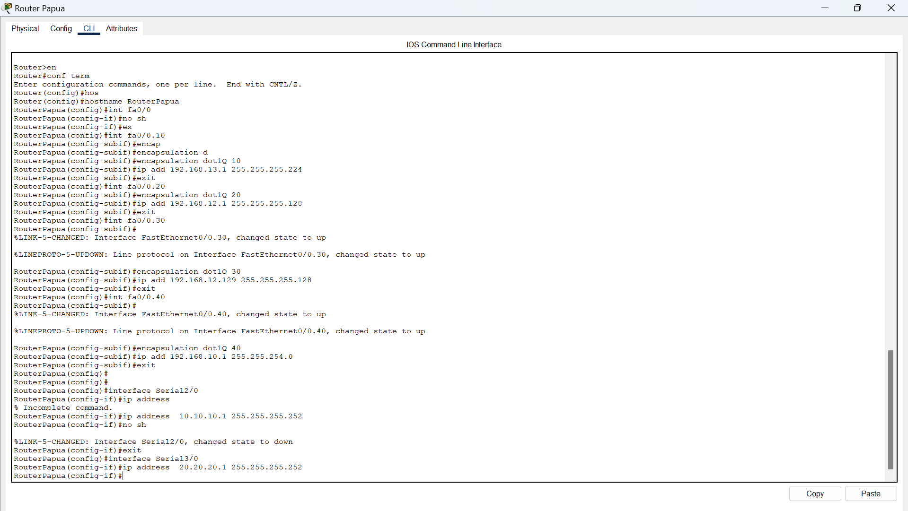

Router Bandung:

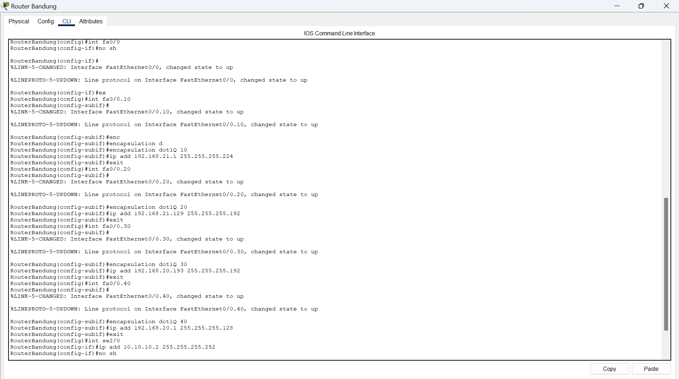

Router Medan:

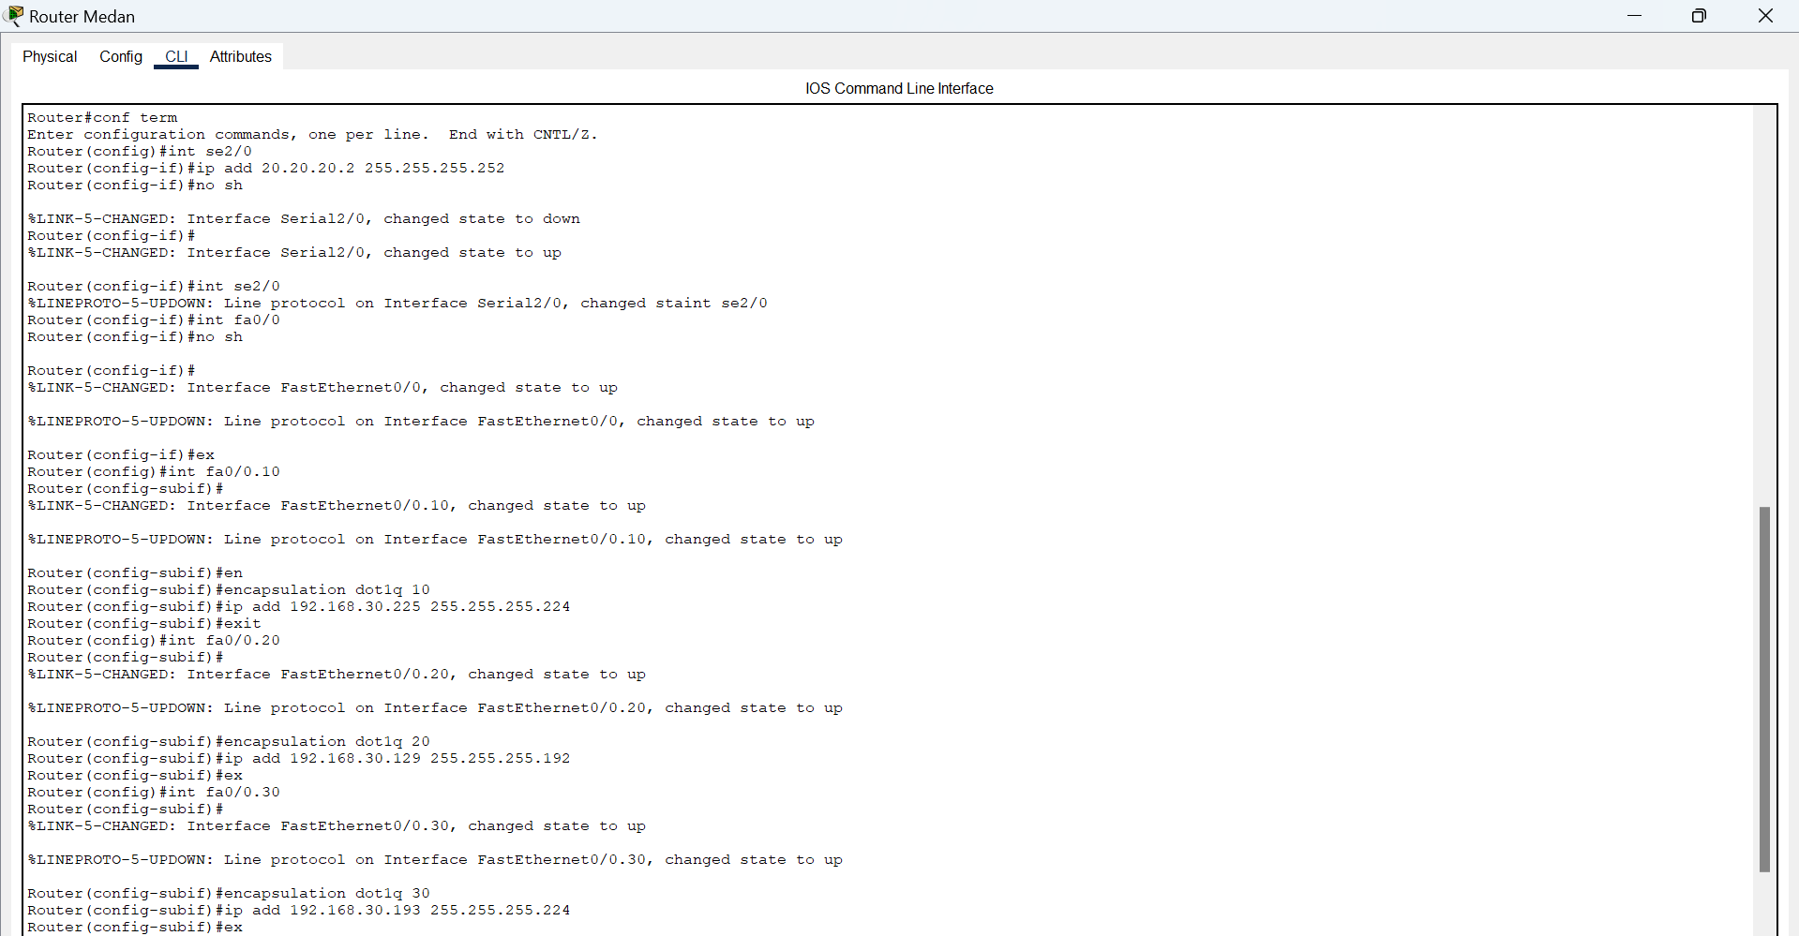

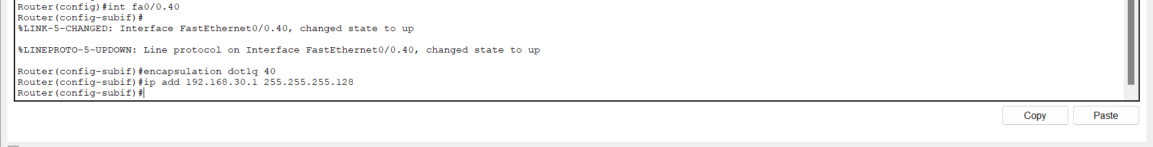

Konfigurasi pada server:

Web server:

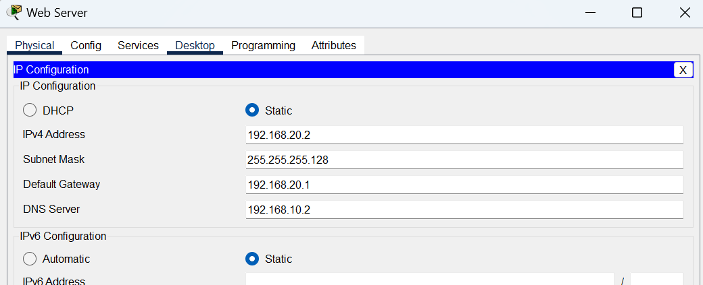

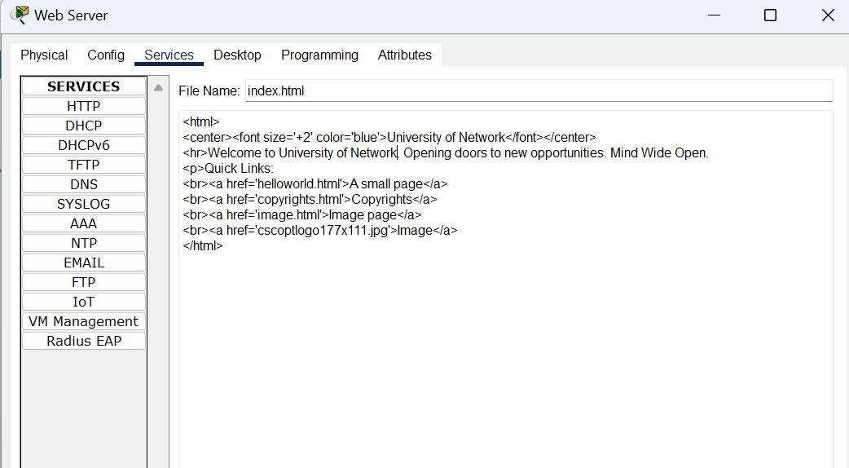

DNS Server:

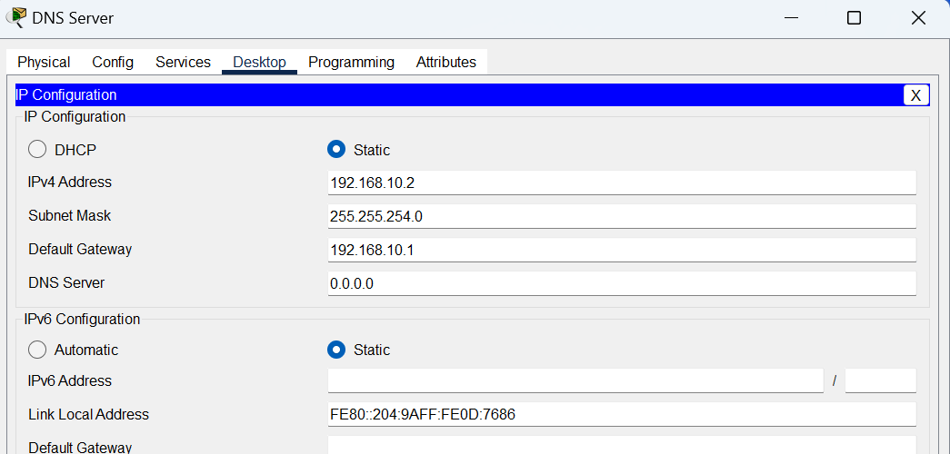

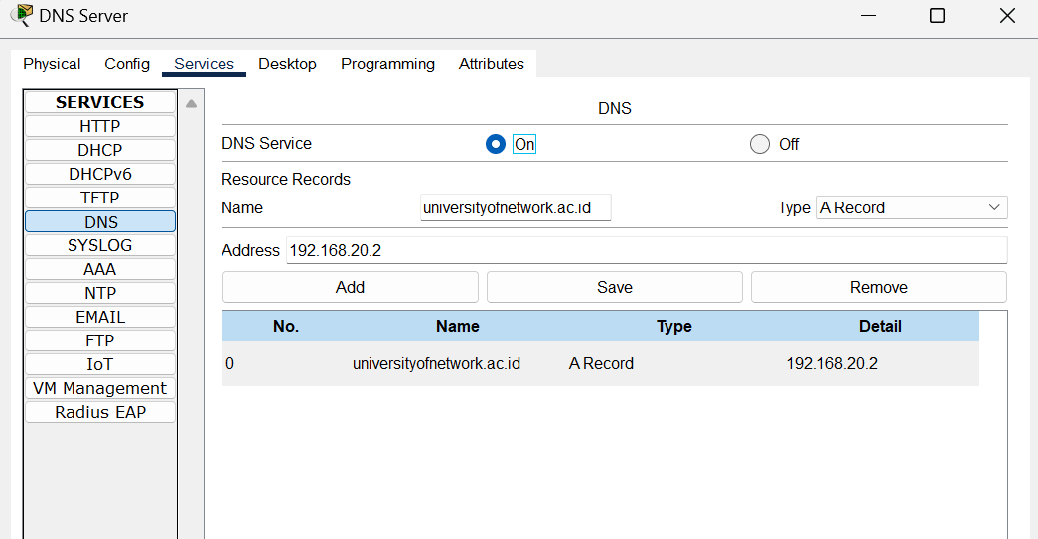

Email Server:

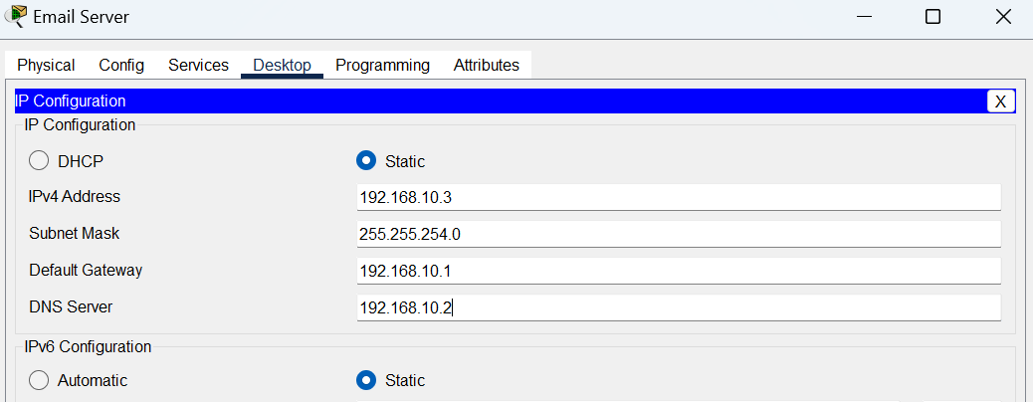

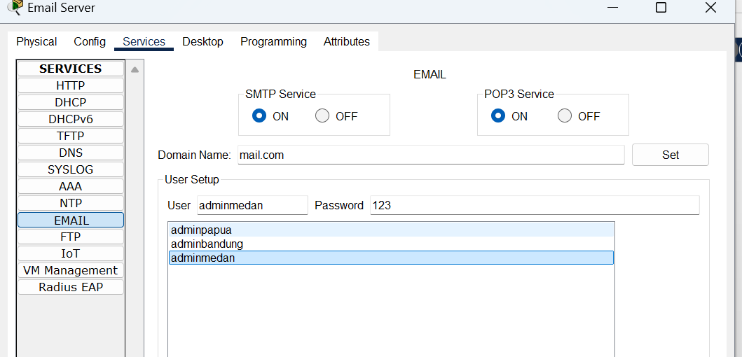

DHCP Server:

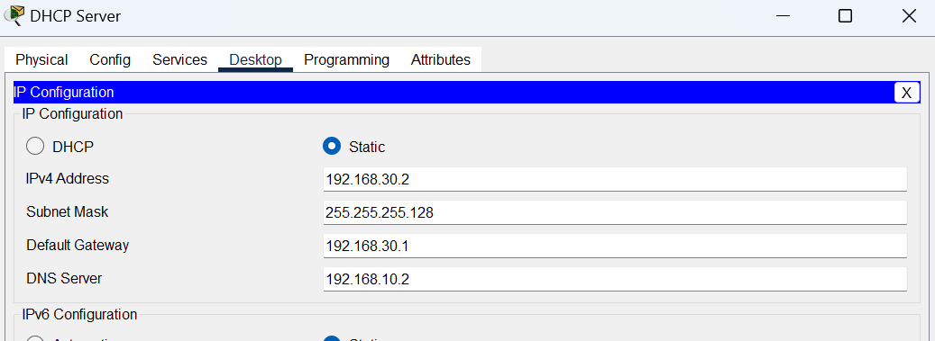

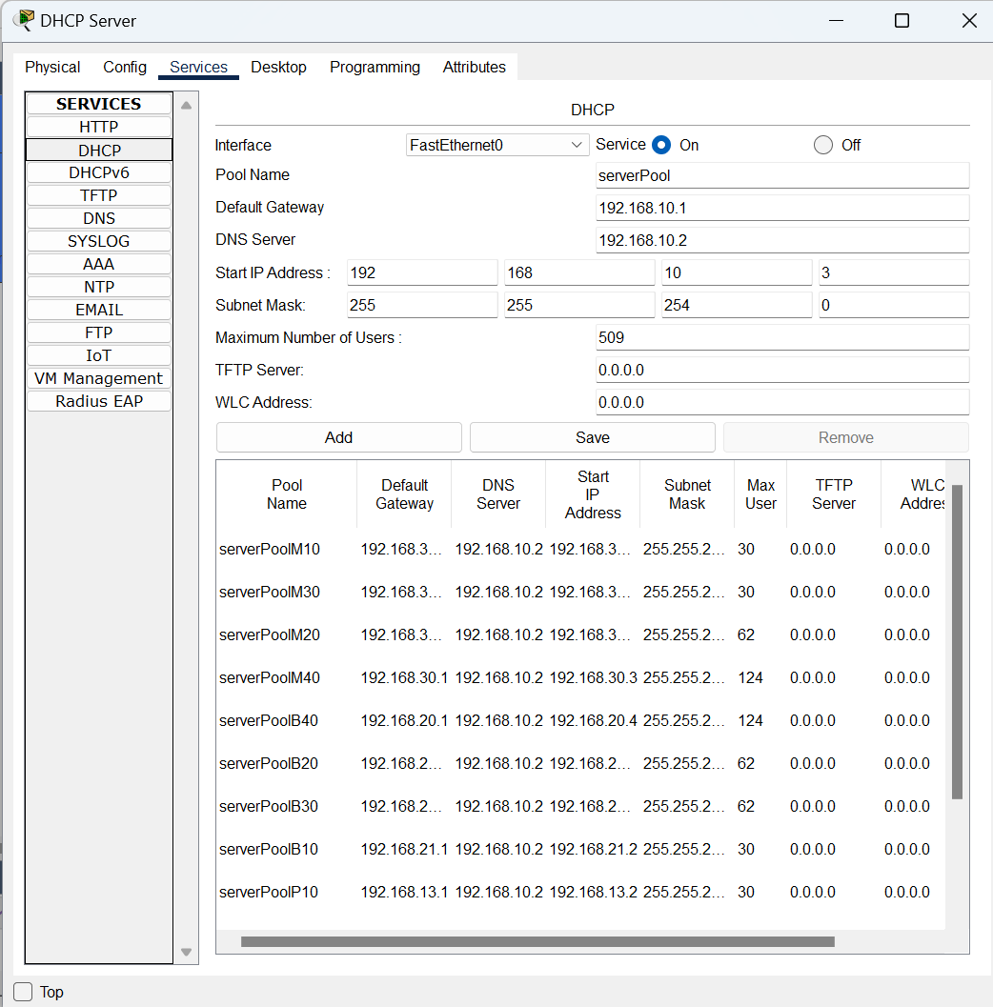

Konfigurasi pada switch:

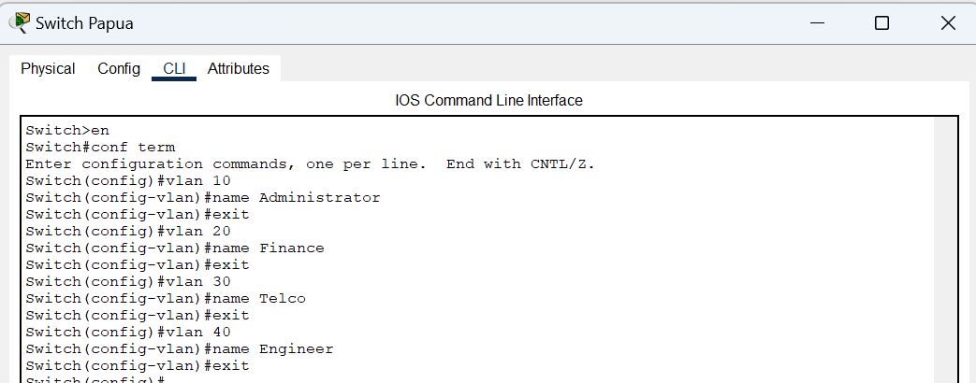

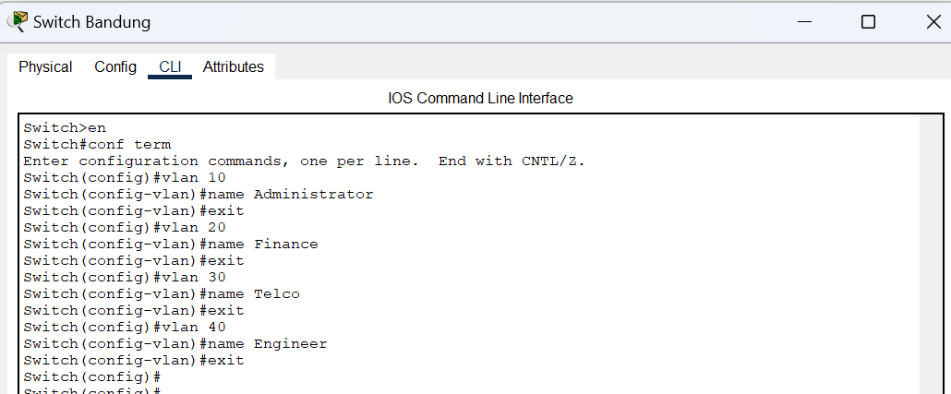

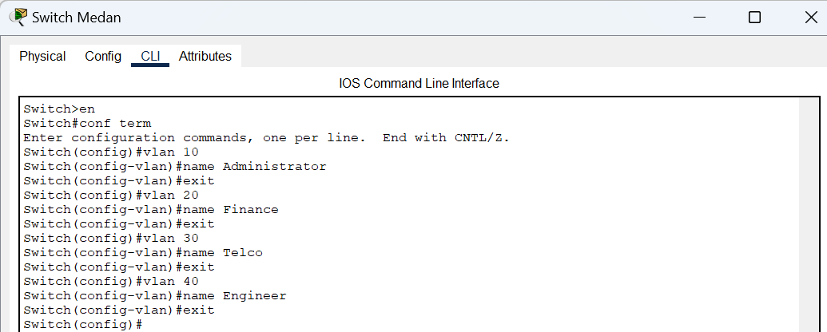

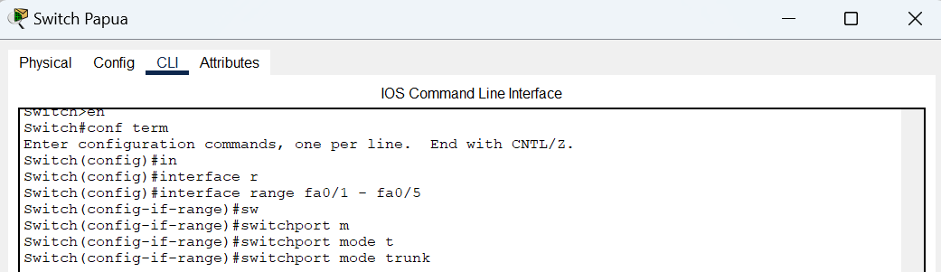

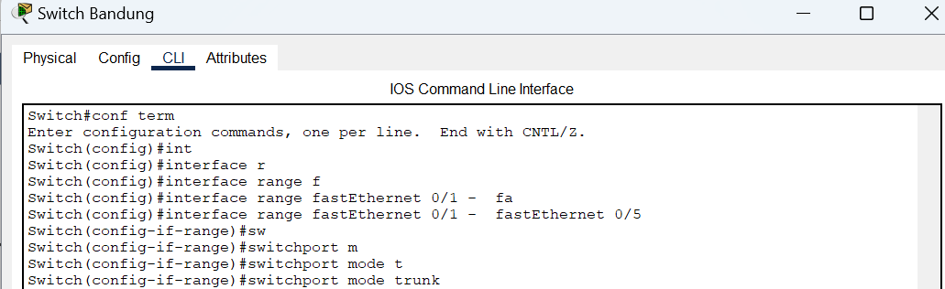

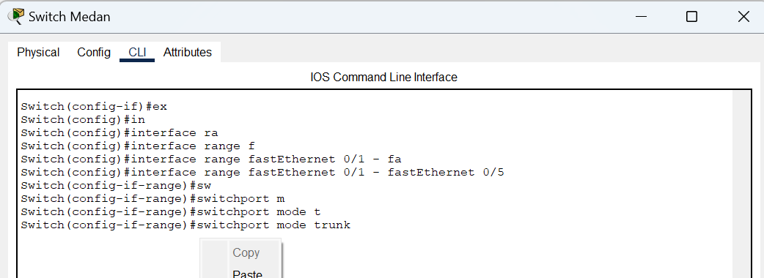

Memberi switchport mode access vlan pada switch contoh:

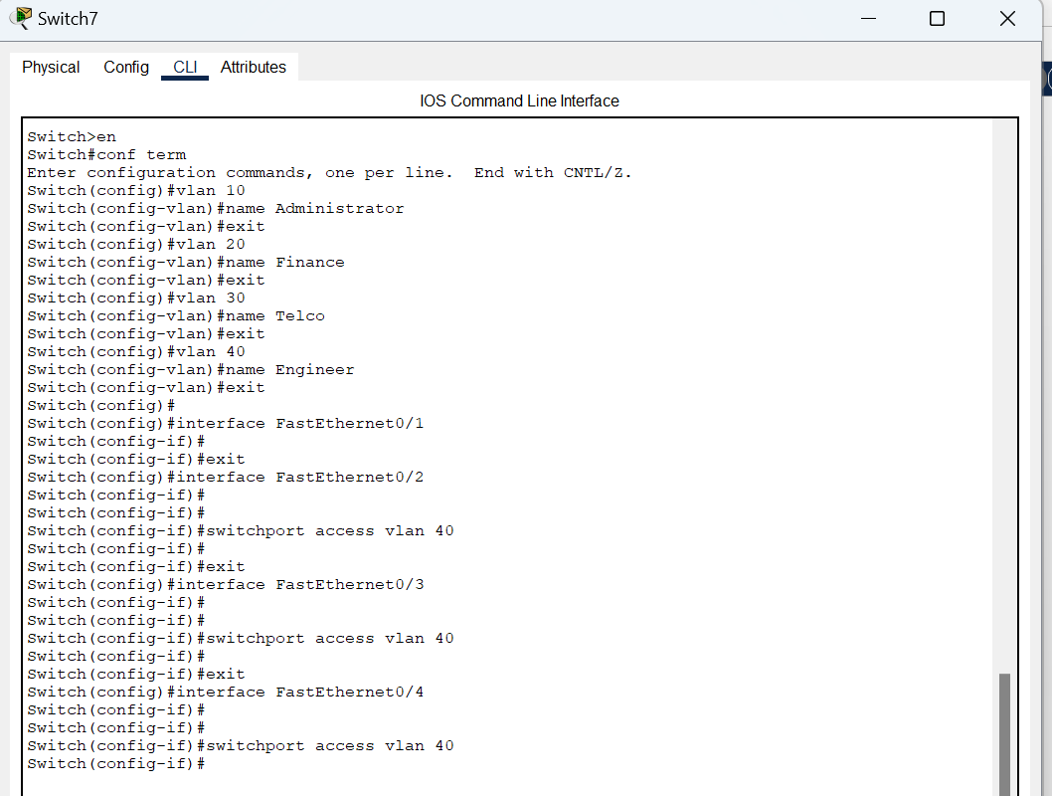

Konfigurasi Routing OSPF pada masing-masing router:

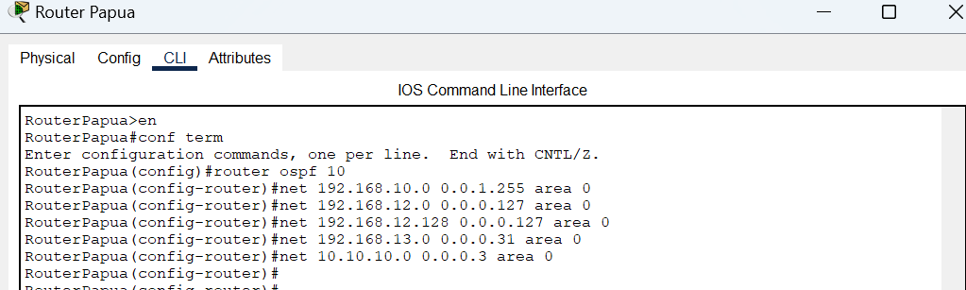



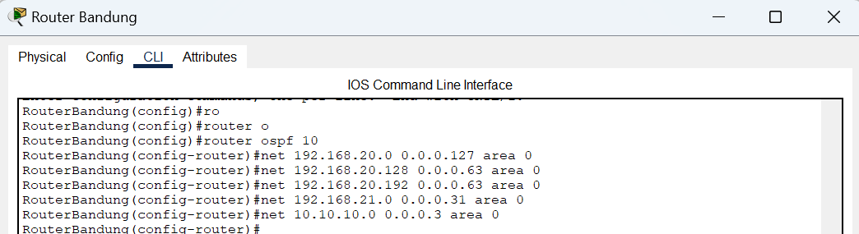

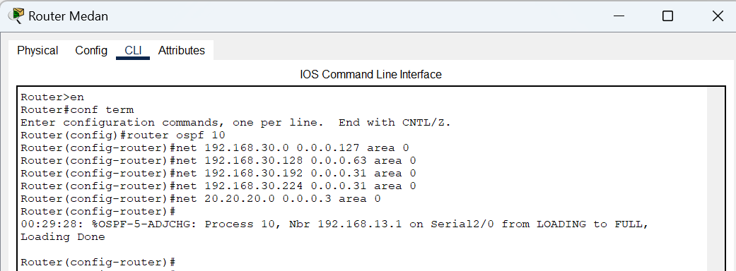

Konfigurasi IP helper address pada masing masing router:

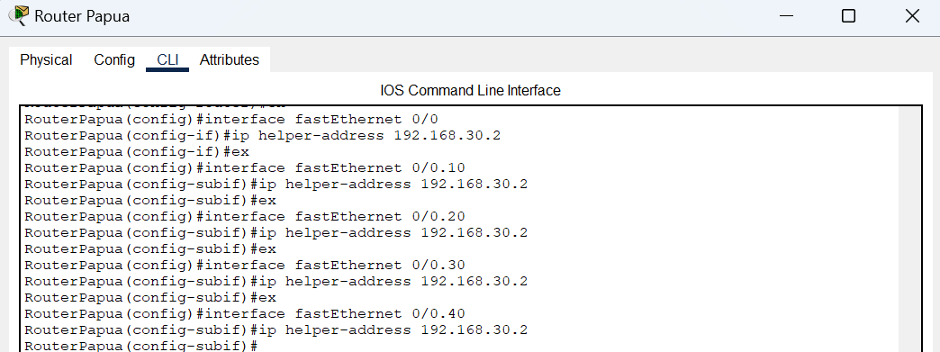

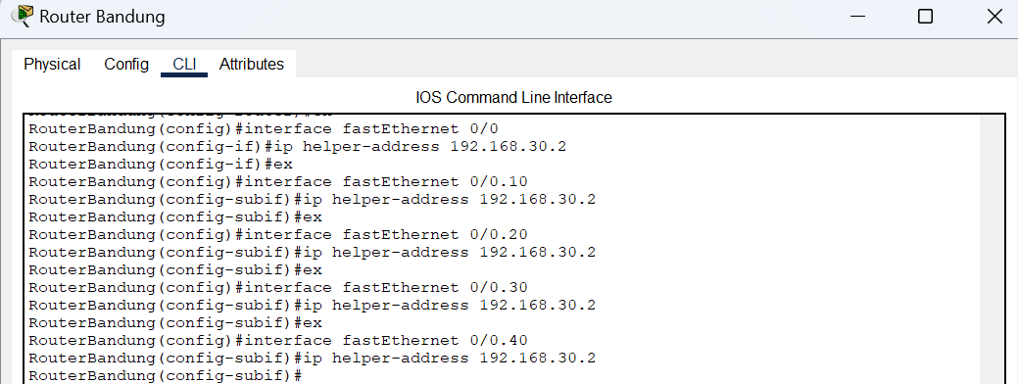

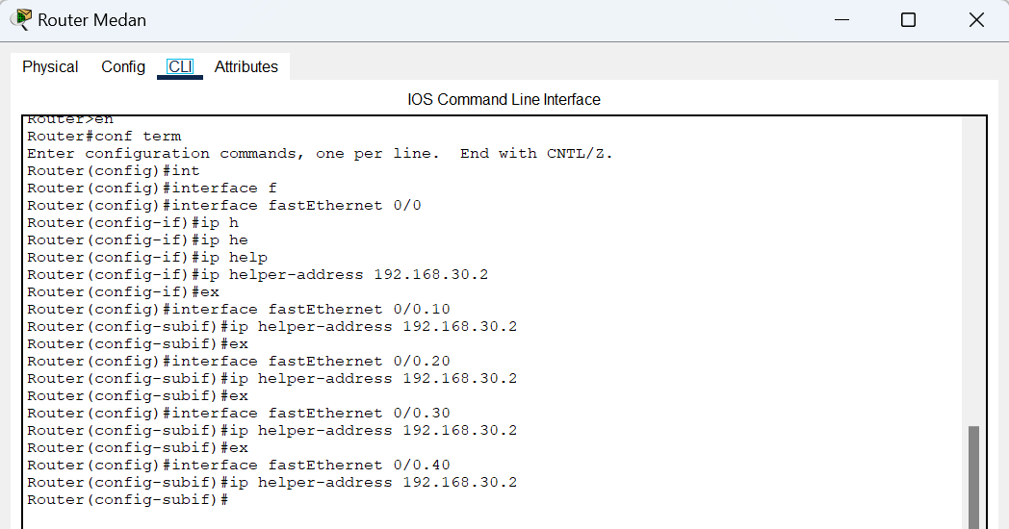

Meminta IP DHCP pada end device:

Contoh pada PC:

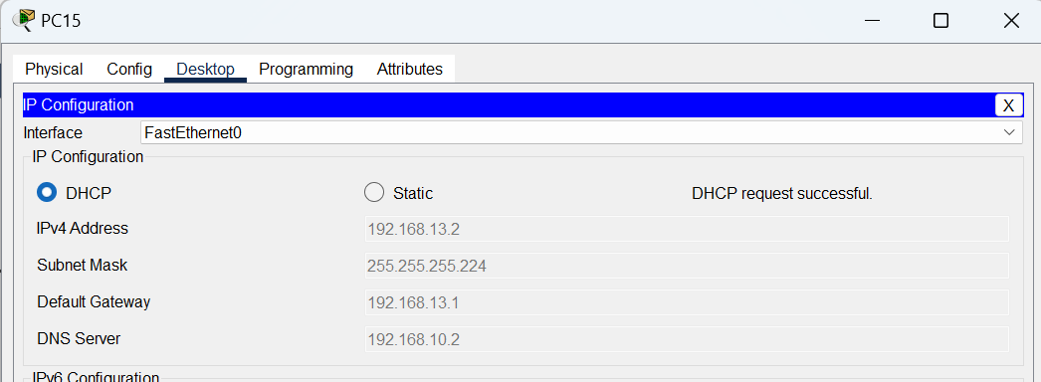

Tes uji koneksi ping antar PC dan end device bisa saling terhubung:

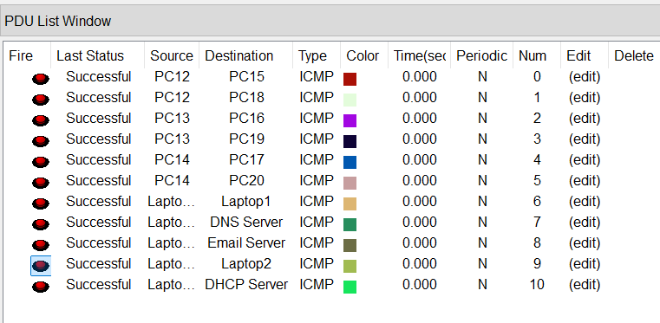

Uji akses web perusahaan dengan domain dns:

Contoh pada PC:

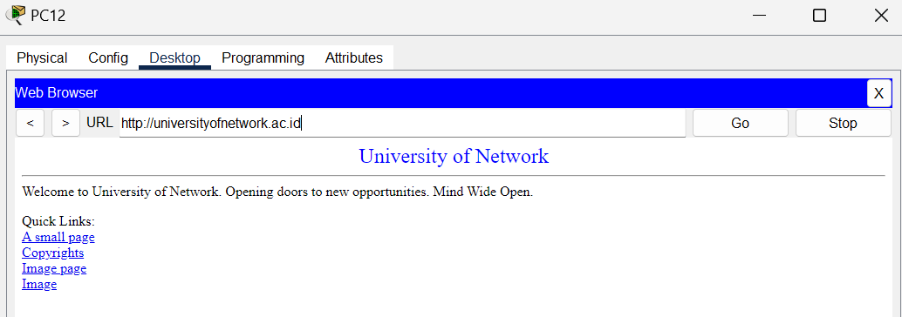

Uji kirim email antar pc admin:

