The Strategy Design Pattern
Calvin O. Kerns
Undergraduate Computer Science Student, Western Washington University, kernsc@wwu.edu

CCS CONCEPTS • Design Patterns • Object-oriented programming • Strategy Design Pattern
Design patterns are an essential part of software development and are responsible for the efficiency and organization that is seen in the technological world today. This paper explores the Strategy design pattern and its purpose to define a family of algorithms, encapsulate each one, and make them interchangeable at runtime. By examining what the design pattern is and the specifics of how it works, the benefits are clear. Illustrated are the effects of the Strategy pattern and some real-world examples of common implementations. The possible downsides of the pattern are also explored, although very few. The findings demonstrate that implementing the Strategy pattern not only simplifies code maintenance but also enables dynamic algorithm selection and promotes code reusability, ultimately leading to more flexible and maintainable software architectures.

1. INTRODUCTION
Design patterns are a way to simply lay out the process of software development to solve problems that may occur during the development process. These patterns provide a template that developers can use to solve recurring design challenges, in the end leading to more efficient and more organized coding processes.
Design patterns are categorized into three main types: creational, structural, and behavioral. Creational patterns focus on object creation, mainly that they are created at the right time. Structural patterns deal with the relationship between creating classes and creating a structure of classes to be beneficial in terms of decoupling and organization. Behavioral patterns, on the other hand, target how specific objects interact and work together to get a common task done.
The significance of design patterns in modern software development can make or break the result of a project or application. As implementation grows in complexity and size, design patterns help to orginize and the planning and implementation process of software development. There are many known obstacles that developers have come across over the years and these patterns are the culmination of the knowledge and experience of these people in the past. Using design patterns will save developers the headache that comes with disorganization and poor modularity. On top of that, it provides a common structure for programs that is a universal language within the realm of object-oriented design. Due to this, programs are easier to create, maintain, and improve.
Within the behavioral category lies the Strategy design pattern. While each design pattern serves its unique purpose, the Strategy pattern stands out as a particularly powerful technique that addresses the common challenge of algorithm variation and selection in software systems. This pattern allows developers to seclude families of different algorithms for a similar purpose. This facilitates the pathway for variation of algorithms in runtime while allowing for straightforward additions of necessary algorithms in the future.

2. HOW THE STRATEGY DESIGN PATTERN WORKS
The Strategy design pattern is one of the central methods of encapsulating algorithms and promoting interchangeability within a program. At its core, Strategy allows for a program to pick from different concrete implementations of the same task during runtime. These concrete algorithms are different strategy classes that are all implementations of a similar interface. By having this common interface that strategy classes must abide by, the context and algorithms of a program are decoupled.
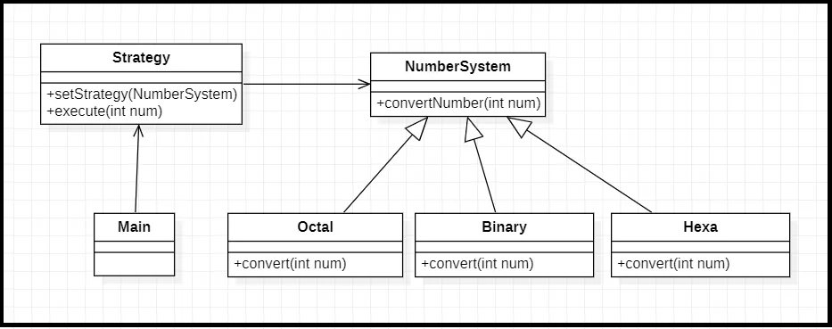Figure 1: Ghosh, T. 2021. Strategy Design Pattern. Medium. (https://tusharghosh09006.medium.com/strategy-design-pattern-f12c3848e31c )
Figure 1 demonstrates an example familiar to all programmers. There are many different ways to represent numbers and sometimes the need to use one system over another is variable. The implementation of the Strategy design pattern illustrated shows the simplicity that the pattern provides when it comes to varying algorithms. Octal, Binary, and Hexa classes each implement the same interface, NumberSystem. Each implementation of the interface is required to provide a concrete implementation of the methods within the interface, in this case, convertNumber(). The Main class has an object of type Strategy that has that has the method execute() to do some tasks given an integer. The needs for this method's input may vary, hence the setStrategy() method. The client can use this method to swap between concrete implementations of the NumberSystem() during runtime. This is an efficient and organized way to ensure that the execute() method receives its parameters in the proper form.

REFERENCES:
- Ghosh, T. 2021. Strategy Design Pattern. Medium. https://tusharghosh09006.medium.com/strategy-design-pattern-f12c3848e31c (accessed November 17th, 2024)

