Concept Review

Longitudinal Speed Control

Why Explore Longitudinal Speed Control?

As an autonomous vehicle drives down a lane it requires the use of a lateral controller to drive in a safe zone while also maintaining a desired speed. The job of a longitudinal controller is to ensure an autonomous vehicle can reach a desired set velocity safely. Depending on the control structure implemented a model of the transmission is required to model how the car’s engine changes as it reaches the desired velocity. The focus of this document will be for vehicles which use electric engines. The control input from the longitudinal can be assumed to be directly sent to the engine with the electric engine time constant being the only phenomenon to modulate the vehicle’s response. This document provides a proposed method for a potential speed control architecture.

Longitudinal Control

Let’s consider the following question when designing a speed controller for vehicle control:

* The time delay of a vehicle’s drivetrain to reach a desired speed
* What does a control input of 0 represent for a vehicle already driving?

The time delay caused by the drivetrain depends on if the vehicle is using an internal combustion engine or an electric motor. Internal Combustion Engine (ICE) vehicles will require the user to also consider the gear changes as part of the control structure. For the purposes of this document the focus will be in electric vehicles which send control inputs directly to the motor. As a control action is sent to the motor a potential consideration is the gear ratio to change from motor command to longitudinal vehicle velocity.

To handle a control input of 0 to the motor a slight modification is made to the final control structure. If a traditional PID controller is used the control input will eventually reach 0 when the vehicle reaches a desired speed. On a regular vehicle this input is related to the throttle input sent to the motor. If the motor is designed to coast a throttle input of 0 will cause the vehicle to slow down every time it reaches a desired velocity. As the car slows down the throttle will engage again with the controller trying to hunt the setpoint. To overcome this concern a feedforward gain is added to ensure the motor is always running even when the control input is zero.

Now the next task is to identify if all three components of a PID controller are required for the vehicle’s longitudinal controller. The motor used on an electric vehicle will have a natural time constant which will attenuate how fast it takes for the motor to reach the desired velocity. This leaves both a proportional and integral gain. Proportional action is required to get the motor driving and overcome any internal friction inside of the motor. Integral control will allow the car to settle down and reach the desired setpoint over time.

A complete overview of the updated control strategy for the longitudinal speed controller will look like:

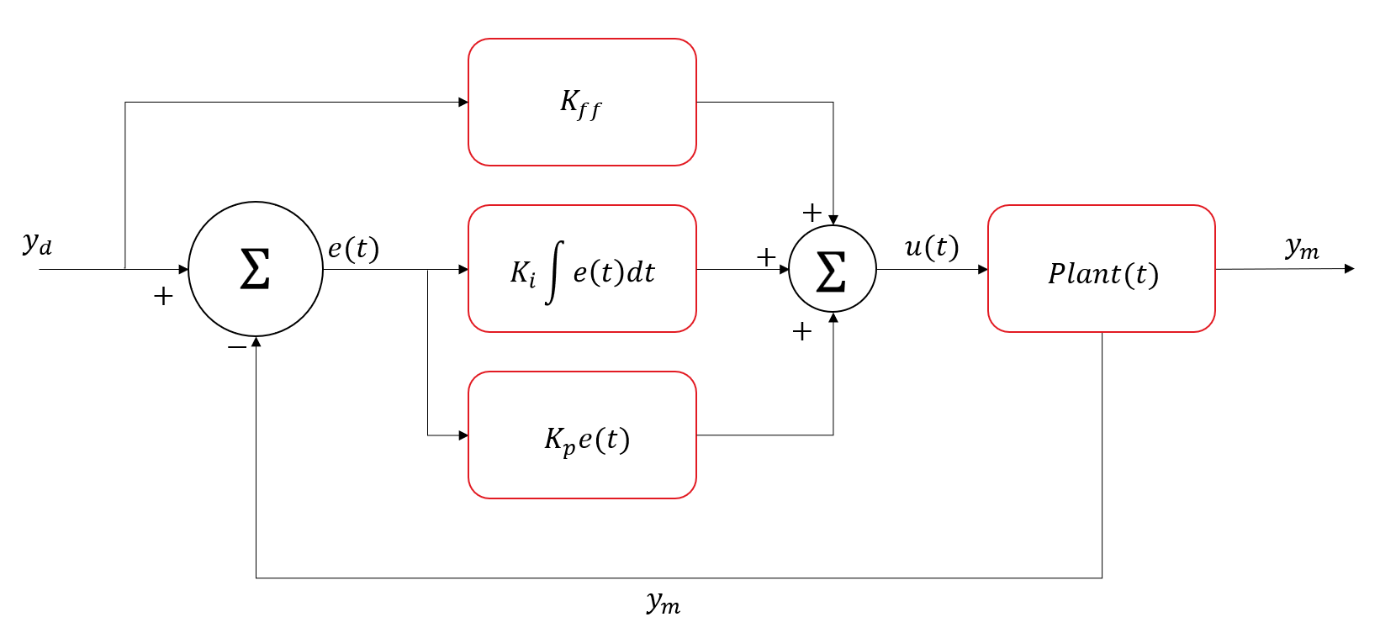

Figure 1: PI +Feedforward control for longitudinal speed control