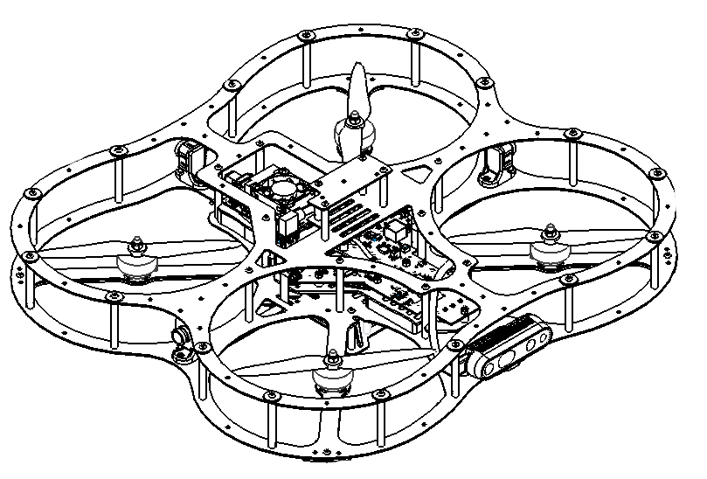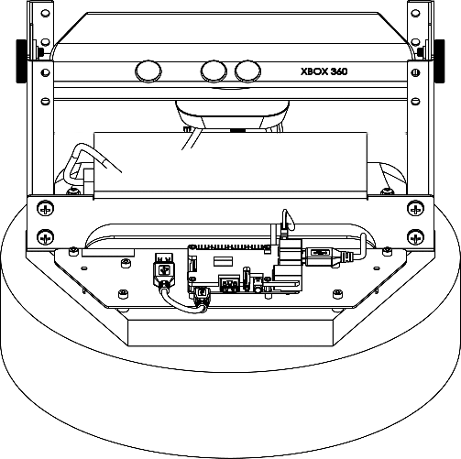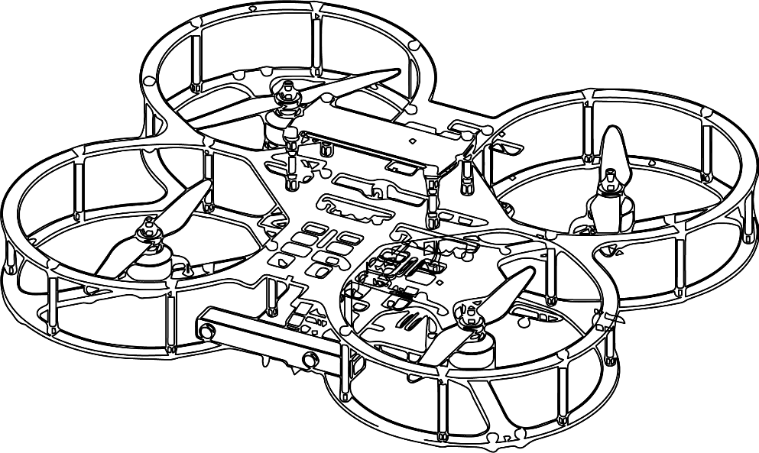

**Autonomous Vehicles Research Studio**

Setup Guide – Introduction

© 2023 Quanser Inc., All rights reserved

For more information on the solutions Quanser Inc. offers,   
please visit the web site at: <http://www.quanser.com>

|  |  |
| --- | --- |
| Quanser Inc.  119 Spy Court  Markham, Ontario  L3R 5H6, Canada | info@quanser.com  Phone : 19059403575  Fax : 19059403576  printed in Markham, Ontario. |

This document and the software described in it are provided subject to a license agreement. Neither the software nor this document may be used or copied except as specified under the terms of that license agreement. Quanser Inc. grants the following rights: a) The right to reproduce the work, to incorporate the work into one or more collections, and to reproduce the work as incorporated in the collections, b) to create and reproduce adaptations provided reasonable steps are taken to clearly identify the changes that were made to the original work, c) to distribute and publicly perform the work including as incorporated in collections, and d) to distribute and publicly perform adaptations. The above rights may be exercised in all media and formats whether now known or hereafter devised. These rights are granted subject to and limited by the following restrictions: a) You may not exercise any of the rights granted to You in above in any manner that is primarily intended for or directed toward commercial advantage or private monetary compensation, and b) You must keep intact all copyright notices for the Work and provide the name Quanser Inc. for attribution. These restrictions may not be waved without express prior written permission of Quanser Inc.

**FCC Notice** This device complies with Part 15 of the FCC rules. Operation is subject to the following two conditions: (1) this device may not cause harmful interference, and (2) this device must accept any interference received, including interference that may cause undesired operation.

**Industry Canada Notice** This Class A digital apparatus complies with Canadian ICES-003. Cet appareil numérique de la classe A est conforme à la norme NMB-003 du Canada.

**Waste Electrical and Electronic Equipment (WEEE)**

This symbol indicates that waste products must be disposed of separately from municipal household waste, according to Directive 2002/96/EC of the European Parliament and the Council on waste electrical and electronic equipment (WEEE). All products at the end of their life cycle must be sent to a WEEE collection and recycling center. Proper WEEE disposal reduces the environmental impact and the risk to human health due to potentially hazardous substances used in such equipment. Your cooperation in proper WEEE disposal will contribute to the effective usage of natural resources.

|  |  |
| --- | --- |
|  | This product meets the essential requirements of applicable European Directives as follows:   * 2006/95/EC; Low-Voltage Directive (safety) * 2004/108/EC; Electromagnetic Compatibility Directive (EMC)   **Warning**: This is a Class A product. In a domestic environment this product may cause radio interference, in which case the user may be required to take adequate measures. |
| caution.png **Caution** | **This equipment is designed to be used for educational and research purposes and is not intended for use by the public.** The user is responsible to ensure that the equipment will be used by technically qualified personnel only. While the end-effector board provides connections for external user devices, users are responsible for certifying any modifications or additions they make to the default configuration. |

Table of Contents

A. What’s Covered? 3

B. File Naming Scheme and Length Limits 4

# A. What’s Covered?

This series consists of steps that will ensure that your **Autonomous Vehicles Research Studio** is fully set up and functional. There are numerous checkpoints during the process to improve the workflow. Ensure that each step is followed carefully. You can track your progress reading each guide and completing each checkpoint using the checklist in the table below.

Go through this guide and the steps in order for the first time setting up the studio. Always start with the word document, if there is software you need to run, the guide will walk you through it. If you only have one type of vehicle, certain guides are separated by vehicle, for example step 2 – batteries. You only have to read the one referring to your vehicle.

|  |  |  |  |  |
| --- | --- | --- | --- | --- |
| Step | Section / Step | Read? | Checkpoint | Done? |
| 1 | Workspace with Nets & Mats |  | Setup Picture |  |
| 2 | Vehicle Batteries |  | No | N/A |
| 3 | Mount OptiTrack Cameras |  | Camera Setup Picture |  |
| 4 | Ground PC Setup |  | PC Connection Picture |  |
| 5 | Software Licensing and Testing |  | Sine Scope Demo |  |
| 6 | Joystick Testing |  | Visualization Demo |  |
| 7 | Router – PC Connection |  | No | N/A |
| 8 | Vehicle Communication |  | TCP/IP Demo |  |
| 9 | Camera Orientation |  | Reference View Screenshot |  |
| 10 | Camera Calibration |  | Captured Volume Screenshot |  |
| 11 | Rigid Body Definition |  | Optitrack Visualization Demo |  |
| 12 | Vehicle I/O Check |  | IO/Check |  |
| 13 | QDrone 1/2 Hover Test |  | Hover Test |  |

# B. File Naming Scheme and Length Limits

The autonomous vehicle examples are separated by product. For more recent products, like the QDrone 2, Simulink files are named as follows:

shortenedProductName_File_associatedExample_fileMatlabVersion.slx

So for example, the QDrone 2(product) Mission Control (File) for Position Control (example), saved in MATLAB/Simulink 2021a is named **QD2_MissionCtrl_Position_2021a.slx**

Windows requires that the path for files are shorter than 256 characters, so file names were shortened due to this limit. However, Simulink will need files from folders that will get generated when building the file and path limits could still be exceeded.

If you try to build a file and the Diagnostic Viewer returns an error due to path length, move the folder where your file is located somewhere else in your computer that will create a shorter path length.

So for example, if the file you are trying to run is located in the folder

C:\Users\yourName\Documents\QUANSER\examples\autonomous_vehicles\multivehicle\swarm_qdrone_1\non_toolchain\swarm_qdrones\2qdrones

Move the folder perhaps to

C:\Users\yourName\Documents\swarm_qdrone1\2qdrones

© Quanser Inc., All rights reserved.

Solutions for teaching and research. Made in Canada.