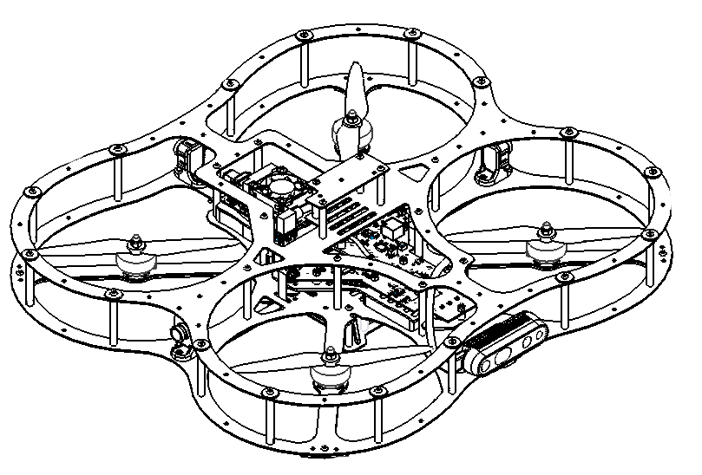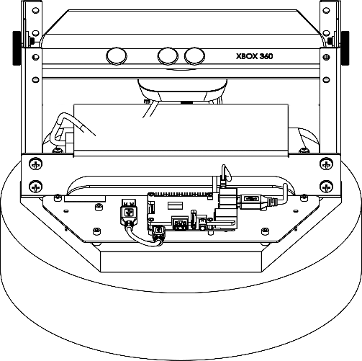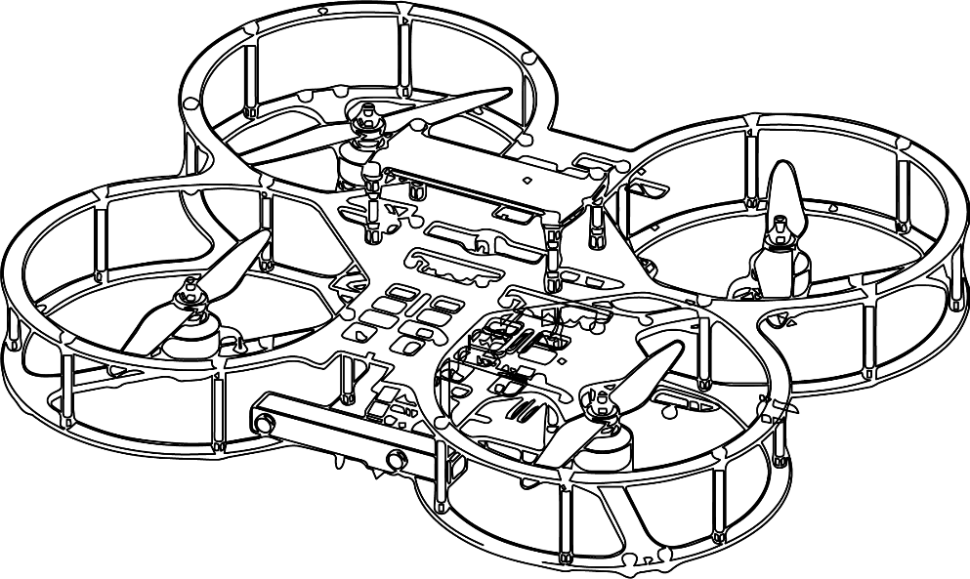

**Autonomous Vehicles Research Studio**

Setup Guide – Calibrating Optitrack Cameras

© 2023 Quanser Inc., All rights reserved

For more information on the solutions Quanser Inc. offers,   
please visit the web site at: <http://www.quanser.com>

|  |  |
| --- | --- |
| Quanser Inc.  119 Spy Court  Markham, Ontario  L3R 5H6, Canada | info@quanser.com  Phone : 19059403575  Fax : 19059403576  printed in Markham, Ontario. |

This document and the software described in it are provided subject to a license agreement. Neither the software nor this document may be used or copied except as specified under the terms of that license agreement. Quanser Inc. grants the following rights: a) The right to reproduce the work, to incorporate the work into one or more collections, and to reproduce the work as incorporated in the collections, b) to create and reproduce adaptations provided reasonable steps are taken to clearly identify the changes that were made to the original work, c) to distribute and publicly perform the work including as incorporated in collections, and d) to distribute and publicly perform adaptations. The above rights may be exercised in all media and formats whether now known or hereafter devised. These rights are granted subject to and limited by the following restrictions: a) You may not exercise any of the rights granted to You in above in any manner that is primarily intended for or directed toward commercial advantage or private monetary compensation, and b) You must keep intact all copyright notices for the Work and provide the name Quanser Inc. for attribution. These restrictions may not be waved without express prior written permission of Quanser Inc.

**FCC Notice** This device complies with Part 15 of the FCC rules. Operation is subject to the following two conditions: (1) this device may not cause harmful interference, and (2) this device must accept any interference received, including interference that may cause undesired operation.

**Industry Canada Notice** This Class A digital apparatus complies with Canadian ICES-003. Cet appareil numérique de la classe A est conforme à la norme NMB-003 du Canada.

**Waste Electrical and Electronic Equipment (WEEE)**

This symbol indicates that waste products must be disposed of separately from municipal household waste, according to Directive 2002/96/EC of the European Parliament and the Council on waste electrical and electronic equipment (WEEE). All products at the end of their life cycle must be sent to a WEEE collection and recycling center. Proper WEEE disposal reduces the environmental impact and the risk to human health due to potentially hazardous substances used in such equipment. Your cooperation in proper WEEE disposal will contribute to the effective usage of natural resources.

|  |  |
| --- | --- |
|  | This product meets the essential requirements of applicable European Directives as follows:   * 2006/95/EC; Low-Voltage Directive (safety) * 2004/108/EC; Electromagnetic Compatibility Directive (EMC)   **Warning**: This is a Class A product. In a domestic environment this product may cause radio interference, in which case the user may be required to take adequate measures. |
| caution.png **Caution** | **This equipment is designed to be used for educational and research purposes and is not intended for use by the public.** The user is responsible to ensure that the equipment will be used by technically qualified personnel only. While the end-effector board provides connections for external user devices, users are responsible for certifying any modifications or additions they make to the default configuration. |

Table of Contents

A. Calibrating Optitrack Cameras 3

i. Calibrating Camera Group 4

ii. Calibrating the Ground Plane 6

B. Research Studio Frame vs Motive Frame 7

C. Checkpoint – Captured Volume Screenshot 7

# A. Calibrating Optitrack Cameras

Once the cameras are set up and oriented (you have followed the instructions in step 3 – camera mounting and step 9 – camera orientation), the cameras are ready for calibration.

The calibration process involves two steps, calibrating the camera group and calibrating the ground plane.

1. **Camera group**: calibrating this will determine the relative position of the cameras.   
   This step uses the calibration wand (Figure 1a). The Motive software compares and cross-references the marker positions observed by multiple cameras to calculate their relative location to each other.
2. **Ground plane**: determines where the camera group is located relative to the ground  
   This step uses the ground calibration square (Figure 1b). Motive uses the marker positions of the ground calibration square as observed by the camera group to calculate their location relative to the ground.

|  |  |
| --- | --- |
|  |  |
| 1. Calibration wand (CW - 500) | b. Calibration ground square (CS - 200) |
| Figure 1: Optitrack calibration tools (Note that the CW-500 wand will  require assembly using the A slots) | |

## i. Calibrating Camera Group

|  |
| --- |
|  |
| Figure 2. Devices pane in Motive:  detecting cameras |

|  |
| --- |
| **Note**: If you do not see any/all cameras, ensure that all USB cables are properly connected and retry |
|  |
| **Important**: Leave Motive open for approximately 15-30 minutes to allow the cameras to warm up completely prior to performing calibration. |

1. Open Motive. Under the Devices pane, ensure that Motive can detect all Flex 13 cameras (Figure 2) Make sure all cameras are in tracking mode.
2. Remove all markers from the view of the cameras. Sharp light from reflective surfaces should be blocked (painter’s tape is a great option for this) or the sources relocated, as these are false positives in terms of marker recognition and can hinder with rigid body identification later.

|  |
| --- |
| **Note**: If you cannot remove certain reflective surfaces, please take a screenshot of the view and reflective surface, and contact Quanser technical support ([tech@quanser.com](mailto:tech@quanser.com)) for help. |

|  |
| --- |
|  |
| Figure 3. Wanding in Motive 2.0.1 |

1. Under Camera Calibration > Calibration > Wanding pane, select the ‘*CW - 500 (500mm)*’ wand, and ensure that the calibration type is set to ‘*Full*’ (Figure 3). Click ‘*Start Wanding*’ and move the wand around in the workspace. Try to move the wand in a way that the generated point cloud fills most of the frame for each camera (Figure 4a).

|  |  |
| --- | --- |
|  |  |
| a. Marker point cloud | b. Sample points used |
| Figure 4: Point cloud generation using markers in Motive 2.0.1 | |

1. The markers detected by the cameras will generate a point cloud (Figure 4a). For proper calibration, keep moving the wand within the workspace until each camera registers approximately 6000-8000 sample points (Figure 4b). When complete, click ‘Calculate’ (top left in figure 4b) under the Camera Calibration > Calibration > Calibration pane.

|  |
| --- |
| **Note**: Empty regions in a particular camera’s point cloud are locations where the other cameras could not see the wand during calibration. This indicates an opportunity to further optimize the workspace by re-orienting cameras. For more information, contact Quanser technical support (tech@quanser.com). |

1. After a brief moment, a prompt with the calibration results will be displayed (Figure 5). **If the result is not ‘Very High’ or ‘Exceptional’, it is recommended to repeat the calibration process with more sample points.**

|  |
| --- |
|  |
| Figure 5: Calibration result (Motive 2.0.1) |

|  |
| --- |
| GROUND STATION PC  z  x |
| Figure 6. Positioning the CS-200 ground square |

## ii. Calibrating the Ground Plane

1. Place the CS - 200 ground square inside the workspace as shown in Figure 6a. The marker on the right-angle corner of the square represents the origin of the reference coordinate frame used by Motive to compute the tracking data. Note that the z axis on the square must point towards the user (Figure 6). This will ensure that all frame assignments in the Autonomous Vehicles Research Studio applications are consistently defined.
2. Under the Camera Calibration > Ground Plane > Ground Plane Calibration Square pane, ensure that the ‘*Vertical Offset (mm)*’ is set to 19 mm (Figure 7). Click ‘*Set Ground Plane*’.

|  |
| --- |
|  |
| Figure 7. setting vertical offset for ground plane (Motive 2.0.1) |

1. Save the resulting file (*.cal) in a convenient location (e.g. Documents > Optitrack). Under the file menu, click on Save Profile As. Save it (*.xml) in a convenient location as well. This will save a profile with no rigid bodies (objects with markers) that can be used to add rigid bodies later.

# B. Research Studio Frame vs Motive Frame

|  |  |  |
| --- | --- | --- |
| x  x  z  y  Autonomous Vehicles  Research Studio Frame  Motive  Frame  GROUND STATION PC | |  | | --- | | **Note**: The Research Studio frame has a fixed orientation with respect to the Motive frame (defined using the ground calibration square). It is recommended to orient the ground square to match the orientation of the black solid frame (pointed towards the ground control station PC, Figure 8). The Research Studio frame corresponds to the solid red frame. | |
| Figure 8: Research Studio frame and Motive frame |

# C. Checkpoint – Captured Volume Screenshot

Once camera calibration is complete, you can view the volume captured by the cameras. This tool is useful in fine tuning the camera view to optimize the volume captured. Note that the displayed volume is an approximation and is generated with larger sized reference markers. Actual capture volume for the QDrones and QBot 2/2e will be slightly smaller than illustrated.

1. In the **Perspective View** toolbar in **Motive**, click on the **Visual Aids** icon.

1. In the drop menu that opens, click on **Capture Volume**.

1. Motive should now display the captured volume in the **Perspective View** window.

Take a screenshot of the captured volume future reference/tech support!

© Quanser Inc., All rights reserved.

Solutions for teaching and research. Made in Canada.