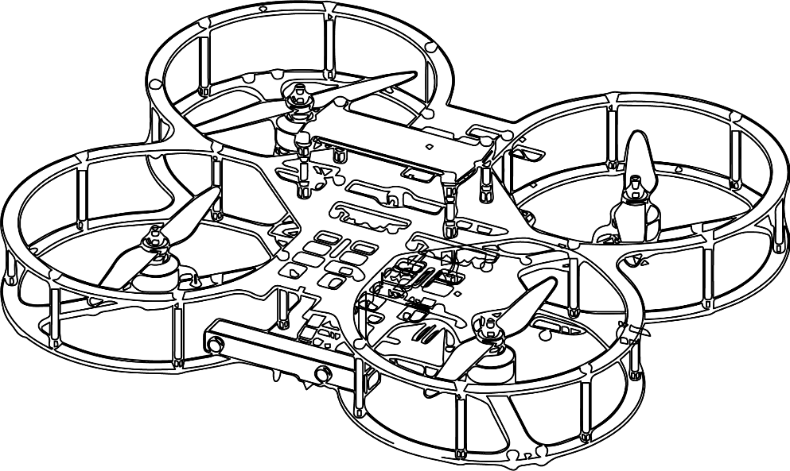

**Autonomous Vehicles Research Studio**

Setup Guide – QDrone 1 I/O Test

© 2023 Quanser Inc., All rights reserved

For more information on the solutions Quanser Inc. offers,   
please visit the web site at: <http://www.quanser.com>

|  |  |
| --- | --- |
| Quanser Inc.  119 Spy Court  Markham, Ontario  L3R 5H6, Canada | info@quanser.com  Phone : 19059403575  Fax : 19059403576  printed in Markham, Ontario. |

This document and the software described in it are provided subject to a license agreement. Neither the software nor this document may be used or copied except as specified under the terms of that license agreement. Quanser Inc. grants the following rights: a) The right to reproduce the work, to incorporate the work into one or more collections, and to reproduce the work as incorporated in the collections, b) to create and reproduce adaptations provided reasonable steps are taken to clearly identify the changes that were made to the original work, c) to distribute and publicly perform the work including as incorporated in collections, and d) to distribute and publicly perform adaptations. The above rights may be exercised in all media and formats whether now known or hereafter devised. These rights are granted subject to and limited by the following restrictions: a) You may not exercise any of the rights granted to You in above in any manner that is primarily intended for or directed toward commercial advantage or private monetary compensation, and b) You must keep intact all copyright notices for the Work and provide the name Quanser Inc. for attribution. These restrictions may not be waved without express prior written permission of Quanser Inc.

**FCC Notice** This device complies with Part 15 of the FCC rules. Operation is subject to the following two conditions: (1) this device may not cause harmful interference, and (2) this device must accept any interference received, including interference that may cause undesired operation.

**Industry Canada Notice** This Class A digital apparatus complies with Canadian ICES-003. Cet appareil numérique de la classe A est conforme à la norme NMB-003 du Canada.

**Waste Electrical and Electronic Equipment (WEEE)**

This symbol indicates that waste products must be disposed of separately from municipal household waste, according to Directive 2002/96/EC of the European Parliament and the Council on waste electrical and electronic equipment (WEEE). All products at the end of their life cycle must be sent to a WEEE collection and recycling center. Proper WEEE disposal reduces the environmental impact and the risk to human health due to potentially hazardous substances used in such equipment. Your cooperation in proper WEEE disposal will contribute to the effective usage of natural resources.

|  |  |
| --- | --- |
|  | This product meets the essential requirements of applicable European Directives as follows:   * 2006/95/EC; Low-Voltage Directive (safety) * 2004/108/EC; Electromagnetic Compatibility Directive (EMC)   **Warning**: This is a Class A product. In a domestic environment this product may cause radio interference, in which case the user may be required to take adequate measures. |
| caution.png **Caution** | **This equipment is designed to be used for educational and research purposes and is not intended for use by the public.** The user is responsible to ensure that the equipment will be used by technically qualified personnel only. While the end-effector board provides connections for external user devices, users are responsible for certifying any modifications or additions they make to the default configuration. |

Table of Contents

A. QDrone 1 I/O Check 3

# QDrone 1 I/O Check

1. From the same folder containing this file, open the folder QDrone IO Check, and open QDrone_IO_Check.mdl. (This file checks all the sensors that are needed for flight, if you want to also see the other sensors, use the QDrone_IO_Check_Full.mdl file after running through these instructions.)
2. In the model that loads, from the **HARDWARE** tab on top of your Simulink model, click on **Hardware Settings** (Gear Icon). (If using an older version, click on **Model Configuration Properties** under the **Simulation** drop menu.)
3. Expand **Code Generation** on the left side of the window, click on **interface** and set the **MEX-file arguments** (Figure 1) as follows

'-w -d %d -uri %u','tcpip://QDrone0xxxxx.local:17001'

where QDrone0xxxxx refers to the hostname of the QDrone 1 you are using (found below the battery compartment plate). If you have a fixed IP for your QDrone or know its IP v4 address, use that instead. Press OK.

|  |
| --- |
|  |
| Figure 1. Setting up the MEX-file arguments |

1. Plug in and secure a battery to turn ON the QDrone. Place the drone at the center of the workspace ensuring the ESC disable switch has a green light (which means the ESC is enabled), as shown in figure 2.

|  |
| --- |
|  |
| Figure 2. ESCs enabled (motors can spin) |

1. Ensure that a connection to the drone is established by pinging to it. See the vehicle communication document for more information.
2. At the root level in the model, ensure the Motor Switch is set to 0. (Figure 3)

|  |  |
| --- | --- |
|  | Figure 3. Motor Switch set to off in the QDrone IO check model. |

1. Ensure both the SAFETY GOGGLES and PROTECTIVE GLOVES are worn.
2. Click on the **HARDWARE** tab on the top menu, and then click the green play button (**Monitor & Tune**), It should build and start the model. If you have an older version of Simulink that does not have a Hardware tab, under the **QUARC** drop down menu, click **Build** and once it finishes click **Start**.
3. After you hear 2 beeps (which indicates that the ESCs are enabled and that the model is running on the drone), set the **Motor Switch** to 1. The four motors should start spinning sequentially (one at a time in clockwise order). Ensure that the motors are turning on and off in a clockwise cyclical order and each motor is spinning in expected directions: bottom right (motor 1, clockwise), bottom left (motor 3, counter-clockwise), top left (motor 4, clockwise) and then top right (motor 2, counter-clockwise).
4. Set the **Motor Switch** to 0.
5. Step into the workspace and set the **ESC Disable** switch on the QDrone to **ON** (that is, the ESCs are DISABLED, which is indicated by a **red LED lit next to the switch**). Move the drone around manually by holding it using the handle on the top frame of the QDrone. Check the attitude of the drone in the **Attitude Estimates (deg)** scope to ensure that the readings are reasonable.

**CAUTION:** DO NOT handle the drone with spinning motors.

**CAUTION:** Ensure that the motors are not spinning (Motor Switch is set to 0).

1. Ensure that the **Low Battery** display is 0 (i.e., battery is charged, low battery threshold is 10.5V).
2. Ensure that the **Sensor Failure** display is 0 (i.e., no sensor issue).

This completes the **QDrone IO check** task and confirms that your QDrone is functioning correctly. The **QDrone IO Check** model can be used to confirm basic functionalities whenever you run into unexpected behavior, to isolate software from hardware issues. If you have any errors, make sure that all the steps prior to this checkpoint have been followed. If further issues persist, please contact Quanser technical support (tech@quanser.com).

© Quanser Inc., All rights reserved.

Solutions for teaching and research. Made in Canada.