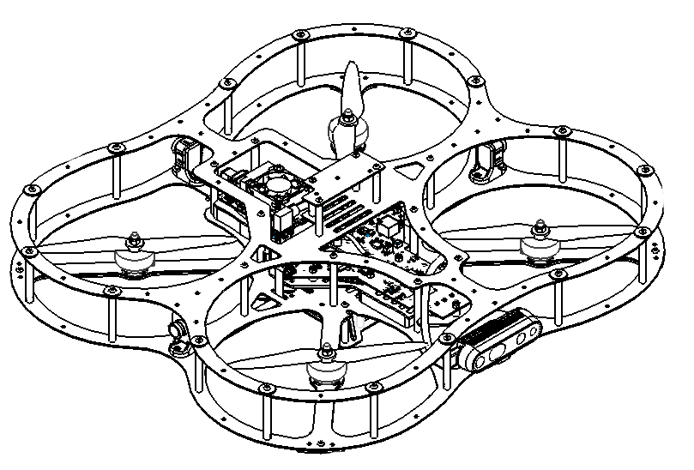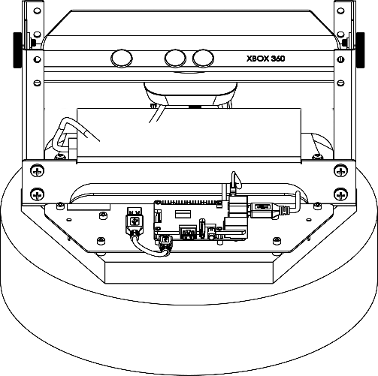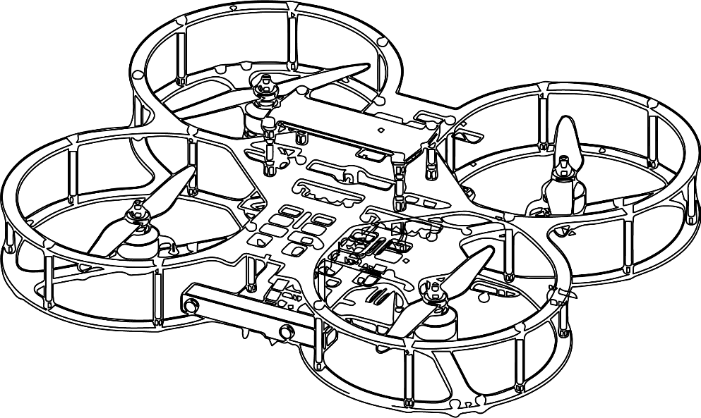

**Autonomous Vehicles Research Studio**

Setup Guide – Workspace Setup and Safety

© 2023 Quanser Inc., All rights reserved

For more information on the solutions Quanser Inc. offers,   
please visit the web site at: <http://www.quanser.com>

|  |  |
| --- | --- |
| Quanser Inc.  119 Spy Court  Markham, Ontario  L3R 5H6, Canada | info@quanser.com  Phone : 19059403575  Fax : 19059403576  printed in Markham, Ontario. |

This document and the software described in it are provided subject to a license agreement. Neither the software nor this document may be used or copied except as specified under the terms of that license agreement. Quanser Inc. grants the following rights: a) The right to reproduce the work, to incorporate the work into one or more collections, and to reproduce the work as incorporated in the collections, b) to create and reproduce adaptations provided reasonable steps are taken to clearly identify the changes that were made to the original work, c) to distribute and publicly perform the work including as incorporated in collections, and d) to distribute and publicly perform adaptations. The above rights may be exercised in all media and formats whether now known or hereafter devised. These rights are granted subject to and limited by the following restrictions: a) You may not exercise any of the rights granted to You in above in any manner that is primarily intended for or directed toward commercial advantage or private monetary compensation, and b) You must keep intact all copyright notices for the Work and provide the name Quanser Inc. for attribution. These restrictions may not be waved without express prior written permission of Quanser Inc.

**FCC Notice** This device complies with Part 15 of the FCC rules. Operation is subject to the following two conditions: (1) this device may not cause harmful interference, and (2) this device must accept any interference received, including interference that may cause undesired operation.

**Industry Canada Notice** This Class A digital apparatus complies with Canadian ICES-003. Cet appareil numérique de la classe A est conforme à la norme NMB-003 du Canada.

**Waste Electrical and Electronic Equipment (WEEE)**

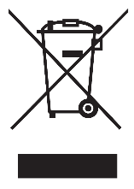This symbol indicates that waste products must be disposed of separately from municipal household waste, according to Directive 2002/96/EC of the European Parliament and the Council on waste electrical and electronic equipment (WEEE). All products at the end of their life cycle must be sent to a WEEE collection and recycling center. Proper WEEE disposal reduces the environmental impact and the risk to human health due to potentially hazardous substances used in such equipment. Your cooperation in proper WEEE disposal will contribute to the effective usage of natural resources.

|  |  |
| --- | --- |
|  | This product meets the essential requirements of applicable European Directives as follows:   * 2006/95/EC; Low-Voltage Directive (safety) * 2004/108/EC; Electromagnetic Compatibility Directive (EMC)   **Warning**: This is a Class A product. In a domestic environment this product may cause radio interference, in which case the user may be required to take adequate measures. |
| caution.png **Caution** | **This equipment is designed to be used for educational and research purposes and is not intended for use by the public.** The user is responsible to ensure that the equipment will be used by technically qualified personnel only. While the end-effector board provides connections for external user devices, users are responsible for certifying any modifications or additions they make to the default configuration. |

Table of Contents

A. Operator Warnings 3

B. Floor Mats 4

C. Netting 5

D. General Safety Guidelines 6

E. Studio Space 7

F. Checkpoint – Workspace Picture 7

# A. Operator Warnings

|  |  |  |
| --- | --- | --- |
| caution.png | **Caution** | This symbol marks specific safety warnings and operating procedures that are important for the safety of the Autonomous Vehicles Research Studio users and involved vehicles (QDrone ½ and QBot 2/2e). Read these warnings carefully. |
|  |  |  |
| caution.png | **Caution** | The QDrone 1/2 are powerful and potentially dangerous vehicles if used improperly. Always follow safe operating procedures when using the QDrones. Quanser is not responsible for damages and injury resulting from improper or unsafe use of the QDrones. |
|  |  |  |
| caution.png | **Caution** | The QBot 2/2e is a powerful and potentially dangerous vehicle if used improperly. Always follow safe operating procedures when using the QBot 2/2e. Quanser is not responsible for damages and injury resulting from improper or unsafe use of the QBot 2/2e. |
|  |  |  |
| caution.png | **Caution** | Before connecting batteries or attempting to run the QDrone 1/2, be sure to read this document and become familiar with the safety features and operating procedures of the QDrone 1/2. |
|  |  |  |
| caution.png | **Caution** | Before connecting batteries or attempting to run the QBot 2/2e, be sure to read this document and become familiar with the safety features and operating procedures of the QBot 2/2e. |
|  |  |  |
| caution.png | **Caution** | When handling the QDrone 1/2, always make sure there are no models running and that the power is turned off, unless otherwise and explicitly stated. The user should always wear protective gloves and safety eye goggles (provided), even when not in the workspace. |
|  |  |  |
| caution.png | **Caution** | The vehicles in the Autonomous Vehicles Research Studio use Lithium Polymer (LiPo) and Lithium Ion (Li-ion) batteries as their power source. Please carefully read and follow the safety guidelines and warnings regarding LiPo and Li-ion battery handling. |
|  |  |  |
|  | **Note** | This document consists of numerous important details that are highlighted in the form of notes. Please read these carefully. |

# B. Floor Mats

The **Autonomous Vehicles Research Studio** comes with 2 ft x 2 ft interlocking rubber mats, as seen in Figure 1, that are intended to protect the drones from drop impacts to the floor and reduce reflections off of the floor.

|  |
| --- |
| Shape  Description automatically generated  Figure 1. Interlocking rubber flooring |
|  |

Keep the following in mind:

|  |
| --- |
| **Note:** The entire localization workspace should be covered with the floor matting |

|  |
| --- |
| **Note:** The floor mats can be cleaned with soap and water |

|  |
| --- |
| **Note:** The boundary outline of the localization workspace can be marked using tape, which will come in handy when orienting and calibrating the localization cameras. |

|  |  |
| --- | --- |
| caution.png | **Caution:** When wet, the floor mats can be slippery |

|  |  |
| --- | --- |
| caution.png | **Caution:** Broken propellers can get lodged into the floor mats and would pose a walking hazard. Inspect the mats and remove any debris from time to time. |

# C. Netting

The **Autonomous Vehicles Research Studio** comes with multiple of 20 ft (length) x 20 ft (height) (approx. 6m x 6m) netting that is required to protect the users from autonomous vehicles operating in the workspace. This netting can be attached to the ceiling using Velcro straps (also provided, Figure 2). Also secure the net at the base (table legs, wall hooks etc.) to ensure that the net is taut.

|  |  |
| --- | --- |
|  | |
| 1. Attaching a net to a false ceiling using Velcro straps | |
|  |  |
| b, Velcro strap attachment | c. Attaching net to I-beams |
| Figure 2: Attaching the netting using Velcro straps to a false ceiling/I-beam | |

Keep the following in mind:

|  |
| --- |
| **Note:** Always secure the net when flying - manually or autonomously |

|  |
| --- |
| **Note:** Ensure the net is tightly secured and stretched (attached to both the top and bottom), and that there are no openings for the drone to pass through the net |

|  |
| --- |
| **Note:** Safety eyeglasses should always be worn, even outside the net. |

|  |
| --- |
| **Note:** Whenever a drone flies into the net, verify that the netting has not been damaged in any way. |

|  |
| --- |
| **Note:** Do not attach the netting to the same mounts as the localization system. When the net is pulled, the localization system may be disturbed, resulting in a loss of calibration. |

|  |  |
| --- | --- |
| caution.png | **Caution:** The net can be a tripping hazard |

|  |  |
| --- | --- |
| caution.png | **Caution:** Never cross the net into the workspace when a model is running |

|  |  |
| --- | --- |
| caution.png | **Caution:** Do not stand close to the net; if a drone flies into the net, the net will deflect |

# D. General Safety Guidelines

The **Autonomous Vehicles Research Studio** comes with safety eyeglasses, as well as protective gloves. Keep the following in mind:

|  |
| --- |
| **Note:** Safety eyeglasses should always be worn, even outside the net. |

|  |  |  |  |  |
| --- | --- | --- | --- | --- |
| |  | | --- | | **Note:** Always assume the QDrone is live until the battery is disconnected. |  |  | | --- | | **Note:** Always manipulate the drone from the handle mounted on the top of the frame (Figure 3) |  |  | | --- | | **Note:** After crashes, inspect the QDrone for damaged structure or wiring. If wires are exposed, repair them immediately. | |  |
| Figure 3: QDrone handle on top frame |

|  |  |
| --- | --- |
| caution.png | **Caution:** Always remove propellers when running a model on the QDrone outside of the netting. |

|  |  |
| --- | --- |
| caution.png | **Caution:** The propellers on the QDrone have sharp edges. |

|  |  |
| --- | --- |
| caution.png | **Caution:** Always wear the gloves and safety eyeglasses when installing or removing propellers. |

# E. Studio Space

The area within the installed netting space will be referred to as the workspace. The ground control station components (PC, router, battery chargers, joystick, and any vehicles not in use) should be placed outside the workspace and away from operating vehicles. Set up a dedicated space for the ground control station PC (with monitors) in a way that the user can visually inspect the workspace at all times. Ideally, the user should be able to see the workspace and monitors at the same time. The Localization system should be placed within the workspace to avoid the netting blocking the camera’s viewpoint.

# F. Checkpoint – Workspace Picture

Take a picture of your workspace with the netting and matting to confirm with a Quanser engineer or technical support specialist (tech@quanser.com) that the workspace is properly configured.

© Quanser Inc., All rights reserved.

Solutions for teaching and research. Made in Canada.