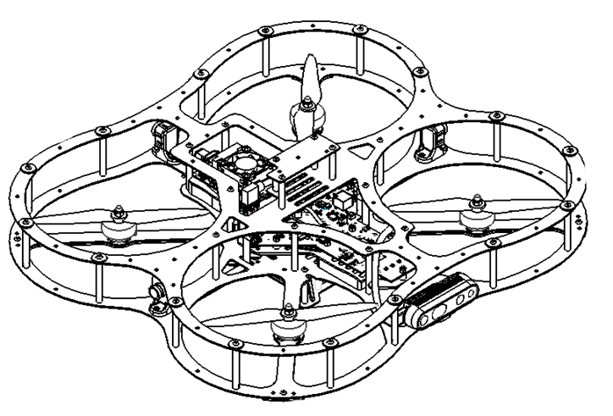

**Autonomous Vehicles Research Studio**

Setup Guide – QDrone 2 Batteries

© 2023 Quanser Inc., All rights reserved

For more information on the solutions Quanser Inc. offers,   
please visit the web site at: <http://www.quanser.com>

|  |  |
| --- | --- |
| Quanser Inc.  119 Spy Court  Markham, Ontario  L3R 5H6, Canada | info@quanser.com  Phone : 19059403575  Fax : 19059403576  printed in Markham, Ontario. |

This document and the software described in it are provided subject to a license agreement. Neither the software nor this document may be used or copied except as specified under the terms of that license agreement. Quanser Inc. grants the following rights: a) The right to reproduce the work, to incorporate the work into one or more collections, and to reproduce the work as incorporated in the collections, b) to create and reproduce adaptations provided reasonable steps are taken to clearly identify the changes that were made to the original work, c) to distribute and publicly perform the work including as incorporated in collections, and d) to distribute and publicly perform adaptations. The above rights may be exercised in all media and formats whether now known or hereafter devised. These rights are granted subject to and limited by the following restrictions: a) You may not exercise any of the rights granted to You in above in any manner that is primarily intended for or directed toward commercial advantage or private monetary compensation, and b) You must keep intact all copyright notices for the Work and provide the name Quanser Inc. for attribution. These restrictions may not be waved without express prior written permission of Quanser Inc.

**FCC Notice** This device complies with Part 15 of the FCC rules. Operation is subject to the following two conditions: (1) this device may not cause harmful interference, and (2) this device must accept any interference received, including interference that may cause undesired operation.

**Industry Canada Notice** This Class A digital apparatus complies with Canadian ICES-003. Cet appareil numérique de la classe A est conforme à la norme NMB-003 du Canada.

**Waste Electrical and Electronic Equipment (WEEE)**

This symbol indicates that waste products must be disposed of separately from municipal household waste, according to Directive 2002/96/EC of the European Parliament and the Council on waste electrical and electronic equipment (WEEE). All products at the end of their life cycle must be sent to a WEEE collection and recycling center. Proper WEEE disposal reduces the environmental impact and the risk to human health due to potentially hazardous substances used in such equipment. Your cooperation in proper WEEE disposal will contribute to the effective usage of natural resources.

|  |  |
| --- | --- |
|  | This product meets the essential requirements of applicable European Directives as follows:   * 2006/95/EC; Low-Voltage Directive (safety) * 2004/108/EC; Electromagnetic Compatibility Directive (EMC)   **Warning**: This is a Class A product. In a domestic environment this product may cause radio interference, in which case the user may be required to take adequate measures. |
| caution.png **Caution** | **This equipment is designed to be used for educational and research purposes and is not intended for use by the public.** The user is responsible to ensure that the equipment will be used by technically qualified personnel only. While the end-effector board provides connections for external user devices, users are responsible for certifying any modifications or additions they make to the default configuration. |

Table of Contents

A. LiPo Battery Safety 3

B. QDrone 2 Batteries 5

C. Charging the QDrone 2 Batteries 6

# LiPo Battery Safety

|  |  |
| --- | --- |
| caution.png | **Caution**: Before using any batteries, chargers/balancers, or power supplies, users must first read the manuals packaged with their equipment. Quanser supplies these guidelines for charging batteries, but it is the users’ responsibility to ensure they are operating their equipment safely and correctly. Quanser is not responsible for any damages resulting from use of batteries, power supplies, chargers, or balancers. |

|  |  |
| --- | --- |
| caution.png | **Caution**: Prior to using the QDrone 2, visually check the battery for bloating or damage. If the battery exhibits bloating **DO NOT USE** it. Visual bloating of the battery is dangerous - discard it in accordance with your country’s relevant recycling and disposal laws. |

|  |
| --- |
| **Note:** Use and store batteries in a dry environment. |

|  |  |
| --- | --- |
| caution.png | **Caution**: Do not charge the battery under direct sunlight. |

|  |  |
| --- | --- |
| caution.png | **Caution**: Do not charge the battery when the battery feels hot. |

|  |  |
| --- | --- |
| caution.png | **Caution**: Always be present when charging batteries and **do not leave batteries connected to the chargers or the QDrone 2 overnight**. |

|  |  |
| --- | --- |
| caution.png | **Caution**: Charge and store LiPo batteries in a location where a battery fire or explosion (including smoke hazard) will not endanger life or property. |

|  |  |
| --- | --- |
| caution.png | **Caution**: Keep LiPo batteries away from children and animals. |

|  |  |
| --- | --- |
| caution.png | **Caution**: Never charge a LiPo battery that has ballooned or swollen due to overcharging, undercharging or from a crash. |

|  |  |
| --- | --- |
| caution.png | **Caution**: Never charge a LiPo battery that has been punctured or damaged in a crash. After a crash, inspect the battery pack for signs of damage. |

|  |  |
| --- | --- |
| caution.png | **Caution**: Never charge the LiPo battery in a moving vehicle. |

|  |  |
| --- | --- |
| caution.png | **Caution**: Never overcharge the LiPo battery. |

|  |  |
| --- | --- |
| caution.png | **Caution**: Never leave the LiPo battery unattended during recharging. |

|  |  |
| --- | --- |
| caution.png | **Caution**: Do not charge LiPo batteries near flammable materials, liquids or objects. |

|  |  |
| --- | --- |
| caution.png | **Caution**: Ensure that charging leads are connected correctly. Reversing polarity charging can lead to battery damage, fire or explosion. |

|  |  |
| --- | --- |
| caution.png | **Caution**: A LiPo battery fire is a chemical fire. Have a suitable fire extinguisher (class D/for electrical fires) or a large bucket of dry sand near the charging area. Do not try to extinguish electrical battery fires with water. |

|  |  |
| --- | --- |
| caution.png | **Caution**: Reduce risks from fire/explosion by storing and charging LiPo batteries inside a suitable container: a LiPo storage sack/bag or metal/ceramic container is advised. |

|  |  |
| --- | --- |
| caution.png | **Caution**: Protect your LiPo batteries from accidental damage during storage and transportation. Do not put battery packs in pockets or bags where they can short circuit or come into contact with sharp or metallic objects. |

|  |  |
| --- | --- |
| caution.png | **Caution**: If your LiPo battery is subjected to a shock (such as a crash) you should place it in a metal container and observe signs of swelling or heating for at least 30 minutes.  **Ensure that the metal container doesn’t short the leads of the battery, which may cause a fire!** |

|  |  |
| --- | --- |
| caution.png | **Caution**: Do NOT attempt to disassemble, modify, or repair the LiPo battery. |

|  |  |
| --- | --- |
| caution.png | **Caution**: Never use a battery that is warm from charging or charge a battery that is warm from usage. |

|  |
| --- |
| **Note:** Consider how you would deal with a LiPo battery fire/explosion as part of your normal fire safety and evacuation planning. |

|  |
| --- |
| **Note:** When discarding a LiPo battery, discard it in accordance with your country’s relevant recycling and disposal laws. |

|  |
| --- |
| **Note:** Monitor charging LiPo batteries for signs of overheating. |

# QDrone 2 Batteries

QDrone 2 is powered using a single pack Lithium-Polymer (LiPo) 4S 3700mAh battery (Figure 1a). For safety, these batteries are shipped uncharged and must be charged prior to first use. Check the voltage of the supplied batteries using the RC battery voltage tester provided (Figure 1b). **Note that the connection starts on the left most pin of the tester with the black (ground) cables and the red cable goes to the right.**

For the supplied batteries the safe operating ranges are between 14.0 V and 16.8V, with the latter being the maximum voltage. If the battery’s voltage is below 16V, it must be charged prior to use with the QDrone 2.

|  |  |
| --- | --- |
|  |  |
| 1. LiPo 4s 3700mAh with balancer cable (5 wire connector) and XT60 female connector (2 wire connector) | 1. RC battery voltage   tester |
| Figure 1: Battery voltage testing and connection in QDrone 2 | |

|  |  |
| --- | --- |
|  | **Caution**: A battery voltage below 13.3V increases the risk of uneven charge between the three cells. If you experience issues charging a battery that is consistently below 13.3V, discard it in accordance with your country’s relevant recycling and disposal laws. |

# Charging the QDrone 2 Batteries

1. Power the battery charger/balancer (Figure 2a) with the supplied power supply (Figure 2b).
2. Connect the 5-pin battery balancer cable to the 5 pin connector for the battery charger (Figure 2c).
3. The top LEDs on the EV-Peak charger will indicate the status of the battery from low to full charge.

|  |  |  |
| --- | --- | --- |
|  |  |  |
| a. charger / balancer | b. charger/balancer power supply cable | c. QDrone 1 connection to charger |
| Figure 2: Wiring and using the RC battery charger/balancer | | |

|  |
| --- |
| **Note:** When the charger/balancer beeps continuously, or the status on the charger stopped flashing at 100%, the battery is fully charged. |

© Quanser Inc., All rights reserved.

Solutions for teaching and research. Made in Canada.