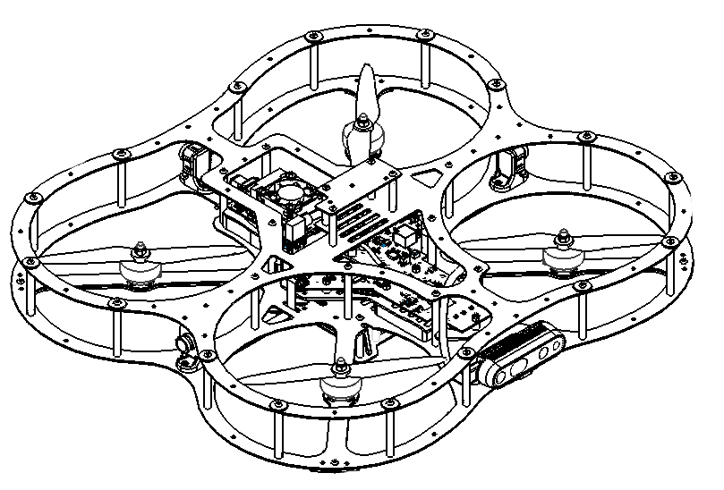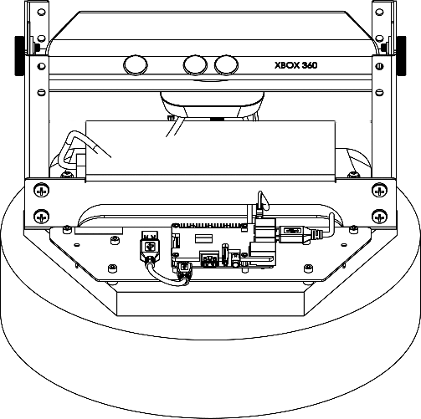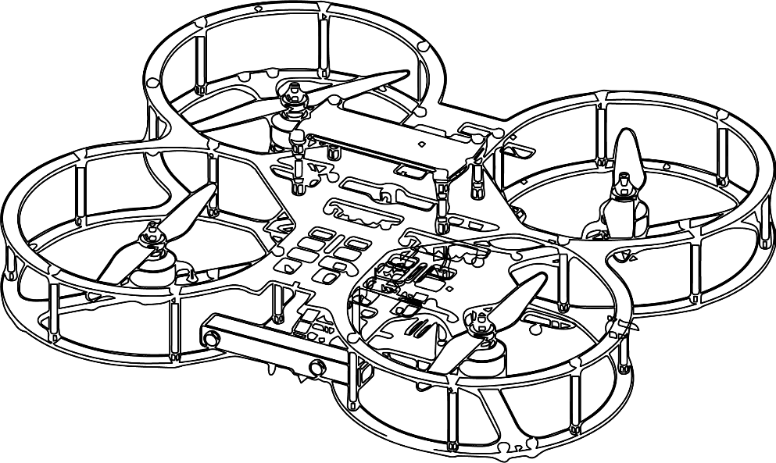

**Autonomous Vehicles Research Studio**

Setup Guide – Ground PC Setup

© 2023 Quanser Inc., All rights reserved

For more information on the solutions Quanser Inc. offers,   
please visit the web site at: <http://www.quanser.com>

|  |  |
| --- | --- |
| Quanser Inc.  119 Spy Court  Markham, Ontario  L3R 5H6, Canada | info@quanser.com  Phone : 19059403575  Fax : 19059403576  printed in Markham, Ontario. |

This document and the software described in it are provided subject to a license agreement. Neither the software nor this document may be used or copied except as specified under the terms of that license agreement. Quanser Inc. grants the following rights: a) The right to reproduce the work, to incorporate the work into one or more collections, and to reproduce the work as incorporated in the collections, b) to create and reproduce adaptations provided reasonable steps are taken to clearly identify the changes that were made to the original work, c) to distribute and publicly perform the work including as incorporated in collections, and d) to distribute and publicly perform adaptations. The above rights may be exercised in all media and formats whether now known or hereafter devised. These rights are granted subject to and limited by the following restrictions: a) You may not exercise any of the rights granted to You in above in any manner that is primarily intended for or directed toward commercial advantage or private monetary compensation, and b) You must keep intact all copyright notices for the Work and provide the name Quanser Inc. for attribution. These restrictions may not be waved without express prior written permission of Quanser Inc.

**FCC Notice** This device complies with Part 15 of the FCC rules. Operation is subject to the following two conditions: (1) this device may not cause harmful interference, and (2) this device must accept any interference received, including interference that may cause undesired operation.

**Industry Canada Notice** This Class A digital apparatus complies with Canadian ICES-003. Cet appareil numérique de la classe A est conforme à la norme NMB-003 du Canada.

**Waste Electrical and Electronic Equipment (WEEE)**

This symbol indicates that waste products must be disposed of separately from municipal household waste, according to Directive 2002/96/EC of the European Parliament and the Council on waste electrical and electronic equipment (WEEE). All products at the end of their life cycle must be sent to a WEEE collection and recycling center. Proper WEEE disposal reduces the environmental impact and the risk to human health due to potentially hazardous substances used in such equipment. Your cooperation in proper WEEE disposal will contribute to the effective usage of natural resources.

|  |  |
| --- | --- |
|  | This product meets the essential requirements of applicable European Directives as follows:   * 2006/95/EC; Low-Voltage Directive (safety) * 2004/108/EC; Electromagnetic Compatibility Directive (EMC)   **Warning**: This is a Class A product. In a domestic environment this product may cause radio interference, in which case the user may be required to take adequate measures. |
| caution.png **Caution** | **This equipment is designed to be used for educational and research purposes and is not intended for use by the public.** The user is responsible to ensure that the equipment will be used by technically qualified personnel only. While the end-effector board provides connections for external user devices, users are responsible for certifying any modifications or additions they make to the default configuration. |

Table of Contents

A. Ground Control Station PC 3

B. Router 4

C. Checkpoint – Setup Picture 5

# A. Ground Control Station PC

The PC should be connected to the following components, as depicted in Figure 1.

1. Peripherals - mouse/keyboard
2. Localization cameras - OptiTrack camera hub and hardware key,

see Step 3 – Camera mounting/setup document.

1. Router - ethernet connection, see Router below.
2. FrSky/joystick USB Dongle, see Step 6 – Joystick document.
3. Monitors
4. Webcam

|  |
| --- |
| **Peripherals**  **OptiTrack Camera Hub**  **Router**  **Joystick USB Dongle**  **Monitors**  **Optitrack Hardware Key**  **Webcam**  **For Prime Cameras**  **or Internet**  **Power** |
| Figure 1: PC wiring |

# B. Router

The Autonomous Vehicles Research Studio comes with a NETGEAR R7000 - Nighthawk AC1900 high performance router (Figure 2). If you have a QDrone 2 it comes with a NETGEAR R7200 - Nighthawk AC2100. It is pre-configured to use both 2.4GHz and 5GHz bands for multiple PCs and autonomous vehicles. The Qdrone 1/2 and QBot 2/2e are pre‑configured to automatically connect to the router when powered on, streamlining the connection process.

|  |  |  |
| --- | --- | --- |
|  |  |  |
| a. Front view of the router | b. Router power supply | c. Ethernet cable |
| **DO NOT USE**  **Power**  **Ground Station PC** | | |
| d. Rear view of the router | | |
| Figure 2: the NETGEAR R7000 - Nighthawk AC1900 router | | |

1. Both routers should look very similar to the one in Figure 2. Connect the power supply (Figure 2b) provided with the router to the power port on the back of the router (Figure 2d).
2. Connect the ground control station PC to the router by using the provided ethernet cable (Figure 2c) and one of the four ports on the back of the router labelled 1 to 4 (Figure 2d).

|  |
| --- |
| **Note: DO NOT** use the yellow port labelled WAN to connect to the ground control station PC.  This port is used to provide an internet connection to the router, which is not recommended, as the router is configured to optimize local traffic only. |

1. Connect the other end of the ethernet cable directly into the ground control station PC using the Ethernet port at the bottom (the PCI-Ethernet adaptor port, see Figure 2).

|  |
| --- |
| **Note: DO NOT** use an ethernet switch or any other device between the router and the ground control station PC |

1. Turn on the router. After a few minutes, the lights on the front of the router (Figure 2a) should start flashing with a white light to indicate to the user that the particular ports are active.

# C. Checkpoint – Setup Picture

Take a picture of your wired setup including the PC and router to confirm with a Quanser engineer or technical support specialist (tech@quanser.com) that the workspace is properly configured.

© Quanser Inc., All rights reserved.

Solutions for teaching and research. Made in Canada.