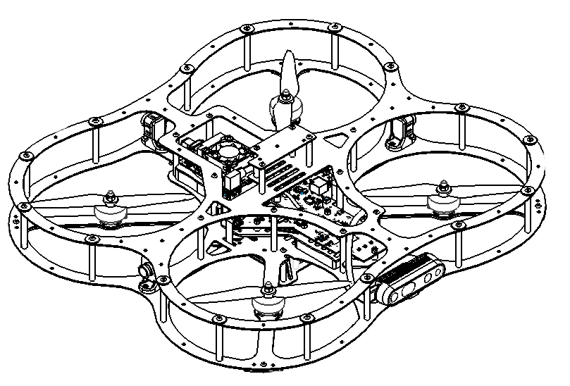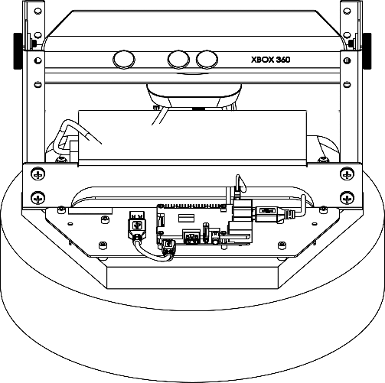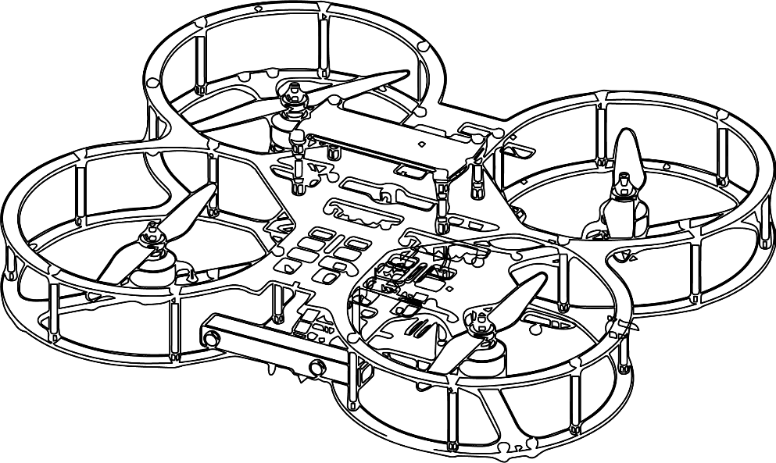

**Autonomous Vehicles Research Studio**

Setup Guide – FrSKY Joystick Setup

© 2023 Quanser Inc., All rights reserved

For more information on the solutions Quanser Inc. offers,   
please visit the web site at: <http://www.quanser.com>

|  |  |
| --- | --- |
| Quanser Inc.  119 Spy Court  Markham, Ontario  L3R 5H6, Canada | info@quanser.com  Phone : 19059403575  Fax : 19059403576  printed in Markham, Ontario. |

This document and the software described in it are provided subject to a license agreement. Neither the software nor this document may be used or copied except as specified under the terms of that license agreement. Quanser Inc. grants the following rights: a) The right to reproduce the work, to incorporate the work into one or more collections, and to reproduce the work as incorporated in the collections, b) to create and reproduce adaptations provided reasonable steps are taken to clearly identify the changes that were made to the original work, c) to distribute and publicly perform the work including as incorporated in collections, and d) to distribute and publicly perform adaptations. The above rights may be exercised in all media and formats whether now known or hereafter devised. These rights are granted subject to and limited by the following restrictions: a) You may not exercise any of the rights granted to You in above in any manner that is primarily intended for or directed toward commercial advantage or private monetary compensation, and b) You must keep intact all copyright notices for the Work and provide the name Quanser Inc. for attribution. These restrictions may not be waved without express prior written permission of Quanser Inc.

**FCC Notice** This device complies with Part 15 of the FCC rules. Operation is subject to the following two conditions: (1) this device may not cause harmful interference, and (2) this device must accept any interference received, including interference that may cause undesired operation.

**Industry Canada Notice** This Class A digital apparatus complies with Canadian ICES-003. Cet appareil numérique de la classe A est conforme à la norme NMB-003 du Canada.

**Waste Electrical and Electronic Equipment (WEEE)**

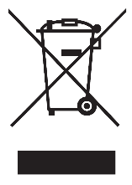This symbol indicates that waste products must be disposed of separately from municipal household waste, according to Directive 2002/96/EC of the European Parliament and the Council on waste electrical and electronic equipment (WEEE). All products at the end of their life cycle must be sent to a WEEE collection and recycling center. Proper WEEE disposal reduces the environmental impact and the risk to human health due to potentially hazardous substances used in such equipment. Your cooperation in proper WEEE disposal will contribute to the effective usage of natural resources.

|  |  |
| --- | --- |
|  | This product meets the essential requirements of applicable European Directives as follows:   * 2006/95/EC; Low-Voltage Directive (safety) * 2004/108/EC; Electromagnetic Compatibility Directive (EMC)   **Warning**: This is a Class A product. In a domestic environment this product may cause radio interference, in which case the user may be required to take adequate measures. |
| caution.png **Caution** | **This equipment is designed to be used for educational and research purposes and is not intended for use by the public.** The user is responsible to ensure that the equipment will be used by technically qualified personnel only. While the end-effector board provides connections for external user devices, users are responsible for certifying any modifications or additions they make to the default configuration. |

Table of Contents

A. FrSKY Binding/Pairing 3

i. Pair Joystick to USB Dongle 4

B. FrSKY Joystick Channels 5

C. Checkpoint – Joystick Visualization Demo 6

|  |
| --- |
| **Note: If you have a different joystick (Spektrum) make sure to instead read the Spektrum_joystick_setup file located in the same folder as this file.** |

# A. FrSKY Binding/Pairing

The provided FrSKY Taranis X9 Lite S joystick (Figure 1a) communicates wirelessly to the FrSKY USB dongle (Figure 1b), which is plugged into a USB port on the ground control station PC. The dongle and joystick have been pre-configured to bind/pair with each other prior to shipping. When the FrSKY USB is connected to a powered PC, the RED status LED will be blinking waiting for a paired connection. Turn on the joystick by holding the power button in the middle for 4 seconds and releasing, the LCD screen will change to show the Quanser logo. Once the FrSKY joystick is turned on the FrSKY USB dongle will have a solid green LED indicating a successful connection to the FrSKY joystick. To power off the FrSKY joystick, hold the power button for 4 seconds and release.

|  |  |
| --- | --- |
|  |  |
| 1. FrSKY Taranis X9 Lite S joystick | b. FrSKY USB dongle |
| Figure 1: FrSKY transmitter and USB dongle bound | |

|  |
| --- |
| **Note: If the USB dongle is connected for long periods of time, then the joystick may stop receiving data. If so, try to disconnect and then reconnect the USB dongle to renew the connection.** |

## i. Pair Joystick to USB Dongle

This section is only important if your joystick and dongle are no longer paired. If you do not have this problem, you can continue to the next section.

**If the binding/pairing is lost (RED LEDs on dongle keep flashing)**, see FrSKY USB Dongle Manual (located in supplementary_material/FrSKY Dongle Manual.pdf).

To bind/pair the FrSKY Taranis joystick transmitter to the FrSKY USB dongle, follow these steps:

1. Ensure that the joystick transmitter is OFF. Disconnect the USB dongle from the PC if it was previously plugged in.
2. While pressing the pair button (Figure 2), connect the USB dongle to the PC. The red and green status LED on the will turn on indicating the dongle is ready for binding.

|  |
| --- |
|  |
| Figure 2: Bind button FrSKY USB dongle |

1. Press and hold the power button on the FrSKY Taranis joystick for 4 seconds to turn on the joystick.
2. Press the MENU button followed by the PAGE button to navigate to page 2 of the main menu.
3. Use the right scroll wheel on the FrSKY Taranis joystick to go to the INTERNAL RF option.
4. Use the scroll wheel to verify the following options:

MODE: ACCST D16

Ch Range: Ch1-16

RxNum : 01[Bnd][Rng]

Failsafe: Custom [set]

1. Once the settings in step 6 have been set use the scroll wheel to highlight the [Bnd] option and click the scroll wheel. The FrSKY Taranis joystick will start beeping and the FrSKY USB dongle’s RED LED will start flashing. Once the joystick has done a complete beeping cycle click the [Bnd] button again to finish the binding process.
2. Disconnect and reconnect the FrSKY USB dongle from the PC.
3. Click the EXIT button twice on the FrSKY Taranis joystick to exit the main menu.

# B. FrSKY Joystick Channels

The FrSKY Taranis joystick has numerous buttons, toggles and sticks. However, only a subset of these relay information to the USB dongle receiver. These are highlighted in Figure 3 along with the reference terminology. The Toggles read TRUE when at position labelled 1 or 2 (middle or front position, moved towards the user), and FALSE at position 0 (back position/away from user). The Throttle stick reads 0 to 1 as it is moved from the bottom to the top. The Yaw, Pitch and Roll sticks read -1 to 1 as they move over their range and 0 if left untouched (spring loaded to maintain center position).

|  |
| --- |
| **Emergency Stop Button**  **Arm/Disarm Toggle**  **Takeoff/Land Toggle**  **Throttle/Yaw Stick**  **Pitch/Roll Stick**  **Not Used**  **Not Used** |
| Figure 3: FrSKY Taranis X9 Lite S joystick buttons, toggles, and sticks |

|  |
| --- |
| **Note**: Some of the buttons/toggles relay information to the USB dongle but are currently not used. These are highlighted in Figure 3 in yellow. For proper operation of the Autonomous Vehicles Research Studio, ensure that these toggles are set to a position tilted away from the user holding the joystick, as illustrated in Figure 3. |

# C. Checkpoint – Joystick Visualization Demo

|  |  |  |  |  |  |  |  |  |  |  |
| --- | --- | --- | --- | --- | --- | --- | --- | --- | --- | --- |
| 1. From the same folder as this file, under Joystick Visualization Demo, open the Joystick_Visualization_2019a.slx model. 2. In the model that loads, double-click the **JOYSTICK_FRSKY** subsystem (Figure 4a) and double-click on the **Host Game Controller** block (Figure 4b). In the pop-up dialog window, ensure that the **Controller number** (Figure 4c) drop down menu has selected the item labelled **FrSky Simulator**.  |  |  | | --- | --- | |  |  | | a. Joystick subsystem | b. Host Game Controller | |  | | | c. Controller number set to FrSky Simulator | | | Figure 4: Selecting the FrSky USB receiver in Simulink/QUARC | |  1. Ensure that the joystick is powered **ON** and that it is bound to the USB dongle plugged into the ground station PC. 2. Go back to the root level in the model, click on the **HARDWARE** tab on the top menu and click the green play button **(Monitor & Tune**) 3. Follow the instructions at the model’s root level to move the drone around. 4. The drone should fly around in directions aligned with the user joystick commands.    1. Pushing the throttle stick up/down should increase/decrease the drone’s height.    2. Pushing the yaw stick left/right should increase/decrease the drone’s heading.    3. Pushing the pitch stick up/down should move the drone forward/backward.    4. Pushing the roll stick left/right should move the drone left/right. |
| This completes the checkpoint task and confirms that your Joystick has been configured successfully. If you encounter any errors, make sure that all the steps prior to this checkpoint have been followed. If further issues persist, please contact Quanser technical support (tech@quanser.com). |

© Quanser Inc., All rights reserved.

Solutions for teaching and research. Made in Canada.