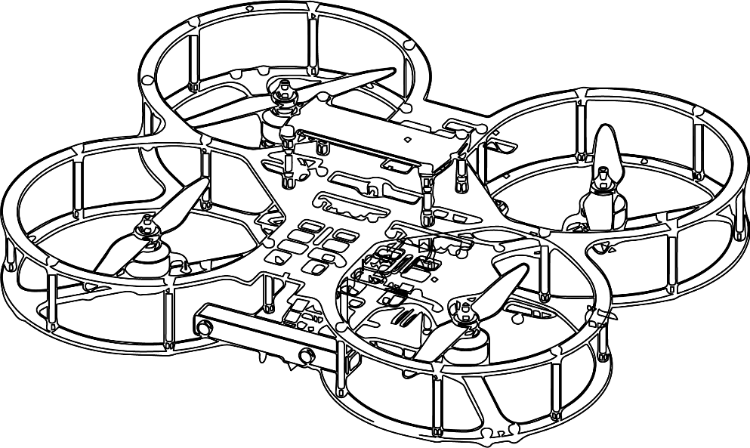

**Autonomous Vehicles Research Studio**

Setup Guide – QDrone 1 Communication

© 2023 Quanser Inc., All rights reserved

For more information on the solutions Quanser Inc. offers,   
please visit the web site at: <http://www.quanser.com>

|  |  |
| --- | --- |
| Quanser Inc.  119 Spy Court  Markham, Ontario  L3R 5H6, Canada | info@quanser.com  Phone : 19059403575  Fax : 19059403576  printed in Markham, Ontario. |

This document and the software described in it are provided subject to a license agreement. Neither the software nor this document may be used or copied except as specified under the terms of that license agreement. Quanser Inc. grants the following rights: a) The right to reproduce the work, to incorporate the work into one or more collections, and to reproduce the work as incorporated in the collections, b) to create and reproduce adaptations provided reasonable steps are taken to clearly identify the changes that were made to the original work, c) to distribute and publicly perform the work including as incorporated in collections, and d) to distribute and publicly perform adaptations. The above rights may be exercised in all media and formats whether now known or hereafter devised. These rights are granted subject to and limited by the following restrictions: a) You may not exercise any of the rights granted to You in above in any manner that is primarily intended for or directed toward commercial advantage or private monetary compensation, and b) You must keep intact all copyright notices for the Work and provide the name Quanser Inc. for attribution. These restrictions may not be waved without express prior written permission of Quanser Inc.

**FCC Notice** This device complies with Part 15 of the FCC rules. Operation is subject to the following two conditions: (1) this device may not cause harmful interference, and (2) this device must accept any interference received, including interference that may cause undesired operation.

**Industry Canada Notice** This Class A digital apparatus complies with Canadian ICES-003. Cet appareil numérique de la classe A est conforme à la norme NMB-003 du Canada.

**Waste Electrical and Electronic Equipment (WEEE)**

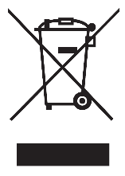This symbol indicates that waste products must be disposed of separately from municipal household waste, according to Directive 2002/96/EC of the European Parliament and the Council on waste electrical and electronic equipment (WEEE). All products at the end of their life cycle must be sent to a WEEE collection and recycling center. Proper WEEE disposal reduces the environmental impact and the risk to human health due to potentially hazardous substances used in such equipment. Your cooperation in proper WEEE disposal will contribute to the effective usage of natural resources.

|  |  |
| --- | --- |
|  | This product meets the essential requirements of applicable European Directives as follows:   * 2006/95/EC; Low-Voltage Directive (safety) * 2004/108/EC; Electromagnetic Compatibility Directive (EMC)   **Warning**: This is a Class A product. In a domestic environment this product may cause radio interference, in which case the user may be required to take adequate measures. |
| caution.png **Caution** | **This equipment is designed to be used for educational and research purposes and is not intended for use by the public.** The user is responsible to ensure that the equipment will be used by technically qualified personnel only. While the end-effector board provides connections for external user devices, users are responsible for certifying any modifications or additions they make to the default configuration. |

Table of Contents

A. Communicating with QDrone 1 3

B. Boot-Up for QDrone 1 4

i. Connecting the Battery 4

iii. Testing the Connection 4

# Communicating with QDrone 1

The QDrone 1 is shipped pre-configured to connect to the wireless network created by the provided router: Quanser_UVS-5G. This happens automatically following a boot sequence when they are powered on. To ensure that the drone is connected, observe if there is an IP in the LCD screen on top of the drone and try to ping it from the command prompt in the ground control station, similar to ensuring that the ground control station PC - router connection has been established in the router to PC documentation.

To connect additional vehicles to the UVS network, the 5GHz and 2.4GHz bands on the router have been configured as follows:

5GHz:

SSID: Quanser_UVS-5G Password: UVS_wifi

2.4GHz:

SSID: Quanser_UVS Password: UVS_wifi

Router login credentials are as follows:

Username: admin Password: Quanser_123

The QDrone does not have a preset IPV4. **If you would rather set a fixed IP, refer to the Setting Fixed IP Addresses document (supplementary_material > setting_fixed_ip).** For a successful connection, the DHCP server option on the router must be enabled. For the Netgear Nighthawk router provided with the AVRS system, the DHCP server can be found by going to Advanced/Setup/LAN Setup.

To ensure compatibility with the Self-Driving Car Research studio, the **5GHz band** for the Netgear Nighthawk router has been configured to **channel 44.** If you do notice intermittent issues with communication to any of the vehicles, it is recommended that you use a WiFi spectrum analyzer and check if there are networks which are broadcasting on the same channel but at a higher signal strength. Microsoft has a free WiFi analyzer: ( [https://www.microsoft.com/en-us/p/wifi-analyzer/9nblggh33n0n?activetab=pivot:overviewtab#](https://www.microsoft.com/en-us/p/wifi-analyzer/9nblggh33n0n?activetab=pivot:overviewtab) )

You can change the Netgear Nighthawk’s channel number by logging into the router and checking the channel number under the 5GHz wireless band.

# B. Boot-Up for QDrone 1

## i. Connecting the Battery

|  |
| --- |
|  |
| Figure 1. Battery setup and hostname |

Insert a fully charged battery into the battery compartment on the QDrone 1 (Figure 1) all the way to the hard stop. **Tighten the battery with the velcro**.

|  |
| --- |
| **Note:** Ensure that the velcro strap is tight and that the battery is secured in place. |

Connect the XT-60 connector on the battery to the XT-60 connector on the drone. This is immediately acknowledged by 3 beeps from the drone, as the drone’s computer boots.

|  |
| --- |
| **Note:** Turn off the QDrone 1 by disconnecting the XT-60 battery cable from the one on the drone whenever the drone is not in use. |

|  |  |
| --- | --- |
|  | **Caution:** Leaving the QDrone 1 with the battery connected will continue to drain power below the minimum voltage threshold of 10V, **and may permanently damage the battery**. |

## ii. Testing the Connection

Open a command prompt on the ground control station PC (type cmd in the start menu). Type the following command:  ping QDrone0XXXXX.local -t where QDrone0xxxxx represents the hostname of the QDrone 1 found on the bottom plate (Figure 1). A reply should be registered as in Figure 2, which indicates that a connection has been established. You can press CTRL+C to terminate the ping.

|  |
| --- |
|  |
| Figure 2. QDrone 1 and the ground control PC connection using the hostname lookup. |

An alternative way of checking connectivity between the QDrone 1 and the router is to use the IPV4 Address which can be found by connecting to the router. Router login credentials are found in section A. The QDrone 1 network information can be found by checking under the Connected/Attached Devices option.

Type the following command: ping 192.168.2.X -t where 192.168.2.x represents the IPV4 address found through the router. A reply should be registered as in Figure 3, which indicates the drone is properly connected.

|  |
| --- |
|  |
| Figure 3: Checking the connection between the QDrone 2 and  the ground control station PC |

|  |
| --- |
| **Note:** If the ping test fails, double-check the network connection from the router and try again. Refer to the Setting Fixed IP Addresses document on more information. Also try power cycling the drone. If issues persist, contact Quanser technical support (tech@quanser.com). |

© Quanser Inc., All rights reserved.

Solutions for teaching and research. Made in Canada.