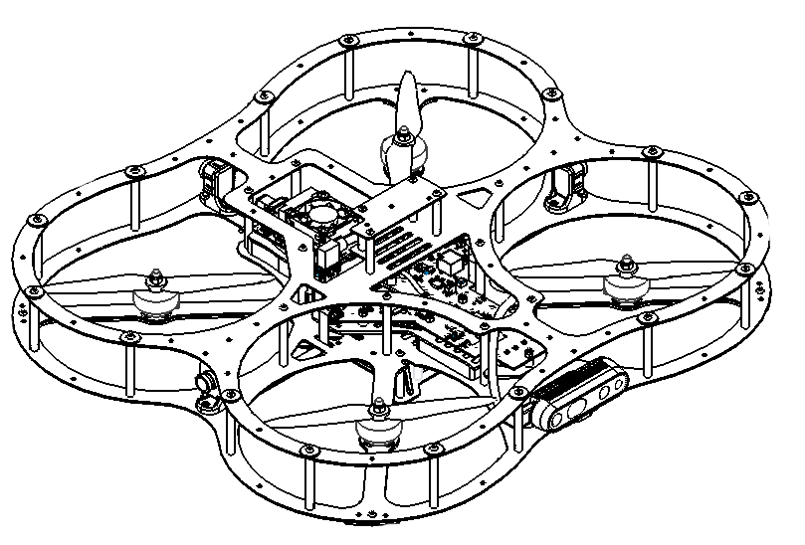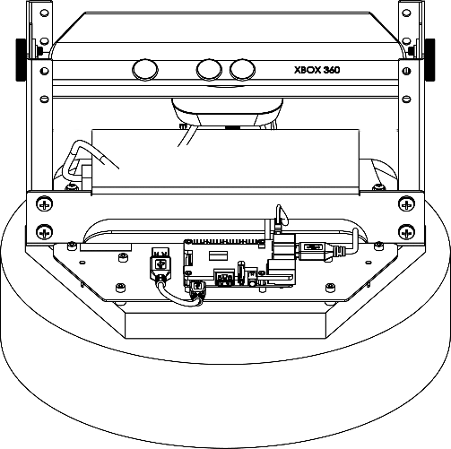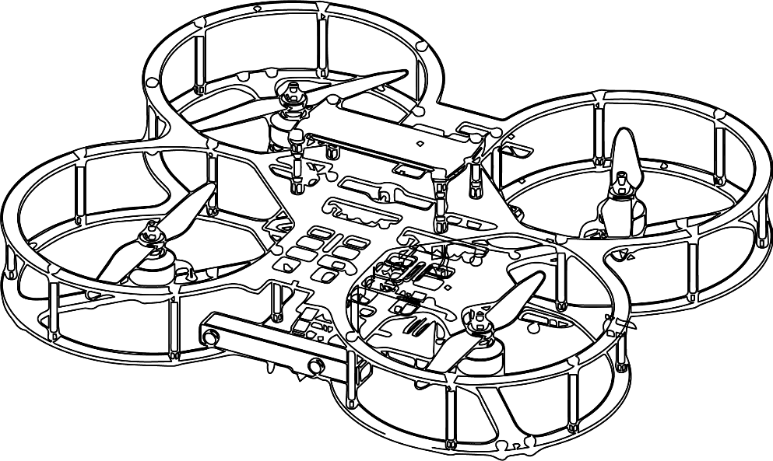

**Autonomous Vehicles Research Studio**

Setup Guide – Orienting Optitrack Cameras

© 2023 Quanser Inc., All rights reserved

For more information on the solutions Quanser Inc. offers,   
please visit the web site at: <http://www.quanser.com>

|  |  |
| --- | --- |
| Quanser Inc.  119 Spy Court  Markham, Ontario  L3R 5H6, Canada | info@quanser.com  Phone : 19059403575  Fax : 19059403576  printed in Markham, Ontario. |

This document and the software described in it are provided subject to a license agreement. Neither the software nor this document may be used or copied except as specified under the terms of that license agreement. Quanser Inc. grants the following rights: a) The right to reproduce the work, to incorporate the work into one or more collections, and to reproduce the work as incorporated in the collections, b) to create and reproduce adaptations provided reasonable steps are taken to clearly identify the changes that were made to the original work, c) to distribute and publicly perform the work including as incorporated in collections, and d) to distribute and publicly perform adaptations. The above rights may be exercised in all media and formats whether now known or hereafter devised. These rights are granted subject to and limited by the following restrictions: a) You may not exercise any of the rights granted to You in above in any manner that is primarily intended for or directed toward commercial advantage or private monetary compensation, and b) You must keep intact all copyright notices for the Work and provide the name Quanser Inc. for attribution. These restrictions may not be waved without express prior written permission of Quanser Inc.

**FCC Notice** This device complies with Part 15 of the FCC rules. Operation is subject to the following two conditions: (1) this device may not cause harmful interference, and (2) this device must accept any interference received, including interference that may cause undesired operation.

**Industry Canada Notice** This Class A digital apparatus complies with Canadian ICES-003. Cet appareil numérique de la classe A est conforme à la norme NMB-003 du Canada.

**Waste Electrical and Electronic Equipment (WEEE)**

This symbol indicates that waste products must be disposed of separately from municipal household waste, according to Directive 2002/96/EC of the European Parliament and the Council on waste electrical and electronic equipment (WEEE). All products at the end of their life cycle must be sent to a WEEE collection and recycling center. Proper WEEE disposal reduces the environmental impact and the risk to human health due to potentially hazardous substances used in such equipment. Your cooperation in proper WEEE disposal will contribute to the effective usage of natural resources.

|  |  |
| --- | --- |
|  | This product meets the essential requirements of applicable European Directives as follows:   * 2006/95/EC; Low-Voltage Directive (safety) * 2004/108/EC; Electromagnetic Compatibility Directive (EMC)   **Warning**: This is a Class A product. In a domestic environment this product may cause radio interference, in which case the user may be required to take adequate measures. |
| caution.png **Caution** | **This equipment is designed to be used for educational and research purposes and is not intended for use by the public.** The user is responsible to ensure that the equipment will be used by technically qualified personnel only. While the end-effector board provides connections for external user devices, users are responsible for certifying any modifications or additions they make to the default configuration. |

Table of Contents

A. Orienting Optitrack Cameras 3

B. Checkpoint – Reference View 6

# A. Orienting Optitrack Cameras

Make sure you have read Step 3 – camera mounting to mount your cameras to the workspace properly.

The example below illustrates the camera orienting process with an 8-camera configuration. However, the steps are applicable for other camera configurations as well. Once the cameras have been mounted, follow these steps to adjust where to point the cameras in the workspace.

1. Mark a spot straight underneath each camera to begin with. This can be done using tape, and will outline the threshold mark for each camera, as shown in Figure 1a. Also mark the center of the workspace.

|  |  |  |
| --- | --- | --- |
|  |  |  |
| a. Threshold marks and workspace center | b. 40% mark for  calibration circle | c. calibration circle with marks at each camera location |
| Figure 1: Top view of workspace showing tape markings for orienting cameras | | |

1. Mark a spot 40% of the way from the workspace center towards the farthest threshold mark from the center. In the example above, this is from the center to the bottom left mark (Figure 1b).
2. Using this 40% distance, create a calibration circle and mark the spots where the circle intersects lines from the workspace center to each of the camera’s threshold marks. In this case, there are 8 calibration marks along a circle highlighted in Figure 1c. The number of calibration marks should match the number of cameras.
3. Open Motive. Under the Devices pane, ensure that Motive can detect all Flex 13 cameras (Figure 2a).

|  |  |
| --- | --- |
|  |  |
| a. Tracking/Reference view toggle | b. Grayscale view for calibration |
| Figure 2. Detecting Cameras | |

|  |
| --- |
| **Note**: If you do not see any/all cameras, ensure that all USB connections are sound and retry |
|  |
| **Important**: Leave Motive open for approximately 15-30 minutes to allow the cameras to warm up prior to performing calibration. |

1. Under the Devices pane, click the button highlighted in Figure 2a. This toggles between tracking and reference views. In the tracking view, only the markers identified by the cameras are displayed. In reference view, the grayscale image of the camera is displayed (Figure 2b), which is useful for orienting cameras. Toggle to the reference view for all cameras (you should see all cameras in grayscale mode).

|  |
| --- |
| **Note**: The grayscale reference view is expected to be a dark image as seen below. |

1. One by one, adjust each camera in such a way that the calibration mark closest to it is just visible in the grayscale view at the bottom of the frame. The threshold mark on the opposite side of the view may or may not be visible in the view, but the camera should be pointed towards it. This is illustrated in Figure 3a.

|  |
| --- |
|  |
| 1. Tilt each camera from the calibration mark close to it towards the  threshold mark of the camera across from it |
|  |
| b. multiple camera views will overlap in the center, creating a stronger captured volume |
| Figure 3. Orienting cameras to maximize captured volume |

1. Repeat this for all the cameras. A second camera’s example has been illustrated in Figure 3b. Note that sometimes the threshold mark of the camera across may not be visible in the view of the camera (as shown by the dotted line in Figure 3b).
2. Fine tune each camera according to the irregularities in your workspace. For example, cameras that are placed along the longer dimension of a rectangular room (and facing the shorter dimension) can be pointed more towards the floor, and vice versa.
3. After doing the next checkpoint, switch all cameras back to tracking view so they only show markers in the space.

# B. Checkpoint – Reference View

Take a screenshot of the camera reference view in all grayscale for all the cameras in Motive (similar to Figure 2b) where the floor marks can bee seen to confirm with a Quanser engineer or technical support specialist (tech@quanser.com) that the workspace is properly configured.

© Quanser Inc., All rights reserved.

Solutions for teaching and research. Made in Canada.