User Manual

**Quanser Traffic   
Light**

© 2023 Quanser Inc., All rights reserved

For more information on the solutions Quanser Inc. offers,   
please visit the web site at: <http://www.quanser.com>

|  |  |
| --- | --- |
| Quanser Inc.  119 Spy Court  Markham, Ontario  L3R 5H6, Canada | info@quanser.com  Phone : 19059403575  Fax : 19059403576  printed in Markham, Ontario. |

This document and the software described in it are provided subject to a license agreement. Neither the software nor this document may be used or copied except as specified under the terms of that license agreement. Quanser Inc. grants the following rights: a) The right to reproduce the work, to incorporate the work into one or more collections, and to reproduce the work as incorporated in the collections, b) to create and reproduce adaptations provided reasonable steps are taken to clearly identify the changes that were made to the original work, c) to distribute and publicly perform the work including as incorporated in collections, and d) to distribute and publicly perform adaptations. The above rights may be exercised in all media and formats whether now known or hereafter devised. These rights are granted subject to and limited by the following restrictions: a) You may not exercise any of the rights granted to You in above in any manner that is primarily intended for or directed toward commercial advantage or private monetary compensation, and b) You must keep intact all copyright notices for the Work and provide the name Quanser Inc. for attribution. These restrictions may not be waved without express prior written permission of Quanser Inc.

**FCC Notice** This device complies with Part 15 of the FCC rules. Operation is subject to the following two conditions: (1) this device may not cause harmful interference, and (2) this device must accept any interference received, including interference that may cause undesired operation.

**Industry Canada Notice** This Class A digital apparatus complies with Canadian ICES-003. Cet appareil numérique de la classe A est conforme à la norme NMB-003 du Canada.

**Waste Electrical and Electronic Equipment (WEEE)**

This symbol indicates that waste products must be disposed of separately from municipal household waste, according to Directive 2002/96/EC of the European Parliament and the Council on waste electrical and electronic equipment (WEEE). All products at the end of their life cycle must be sent to a WEEE collection and recycling center. Proper WEEE disposal reduces the environmental impact and the risk to human health due to potentially hazardous substances used in such equipment. Your cooperation in proper WEEE disposal will contribute to the effective usage of natural resources.

|  |  |
| --- | --- |
|  | This product meets the essential requirements of applicable European Directives as follows:   * 2006/95/EC; Low-Voltage Directive (safety) * 2004/108/EC; Electromagnetic Compatibility Directive (EMC)   **Warning**: This is a Class A product. In a domestic environment this product may cause radio interference, in which case the user may be required to take adequate measures. |
| caution.png **Caution** | **This equipment is designed to be used for educational and research purposes and is not intended for use by the public.** The user is responsible to ensure that the equipment will be used by technically qualified personnel only. While the end-effector board provides connections for external user devices, users are responsible for certifying any modifications or additions they make to the default configuration. |

# Table of Contents

Table of Contents 2

A. Presentation 3

B. Configuration 4

Orientation Configurations 5

Color Configurations 6

C. Handling and Setup 6

Power Up 6

D. Communication 7

F. Specifications 8

G. Environmental 8

H. Electrical Considerations 8

# A. Presentation

Quanser’s Traffic Light, pictured in Figure 1, is a scaled down infrastructure device as part of Quanser’s [Self-Driving Car Studio.](https://www.quanser.com/products/self-driving-car-studio/#overview) The Quanser Traffic Light is designed to automatically connect to the network infrastructure upon powerup. It can be controlled by the user using python3 from a host computer also in the Self-Driving Car Studio network.

|  |  |
| --- | --- |
|  | |
| Figure 1. Quanser Traffic Light | |
|  |  |
|  | |
| Figure 2. Quanser Traffic Light Layout | |

|  |  |  |  |
| --- | --- | --- | --- |
| **ID** | **Component** | **ID** | **Component** |
| **1** | Controllable LEDs | **3** | Rotatable back plate |
| **2** | Base | **4** | Micro USB power port |

Table 1. Quanser Traffic Light Components

# B. Configuration

The Quanser Traffic light has two ways it can be modified:

* LED orientation (landscape to portrait)
* LED cover color (black or yellow)

To modify the color and/or orientation you can use Figure 4.

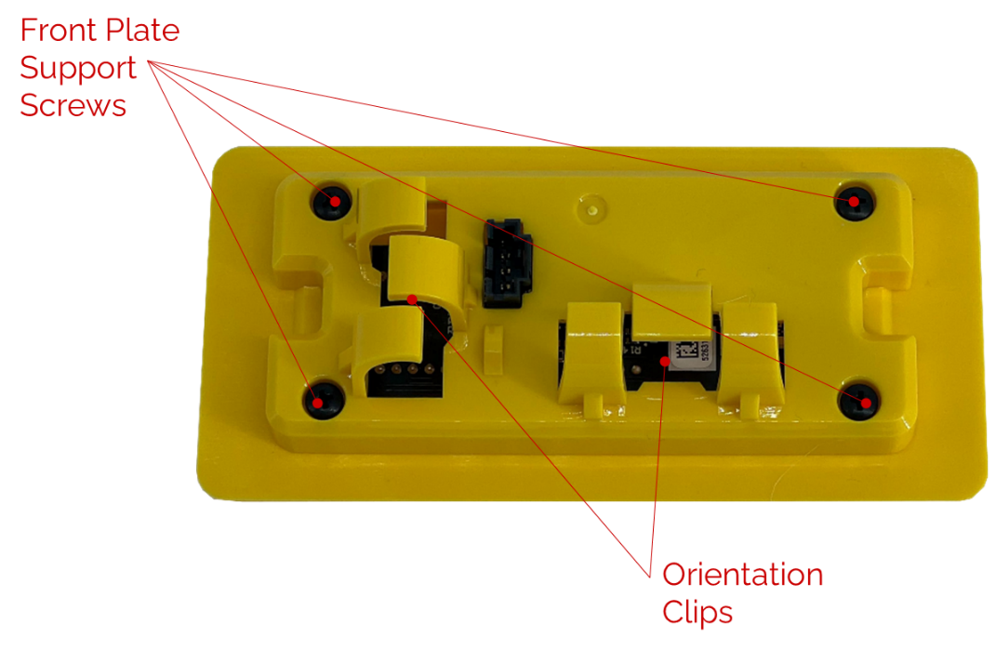

Figure 4. Traffic light customization ports.

## Orientation Configurations

Use the orientation clips, shown in Figure 4, to modify the orientation of the traffic light. Use Figure 5. as reference.

|  |  |
| --- | --- |
|  |  |
| 1. Landscape traffic light orientation | 1. Portrait traffic light Orientation |
| Figure 5. Quanser traffic light supported orientations. | |

## Color Configurations

Remove the 4 front plate support screws, shown in Figure 4, to change the color of the Quanser Traffic Light LEDs. The two color options are shown in Figure 6.

|  |  |
| --- | --- |
|  |  |
| 1. Yellow Front Plate | 1. Black front plate |
| Figure 6. Quanser traffic light color combinations. | |

# C. Handling and Setup

## Power Up

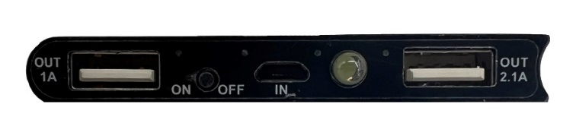

Figure 7. Power up connections for power supply

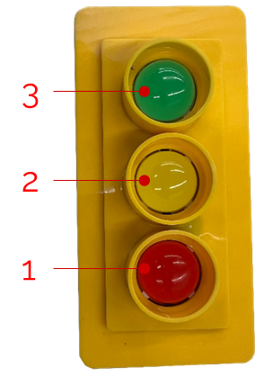

Figure 8. LED configuration

Upon power up the LEDs of the traffic light will flash in the following sequence:

1. LED 2 (Yellow) will pulse **ON** to indicate power-up
2. LED 1,2,3 (Red, Green, Yellow) will flash **ON** to indicate it has powered on successfully.
3. The traffic is configured to connect to the **Quanser_UVS** network SSID. It will obtain an IPV4 address with the following structure **192.168.2.XXX**. Once an IPV4 address is obtained LEDs 3, 1 (Green and Yellow) will flash using the following color convention:
   1. LED 3 will flash based on the individual number in sequence **XXX.**
   2. LED 2 will flash once to designate a digit change.

Ex: If the IPV4 address of the Quanser Traffic Light is 192.168.2.14 the LED sequence will be:

1. LED 3 flash **ON** once
2. LED 3 **OFF**, LED 2 flash **ON** once
3. LED 3 flash **ON** 4 times

# D. Communication

On a PC connected to the Quanser_UVS network type the following in the address bar:

192.168.2.XXX:5000

A successful response will show:

I'm a light at 192.168.2.XXX:5000

Useful commands to send to the traffic light via web browser:

* 192.168.2.XXX:5000/status
* 192.168.2.XXX:5000/timed/0/0/0

To send commands via python use the provided script **CommandLight.py**

* python CommandLight.py 192.168.2.XXX status
* python CommandLight.py 192.168.2.XXX auto

The syntax for commanding the Quanser Traffic Light using python:

* python CommandLight.py 192.168.2.XXX [auto/immediate/timed/status/shutdown] [R] [Y] [G]

Note:

* Command input of **immediate** will turn on the LED specified in the order [R] [Y] [G]

Ex: To turn on the red LED

python CommandLight.py 192.168.2.XXX immediate [1] [0] [0]

* Command input of **timed** will keep the LED specified in the order [R] [Y] [G] on for the time specified in brackets

Ex: To turn on the red LED for 1s

python CommandLight.py 192.168.2.XXX timed [1] [0] [0]

# F. Specifications

The battery bank at full charge the operating

|  |  |
| --- | --- |
| **Battery Life (h)** |  |

Table 6. Traffic Light Battery life   
+durations tested at room temperature

# G. Environmental

The QArm is designed to function under the following environmental conditions:

* Indoor use only
* Atmospheric conditions
  + Temperature - 15◦C to 35◦C
  + Altitude - up to 2000 m
  + Relative humidity - 30% to 60%
  + Air Pressure – 86 kPa (860 mbar) – 106 kPa (1060 mbar)

# H. Electrical Considerations

|  |  |  |
| --- | --- | --- |
| caution.png | **Caution** | The Quanser Traffic Light is not waterproof. |

# 

© Quanser Inc., All rights reserved.



Solutions for teaching and research. Made in Canada.