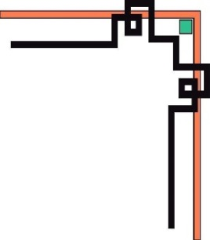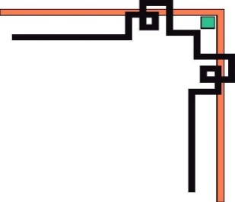

**DANANG SOFTWARE CORPORATION**

**SOFTECH-APTECH**



EProject :



BookShop Online

Guiding faculty : Trần Nhật Kha

Members :

* Võ Dưỡng
* Lê Kim Phúc
* Võ Trần Nguyên
* Nguyễn Thanh Phương

Group: 03

Batch: 149

**CONTENTS**

**I. ACKNOWLEDGEMENTS** 1

**II. INTRODUCTION** 1

**III. PROBLEM DEFINITION** 1

**IV. Use Case Diagram** 2

**V. Use Case Details** 3

**VI. Project Plan** 66

**VII. ERD Diagram** 69

**VIII. Database Detail** 69

**IX. Interface Website** 73

# 

# **I. ACKNOWLEDGEMENTS**

We would like sincerely thanks for all teachers and friends who have got enthusiastic about help us to had a successful project.

We wish to express our deep gratitude to the eProject Team at the Head Office, who guided and helped us. Particularly thanks to Mr. Nhat Kha who suggested the “debugging is parallelizable” formulation, helped us develop the analysis proceeding from it and debugged code. We also would like to express our great gratitude to all the student of our center (Softech Aptech Da Nang).

Although we have made many attempts, because of the limited time, the practice could not be able to avoid the mistakes and missions. We hope that our project will be considered and evaluated. And finally, we would like to offer many thanks to all our friends for their valuable suggestions and constructive feedbacks.

# **II. INTRODUCTION**

The era of information technology is growing, everyone can stay at home and shop online. The BS site helps users to do that. Users can buy books easily, conveniently, quickly without having to go to a bookstore. On our website, customers can be assured of the quality and price of their books, with thousands great books and reputable authors, and of course guaranteed the lowest prices on the market.

# **III. PROBLEM DEFINITION**

1. **Problem Abstraction:**

As the Internet and the web being the growth engines of the new millennium, the management had decided to maintain the details of their services and that of their clients along with the services that they prefer, payment details. So, they want an online shop to be introduced into their system through which they can keep track of the products they provide, their clients, type of products that their clients had preferred, and the procedures of their clients and the details of the customers. So, they had approached us in order to help them by creating a web shop online for them meeting their requirements.

1. **Boundaries of the System:**

+ The details of the products offered are to be maintained.

+ The different department details are to be maintained. The different department that Book Store has is as follows:

1. HR management
2. Administration
3. Service
4. Purchase
5. Shopping cart
6. Auditors

# **IV. Use Case Diagram**

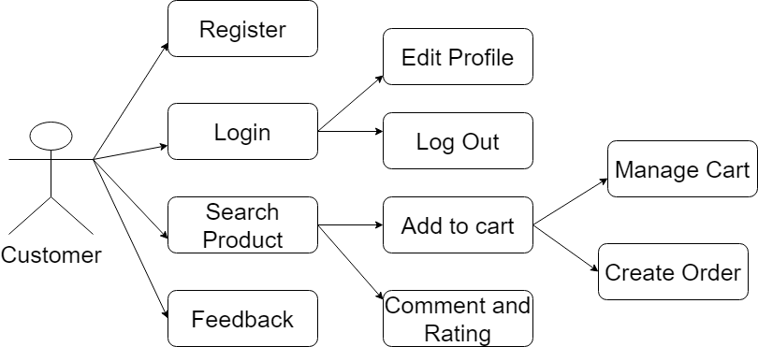

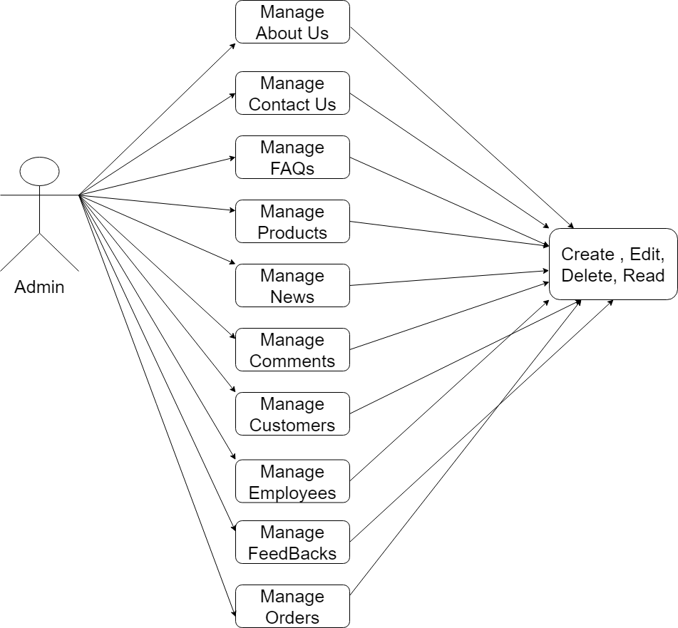

# **V. Use Case Details**

1. **Login Admin**

|  |  |  |  |
| --- | --- | --- | --- |
| **Use case No** | UC-01 | **Use case version** | 1.1 |
| **Name** | Login | | |
| **Actor** | Admin, Employee | | |
| **Summary** | Login | | |
| **Goal** | Login | | |
| **Triggers**  **Priconditions**   * Network   **Post Conditions**   * Have account   **Main Seccess Senario**  1.Go to the admin  2.Input username and password  3.Successful, go to the site  4.Unsuccessful, go back to step2 | | | |
| **Alternative Scenario** |  | | |
| **Exception** |  | | |
| **Relationships** |  | | |

1. **Logout Admin**

|  |  |  |  |
| --- | --- | --- | --- |
| **Use case No** | UC-02 | **Use case version** | 1.1 |
| **Name** | Logout Admin | | |
| **Actor** | Admin, Employee | | |
| **Summary** | Logout | | |
| **Goal** | Logout | | |
| **Triggers**  **Priconditions**   * Network * Is the system   **Post Conditions**  **Main Seccess Senario**  1.Select logout  2.Exit the system | | | |
| **Alternative Scenario** |  | | |
| **Exception** |  | | |
| **Relationships** |  | | |

1. **Product**
2. **Add Product**

|  |  |  |  |
| --- | --- | --- | --- |
| **Use case No** | UC-03 | **Use case version** | 1.1 |
| **Name** | Add product | | |
| **Actor** | Admin, Employee | | |
| **Summary** | Add product | | |
| **Goal** | Add product | | |
| **Triggers**  **Priconditions**   * Have Internet * Account logined system   **Post Conditions**   * Admin add new product   **Main Seccess Senario**  1.Login(if faild show message login faild and go back to 1)  2.Click “Product” from menu left of page admin  3. Show list product  4. Click on button “Create new”  5. Show form and input form add new product  6.Click “Create”  7.System determines the validity of the information  8.Add new in database  9.Show message notify “Success” of “error”  10.Show list new product on page | | | |
| **Alternative Scenario** |  | | |
| **Exception** |  | | |
| **Relationships** |  | | |

|  |  |  |  |
| --- | --- | --- | --- |
| **Use case No** | UC-04 | **Use case version** | 1.1 |
| **Name** | Edit product | | |
| **Actor** | Admin, Employee | | |
| **Summary** | Edit product | | |
| **Goal** | Edit product | | |
| **Triggers**  **Priconditions**   * Have Internet * Account logined system   **Post Conditions**   * Admin update product   **Main Seccess Senario**  1.Login(if faild show message login faild and go back to 1)  2.Click “Product” from menu left of page admin  3. Show list product  4. Click on button “Edit”  5. Show form and input form edit product  6.Click “Save”  7.System determines the validity of the information  8. Update in database  9.Show message notify “Success” of “error”  10.Show list new product on page | | | |
| **Alternative Scenario** |  | | |
| **Exception** |  | | |
| **Relationships** |  | | |

1. **Edit product**
2. **Delete Product**

|  |  |  |  |
| --- | --- | --- | --- |
| **Use case No** | UC-05 | **Use case version** | 1.1 |
| **Name** | Delete Product | | |
| **Actor** | Admin, Employee | | |
| **Summary** | Delete Product | | |
| **Goal** | Delete Product | | |
| **Triggers**  **Priconditions**   * Have Internet * Account logined system   **Post Conditions**   * Admin delete product   **Main Seccess Senario**  1.Login(if faild show message login faild and go back to 1)  2.Click “Product” from menu left of page admin  3. Show list product  4. Click on button “Delete”  5. Show form and input form edit product  6.Click “Delete”  7.System determines the validity of the information  8. Update in database  9.Show message notify “Success” of “error”  10.Show list product on page | | | |
| **Alternative Scenario** |  | | |
| **Exception** |  | | |
| **Relationships** |  | | |

1. **Search Product**

|  |  |  |  |
| --- | --- | --- | --- |
| **Use case No** | UC-06 | **Use case version** | 1.1 |
| **Name** | Search Product | | |
| **Actor** | Admin, Employee | | |
| **Summary** | Search Product | | |
| **Goal** | Search Product | | |
| **Triggers**  **Priconditions**   * Have Internet * Account logined system   **Post Conditions**   * Admin delete product   **Main Seccess Senario**  1.Login(if faild show message login faild and go back to 1)  2.Click “Product” from menu left of page admin  3. Show list product  4. Input form search on page  5. Click on “search”  6.Show list product on page | | | |
| **Alternative Scenario** |  | | |
| **Exception** |  | | |
| **Relationships** |  | | |

1. **Customer Management**
2. **Add customer**

|  |  |  |  |
| --- | --- | --- | --- |
| **Use case No** | UC-07 | **Use case version** | 1.1 |
| **Name** | Add Customer | | |
| **Actor** | Admin | | |
| **Summary** | Add Customer | | |
| **Goal** | Add Customer | | |
| **Triggers**  **Priconditions**   * Have Internet * Account logined system   **Post Conditions**   * Admin add new Customer   **Main Seccess Senario**  1.Login(if faild show message login faild and go back to 1)  2.Click “ Add Customer ” from menu left of page admin  3. Show list customer  4. Click on button “Create new”  5. Show form and input form add new customer  6.Click “Create”  7.System determines the validity of the information  8.Add new in database  9.Show message notify “Success” of “error”  10.Show list new customer on page | | | |
| **Alternative Scenario** |  | | |
| **Exception** |  | | |
| **Relationships** |  | | |

1. **Edit Customer**

|  |  |  |  |
| --- | --- | --- | --- |
| **Use case No** | UC-08 | **Use case version** | 1.1 |
| **Name** | Update Customer | | |
| **Actor** | Admin | | |
| **Summary** | Update Customer | | |
| **Goal** | Update Customer | | |
| **Triggers**  **Priconditions**   * Have Internet * Account logined system   **Post Conditions**   * Admin update customer   **Main Seccess Senario**  1.Login(if faild show message login faild and go back to 1)  2.Click “Customer” from menu left of page admin  3. Show list product  4. Click on button “Edit”  5. Show form and input form edit customer  6.Click “Save”  7.System determines the validity of the information  8. Update in database  9.Show message notify “Success” of “error”  10.Show list new customer on page | | | |
| **Alternative Scenario** |  | | |
| **Exception** |  | | |
| **Relationships** |  | | |

1. **Delete customer**

|  |  |  |  |
| --- | --- | --- | --- |
| **Use case No** | UC-09 | **Use case version** | 1.1 |
| **Name** | Delete Product | | |
| **Actor** | Admin | | |
| **Summary** | Delete Product | | |
| **Goal** | Delete Product | | |
| **Triggers**  **Priconditions**   * Have Internet * Account logined system   **Post Conditions**   * Admin delete customer   **Main Seccess Senario**  1.Login(if faild show message login faild and go back to 1)  2.Click “Delete” from menu left of page admin  3. Show list customer  4. Click on button “Delete”  5. Show form and input form edit product  6.Click “Delete”  7.System determines the validity of the information  8. Update in database  9.Show message notify “Success” of “error”  10.Show list customer on page | | | |
| **Alternative Scenario** |  | | |
| **Exception** |  | | |
| **Relationships** |  | | |

1. **Search cutomer**

|  |  |  |  |
| --- | --- | --- | --- |
| **Use case No** | UC-10 | **Use case version** | 1.1 |
| **Name** | Search Customer | | |
| **Actor** | Admin | | |
| **Summary** | Search Customer | | |
| **Goal** | Search Customer | | |
| **Triggers**  **Priconditions**   * Have Internet * Account logined system   **Post Conditions**   * Admin delete customer   **Main Seccess Senario**  1.Login(if faild show message login faild and go back to 1)  2.Click “ Customer Managemant” from menu left of page admin  3. Show list customer  4. Input form search on page  5. Click on “search”  6.Show list customer on page | | | |
| **Alternative Scenario** |  | | |
| **Exception** |  | | |
| **Relationships** |  | | |

1. **Employee Management**
2. **Create Employee**

|  |  |  |  |
| --- | --- | --- | --- |
| **Use case No** | UC-11 | **Use case version** | 1.1 |
| **Name** | Add Emloyee Management | | |
| **Actor** | Admin | | |
| **Summary** | Add Emloyee Management | | |
| **Goal** | Add Emloyee Management | | |
| **Triggers**  **Priconditions**   * Have Internet * Account logined system   **Post Conditions**   * Admin add new Employee   **Main Seccess Senario**  1.Login(if faild show message login faild and go back to 1)  2.Click “ Emloyee Management ” from menu left of page admin  3. Show list employee  4. Click on button “Create new”  5. Show form and input form add new employee  6.Click “Create”  7.System determines the validity of the information  8.Add new in database  9.Show message notify “Success” of “error”  10.Show list new employee on page | | | |
| **Alternative Scenario** |  | | |
| **Exception** |  | | |
| **Relationships** |  | | |

1. **Edit Employee**

|  |  |  |  |
| --- | --- | --- | --- |
| **Use case No** | UC-12 | **Use case version** | 1.1 |
| **Name** | Update Employee | | |
| **Actor** | Admin | | |
| **Summary** | Update Employee | | |
| **Goal** | Update Employee | | |
| **Triggers**  **Priconditions**   * Have Internet * Account logined system   **Post Conditions**   * Admin update Employee   **Main Seccess Senario**  1.Login(if faild show message login faild and go back to 1)  2.Click “Employee managermant” from menu left of page admin  3. Show list employee  4. Click on button “Edit”  5. Show form and input form edit employee  6.Click “Save”  7.System determines the validity of the information  8. Update in database  9.Show message notify “Success” of “error”  10.Show list new employee on page | | | |
| **Alternative Scenario** |  | | |
| **Exception** |  | | |
| **Relationships** |  | | |

1. **Delete Employee**

|  |  |  |  |
| --- | --- | --- | --- |
| **Use case No** | UC-013 | **Use case version** | 1.1 |
| **Name** | Delete Employee | | |
| **Actor** | Admin | | |
| **Summary** | Delete Employee | | |
| **Goal** | Delete Employee | | |
| **Triggers**  **Priconditions**   * Have Internet * Account logined system   **Post Conditions**   * Admin delete Employee   **Main Seccess Senario**  1.Login(if faild show message login faild and go back to 1)  2.Click “Delete” from menu left of page admin  3. Show list employee  4. Click on button “Delete”  5. Show form and input form delete employee  6.Click “Delete”  7.System determines the validity of the information  8. Update in database  9.Show message notify “Success” of “error”  10.Show list employee on page | | | |
| **Alternative Scenario** |  | | |
| **Exception** |  | | |
| **Relationships** |  | | |

1. **Search Employee**

|  |  |  |  |
| --- | --- | --- | --- |
| **Use case No** | UC-14 | **Use case version** | 1.1 |
| **Name** | Search Employee | | |
| **Actor** | Admin | | |
| **Summary** | Search Employee | | |
| **Goal** | Search Employee | | |
| **Triggers**  **Priconditions**   * Have Internet * Account logined system   **Post Conditions**   * Admin delete Employee   **Main Seccess Senario**  1.Login(if faild show message login faild and go back to 1)  2.Click “ Employee Managemant” from menu left of page admin  3. Show list employee  4. Input form search on page  5. Click on “search”  6.Show list employee on page | | | |
| **Alternative Scenario** |  | | |
| **Exception** |  | | |
| **Relationships** |  | | |

1. **Order Management**
2. **Create order**

|  |  |  |  |
| --- | --- | --- | --- |
| **Use case No** | UC-15 | **Use case version** | 1.1 |
| **Name** | Add Order Management | | |
| **Actor** | Admin, Employee | | |
| **Summary** | Add Order Management | | |
| **Goal** | Add Order Management | | |
| **Triggers**  **Priconditions**   * Have Internet * Account logined system   **Post Conditions**   * Admin add new Order   **Main Seccess Senario**  1.Login(if faild show message login faild and go back to 1)  2.Click “ Order Management ” from menu left of page admin  3. Show list order  4. Click on button “Create new”  5. Show form and input form add new order  6.Click “Create”  7.System determines the validity of the information  8.Add new in database  9.Show message notify “Success” of “error”  10.Show list new order on page | | | |
| **Alternative Scenario** |  | | |
| **Exception** |  | | |
| **Relationships** |  | | |

1. **Update Order Management**

|  |  |  |  |
| --- | --- | --- | --- |
| **Use case No** | UC-16 | **Use case version** | 1.1 |
| **Name** | Update Order | | |
| **Actor** | Admin, Employee | | |
| **Summary** | Update Order | | |
| **Goal** | Update Order | | |
| **Triggers**  **Priconditions**   * Have Internet * Account logined system   **Post Conditions**   * Admin update Order   **Main Seccess Senario**  1.Login(if faild show message login faild and go back to 1)  2.Click “ Order managermant” from menu left of page admin  3. Show list order  4. Click on button “Edit”  5. Show form and input form edit order  6.Click “Save”  7.System determines the validity of the information  8. Update in database  9.Show message notify “Success” of “error”  10.Show list new order on page | | | |
| **Alternative Scenario** |  | | |
| **Exception** |  | | |
| **Relationships** |  | | |

1. **Delete Order Management**

|  |  |  |  |
| --- | --- | --- | --- |
| **Use case No** | UC-017 | **Use case version** | 1.1 |
| **Name** | Delete Order | | |
| **Actor** | Admin, Employee | | |
| **Summary** | Delete Order | | |
| **Goal** | Delete Order | | |
| **Triggers**  **Priconditions**   * Have Internet * Account logined system   **Post Conditions**   * Admin delete Order   **Main Seccess Senario**  1.Login(if faild show message login faild and go back to 1)  2.Click “Order Management” from menu left of page admin  3. Show list order  4. Click on button “Delete”  5. Show form and input form delete order  6.Click “Delete”  7.System determines the validity of the information  8. Update in database  9.Show message notify “Success” of “error”  10.Show list order on page | | | |
| **Alternative Scenario** |  | | |
| **Exception** |  | | |
| **Relationships** |  | | |

1. **Search Order Management**

|  |  |  |  |
| --- | --- | --- | --- |
| **Use case No** | UC-18 | **Use case version** | 1.1 |
| **Name** | Search Order | | |
| **Actor** | Admin ,Employee | | |
| **Summary** | Search Order | | |
| **Goal** | Search Order | | |
| **Triggers**  **Priconditions**   * Have Internet * Account logined system   **Post Conditions**   * Admin delete Order   **Main Seccess Senario**  1.Login(if faild show message login faild and go back to 1)  2.Click “ Order Managemant” from menu left of page admin  3. Show list order  4. Input form search on page  5. Click on “search”  6.Show list order on page | | | |
| **Alternative Scenario** |  | | |
| **Exception** |  | | |
| **Relationships** |  | | |

1. **FAQ Management**
2. **Create New**

|  |  |  |  |
| --- | --- | --- | --- |
| **Use case No** | UC-19 | **Use case version** | 1.1 |
| **Name** | Add FAQ Management | | |
| **Actor** | Admin, employee | | |
| **Summary** | Add FAQ Management | | |
| **Goal** | Add FAQ Management | | |
| **Triggers**  **Priconditions**   * Have Internet * Account logined system   **Post Conditions**   * Admin add new FAQ   **Main Seccess Senario**  1.Login(if faild show message login faild and go back to 1)  2.Click “ FAQ Management ” from menu left of page admin  3. Show list FAQ  4. Click on button “Create new”  5. Show form and input form add new FAQ  6.Click “Create”  7.System determines the validity of the information  8.Add new in database  9.Show message notify “Success” of “error”  10.Show list new FAQ on page | | | |
| **Alternative Scenario** |  | | |
| **Exception** |  | | |
| **Relationships** |  | | |

1. **Update FAQ**

|  |  |  |  |
| --- | --- | --- | --- |
| **Use case No** | UC-20 | **Use case version** | 1.1 |
| **Name** | Update FAQ | | |
| **Actor** | Admin, employee | | |
| **Summary** | Update FAQ | | |
| **Goal** | Update FAQ | | |
| **Triggers**  **Priconditions**   * Have Internet * Account logined system   **Post Conditions**   * Admin update FAQ   **Main Seccess Senario**  1.Login(if faild show message login faild and go back to 1)  2.Click “ FAQ managermant” from menu left of page admin  3. Show list FAQ  4. Click on button “Edit”  5. Show form and input form edit FAQ  6.Click “Save”  7.System determines the validity of the information  8. Update in database  9.Show message notify “Success” of “error”  10.Show list new FAQ on page | | | |
| **Alternative Scenario** |  | | |
| **Exception** |  | | |
| **Relationships** |  | | |

1. **Delete FAQ**

|  |  |  |  |
| --- | --- | --- | --- |
| **Use case No** | UC-021 | **Use case version** | 1.1 |
| **Name** | Delete FAQ | | |
| **Actor** | Admin, employee | | |
| **Summary** | Delete FAQ | | |
| **Goal** | Delete FAQ | | |
| **Triggers**  **Priconditions**   * Have Internet * Account logined system   **Post Conditions**   * Admin delete FAQ   **Main Seccess Senario**  1.Login(if faild show message login faild and go back to 1)  2.Click “FAQ Management” from menu left of page admin  3. Show list FAQ  4. Click on button “Delete”  5. Show form and input form delete FAQ  6.Click “Delete”  7.System determines the validity of the information  8. Update in database  9.Show message notify “Success” of “error”  10.Show list FAQ on page | | | |
| **Alternative Scenario** |  | | |
| **Exception** |  | | |
| **Relationships** |  | | |

1. **Search FAQ**

|  |  |  |  |
| --- | --- | --- | --- |
| **Use case No** | UC-22 | **Use case version** | 1.1 |
| **Name** | Search FAQ | | |
| **Actor** | Admin, Employee | | |
| **Summary** | Search FAQ | | |
| **Goal** | Search FAQ | | |
| **Triggers**  **Priconditions**   * Have Internet * Account logined system   **Post Conditions**   * Admin delete FAQ   **Main Seccess Senario**  1.Login(if faild show message login faild and go back to 1)  2.Click “ FAQ Managemant” from menu left of page admin  3. Show list FAQ  4. Input form search on page  5. Click on “search”  6.Show list FAQ on page | | | |
| **Alternative Scenario** |  | | |
| **Exception** |  | | |
| **Relationships** |  | | |

1. **AboutUs Management**
2. **Create About us**

|  |  |  |  |
| --- | --- | --- | --- |
| **Use case No** | UC-23 | **Use case version** | 1.1 |
| **Name** | Add About us Management | | |
| **Actor** | Admin, employee | | |
| **Summary** | Add About us Management | | |
| **Goal** | Add About us Management | | |
| **Triggers**  **Priconditions**   * Have Internet * Account logined system   **Post Conditions**   * Admin add new About Us   **Main Seccess Senario**  1.Login(if faild show message login faild and go back to 1)  2.Click “ About us Management ” from menu left of page admin  3. Show list About us  4. Click on button “Create new”  5. Show form and input form add new About us  6.Click “Create”  7.System determines the validity of the information  8.Add new in database  9.Show message notify “Success” of “error”  10.Show list new About us on page | | | |
| **Alternative Scenario** |  | | |
| **Exception** |  | | |
| **Relationships** |  | | |

1. **Upload About us**

|  |  |  |  |
| --- | --- | --- | --- |
| **Use case No** | UC-24 | **Use case version** | 1.1 |
| **Name** | Update About us | | |
| **Actor** | Admin, employee | | |
| **Summary** | Update About us | | |
| **Goal** | Update About us | | |
| **Triggers**  **Priconditions**   * Have Internet * Account logined system   **Post Conditions**   * Admin update About us   **Main Seccess Senario**  1.Login(if faild show message login faild and go back to 1)  2.Click “ About us managermant” from menu left of page admin  3. Show list About us  4. Click on button “Edit”  5. Show form and input form edit About us  6.Click “Save”  7.System determines the validity of the information  8. Update in database  9.Show message notify “Success” of “error”  10.Show list new About us on page | | | |
| **Alternative Scenario** |  | | |
| **Exception** |  | | |
| **Relationships** |  | | |

1. **Delete About us**

|  |  |  |  |
| --- | --- | --- | --- |
| **Use case No** | UC-025 | **Use case version** | 1.1 |
| **Name** | Delete About us | | |
| **Actor** | Admin, employee | | |
| **Summary** | Delete About us | | |
| **Goal** | Delete About us | | |
| **Triggers**  **Priconditions**   * Have Internet * Account logined system   **Post Conditions**   * Admin delete About us   **Main Seccess Senario**  1.Login(if faild show message login faild and go back to 1)  2.Click “About us Management” from menu left of page admin  3. Show list About us  4. Click on button “Delete”  5. Show form and input form delete About us  6.Click “Delete”  7.System determines the validity of the information  8. Update in database  9.Show message notify “Success” of “error”  10.Show list About us on page | | | |
| **Alternative Scenario** |  | | |
| **Exception** |  | | |
| **Relationships** |  | | |

1. **Search About us**

|  |  |  |  |
| --- | --- | --- | --- |
| **Use case No** | UC-26 | **Use case version** | 1.1 |
| **Name** | Search About us | | |
| **Actor** | Admin, Employee | | |
| **Summary** | Search About us | | |
| **Goal** | Search About us | | |
| **Triggers**  **Priconditions**   * Have Internet * Account logined system   **Post Conditions**   * Admin search About us   **Main Seccess Senario**  1.Login(if faild show message login faild and go back to 1)  2.Click “ About us Managemant” from menu left of page admin  3. Show list About us  4. Input form search on page  5. Click on “search”  6.Show list About us on page | | | |
| **Alternative Scenario** |  | | |
| **Exception** |  | | |
| **Relationships** |  | | |

1. **Contact Management**
2. **Add new Contact**

|  |  |  |  |
| --- | --- | --- | --- |
| **Use case No** | UC-27 | **Use case version** | 1.1 |
| **Name** | Add Contact Management | | |
| **Actor** | Admin, employee | | |
| **Summary** | Add Contact Management | | |
| **Goal** | Add Contact Management | | |
| **Triggers**  **Priconditions**   * Have Internet * Account logined system   **Post Conditions**   * Admin add new Contact   **Main Seccess Senario**  1.Login(if faild show message login faild and go back to 1)  2.Click “ Contact Management ” from menu left of page admin  3. Show list Contact  4. Click on button “Create new”  5. Show form and input form add new Contact  6.Click “Create”  7.System determines the validity of the information  8.Add new in database  9.Show message notify “Success” of “error”  10.Show list new Contact on page | | | |
| **Alternative Scenario** |  | | |
| **Exception** |  | | |
| **Relationships** |  | | |

1. **Update Contact**

|  |  |  |  |
| --- | --- | --- | --- |
| **Use case No** | UC-28 | **Use case version** | 1.1 |
| **Name** | Update Contact | | |
| **Actor** | Admin, employee | | |
| **Summary** | Update Contact | | |
| **Goal** | Update Contact | | |
| **Triggers**  **Priconditions**   * Have Internet * Account logined system   **Post Conditions**   * Admin update Contact   **Main Seccess Senario**  1.Login(if faild show message login faild and go back to 1)  2.Click “ Contact managermant” from menu left of page admin  3. Show list About us  4. Click on button “Edit”  5. Show form and input form edit Contact  6.Click “Save”  7.System determines the validity of the information  8. Update in database  9.Show message notify “Success” of “error”  10.Show list new Contact on page | | | |
| **Alternative Scenario** |  | | |
| **Exception** |  | | |
| **Relationships** |  | | |

1. **Delete Contact**

|  |  |  |  |
| --- | --- | --- | --- |
| **Use case No** | UC-029 | **Use case version** | 1.1 |
| **Name** | Delete Contact | | |
| **Actor** | Admin, employee | | |
| **Summary** | Delete Contact | | |
| **Goal** | Delete Contact | | |
| **Triggers**  **Priconditions**   * Have Internet * Account logined system   **Post Conditions**   * Admin delete Contact   **Main Seccess Senario**  1.Login(if faild show message login faild and go back to 1)  2.Click “ Contact Management” from menu left of page admin  3. Show list Contact  4. Click on button “Delete”  5. Show form and input form delete Contact  6.Click “Delete”  7.System determines the validity of the information  8. Update in database  9.Show message notify “Success” of “error”  10.Show list Contact on page | | | |
| **Alternative Scenario** |  | | |
| **Exception** |  | | |
| **Relationships** |  | | |

1. **Feedback Management**

|  |  |  |  |
| --- | --- | --- | --- |
| **Use case No** | UC-30 | **Use case version** | 1.1 |
| **Name** | Add Feedback Management | | |
| **Actor** | Admin, employee | | |
| **Summary** | Add Feedback Management | | |
| **Goal** | Add Feedback Management | | |
| **Triggers**  **Priconditions**   * Have Internet * Account logined system   **Post Conditions**   * Admin add new Feedback   **Main Seccess Senario**  1.Login(if faild show message login faild and go back to 1)  2.Click “ Feedback Management ” from menu left of page admin  3. Show list Feedback  4. Click on button “Create new”  5. Show form and input form add new Feedback  6.Click “Create”  7.System determines the validity of the information  8.Add new in database  9.Show message notify “Success” of “error”  10.Show list new Feedback on page | | | |
| **Alternative Scenario** |  | | |
| **Exception** |  | | |
| **Relationships** |  | | |

1. **Add new Feedback**
2. **Update Feedback**

|  |  |  |  |
| --- | --- | --- | --- |
| **Use case No** | UC-31 | **Use case version** | 1.1 |
| **Name** | Update Feedback | | |
| **Actor** | Admin, employee | | |
| **Summary** | Update Feedback | | |
| **Goal** | Update Feedback | | |
| **Triggers**  **Priconditions**   * Have Internet * Account logined system   **Post Conditions**   * Admin update Feedback   **Main Seccess Senario**  1.Login(if faild show message login faild and go back to 1)  2.Click “ Feedback managermant” from menu left of page admin  3. Show list Feedback  4. Click on button “Edit”  5. Show form and input form edit Feedback  6.Click “Save”  7.System determines the validity of the information  8. Update in database  9.Show message notify “Success” of “error”  10.Show list new Feedback on page | | | |
| **Alternative Scenario** |  | | |
| **Exception** |  | | |
| **Relationships** |  | | |

1. **Delete feedback**

|  |  |  |  |
| --- | --- | --- | --- |
| **Use case No** | UC-32 | **Use case version** | 1.1 |
| **Name** | Delete Feedback | | |
| **Actor** | Admin, employee | | |
| **Summary** | Delete Feedback | | |
| **Goal** | Delete Feedback | | |
| **Triggers**  **Priconditions**   * Have Internet * Account logined system   **Post Conditions**   * Admin delete Feedback   **Main Seccess Senario**  1.Login(if faild show message login faild and go back to 1)  2.Click “ Feedback Management” from menu left of page admin  3. Show list Feedback  4. Click on button “Delete”  5. Show form and input form delete Feedback  6.Click “Delete”  7.System determines the validity of the information  8. Update in database  9.Show message notify “Success” of “error”  10.Show list Feedback on page | | | |
| **Alternative Scenario** |  | | |
| **Exception** |  | | |
| **Relationships** |  | | |

1. **Search Feedback**

|  |  |  |  |
| --- | --- | --- | --- |
| **Use case No** | UC-33 | **Use case version** | 1.1 |
| **Name** | Search Feedback | | |
| **Actor** | Admin, Employee | | |
| **Summary** | Search Feedback | | |
| **Goal** | Search Feedback | | |
| **Triggers**  **Priconditions**   * Have Internet * Account logined system   **Post Conditions**   * Admin search About us   **Main Seccess Senario**  1.Login(if faild show message login faild and go back to 1)  2.Click “ Feedback Managemant” from menu left of page admin  3. Show list Feedback  4. Input form search on page  5. Click on “search”  6.Show list Feedback on page | | | |
| **Alternative Scenario** |  | | |
| **Exception** |  | | |
| **Relationships** |  | | |

1. **Comment Management**
2. **Add new Comment**

|  |  |  |  |
| --- | --- | --- | --- |
| **Use case No** | UC-34 | **Use case version** | 1.1 |
| **Name** | Add Comment Management | | |
| **Actor** | Admin, employee | | |
| **Summary** | Add Comment Management | | |
| **Goal** | Add Comment Management | | |
| **Triggers**  **Priconditions**   * Have Internet * Account logined system   **Post Conditions**   * Admin add new Comment   **Main Seccess Senario**  1.Login(if faild show message login faild and go back to 1)  2.Click “ Comment Management ” from menu left of page admin  3. Show list Comment  4. Click on button “Create new”  5. Show form and input form add new Comment  6.Click “Create”  7.System determines the validity of the information  8.Add new in database  9.Show message notify “Success” of “error”  10.Show list new Comment on page | | | |
| **Alternative Scenario** |  | | |
| **Exception** |  | | |
| **Relationships** |  | | |

1. **Update Comment**

|  |  |  |  |
| --- | --- | --- | --- |
| **Use case No** | UC-35 | **Use case version** | 1.1 |
| **Name** | Update Comment | | |
| **Actor** | Admin, employee | | |
| **Summary** | Update Comment | | |
| **Goal** | Update Comment | | |
| **Triggers**  **Priconditions**   * Have Internet * Account logined system   **Post Conditions**   * Admin update Comment   **Main Seccess Senario**  1.Login(if faild show message login faild and go back to 1)  2.Click “ Comment managermant” from menu left of page admin  3. Show list Comment  4. Click on button “Edit”  5. Show form and input form edit Comment  6.Click “Save”  7.System determines the validity of the information  8. Update in database  9.Show message notify “Success” of “error”  10.Show list new Comment on page | | | |
| **Alternative Scenario** |  | | |
| **Exception** |  | | |
| **Relationships** |  | | |

1. **Delete Comment**

|  |  |  |  |
| --- | --- | --- | --- |
| **Use case No** | UC-036 | **Use case version** | 1.1 |
| **Name** | Delete Comment | | |
| **Actor** | Admin, employee | | |
| **Summary** | Delete Comment | | |
| **Goal** | Delete Comment | | |
| **Triggers**  **Priconditions**   * Have Internet * Account logined system   **Post Conditions**   * Admin delete Comment   **Main Seccess Senario**  1.Login(if faild show message login faild and go back to 1)  2.Click “ Comment Management” from menu left of page admin  3. Show list Comment  4. Click on button “Delete”  5. Show form and input form delete Comment  6.Click “Delete”  7.System determines the validity of the information  8. Update in database  9.Show message notify “Success” of “error”  10.Show list Comment on page | | | |
| **Alternative Scenario** |  | | |
| **Exception** |  | | |
| **Relationships** |  | | |

1. **Search Comment**

|  |  |  |  |
| --- | --- | --- | --- |
| **Use case No** | UC-37 | **Use case version** | 1.1 |
| **Name** | Search Comment | | |
| **Actor** | Admin, Employee | | |
| **Summary** | Search Comment | | |
| **Goal** | Search Comment | | |
| **Triggers**  **Priconditions**   * Have Internet * Account logined system   **Post Conditions**   * Admin search Comment   **Main Seccess Senario**  1.Login(if faild show message login faild and go back to 1)  2.Click “ Comment Managemant” from menu left of page admin  3. Show list Feedback  4. Input form search on page  5. Click on “search”  6.Show list Comment on page | | | |
| **Alternative Scenario** |  | | |
| **Exception** |  | | |
| **Relationships** |  | | |

1. **News Management**
2. **Add News Management**

|  |  |  |  |
| --- | --- | --- | --- |
| **Use case No** | UC-38 | **Use case version** | 1.1 |
| **Name** | Add News Management | | |
| **Actor** | Admin, employee | | |
| **Summary** | Add News Management | | |
| **Goal** | Add News Management | | |
| **Triggers**  **Priconditions**   * Have Internet * Account logined system   **Post Conditions**   * Admin add new News   **Main Seccess Senario**  1.Login(if faild show message login faild and go back to 1)  2.Click “ News Management ” from menu left of page admin  3. Show list News  4. Click on button “Create new”  5. Show form and input form add new News  6.Click “Create”  7.System determines the validity of the information  8.Add new in database  9.Show message notify “Success” of “error”  10.Show list new News on page | | | |
| **Alternative Scenario** |  | | |
| **Exception** |  | | |
| **Relationships** |  | | |

1. **Update News Management**

|  |  |  |  |
| --- | --- | --- | --- |
| **Use case No** | UC-39 | **Use case version** | 1.1 |
| **Name** | Update News | | |
| **Actor** | Admin, employee | | |
| **Summary** | Update News | | |
| **Goal** | Update News | | |
| **Triggers**  **Priconditions**   * Have Internet * Account logined system   **Post Conditions**   * Admin update Comment   **Main Seccess Senario**  1.Login(if faild show message login faild and go back to 1)  2.Click “ News managermant” from menu left of page admin  3. Show list News  4. Click on button “Edit”  5. Show form and input form edit News  6.Click “Save”  7.System determines the validity of the information  8. Update in database  9.Show message notify “Success” of “error”  10.Show list new News on page | | | |
| **Alternative Scenario** |  | | |
| **Exception** |  | | |
| **Relationships** |  | | |

1. **Delete News Management**

|  |  |  |  |
| --- | --- | --- | --- |
| **Use case No** | UC-040 | **Use case version** | 1.1 |
| **Name** | Delete News | | |
| **Actor** | Admin, employee | | |
| **Summary** | Delete News | | |
| **Goal** | Delete News | | |
| **Triggers**  **Priconditions**   * Have Internet * Account logined system   **Post Conditions**   * Admin delete News   **Main Seccess Senario**  1.Login(if faild show message login faild and go back to 1)  2.Click “ News Management” from menu left of page admin  3. Show list News  4. Click on button “Delete”  5. Show form and input form delete News  6.Click “Delete”  7.System determines the validity of the information  8. Update in database  9.Show message notify “Success” of “error”  10.Show list News on page | | | |
| **Alternative Scenario** |  | | |
| **Exception** |  | | |
| **Relationships** |  | | |

1. **Search News**

|  |  |  |  |
| --- | --- | --- | --- |
| **Use case No** | UC-41 | **Use case version** | 1.1 |
| **Name** | Search News | | |
| **Actor** | Admin, Employee | | |
| **Summary** | Search News | | |
| **Goal** | Search News | | |
| **Triggers**  **Priconditions**   * Have Internet * Account logined system   **Post Conditions**   * Admin search News   **Main Seccess Senario**  1.Login(if faild show message login faild and go back to 1)  2.Click “ News Managemant” from menu left of page admin  3. Show list News  4. Input form search on page  5. Click on “search”  6.Show list News on page | | | |
| **Alternative Scenario** |  | | |
| **Exception** |  | | |
| **Relationships** |  | | |

1. **Search**
2. **Search author**

|  |  |  |  |
| --- | --- | --- | --- |
| **Use case No** | UC-42 | **Use case version** | 1.1 |
| **Name** | Search Author | | |
| **Actor** | Admin, Employee | | |
| **Summary** | Search Author | | |
| **Goal** | Search Author | | |
| **Triggers**  **Priconditions**   * Have Internet * Account logined system   **Post Conditions**   * Admin search Author   **Main Seccess Senario**  1.Login(if faild show message login faild and go back to 1)  2.Click “ Author Managemant” from menu left of page admin  3. Show list Author  4. Input form search on page  5. Click on “search”  6.Show list Author on page | | | |
| **Alternative Scenario** |  | | |
| **Exception** |  | | |
| **Relationships** |  | | |

1. **Employee Profile**
2. **View profile**

|  |  |  |  |
| --- | --- | --- | --- |
| **Use case No** | UC-43 | **Use case version** | 1.1 |
| **Name** | View profile | | |
| **Actor** | Admin, employee | | |
| **Summary** | View profile | | |
| **Goal** | View profile | | |
| **Triggers**  **Priconditions**   * Have Internet * Account logined system   **Post Conditions**   * Admin, Employee View profile   **Main Seccess Senario**  1.Login(if faild show message login faild and go back to 1)  2.Click “ View profile” from menu  3. Show View profile | | | |
| **Alternative Scenario** |  | | |
| **Exception** |  | | |
| **Relationships** |  | | |

1. **Edit profile**

|  |  |  |  |
| --- | --- | --- | --- |
| **Use case No** | UC-44 | **Use case version** | 1.1 |
| **Name** | Update profile | | |
| **Actor** | Admin, employee | | |
| **Summary** | Update profile | | |
| **Goal** | Update profile | | |
| **Triggers**  **Priconditions**   * Have Internet * Account logined system   **Post Conditions**   * Admin update profile   **Main Seccess Senario**  1.Login(if faild show message login faild and go back to 1)  2.Click “ Proflie ” from menu  3. Show profile  4. Click on button “Edit”  5. Show form and input form edit profile  6.Click “Save”  7.System determines the validity of the information  8. Update in database  9.Show message notify “Success” of “error”  10.Show list new profile on page | | | |
| **Alternative Scenario** |  | | |
| **Exception** |  | | |
| **Relationships** |  | | |

# **VI. Project Plan**

|  |  |  |  |  |  |
| --- | --- | --- | --- | --- | --- |
| **ID** | **Name** | **Member** | **Start** | **Finish** | **Note** |
| **Admin** | | | | | |
| BS-001 | Login, logout | Nguyen | 5/5/2020 | 5/5/2020 | Finished |
| BS-002 | Customer management | phuc, nguyen, phuong | 5/5/2020 | 5/5/2020 | Finished |
| BS-003 | Employee management | phuc, nguyen, phuong | 6/5/2020 | 8/5/2020 | Finished |
| BS-004 | Product management | phuc, phuong | 6/5/2020 | 8/5/2020 | Finished |
| BS-005 | Order management | phuong | 15/5/2020 | 6/6/2020 | Finished |
| BS-006 | Be albe to insert, update, delete FAQs details | phuc phuong | 11/5/2020 | 11/5/2020 | Finished |
| BS-007 | Be albe to reply to feedbacks & queries | duong | 29/5/2020 | 2/6/2020 | Finished |
| BS-008 | Startistics | phuc | 25/5/2020 | 29/5/2020 | Finished |
| **Product** | | | | | |
| BS-009 | Show product catalog | nguyen | 12/5/2020 | 12/5/2020 | Finished |
| BS-010 | Show product details | nguyen | 12/5/2020 | 12/5/2020 | Finished |
| BS-011 | Show new books | nguyen | 12/5/2020 | 12/5/2020 | Finished |
| **Search** | | | | | |
| BS-012 | Name, author | phuc | 8/5/2020 | 11/5/2020 | Finished |
| BS-013 | Advanced search (Price) | phuc | 11/5/2020 | 14/5/2020 | Finished |
| **Sort** | | | | | |
| BS-014 | Sort by category | phuc | 15/5/2020 | 18/5/2020 | Finished |
| BS-015 | Sort by price | phuc | 15/5/2020 | 18/5/2020 | Finished |
| **Product suggestions** | | | | | |
| BS-016 | By category | nguyen | 29/5/2020 | 2/6/2020 | Finished |
| **Review** | | | | | |
| BS-017 | Comment | phuc | 18/5/2020 | 18/5/2020 | Finished |
| BS-018 | Rating | phuc | 29/5/2020 | 2/6/2020 | Finished |
| **Customer (Client)** | | | | | |
| BS-019 | Log in sign up | duong | 10/5/2020 | 14/5/2020 | Finished |
| BS-020 | Display customer information | duong | 10/5/2020 | 14/5/2020 | Finished |
| BS-021 | Change password | nguyen, phuong | 10/5/2020 | 14/5/2020 | Finished |
| BS-022 | Update personal information | nguyen, phuong | 10/5/2020 | 14/5/2020 | Finished |
| **Order** | | | | | |
| BS-023 | Show orders | phuong | 15/5/2020 | 6/6/2020 | Finished |
| BS-024 | Payments (Postpaid) | phuong | 15/5/2020 | 6/6/2020 | Finished |
| **Order tracking** | | | | | |
| BS-025 | Order status | phuong | 15/5/2020 | 6/6/2020 | Finished |
| BS-026 | Cancel the order | phuong | 15/5/2020 | 6/6/2020 | Finished |
| BS-027 | Order update | phuong | 15/5/2020 | 6/6/2020 | Finished |
| **FAQs Module** | | | | | |
| BS-028 | Displaying questions along with answers available. | phuc | 7/6/2020 | 7/6/2020 | Finished |
| **Feedbach Module** | | | | | |
| BS-029 | Chat box | duong | 21/5/2020 | 24/5/2020 | Finished |
| **Contact Information Module** | | | | | |
| BS-030 | Displaying the book store contact information | duong | 2/6/2020 | 5/6/2020 | Finished |
| **About Us Module** | | | | | |
| BS-031 | Displaying information about the book store | duong | 2/6/2020 | 5/6/2020 | Finished |
| **New** | | | | | |
| BS-032 | Display news (Client) | phuc | 5/5/2020 | 7/5/2020 | Finished |

# **VII. ERD Diagram**



# **VIII. Database Detail**

1. Abouts

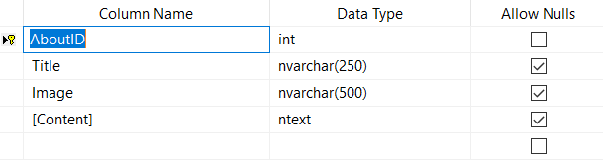

1. Authors

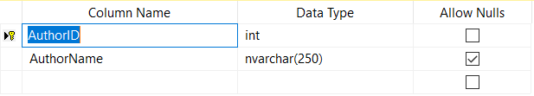

1. Books

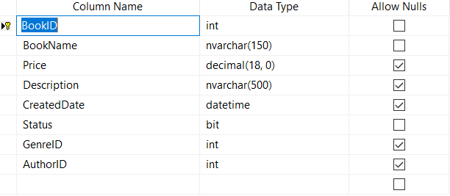

1. Comments

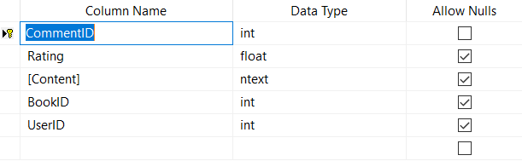

1. Contact

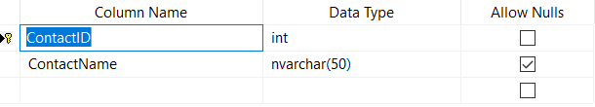

1. Employees

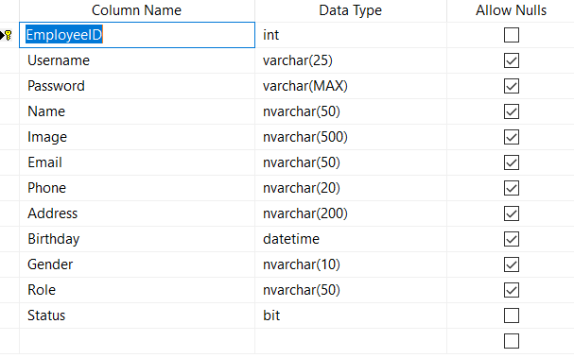

1. FAQs

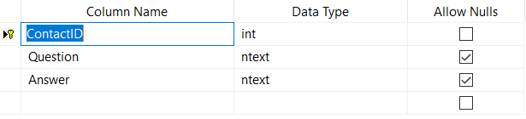

1. Feedkacks

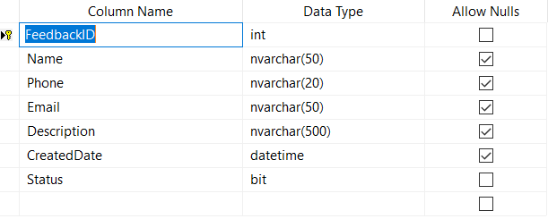

1. Files

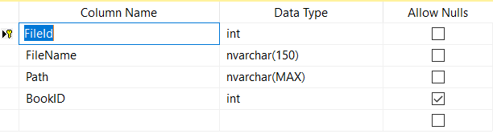

1. Genre

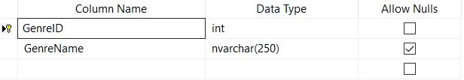

1. News

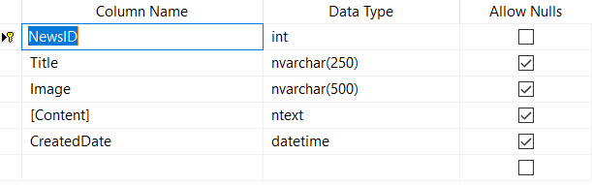

1. Orders

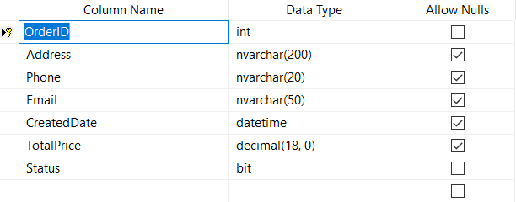

1. Order Details

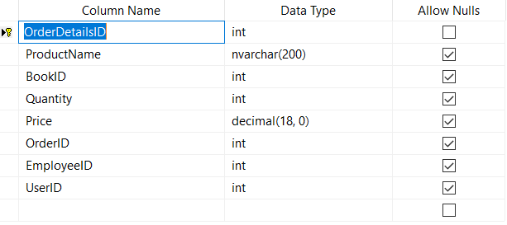

1. Users

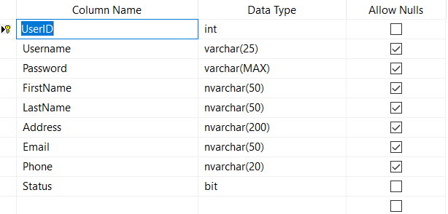

# **IX. Interface Website**

1. Admin
2. Login

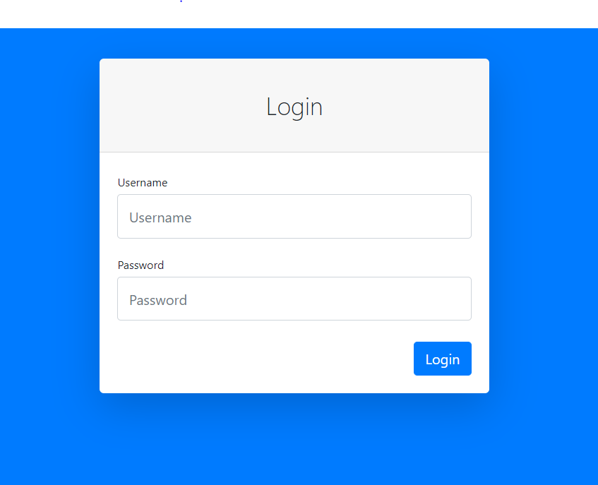

1. Dashboard
2. Menu left compoment

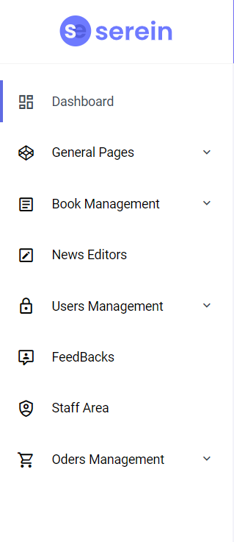

1. Menu top compoment



1. Add new component

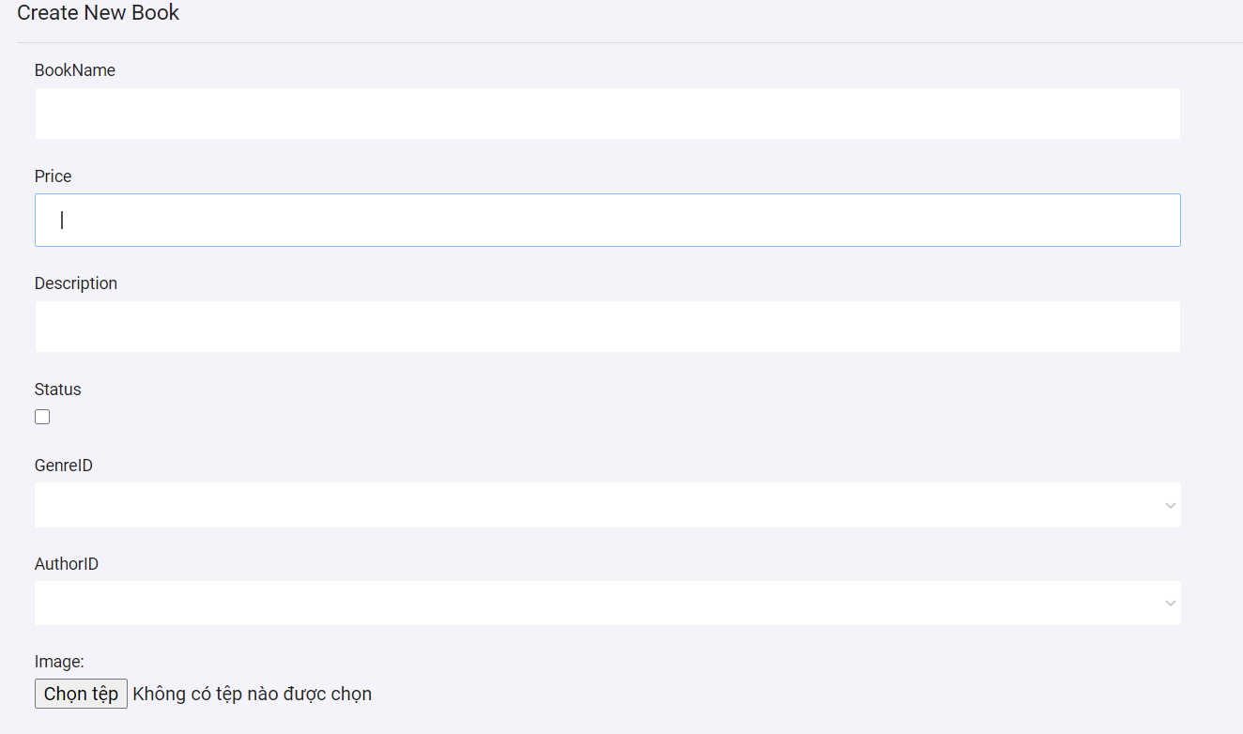

1. Client
2. Login

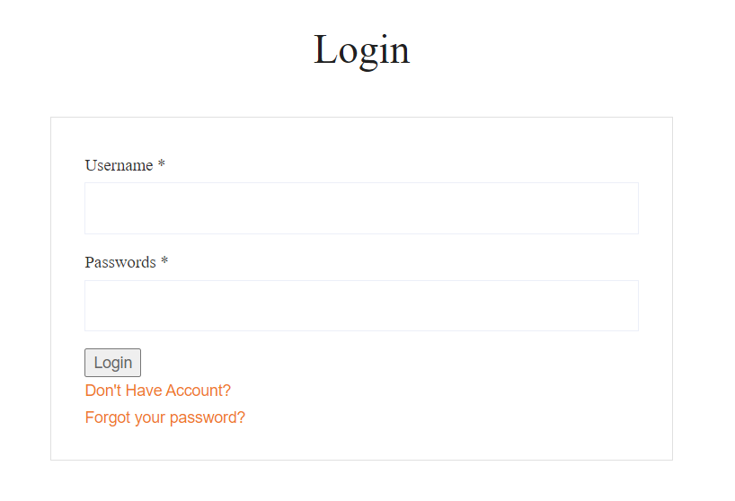

1. Register

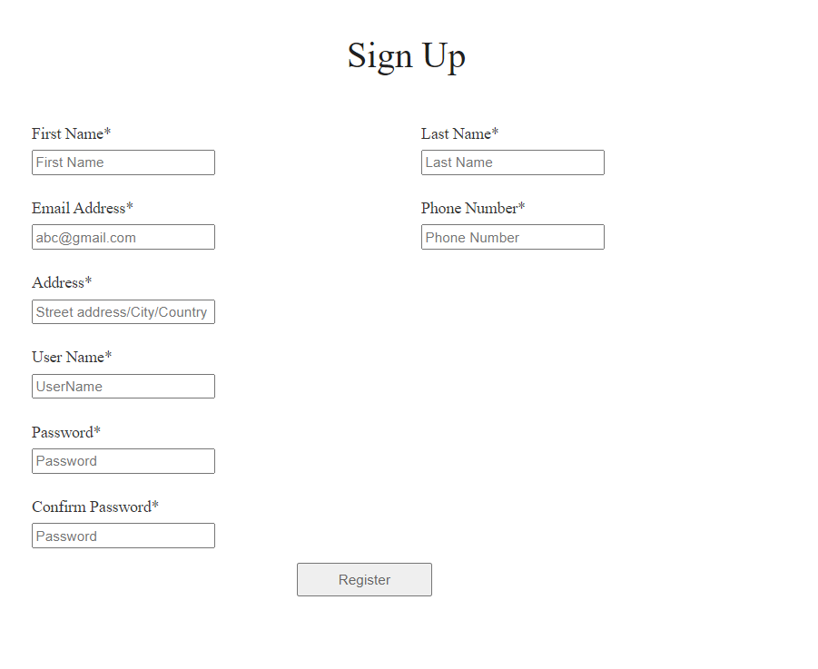

1. Home
2. 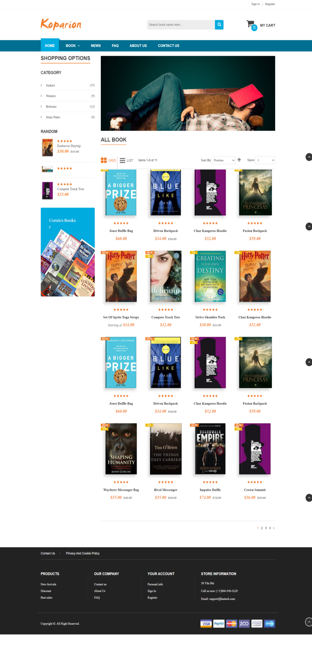Menu top

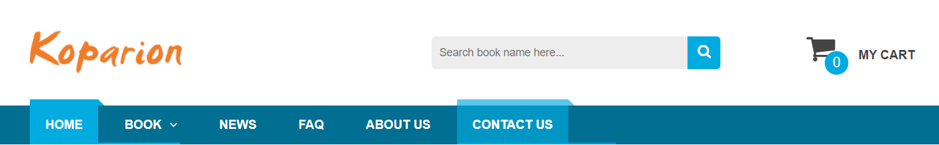

1. Footer

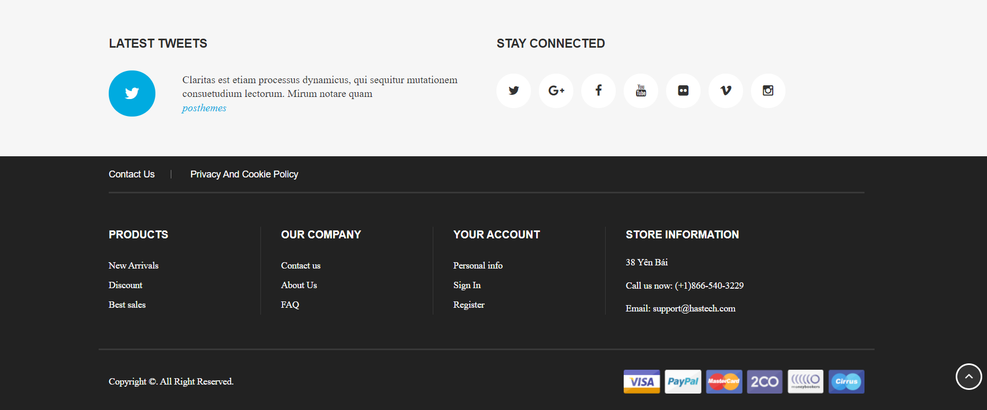

1. Feedback

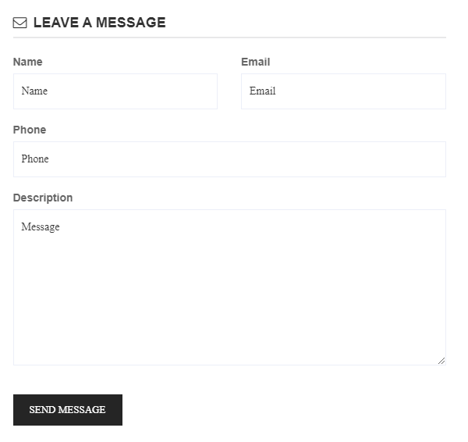

1. Contact

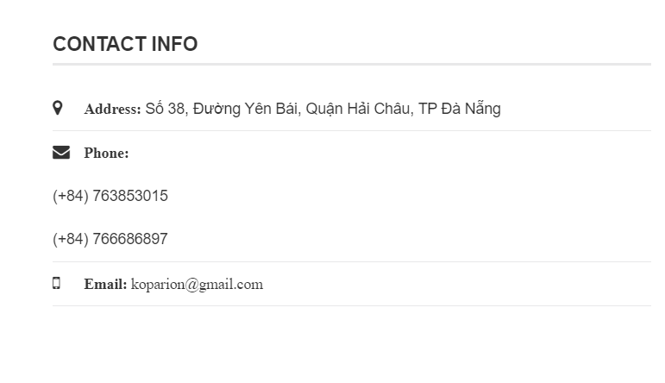

1. Shops

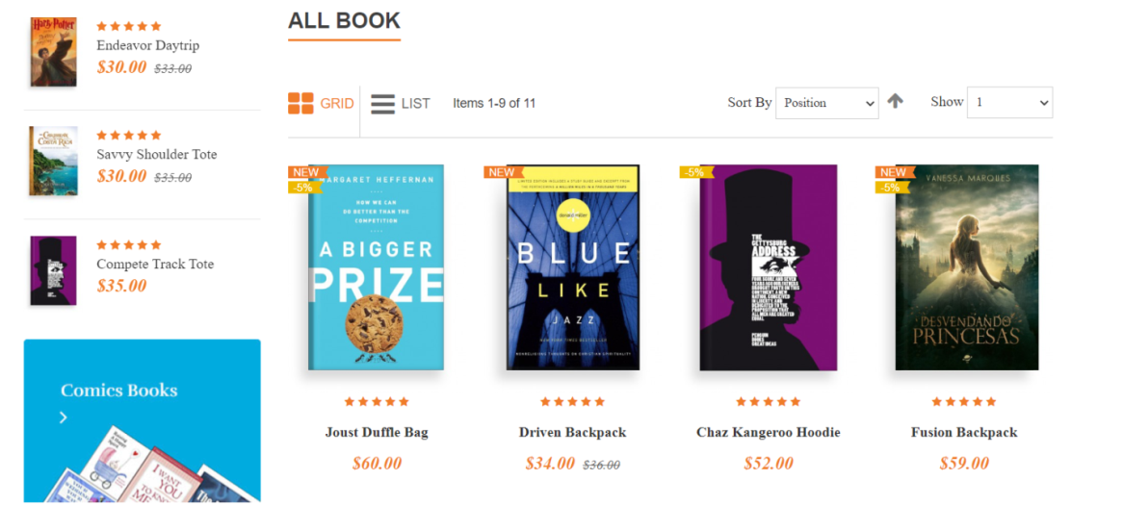

1. About

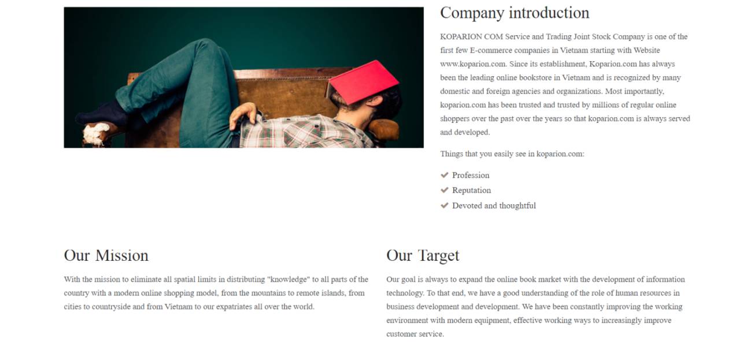

1. Cart

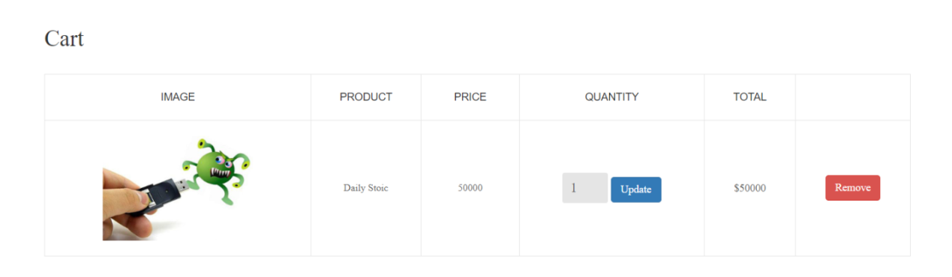

**X. TECHNICAL**

Software: Visual Studio.

Web Browser: Chrome, Firefox, IE, etc., support design responsive.

The technique used to build the website:

* HTML5 & CSS3.
* Bootstrap.
* JQuery & JavaScript.
* ASP.NET MVC5