Appendix A. National polling on shutting down USAID, 2025
Six national polls in the Roper iPoll archive asked about the shutdown of USAID in 2025. Five of them measured support or opposition; the sixth, KFF’s February Health Tracking Poll, measured only whether people had heard about the cuts, so it carries no support or oppose figure. Opposition ran ahead of support in all five, by an average of 18 points.
The wording is not identical across the five, which is why I give the full question text and the response frame alongside the percentages. CNN bundles USAID with the Consumer Financial Protection Bureau and asks whether shutting such agencies down is a good or bad thing. The Washington Post describes the agency rather than naming it. Pew and CNN both offer a middle or unsure option that the two Ipsos polls do not, which is most of the gap in the last column.

Table A1. Support and opposition to shutting down USAID
Poll | Field dates | n | Question wording | Response frame | % Support | % Oppose | % Neither or not sure
Ipsos | Feb 7–10, 2025 | 1,013 | “To what extent do you support or oppose the following policies?…Efforts to dismantle the United States Agency for International Development (USAID).” | Support / oppose | 37 | 58 | 5
CNN / SSRS | Feb 13–17, 2025 | 1,206 | “Please indicate whether you think Donald Trump doing each of the following is a good thing, a bad thing, or neither…Attempting to shut down entire United States government agencies, such as the US Agency for International Development (USAID) and the Consumer Financial Protection Bureau (CFPB).” | Good thing / bad thing | 28 | 53 | 19
Washington Post / Ipsos | Feb 13–18, 2025 | 1,301 | “Do you support or oppose each of the following?…Shutting down the United States agency that provides humanitarian aid to low-income countries.” | Support / oppose | 38 | 59 | 3
KFF / SSRS | Feb 18–25, 2025 | 1,322 | “How much, if anything, have you heard about the Trump administration’s plans to significantly downsize the United States Agency for International Development, known as U.S.A.I.D.?” | Awareness only | — | — | —
Reuters / Ipsos | Mar 3–4, 2025 | 1,174 | “To what extent do you support or oppose the following policies?…Closing down the United States Agency for International Development (USAID), the federal body that administers civilian foreign aid.” | Support / oppose | 41 | 55 | 4
Pew / SSRS | Mar 24–30, 2025 | 3,605 | “Do you approve of each of the following? The United States…ending most United States Agency for International Development (USAID) programs.” | Approve / disapprove | 35 | 45 | 19
Average, five comparable polls |  |  |  |  | 35.8 | 54.0 | 10.0

Notes: Percentages are as published and are weighted. Question wording is quoted from the Roper iPoll record; an ellipsis marks the break between the stem and the item. n is the number of respondents asked the item, which is half the sample for the Washington Post poll and the full sample elsewhere. The last column holds whatever middle or non-response category the poll offered, which is “neither good nor bad” for CNN, “not sure” for Pew, and item non-response for Ipsos and Reuters. The average row covers the five polls with a support or oppose measure and is unweighted. Dashes mark the KFF poll, which did not ask one.
Sources: Roper iPoll study records. Ipsos Poll on Executive Orders, #31122394. CNN Poll, #31122387. Washington Post-Ipsos Poll, #31122388. KFF February 2025 Health Tracking Poll on Health Information and Trust, #31122407. Reuters/Ipsos Pre-Joint Session Survey, #31122408. Pew Research Center American Trends Panel Wave 166, #31122581.

Figure A1. Polling average, February to March 2025
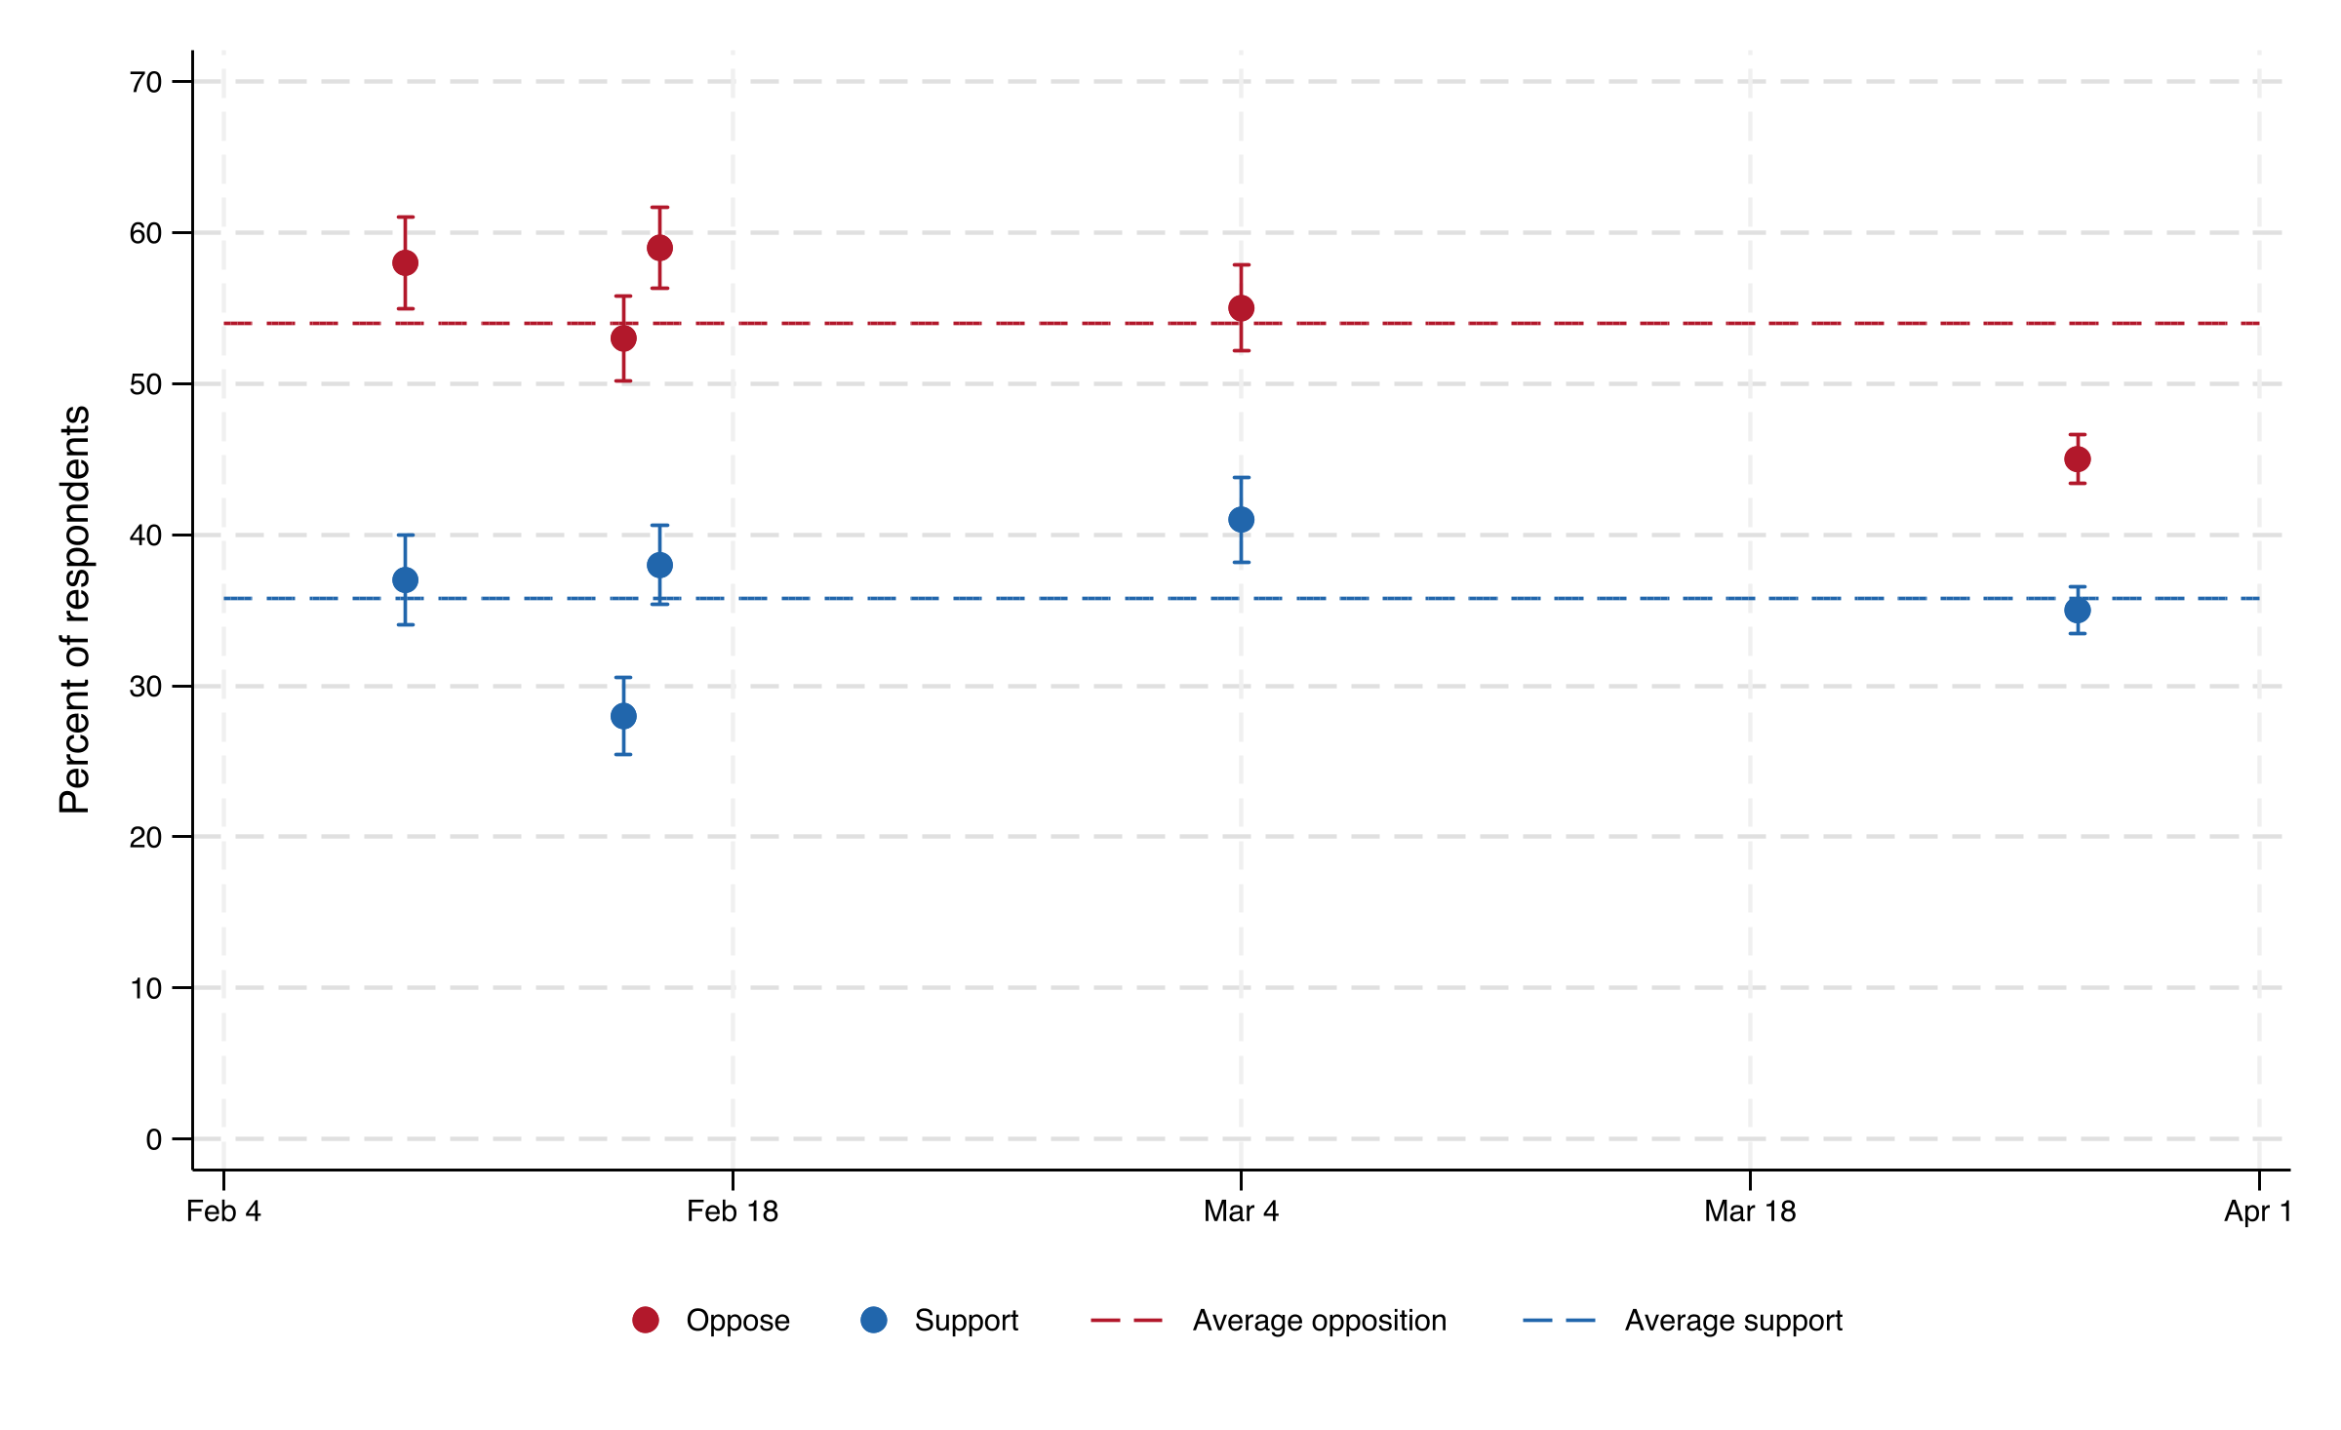
Notes: Each point is one poll, plotted at the midpoint of its field period. Intervals are 95 percent and are computed as p ± 1.96√(p(1−p)/n) on the number of respondents asked the item. They assume simple random sampling, so they are slightly narrower than the design-based intervals the pollsters publish. Dashed lines are the unweighted average across the five polls.

