COMP 431 Internet Protocols & Services

Spring 2017  
Kevin Jeffay

Worksheet 11, February 28

1) Host A and B are communicating over a TCP connection, and Host B has already received from A all bytes up through byte 126. Suppose Host A then sends two segments to Host B back-to-back. The first and second segments contain 80 and 40 bytes of data, respectively. In the first segment, the sequence number is 127, the source port number is 302, and the destination port number is 80. Host B sends an acknowledgment whenever it receives a segment from Host A.

*a*) In the second segment sent from Host A to B, what are the sequence number, source port number, and destination port number?

*207, source 302, destination 80*

*b*) If the first segment arrives before the second segment, in the acknowledgment of the first arriving segment, what is the acknowledgment number, the source port number, and the destination port number?

*ACK: 127+80 = 207, source 80, dest 302*

*c*) If the second segment arrives before the first segment, in the acknowledgment of the first arriving segment, what is the acknowledgment number?

*ACK: 127*

*d*) Suppose the two segments sent by A arrive in order at B. The first acknowledgment is lost and the second acknowledgment arrives after the first timeout interval. Draw a timing diagram, showing these segments and all other segments and acknowledgments sent. (Assume there is no additional packet loss.) For each segment in your figure, provide the sequence number and the number of bytes of data; for each acknowledgment that you add, provide the acknowledgment number.

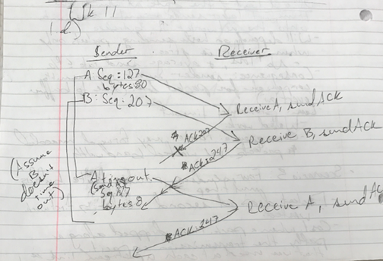

2) Host A and B are directly connected with a 100 Mbps link. There is one TCP connection between the two hosts, and Host A is sending to Host B an enormous file over this connection. Host A can send its application data into its TCP socket at a rate as high as 120 Mbps but Host B can read out of its TCP receive buffer at a maximum rate of 50 Mbps. Describe the effect of TCP flow control.

Every time the receiver sends a packet, it includes its window size. The sender will know how much to send so that Host B isn’t overwhelmed and has buffer overflow. As a result, the sender end up sending data at 50 Mbps.

3) In the lecture it was mentioned that TCP waits until it has received three duplicate ACKs before performing a fast retransmit. Why do you think the TCP designers chose not to perform a fast retransmit after the first duplicate ACK for a segment is received?

They probably wanted to reduce network congestion, and if the packet is delayed and arrives after a timeout, the sender won’t end up sending a duplicate ACK. Waiting for three duplicate ACKs can help ensure that the data really was lost.