COMP 431 Internet Protocols & Services

Spring 2017  
Kevin Jeffay

Worksheet 12, March 7

1) In the lecture, we said that if a TCP connection is operating in an environment where *RTT* > *w* x *MSS*/*R* then the rate at which a TCP connection can transmit data is independent of (and lower than) the speed of the link and instead is solely a function of the size of the TCP congestion window or the receiver’s advertised window.

*a*) Explain in your own words why this is true.

In this case, the RTT is the limiting factor because it is longer than the time it would take to transmit the data at the speed of the link.

*b*) If a TCP connection is operating in an environment where *RTT* > *w* x *MSS*/*R*, what is the effect of doubling the transmission rate on the link (*i.e.*, making *R* twice as large)?

There is no effect because the RTT is still the limiting factor.

2) In the lecture, we also said that if a TCP connection is operating in an environment where *RTT* < *w* x *MSS*/*R* then the size of the TCP connection window doesn’t matter (doesn’t influence the rate at which the connection can transmit data).

*a*) Explain in your own words why this is true and explain what the transmission rate of the TCP connection will be in this environment.

In this case, the transmission time is the limiting factor since it takes longer than propagation. The sender is receiving ACKs back before the window was filled.

*b*) If a TCP connection is operating in an environment where *RTT* < *w* x *MSS*/*R*, what is the effect of doubling the congestion window?

The increasing the window has no effect because the transmission speed is still the limiting factor and not the pipelined data in each trip. We can get acks back faster than sending the data.

*c*) If a TCP connection is operating in an environment where *RTT* < *w* x *MSS*/*R*, can the receiver’s advertised window effect the transmission rate of the connection? Explain.

Yes, because LastByteSent – LastByteACKed <= MIN(cWin, RcvWindow) (slide 16.) This makes sense because if the receiver can fewer packets then the sender will have to throttle back.

3) What happens if a TCP connection is operating in an environment where *RTT* = *w* x *MSS*/*R*?

We’re not bottlenecked by propagation or window size, so the limits on the connection are equal from each direction.

2) In the lecture, we discussed TCP’s estimation of RTT and said that TCP does not consider retransmitted segments when measuring sample RTT values. Why do you think TCP avoids measuring the RTT for retransmitted segments?

We don’t measure RTTs for retransmitted segments because we don’t know why we had to retransmit (if it was delayed, etc.) and because if the original packet’s ACK shows up immediately after the retransmission, the sender cannot tell if it was from the original or the retransmission. Therefore, the results can be skewed.

3) Consider the figure below. Assuming TCP Reno is the protocol experiencing the behavior shown above, answer the following questions. In all cases, you should provide a short discussion justifying your answer.

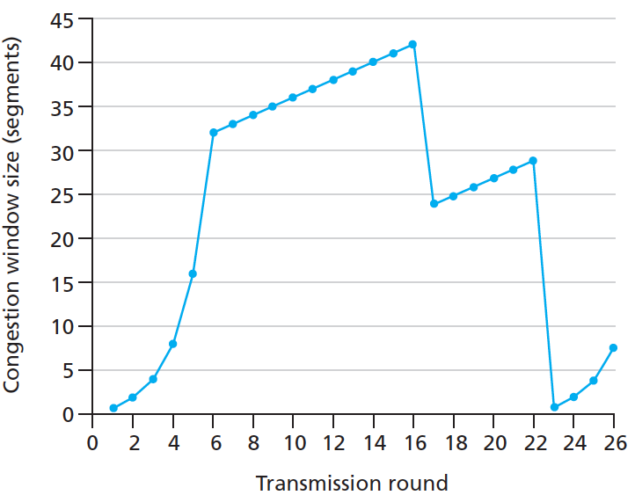

1. Identify the intervals of time when TCP slow start is operating.
   1. (0,6), (23, 26) (exponential curves)
2. Identify the intervals of time when TCP congestion avoidance is operating.
   1. (6, 16), (17,22) (Additive increase. Linear growth)
3. After the 16th transmission round, is segment loss detected by a triple duplicate ACK or by a timeout?
   1. Duplicate ACKs, doesn’t return to slow start

*d*) After the 22nd transmission round, is segment loss detected by a triple duplicate ACK or by a timeout?

Timeout (returns to slow start)

1. What is the initial value of the slow-start threshold (“*ssthresh*”) at the first transmission round?
   1. 32 (out of slow start threshold)
2. What is the value of *ssthresh* at the 18th transmission round?
   1. 24: cwd: 42/2+3
3. What is the value of *ssthresh* at the 24th transmission round?
   1. About 14

*h*) During what transmission round is the 70th segment sent?

*7*

1. Assuming a packet loss is detected after the 26th round by the receipt of a triple duplicate ACK, what will be the values of the congestion window size and of *ssthresh*?
   1. 8/2= 4, congestion window: 4+3 = 7.

*j*) Suppose TCP Tahoe is used (instead of TCP Reno), and assume that triple duplicate ACKs are received at the 16th round. What are the *ssthresh* and the congestion window size at the 19th round?

*k*) Again suppose TCP Tahoe is used, and there is a timeout event at 22nd round. How many packets have been sent out from 17th round till 22nd round, inclusive?