COMP 431 Internet Protocols & Services

Spring 2017  
Kevin Jeffay

Worksheet 16, March 30

1. Consider the network shown below, and assume that each node initially knows the costs to each of its neighbors. Assume a synchronous version of the distance-vector algorithm wherein nodes iterate through the Bellman-Ford algorithm at the same time and in each iteration, a node exchanges its new minimum cost distance vectors (if any) with its neighbors and receives their new minimum cost distance vectors. Simulate the distance vector algorithm and show the distance table entries at each node after each iteration. How many iterations does it take for the algorithm to converge?

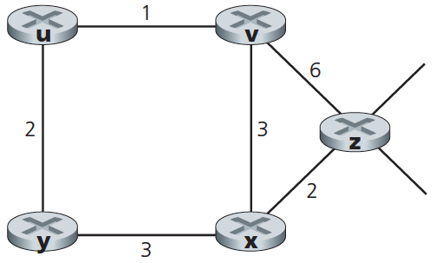

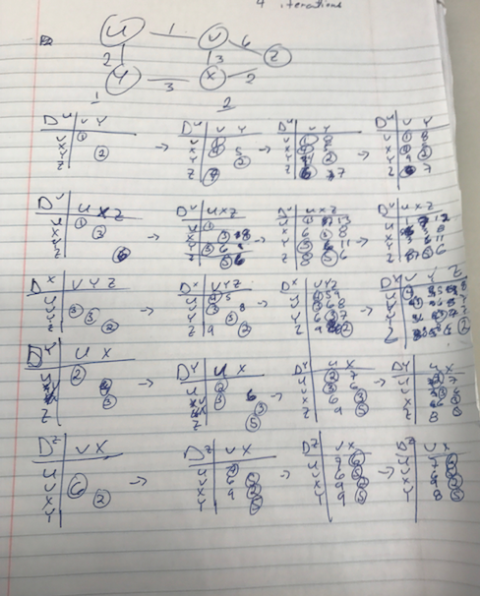

2. Consider a generic network topology. (That is, assume some random network topology.) Assume distance vector routing using a synchronous version of the Bellman-Ford algorithm as in the previous problem.

Assuming that the distance vector algorithm begins with each node knowing only the costs to its immediate neighbors, what is the maximum number of iterations required before all nodes converge on a set of minimum cost routes and the nodes stop sending out routing messages? Justify your answer. (Hint: See if you can relate the number of iterations required to some measure of the network’s topology graph.)