**Question set 1**

1. Inheritance. The species object expands or acquires from the class objects.
2. Aggregation. The species object is a field inside the example which implies no inheritance but a relationship.
3. Species

-speciesName:String

+Species(s:String, g:String)

+setSpeciesName(s:String):void

+getSpeciesName():String

+toString():String

+equals(s:Species):boolean

1. -Code maintenance : all species have the same fields and if they are updated(genus), they all will be updated.

-Polymorphism : All species objects can be treated as genus objects.

1. (i) Species extends genus, so species can call methods from genus. Species’s toString() method is overriding genus’s toString() method.

(ii) Polymorphism or overriding

**Question set 2**

1. A coding practice that hides details of methods from the caller. Keep different classes from doing anything to a class' fields by setting them to private and giving getter or setter methods to those fields.
2. - data security/ validation: using setter methods, one can keep invalid data/information from being allocated to a variable.

- is being able to change a method's code without having to rewrite it everywhere because the caller depends on the return values.

-Maintenance can be done at ease.

1. getName(), getCage(), getTOA()
2. name, cageNumber, toa
3. A screenshot of a cell phone

   Description automatically generated
4. -Advantage is having specimen inherit from species would be being able to store all the data in a single collection, so they can be easily examined/ stored.

-Disadvantage would be losing a certain amount of organizational structure and a potential data duplication.

**Question set 3**

1. Add private String markings = “None”; in specimen class. Add a getter and a setter for the markings. Also add the “marking” in the toString() method.

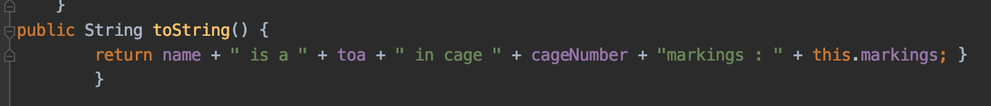

1. I used array list because it is easier and im already aware of the array list method.

1. First. Define and create a list for the species with the length of the list. List = listSpecies[20] and add Boolean new_species = true.

For (each element in animals) {

For (each element in listSpecies) {

If (animal[i] = = listSpecies[J]) {

New_species = false } end if end loop

If new_species = true then listSpecies[] append the new animal. End if end loop

print out list

**Question set 4**

1. No features of abstract in there. Actions or methods are standard.
2. **A close up of a street

   Description automatically generated**

1. **A screenshot of a cell phone

   Description automatically generated**