**codeQL dry run test now LOGICs README**

# \*\***codeQL dry run test now LOGICs README**\*\* @main=”””codeQL___dummytestV0OSSModelpipeEQ___dryrunsonlyTESTINGNOWONLYPUSHCODEUPDATENOW___nothingelse

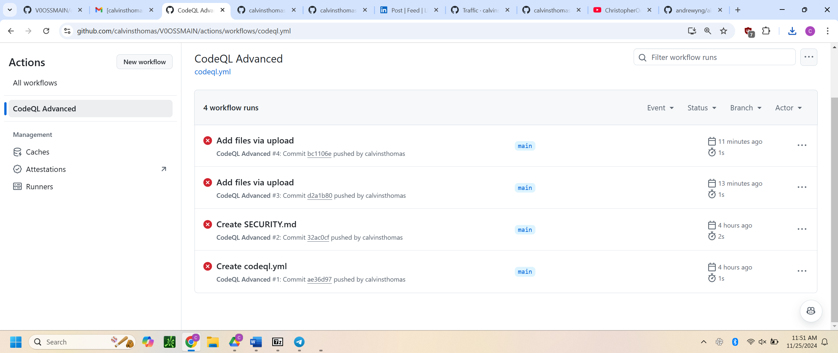”””

## main dry runs codeQL (knowing empty thrown errs. (errors) will be caught in an isolated bubble env. (my PC/sys.s/dotATRISKTESTNOWPUSHUPDATENOWV0OSSMODELRISKPARAMSTRIGGERED)



DISCLAIMER: YOUR CONFEDERATEFLAGGing__DRYRUNS_TESTNOW_PUSH_UPDATE_NOW_NOTHING_ELSE_MALLORYGOOD_BOILERPLATEPUSHUPDATE_CODEQL_NO_DESCdot___PROMPT (>>GOOD<< HERE NOTHINGELSEOFFER)