Steps taken to prepare the data to be visualized in Excel:

1) First SQL query is used to confirm that Seattle is on the list of cities:

SELECT * FROM city_list

WHERE city=‘Seattle’;

2) Second SQL query is used to select the temperature/year data for Seattle:

SELECT * FROM city_data

WHERE city=‘Seattle’;

3) Downloaded and saved it as SEATTLE.csv

4) Third SQL query is used to select matching start/end year range data Globally:

SELECT * FROM global_data

WHERE year BETWEEN 1828 AND 2013;

5) Downloaded and saved it as WORLD.csv

6) Open either file in Excel to create visuals of the 5 year moving averages.

7) After opening the Seattle and/or GLOBAL files remove all columns except for “year” and “avg_temp”.

8) Then in C1 add title: “5 year move average”.

9) In C6 type: “=(B2+B3+B4+B5+B6)/5” this will then produce the 1st result of the 5 year moving average.

10) With C6 selected click (and hold) the small box on the bottom right corner and then drag it down to the last row of data, in my case C187.

11) Select all the data points including the column titles and then create a Line Chart.

12) Once you make the visual the size you want along with any other formatting changes like axis labels then you right click the visual on the white space and save the visual as an image.

13) Following this formula (steps 8-12) you can create another 5 year moving average visual for the WORLD file.

Some important considerations for the visualizations include: axis labels, good start and end year ranges (x-axis), good choice for the yearly increments (x-axis), I decided to have both the average temperatures and the moving averages for each visual because it allows you to see some interesting similarities and contrasts in the data.

Seattle temperature in Celsius from years 1828-2013

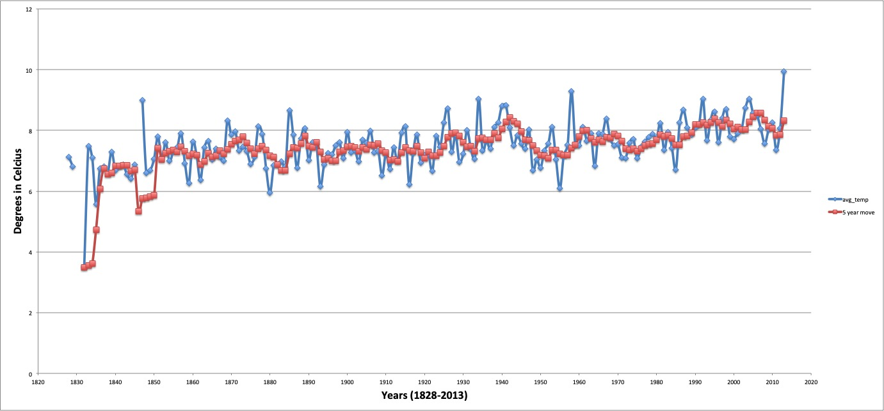

Global temperature in Celsius from years 1828-2013

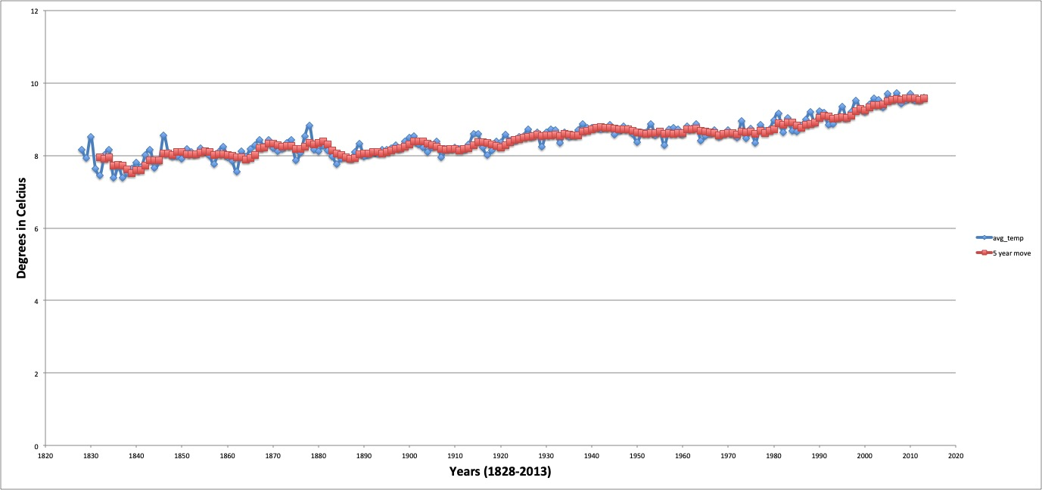

Some observations of similarities and differences in the trends are:

1. The global data trend for average temperature and the moving average are both smoother lines than the lines for the Seattle visual. I would have thought the global data would have much more variance or wider ranges than what is shown.
2. The global data trend lines show a much clearer picture of an increasing temperature (overall) than that of the Seattle data trend lines (though it is still also upward trending).
3. The peaks and valleys of the Seattle moving average line follow the Seattle average temperature line much more closely than the global moving average line follows the global average temperature line.
4. I think part of the issue for the variance/wide range of data points in the Seattle lines is due to some missing data points. Given the moving average incorporates five sequential points of data throughout the overall table of data, even one or two missing data points will significantly decrease the overall average. As is seen at the start of the line(s) for the Seattle visual.