1) Using the matrix calculation of the last slide titled "Inventory calculation" from ‘Full Life Cycle Inventory: Car case study part A’, use the second row of the matrix to calculate the contribution of each intermediary flow to the total CO2 emissions and select the two correct answers
(Hint look at the calculation we did with the first row for energy, and repeat this with the second row for CO2, keeping the contribution of each intermediary flow separate)

2) Then perform the sensitivity study for cumulative CO2 emitted for steel as a function of the travelled distance, adding a steel line on the figure below using the line that you can move manually on the figure
(Hint: sum up all the manufacturing CO2 emissions (all but the gasoline and the disposal), which will give you the intercept at 0km, then add the gasoline contribution for 200,000 km that will provide you the emissions at 200,000 km).

In comparison for the aluminum scenario, the CO2 emissions after manufacturing amount to 49.5 kgCO2, the disposal to 0.076 kgCO2 and the total with gasoline to 134.7 kgCO2

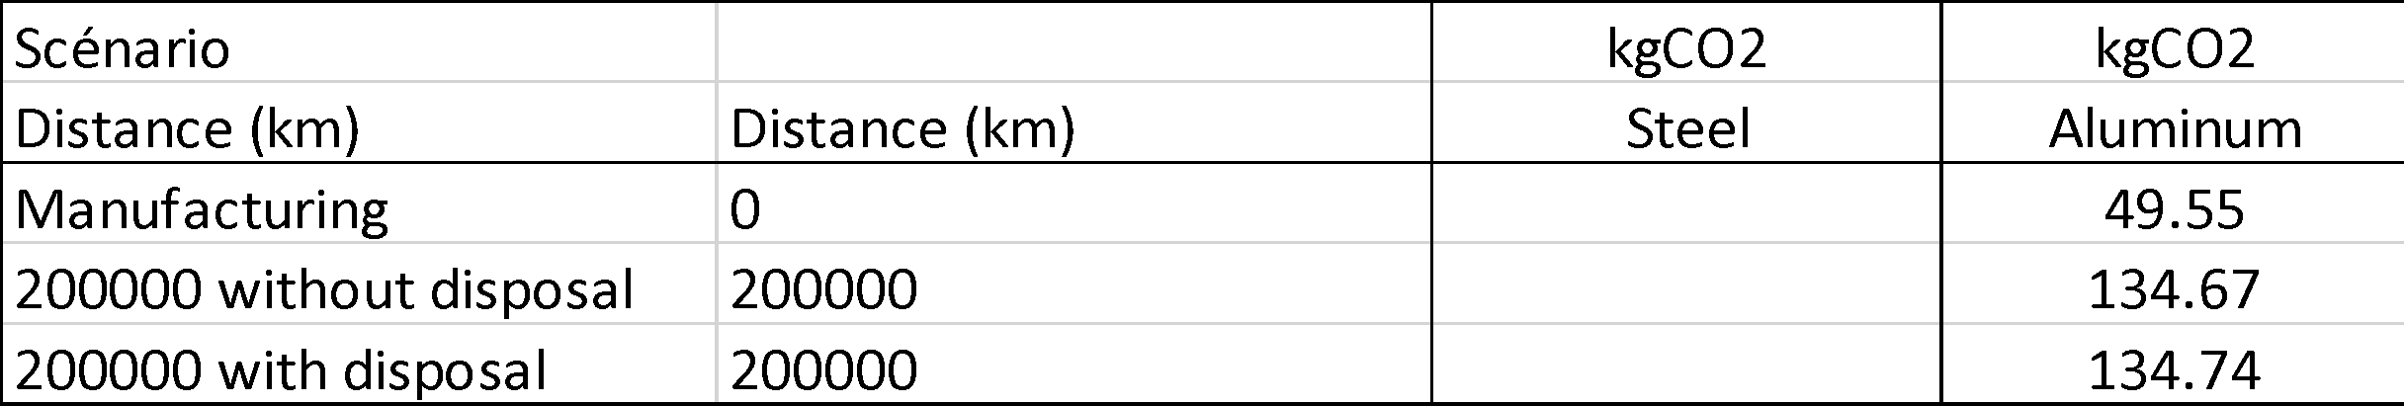

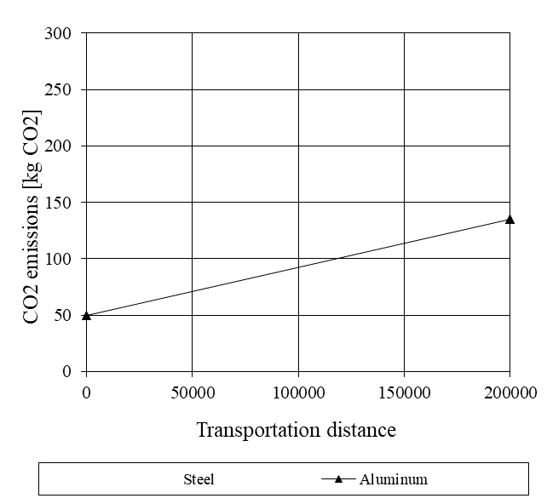

3) Compare the steel line with the aluminum scenario and determine graphically the break-even distance at which the virgin aluminum scenario starts to emit less CO2 than the steel scenario.

4) Answer the following question

The break even distance is between ….. and………. km

