A life cycle comparison of conventional stove top and liquid propane gas grill

Authors

Introduction and goal definition
It is well established that the environmental and human health impacts of cooking with solid fuels, such as charcoal, are substantially greater than cooking with propane or natural gas fuels 1. However, it is less understood how the impacts of the latter two cooking methods compare. The purpose of this case study is to compare the environmental and human health impacts of cooking on a liquid propane gas (LPG) outdoor grill versus an indoor natural gas stovetop. This case study will specifically examine the main processes contributing to the energy consumed and CO2 emitted when using the two cooking methods mentioned above, and then expand the analysis to consider broader impact categories.

Methods, data, and inventory
Data sources. Based on Johnson et al., 2009, we defined our functional unit as 1.5 kg of food thoroughly cooked. From this article, we also obtained data on materials for the LPG grill as well as fuel consumption with 95% confidence limits. We obtained data on fuel efficiencies for the LPG grill and gas stovetop, and materials data for the stovetop, from Jungbluth et al., 1997 2. We matched materials data from the literature to life cycle data from Ecoinvent 3.0, and using SimaPro we conducted life cycle analyses for both scenarios. To account for combustion-related emissions, we obtained emission factor data for both fuel types from Zhang et al., 1999 3.
Sensitivity study. Fuel consumption is a key parameter in this study. However, due to a data constraint, we derived fuel consumption for the gas stovetop as a function of LPG grill fuel consumption, i.e., scaling it by the ratio of fuel-efficiency- adjusted energy densities for both fuel types. For a sensitivity study, we calculated energy consumption (MJ) for the gas stovetop by varying the estimated LPG fuel consumption, and applying a high efficiency LPG grill at 0.40 MJ_useful/MJ_final as a third scenario for comparison.
Use-phase impact assessment. We conducted a screening-level assessment of the human health impact (DALY) during use for the two main scenarios, focusing on fine particulate matter (PM_{2.5}) exposures. For this, we utilized a PM_{2.5} Characterization Model developed by Fantke et al. 4. Using data for the region of Detroit--Ann Arbor--Flint, MI CMSA (United States), we estimated use-phase health impact as the product of a mass emission (kg_emitted), an intake fraction (kg_in/kg_emitted), and a non-linear, epidemiologic- based health effect factor (YLL/kg_in). Lastly, we converted YLL to DALY using a 0.82 YLL/DALY factor derived from Gronlund et al., 2015 5.

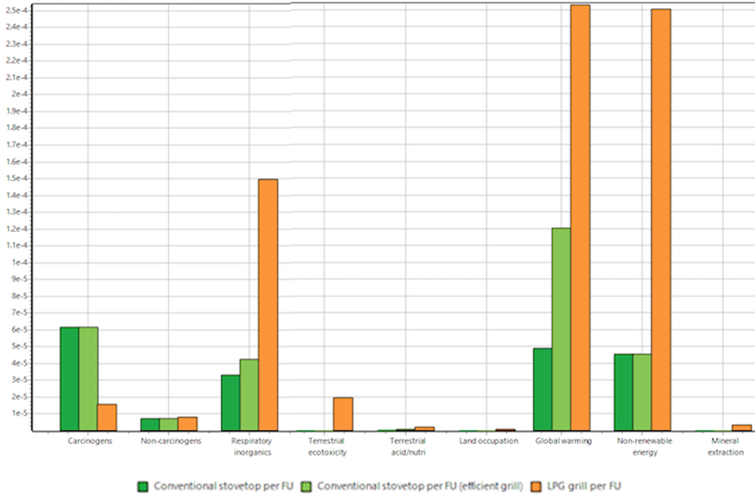
Results, impact assessment, and discussion (maximum: 400 words)
Reference flows. Considering the number of uses per lifetime, the main reference flows per functional unit for the LPG grill are as follows: 1/150th of a grill, 1/425th of a LPG cylinder, 0.5 kg fuel per functional unit. For the stovetop scenario: 1/285th of a stovetop allocated to 1 of 4 burners, 1/750th of a skillet, and and 0.10 kg fuel.
Relative impacts. For the LPG grill, fuel use is the dominant contributor to total energy use (73%) and total CO2 emissions (77%). Steel supply and manufacturing contribute to 17% of total energy use and 14% of total CO2 emissions. Total energy use for the grill is 33.3 MJ/FU (95% CI 25.3 to 40.7), and total CO2 emission is 2.3 kg (95% CI 1.7 to 2.8). Similarly, for the gas stovetop, fuel consumption accounts for the majority of energy use and CO2 emissions, with 6.17 MJ/FU (95% CI 4.42 to 7.90) and 0.37 kgCO2 (95% CI 0.25 to 0.47), respectively.
Figure 1. Simapro Normalized impact comparison for 3 scenarios

The SimaPro normalized impact assessment, shown in Figure 1, reveals consistently higher far-field impacts for the LPG grill, except for carcinogens for which the stovetop scenario is more impactful, and non-carcinogens for which both scenarios are similar. The sensitivity study reveals that the “break-even” point in terms of energy use would occur at a LPG fuel efficiency of 0.64, i.e., 0.04 in excess of the natural gas fuel efficiency. This value does not seem feasible in light of a highest observed LPG efficiency of 0.40 used as a third sensitivity scenario in Figure 1. Assuming this higher efficency grill, the far-field impacts of of the natural gas stovetop are greater for the respiratory inorganics and global warming impact categories.
Figure 2 displays, for each main scenario, the near-field human health impacts associated with fuel combustion and PM_{2.5} emissions during use phase. Due to a higher indoor intake fraction, the natural gas stovetop has at least 3 orders of magnitude greater impact (2.10E+01 μDALY/FU) than the outdoor LPG grill, and the difference is pronounced especially in a rural environment (5.44E-03 vs. 7.77E-02 μDALY/FU).

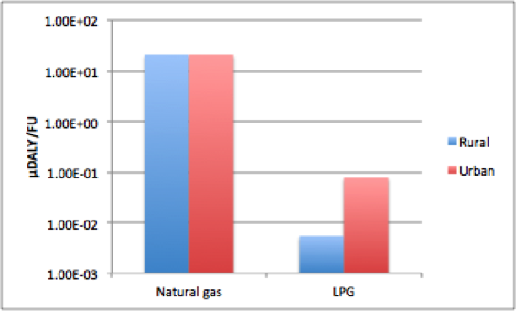
Conclusions and recommendations
The results of our LCA case study demonstrate that the LPG grill scenario has substantially greater impacts for endpoints of global warming, non-renewable energy use, terrestrial ecotoxicity, and far-field exposures to respiratory inorganics, even with higher fuel efficiency. The gas stovetop, however, contributes more to carcinogen-related impacts. Moreover, use-phase health impacts of the gas stovetop are at least 3 orders of magnitude greater than for the LPG grill due to a higher indoor intake fraction. This underscores the importance of proper ventilation during use of the stovetop. Further research could elucidate the relative tradeoffs between the two cooking methods in order to determine the optimal cooking method in terms of environmental quality and human health.
Figure 2. Use-phase human health impacts of natural gas stovetop and LPG grill for rural and urban environments.

References
- Johnson, E. Charcoal versus LPG grilling: A carbon-footprint comparison. Environmental Impact Assessment Review 29 (2009) 370–378.
- Jungbluth, Niels. Life-cycle-assessment for stoves and ovens. ETH, Eidgenössische Technische Hochschule Zürich, 1997.
- Zhang, J., et al. "Greenhouse gases and other airborne pollutants from household stoves in China: a database for emission factors." Atmospheric Environment 34.26 (2000): 4537-4549.
- Fantke, P. et al., PM2.5 characterization model, model for characterizing indoor and outdoor exposures and health impacts from indoor and outdoor PM2.5 sources
- Gronlund, Carina J., et al. "Characterizing the burden of disease of particulate matter for life cycle impact assessment." Air Quality, Atmosphere & Health 8.1 (2015): 29-46.

