Reliability and Safety Analysis (Spring 2020)

Team:8

Project: Audio Beamer

Creation Date: 4/6/20

Last Modified: 4/6/20

Author: Aditya Biala Email: abiala@purdue.edu

Assignment Evaluation:

|  |  |  |  |  |
| --- | --- | --- | --- | --- |
| **Item** | **Score (0-5)** | **Weight** | **Points** | **Notes** |
| **Assignment-Specific Items** | | | | |
| **Reliability Analysis** |  | x2 |  |  |
| **MTTF Tables** |  | x3 |  |  |
| **FMECA Analysis** |  | x2 |  |  |
| **Schematic of Functional Blocks (Appendix A)** |  | x2 |  |  |
| **FMECA Worksheet (Appendix B)** |  | x3 |  |  |
| **Writing-Specific Items** | | | | |
| **Spelling and Grammar** |  | x2 |  |  |
| **Formatting and Citations** |  | x1 |  |  |
| **Figures and Graphs** |  | x2 |  |  |
| **Technical Writing Style** |  | x3 |  |  |
| **Total Score** |  | | |  |

5: Excellent 4: Good 3: Acceptable 2: Poor 1: Very Poor 0: Not attempted

Comments:

*Comments from the grader will be inserted here*

1. Reliability Analysis

The components in this project that are most likely to fail are the MSP430FR5994 Microcontroller, the AP2127K LDO, & PCM3002 Audio Codec.

The AP2127K LDO is more likely to fail because of its dynamic heating possibilities. The LDO junction temperature can vary on its input voltage which can range from 4.2V-3.4V from the Li-ion cell or 5V from the USB input.

The PCM3002 Audio Codec is responsible for all audio analog-digital conversions and is interfaced with the MCU, an Op-amp & external speakers. It likely to fail because of its complexity.

The MSP320FR5994 has a higher probability of failure mainly due to it being the most complex subsystem on the project.

Assumptions:

MIL-HDBK-217f was referred to model all Failure per million hours & MTTF calculations.

The following formulas were used:

λP = (C1 πT + C2 πE) πQ* πL

MTTF = 106 / (24 * 365 * λP) years

Additionally, some parameters in the failure model were assumed to be constant among all components on the system.

Environmental factor is assumed to be 4.0 as we consider our system to be a mobile device

Quality factor is assumed to be 10 which is a lenient estimate for modern consumer products

Learning factor is assumed to be 1 since all of our components have been on the market for at least 2 years.

**MSP430FR5994 - Microcontroller**

|  |  |  |  |
| --- | --- | --- | --- |
| Parameter name | Description | Value | *Comments* |
| C1 | Die complexity | 0.28 | *Based on MIL-HDBK-217F for 16 bit MCUs* |
| πT | Temperature coeff. | *0.98* | Assuming maximum operating temperature of 85C |
| C2 | Package failure rate | *0.032* | 80 pins on MCU |
| πE | Environmental factor | *4.0* | *Handbook value for mobile device* |
| πQ | Quality factor | *10* | *Commercial part* |
| πL | Learning factor | *1* | *MCU has been in production for more than 2 years* |
| Entire design: |  |  |  |
| λP | Failure per million hours | *4.028* |  |
| MTTF | *Mean Time To Failure* | *245280 hours* | *Approx. 28 years to failure* |

**AP2127K-3.3 - LDO**

|  |  |  |  |
| --- | --- | --- | --- |
| Parameter name | Description | Value | *Comments* |
| C1 | Die complexity | 0.02 | *Based on MIL-HDBK-217F for 100-300 bipolar transistors* |
| πT | Temperature coeff. | *5.6* | Assuming maximum operating temperature of 150C |
| C2 | Package failure rate | *0.016* | 5 pins on IC |
| πE | Environmental factor | *4.0* | *Handbook value for mobile device* |
| πQ | Quality factor | *10* | *Commercial part* |
| πL | Learning factor | *1* | *MCU has been in production for more than 2 years* |
| Entire design: |  |  |  |
| λP | Failure per million hours | *1.76* |  |
| MTTF | *Mean Time To Failure* | *568181 hours* | *Approx. 64.8 years to failure* |

**PCM3002 – Audio Codec**

|  |  |  |  |
| --- | --- | --- | --- |
| Parameter name | Description | Value | *Comments* |
| C1 | Die complexity | 0.08 | *Based on MIL-HDBK-217F for CMOS based IC with 3001-10,000 transistors* |
| πT | Temperature coeff. | *0.98* | Assuming maximum operating temperature of 85C |
| C2 | Package failure rate | *0.087* | 24 pins on IC |
| πE | Environmental factor | *4.0* | *Handbook value for mobile device* |
| πQ | Quality factor | *10* | *Commercial part* |
| πL | Learning factor | *1* | *MCU has been in production for more than 2 years* |
| Entire design: |  |  |  |
| λP | Failure per million hours | *4.264* |  |
| MTTF | *Mean Time To Failure* | *234521 hours* | *Approx. 26.8 years to failure* |

**Summary:**

According to my calculations, the system seems to be reliable in the correct operating conditons. Therefore, this means that the device has a decent lifespan. The failure rate is acceptable for a consumer system.

The product’s reliabliity can be improved in terms of thermal dissipation for the LDO & audio codec which can run hot. While it is possible to improve reliability, its cost & effort is not justified in making a product last more than at least 26.8 years.

1. Failure Mode, Effects, and Criticality Analysis (FMECA)

Our project can be broken down into the following functional blocks:

1. Power system
2. Bluetooth communication
3. Audio System
4. Microcontroller

The power system is the only system whose failure could be high critical. The power system is responsible for supplying 3.3V, 300mA to the main system while maintaining Li-ion charge control and supplying battery capacity information to the MCU. There is a PMOS that controls whether USB or the Li-ion battery supplies power to the system. A failure of this PMOS would allow the system to draw current from the battery while it is being charged. This can cause unpredictable battery behavior which can cause a fire from the Li-ion cell which is high critical failure. Otherwise a failure in this system is a medium critical failure. A user can detect a failure when the system no longer powers on.

The Bluetooth communication system is responsible for receiving user customizable parameters from a phone app and pass them to the MCU for the DSP. The RN4020 has good reliability and is widely used in the industry. Shorting of bypass capacitors will effectively short PWR & GND which will damage the Bluetooth IC. A failure of this system is considered low critical. The overall system will work, but the user will not be able to change audio processing parameters, and most likely will not be able to pair the smartphone with our device.

The audio system is responsible for (pre)-amplification of the input signal, audio output & A/D, D/A conversation via an audio codec. Causes for failure in this system include plugging in the wrong audio input/output which can cause the audio codec to sink a large amount of current and damage it. Additionally, a failure of bypass capacitors will short the audio codec or the op amp effectively damaging it. A failure in this system is low critical. The user will be able to identify this failure easily because of the lack of audio output.

The microcontroller may behave unexpectedly when the bypass capacitors get shorted causing overheating. A microcontroller failure would make the entire system unusable and would be considered medium criticality due to unpredictable behavior that could cause a large amount of current to be drawn from the Li-ion cell.

2.1 Levels of Criticality

Low critical failure means that it is a negligible failure. This means that the failure mode is not harmful to the user or destructive of the rest of the board. Low critical failures have a failure rate of 10-6.

Medium critical failures are failures that cause damage the system and may present a potential harm to the user. Medium critical failures are aimed to have a failure rate of 10-7 or less.

‘High’ criticality is reserved for failures that have a high probability of potential harm to the user such as burns. These failures are very unlikely to happen and have a failure rate of 10-10.

3.0 Sources Cited:

1. “MSP430FR5994,” 2020. [Online]. Available: <http://www.ti.com/lit/ds/symlink/msp430fr5994.pdf> [Accessed April 10, 2020].
2. "PCM3002, Burr Brown,” 2020. [Online]. Available: <http://www.ti.com/lit/ds/symlink/pcm3002.pdf> [Accessed April 10, 2020].
3. “AP2127K,” 2020. [Online]. Available: <https://www.diodes.com/assets/Datasheets/AP2127.pdf> [Accessed April 10, 2020].
4. “Military Handbook Reliability Prediction of Electronic Equipment” Department of Defense. Washington DC. MIL-HDBK-217F, Dec. 2, 1991.

Appendix A: Schematic Functional Blocks

1. Power System

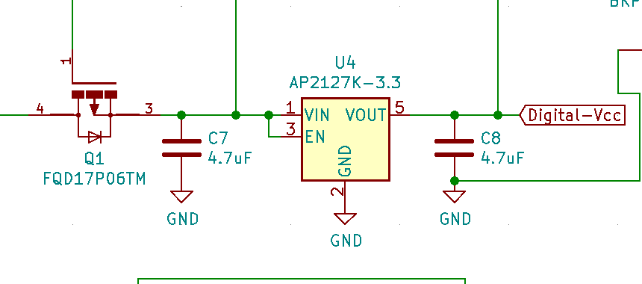

Figure 1: Low Dropout Regulator circuit

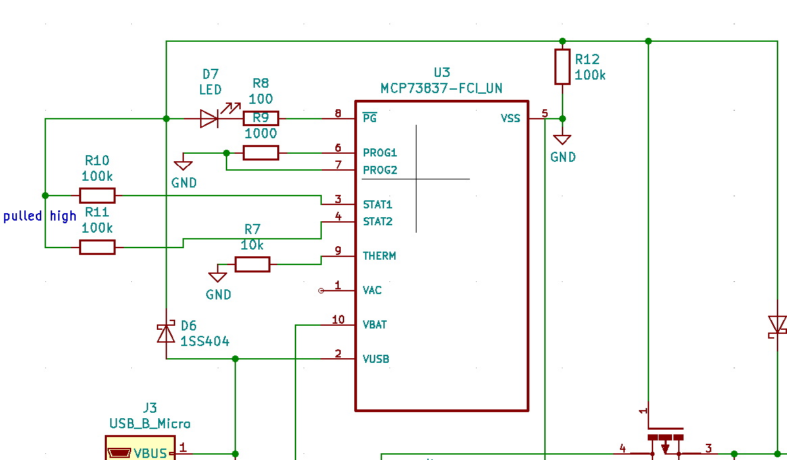

Figure 2: Battery charging circuit

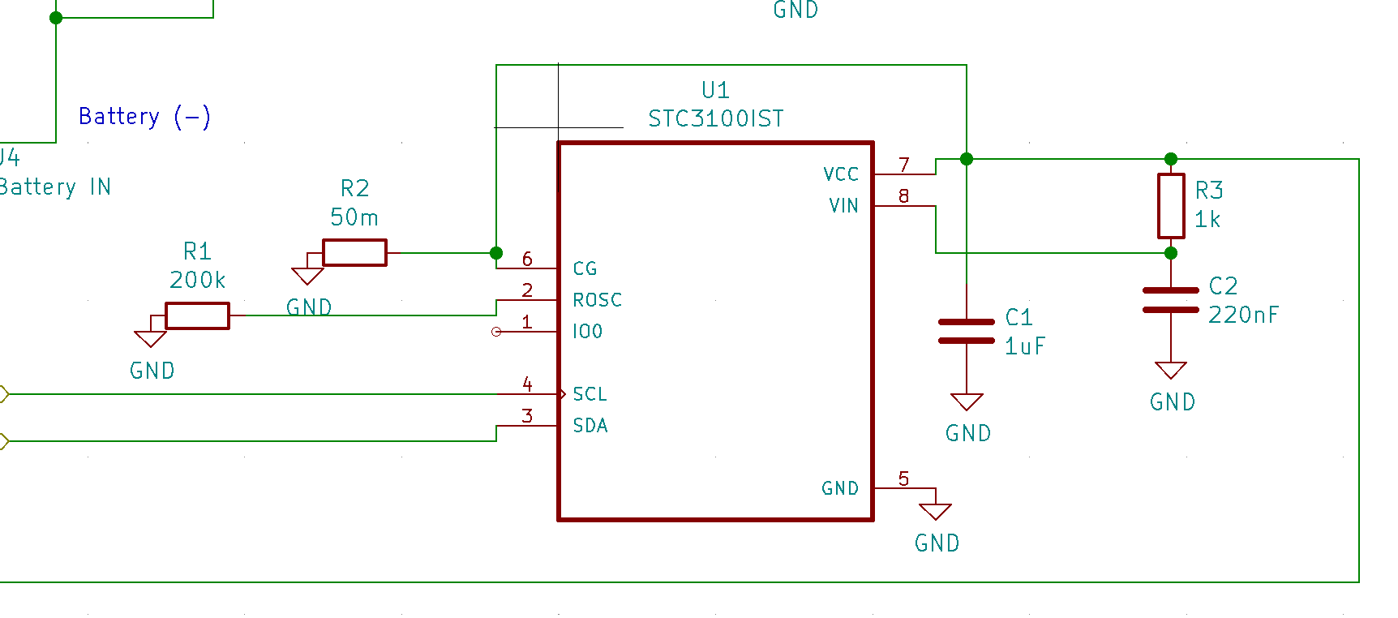

Figure 3: PMIC to calculate battery capacity

1. Audio System

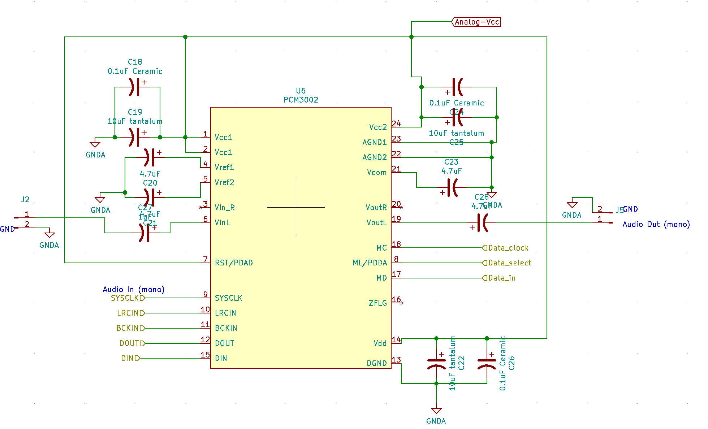

Figure 4: Audio Codec circuit

1. Bluetooth System

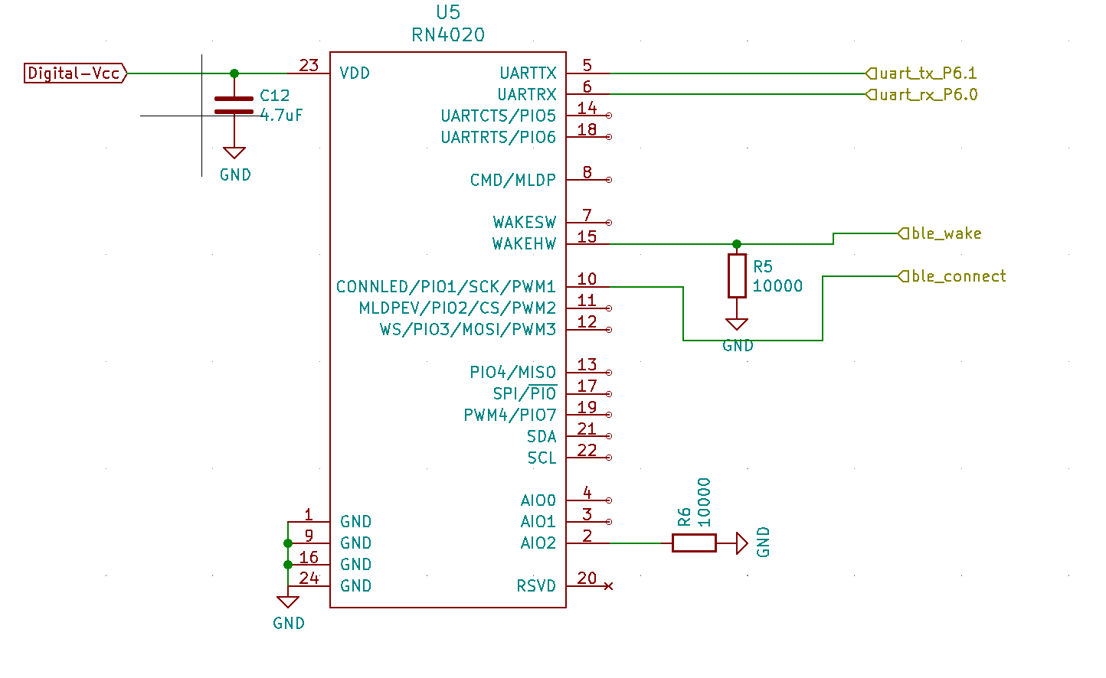

Figure 5: RN4020 BLE transceiver circuit

1. Microcontroller

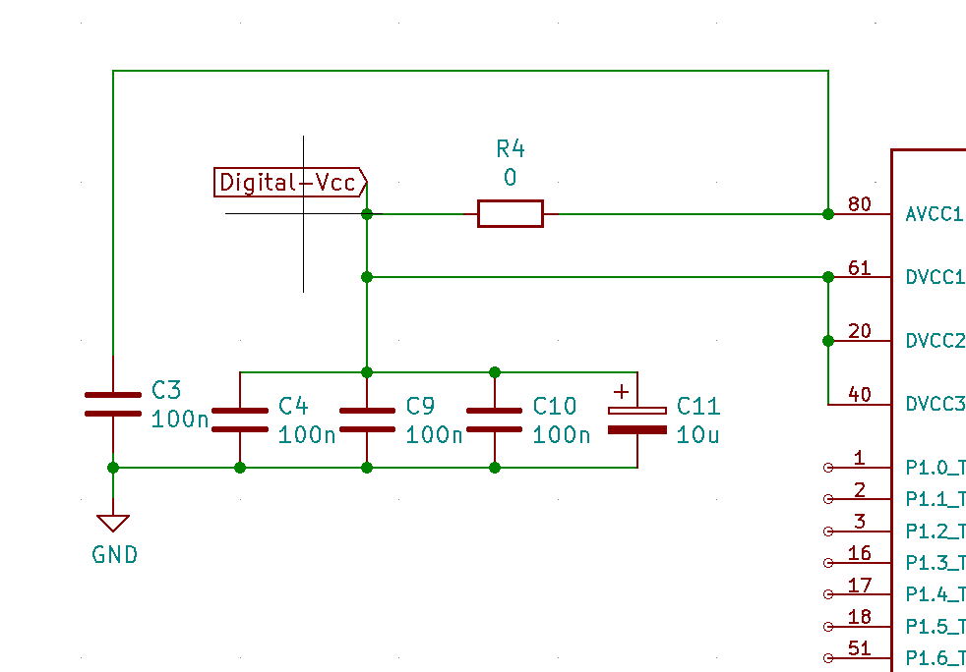

Figure 6: Microcontroller bypass capacitors

Appendix B: FMECA Worksheet

1. Power System

|  |  |  |  |  |  |  |
| --- | --- | --- | --- | --- | --- | --- |
| **Failure No.** | **Failure Mode** | **Possible Causes** | **Failure Effects** | **Method of Detection** | **Criticality** | **Remarks** |
| A1 | Unreliable battery performance | PMOS switch failure | Battery life degradation due to simultaneous charge & discharge | Voltage drop across PMOS using probe | High | May cause battery fire |
| A2 | No LDO output | Shorted bypass capacitor, LDO failure,  Completely depleted Li-ion cell | Board does not power up | Observation | Medium | May damage other components on system |
| A3 | Voltage greater than 3.3V on LDO | V > 5V on USB input | Schottky diode & LDO failure | Observation | Low | Will only damage schottky diodes before damaging the rest of the board |

It is not necessary to calculate the probability of each failure mode. These numbers would usually be taken from the reliability analysis, but since you are not performing a complete analysis, they do not need to be included in your FMECA worksheet.

1. Audio System

|  |  |  |  |  |  |  |
| --- | --- | --- | --- | --- | --- | --- |
| **Failure No.** | **Failure Mode** | **Possible Causes** | **Failure Effects** | **Method of Detection** | **Criticality** | **Remarks** |
| B1 | No audio output | Bypass capacitor short | Audio codec/amplifier failure | Observation | Low | N/A |
| B2 | No Audio Output | Output speaker drawing too much current, or wrong audio input | Audio Codec Failure | Observation | Low | N/A |

1. Bluetooth System

|  |  |  |  |  |  |  |
| --- | --- | --- | --- | --- | --- | --- |
| **Failure No.** | **Failure Mode** | **Possible Causes** | **Failure Effects** | **Method of Detection** | **Criticality** | **Remarks** |
| B1 | Unable to pair/detect device | Bypass capacitor short, BT antenna damage | BT IC failure | Observation | Low | N/A |

1. Microcontroller

|  |  |  |  |  |  |  |
| --- | --- | --- | --- | --- | --- | --- |
| **Failure No.** | **Failure Mode** | **Possible Causes** | **Failure Effects** | **Method of Detection** | **Criticality** | **Remarks** |
| B1 | Unresponsive board | Bypass capacitor short, power supply issues, physical board damage | Unusable device | Observation | Low | N/A |