User Manual

Year: 2020

Semester: Spring

Team:8

Project: AudioBeamer

Creation Date: 4/28/20

Last Modified: 5/1/20

Author: Aditya Thagarthi Arun Email: athagart@purdue.edu

Assignment Evaluation:

|  |  |  |  |  |
| --- | --- | --- | --- | --- |
| **Item** | **Score (0-5)** | **Weight** | **Points** | **Notes** |
| **Assignment-Specific Items** | | | | |
| **Product Description** |  | x1 |  |  |
| **Product Illustration** |  | x2 |  |  |
| **Setup Instructions** |  | x3 |  |  |
| **Usage Instructions** |  | x3 |  |  |
| **Troubleshooting Instructions** |  | x3 |  |  |
| **Writing-Specific Items** | | | | |
| **Spelling and Grammar** |  | x2 |  |  |
| **Formatting and Citations** |  | x1 |  |  |
| **Figures and Graphs** |  | x2 |  |  |
| **Technical Writing Style** |  | x3 |  |  |
| **Total Score** |  | | |  |

5: Excellent 4: Good 3: Acceptable 2: Poor 1: Very Poor 0: Not attempted

Comments:

*Comments from the grader will be inserted here.*

1. Product Description

With the Audiobeamer we aim to make the joy of playing an electric guitar a convenient one. With a seamless mobile application, you can control the device to change how your electric guitar sounds by setting desired equalization values and adding effects such as distortion and reverb.

The product box includes:

-Charging adapter

-Cable for the charger

-User manual

-Audiobeamer device

1. Product Illustrations

*Figure 1 – Product Illustration*

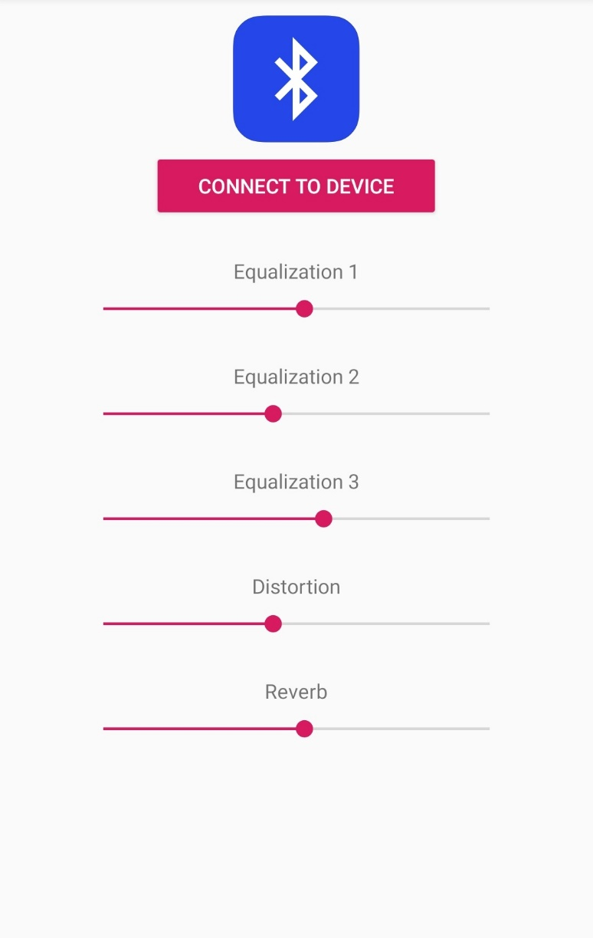

*Figure 2 - Android Application*

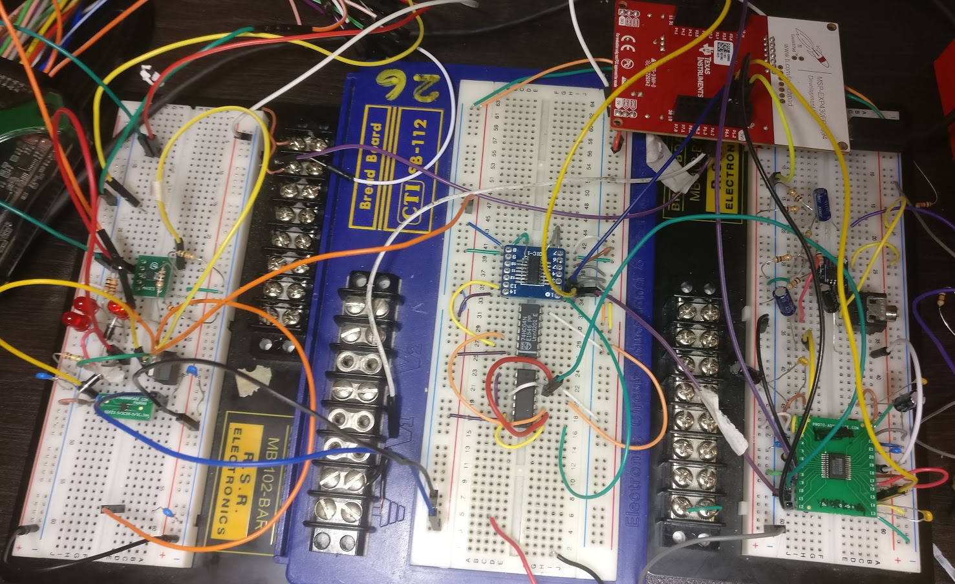

*Figure 3 – Breadboard Prototype*

1. Setup Instructions
2. Device start up: Power on the device and charge the device if the red led is on. Follow the instructions below to connect the device to your android device. Refer to figure 1 from the product illustration section for a visual.
3. Connecting the device: The device is controlled wirelessly via a mobile application(android). Open the application and “allow” permission for connecting to Bluetooth. Click the “connect to device” button, this will automatically connect to a nearby Audiobeamer device. After the “successfully connected” dialog comes on screen you can set the slider value according to your needs, this information will be automatically sent to the device to alter the sound. Figure 2 from the product illustrations section will provide a better idea of what the application looks like.
4. Usage Instructions
5. Storage: When not in use, store in a cool dry place. And make sure to keep the device relatively clean. The device is not waterproof, or spill proof so please beware of that.
6. Charging: A red light led will appear when the device battery is low on power. Only charge with the provided charging cable (micro usb) and adapter to avoid damage to the device electronics. It is completely ok to use the device while it is being charged.
7. Portability: The AudioBeamer is not meant to be ultra-portable but moving it around is fine.
8. **Connecting to the guitar**: Connect the Audiobeamer to a guitar via a quarter inch jack and control it wirelessly from a phone with an easy to use application made specifically for this device.
9. Troubleshooting Instructions

|  |  |
| --- | --- |
| Problem | Possible solution |
| Bluetooth not connecting | * Restart the Audiobeamer * Restart the Bluetooth on your mobile device * Try connecting again |
| Device does not connect, and the battery indicator is red | * Charge your device with the cable provided and try turning on the device (the red led will turn of when the battery has gained charge) |

We have a 24/7 professional customer support, feel free to contact us on:

 : +1 8001234567

 : audiobeamer@audio.com

 : www.audiobeamer.com