Mechanical Overview (Spring 2020)

Team: 8

Project: AudioBeamer

Creation Date: 2/12/20

Last Modified: 2/14/20

Author: Carson Tabachka Email: ctabachk@purdue.edu

Assignment Evaluation:

|  |  |  |  |  |
| --- | --- | --- | --- | --- |
| **Item** | **Score (0-5)** | **Weight** | **Points** | **Notes** |
| **Assignment-Specific Items** | | | | |
| **Commercial Packaging Analysis 1** |  | x2 |  |  |
| **Commercial Packaging Analysis 2** |  | x2 |  |  |
| **CAD Model Illustrations** |  | x4 |  |  |
| **Project Packaging Specifications** |  | x2 |  |  |
| **PCB Footprint Layout** |  | x2 |  |  |
| **Writing-Specific Items** | | | | |
| **Spelling and Grammar** |  | x2 |  |  |
| **Formatting and Citations** |  | x1 |  |  |
| **Figures and Graphs** |  | x2 |  |  |
| **Technical Writing Style** |  | x3 |  |  |
| **Total Score** |  | | |  |

5: Excellent 4: Good 3: Acceptable 2: Poor 1: Very Poor 0: Not attempted

Comments:

*Comments from the grader will be inserted here.*

1. Commercial Product Packaging
   1. Product #1

**JUST Mixer Portable Pocket Audio Mixer**

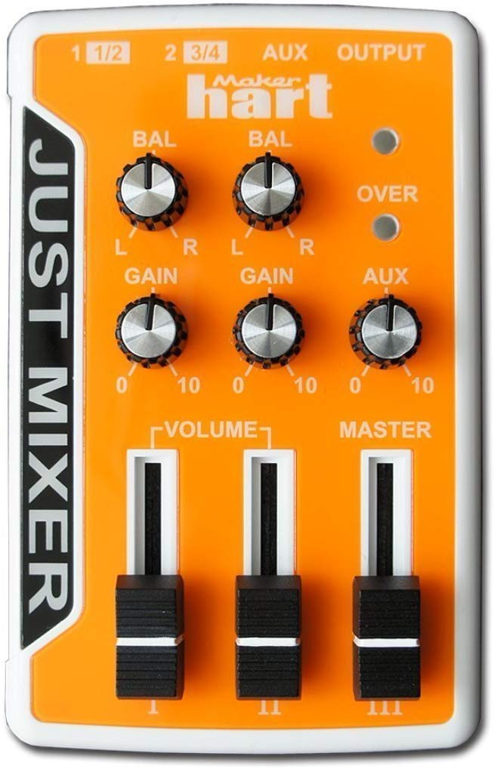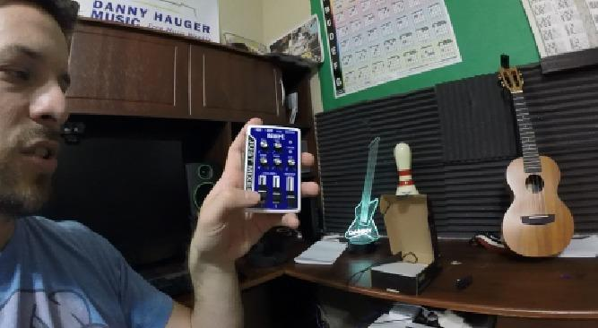

**Product Packaging**

* Stereo 3 in/1 out configuration
* 3 stereo channels
* Up to 5 mono input connections
* LED overload indicator
* Battery or USB powered
  + 2 AAA batteries
  + Lasts about 8 hours
* AUX input
* Power indicator
* Balance, aux, and gain adjustment knobs
* Channel and master volume sliders
* Weight: 4 ounces
* Dimensions: 4.1 x 0.9 x 2.7 inches

Pros:

* Multiple color options
* Very compact
  + Can fit in a pocket
* Communicates with user via LEDs
* All UI elements are appropriately labeled

Cons:

* May be too small for certain users with impaired vision
* Knobs and sliders may be too small for users with movement impairments

**What We Plan to Adapt**

* Descriptive UI elements
  + For our app
* Communication with the user via LEDs

**How It Is Different**

* This product has no Bluetooth capabilities
* It cannot be controlled from an app
* This product does not include any equalization modification
  1. Product #2

# **3 Channel Bluetooth Audio Mixer (**PAD30MXUBT**)**

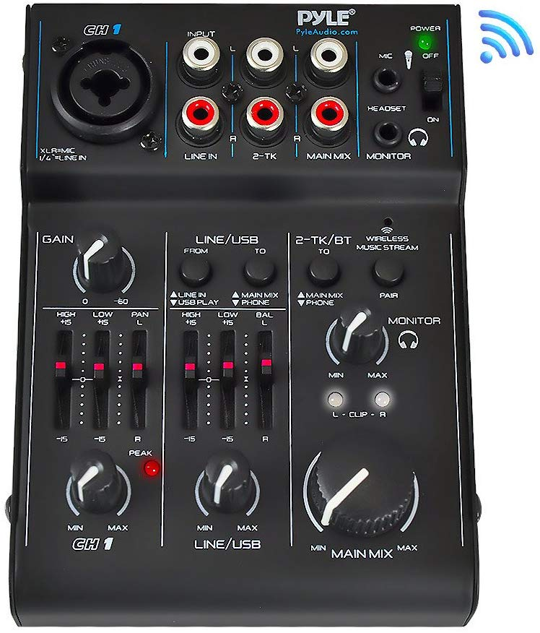

**Product Packaging**

* Dimensions (L x W x H): 4.0'' x 5.3'' x 1.6''
* Weight: 1.4 pounds
* Includes LED light indicators
* Included 3.5 mm jack
* Included I/O for 3 channels

Pros:

* Design looks intuitive and simple
* Can be used by professionals as well
* Controls looks organized
* Included adapter that allows the device to work with AC
* Relatively portable size

Cons:

* This device included several controls and the dimensions might be too small to accommodate that

**What We Plan to Adapt**

* Communication with the user via LEDs

**How It Is Different**

* This product doesn’t seem to have the ability to control the effects through Bluetooth
* It cannot be controlled from an app
* Our device doesn’t have an XLR mic connector

3.0 Sources Cited

1. “3 Channel Bluetooth Audio Mixer - DJ Sound Controller Interface with USB Soundcard for PC Recording, XLR, 3.5mm Microphone Jack, 18V Power, RCA Input/Output for Professional and Beginners – PAD30MXUBT.” [Online]. Available: <https://www.amazon.com/Channel-Bluetooth-Audio-Mixer-Professional/dp/B015NBUVE0/ref=sr_1_6?keywords=audio%2Bequalizer%2Bbattery%2Bpowered&qid=1581528019&s=musical-instruments&sr=1-6&th=1> [Accessed February 12, 2020].
2. “JUST MIXER Audio Mixer - Battery/USB Powered Portable Pocket Audio Mixer w/ 3 Stereo Channels (3.5mm) Plus On/Off Switch.” [Online]. Available: <https://www.amazon.com/JUST-MIXER-Audio-Mixer-Portable/dp/B01LPT8KQA/ref=sr_1_1?keywords=audio+equalizer+battery+powered&qid=1581528019&s=musical-instruments&sr=1-1> [Accessed February 12, 2020].

Appendix 1: CAD Model Illustrations

*Figure 1: Top-down view*

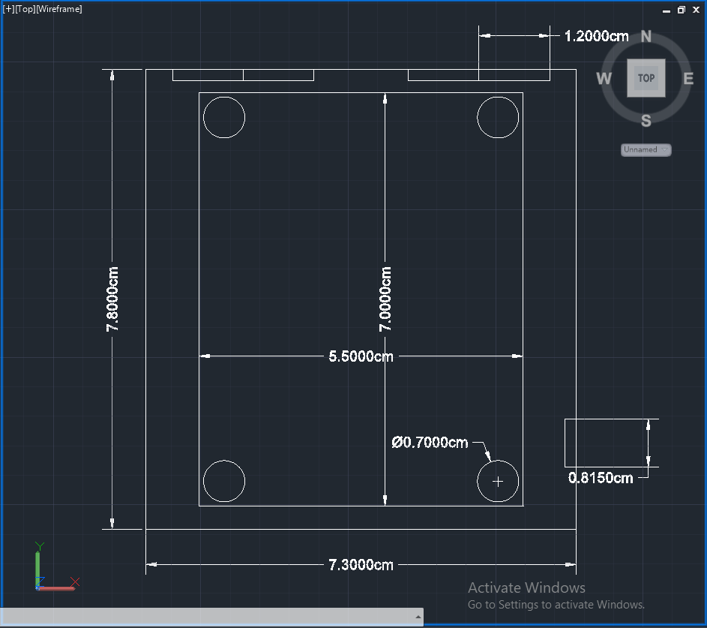

*Figure 2: NE Isometric view*

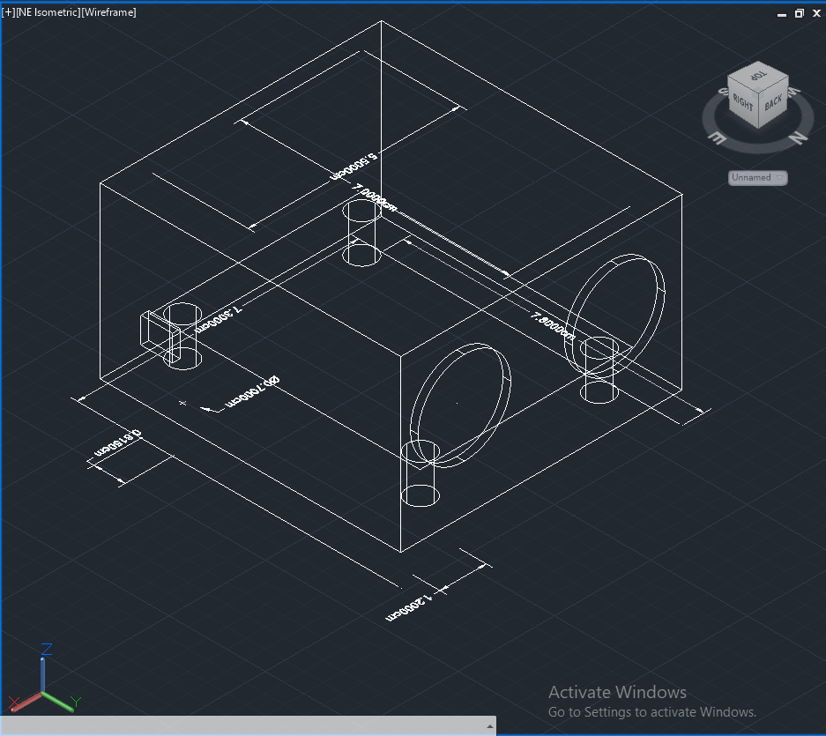

Appendix 2: Project Packaging Specifications

*We are using plastic for the casing.*

|  |  |  |
| --- | --- | --- |
| *Materials* | *Estimated weight* | *Estimated*  *cost* |
| *PCb with*  *Components* | *20g* | *$30* |
| *Casing* | *25g* | *Free with use of Purdue 3D printing resources* |
| *Micro usb cable* | *50g* | *$7* |
| *total* | *95g* | *$37* |

Appendix 3: PCB Footprint Layout

*Estimated dimensions of PCB*

*5.5x7cm*

