fasterhttp
（HTTP解析器）
厉华

版本修订
修订日期 | 修订版本 | 修订人 | 修订内容
2016-07-09 | 1.0.0 | 厉华 | 第一版

目录索引
1 简介 5
2 HTTP协议简述 6
2.1 HTTP报文格式 6
2.1.1 HTTP请求格式 6
2.1.2 HTTP响应格式 7
2.2 HTTP解析器 8
3 使用说明 8
3.1 堵塞模型 8
3.2 非堵塞/多路复用模型 15
3.3 一个基于epoll的小型HTTP服务器 23
4 性能压测 34
4.1 压测方案 34
4.2 压测结果 35
4.3 压测评价 40
1.1 压测代码 41
5 开发参考 48
5.1 HTTP环境 48
5.1.1 环境 48
5.1.2 环境属性 49
5.1.3 全局参数 51
5.2 HTTP通讯与解析 52
5.2.1 HTTP客户端高层API 52
5.2.2 HTTP客户端低层API 53
5.2.3 HTTP客户端低层API（非堵塞版本） 54
5.2.4 HTTP服务端高层API 55
5.2.5 HTTP服务端低层API 55
5.2.6 HTTP服务端低层API（非堵塞版本） 57
5.3 HTTP头与体信息 58
5.3.1 HTTP首行头信息 58
5.3.2 HTTP头选项 61
5.3.3 HTTP体 64
5.4 HTTP缓冲区 65
5.4.1 得到HTTP缓冲区结构 65
5.4.2 得到HTTP缓冲区结构内信息 65
5.4.3 组织HTTP缓冲区数据 66
6 内部实现 69
6.1 客户端API内部调用关系 69
6.2 服务端API内部调用关系 70

简介
fasterhttp是一个C语言编写的高性能、跨平台、流式HTTP协议解析器，实现了通讯数据层和HTTP协议解析层的处理，包括HTTP请求和响应的数据解析和数据组织。
fasterhttp对解析的内容不做提取，仅仅指明内容的位置，所以性能非常快。（参见性能压测章节）
fasterhttp提供了多层次API供应用选择使用，可以直接使用高层函数实现单次HTTP交互，也可以使用低层函数组合出自定义的HTTP解析过程，这在多路复用并发模型中尤其需要。

特性：
支持完整HTTP/1.x协议标准
支持TLS（基于OpenSSL）
支持同步堵塞、非堵塞流式处理（可以和select、epoll配合使用）
可用于HTTP客户端/服务端
内置gzip,deflate压缩解压处理（基于zlib）
不依赖其它第三方库（除OpenSSL和zlib外）
只有一对.h .c，小巧轻量、便于修改、移植和嵌入到项目中
跨平台，支持UNIX、Linux、WINDOWS

解析器在解析HTTP头部时，实现了对下列头部选项的语义检查和处理：
请求方法
HTTP版本
返回的HTTP响应码
Content-Length
Transfer-Encoding: chunked以及TRAILER
Content-Encoding: gzip,deflate和Accept-Encoding: gzip,deflate（可选）
Connection: Keep-Alive和Connection: Close
解析器还指明了其它HTTP头选项和HTTP消息主体位置供直接访问。

HTTP协议简述
HTTP协议基于TCP协议之上。
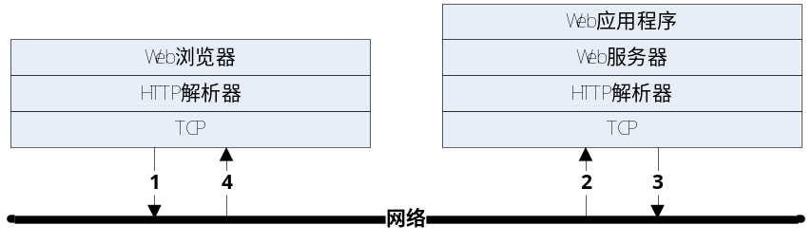
客户端（Web浏览器）创建TCP（也支持UDP，但很少用）、连接上服务端（Web服务器），发送HTTP请求，服务端接收、解析、处理请求，组织、发送HTTP响应回客户端。
如果双方协调保持连接，那么在同一条TCP连接上可迭代多轮HTTP请求和响应。

HTTP报文格式

HTTP请求格式
HTTP请求由请求首行、头选项区域、头体分割空行、体数据（可选）四部分组成。完整格式为：
请求方法 统一资源标识符 HTTP版本号<CR><LF>
头选项名: 头选项值<CR><LF>
头选项2名: 头选项2值<CR><LF>
头选项3名: 头选项3值<CR><LF>
<CR><LF>
体数据
请求首行格式为（三段之间用空格或TAB分隔）：
请求方法 统一资源标识符 HTTP版本号<CR><LF>
“请求方法”常用的有“GET”（不带体数据的请求）、“POST”（带体数据的请求）等，但不绝对
“统一资源标识符”URI即统一资源定位符URL去掉左边的“协议名”、“域名”或“IP”等信息后的右边虚拟根路径部分，如HTTP网址“http://zhidao.baidu.com/question/68016373.html”的URI为“/question/68016373.html”
“HTTP版本号”常用的有“HTTP/1.1”和“HTTP/1.0”，外还有“HTTP/0.9”很少看到了，现在正在制订“HTTP/2.0”标准，不过改动很大了
“<CR><LF>”为换行符，由ASCII字符0x0D和0x0A组成。
头选项区域由0~n行头选项行组成，每行格式为：
头选项名: 头选项值<CR><LF>
其中头选项“Content-Length”的值指明了体数据的长度。如果没有体数据，则无需设置头选项“Content-Length”或设置值为0。
头选项区域和体数据之间用一个空行分隔
<CR><LF>

HTTP响应格式
HTTP响应由响应首行、头选项区域、头体分割空行、体数据（可选）四部分组成。完整格式为：
HTTP版本号 响应状态码 状态码描述文本<CR><LF>
头选项名: 头选项值<CR><LF>
头选项2名: 头选项2值<CR><LF>
头选项3名: 头选项3值<CR><LF>
<CR><LF>
体数据
响应首行格式为（三段之间用空格或TAB分隔）：
HTTP版本号 响应状态码 状态码描述文本<CR><LF>
“响应状态码”最常用的有“200”表示请求成功、“404”表示没有找到页面/文件、“505”服务器内部错误等。
“状态码描述文本”是对“响应状态码”的英文描述，如“200”的描述文本是“OK”、“404”的描述文本是“Not Found”、“505”的描述文本是“Internal Server Error”等。可以自定义该描述文本。

HTTP解析器
HTTP解析器的主要功能是读取TCP连接上的数据，解析HTTP请求或响应，分解出首行、头选项和值、体数据，交由Web服务器使用，Web服务器才能正确对外提供服务，HTTP解析器的解析性能直接影响Web服务器对外提供服务的效率。

使用说明

堵塞模型
每个HTTP客户端或服务端使用一个HTTP环境对象，调用函数CreateHttpEnv来构建
struct HttpEnv *e = NULL ;
…
e = CreateHttpEnv();
…
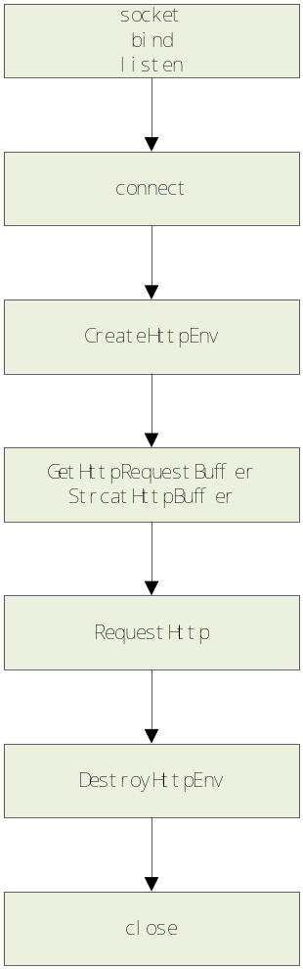
客户端调用socket和connect，调用函数GetHttpRequestBuffer和函数StrcatHttpBuffer组织HTTP请求数据（包括HTTP头和HTTP体），接着调用函数RequestHttp发起单次HTTP请求并接收解析HTTP响应，调用函数GetHttpHeaderPtr得到HTTP响应头选项，调用函数GetHttpBodyPtr和GetHttpBodyLen访问HTTP响应体。
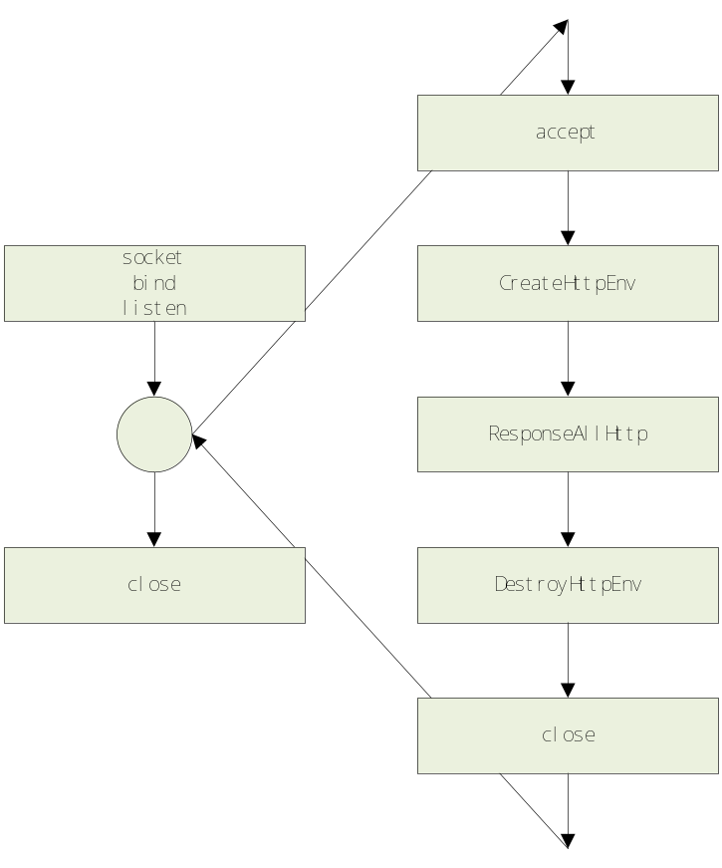
服务端调用socket、bind、listen、accept建立好一条TCP连接，调用函数ResponseAllHttp并指定回调函数ProcessHttpRequest以处理单次HTTP请求、生成HTTP响应。回调函数里可以调用函数GetHttpHeaderPtr得到HTTP请求头选项，调用函数GetHttpBodyPtr和GetHttpBodyLen访问HTTP请求体，调用函数GetHttpResponseBuffer和StrcatHttpBuffer组织HTTP响应数据。
每个HTTP环境对象使用完后调用函数DestroyHttpEnv销毁之。如需重复使用则调用函数ResetHttpEnv重置内部状态。
ResetHttpEnv( e );
...
DestroyHttpEnv( e );

下面是一对简单的客户端和服务端示例（为突出显示主干，删除了所有出错处理；fasterhttp API加粗显示），客户端先（位于源代码包test/test_client_block.c）：
#include "fasterhttp.h"

static int TestParseHttpRequest( struct HttpEnv *e , char *str )
{
SOCKET connect_sock ;
struct sockaddr_in connect_addr ;

struct HttpBuffer *b = NULL ;

int nret = 0 ;

ResetHttpEnv( e );

connect_sock = socket( AF_INET , SOCK_STREAM , IPPROTO_TCP ) ;

memset( & connect_addr , 0x00 , sizeof(struct sockaddr_in) );
connect_addr.sin_family = AF_INET;
connect_addr.sin_addr.s_addr = inet_addr( "127.0.0.1" );
connect_addr.sin_port = htons( (unsigned short)9527 );

nret = connect( connect_sock , (struct sockaddr *) & connect_addr , sizeof(struct sockaddr) ) ;

b = GetHttpRequestBuffer(e) ;
nret = StrcatHttpBuffer( b , str ) ;

nret = RequestHttp( connect_sock , NULL , e ) ;
CLOSESOCKET( connect_sock );

return 0;
}

int test_client_block()
{
struct HttpEnv *e = NULL ;

int nret = 0 ;

e = CreateHttpEnv();

nret = TestParseHttpRequest( e , "GET / HTTP/1.1\r\n"
"Host: www.baidu.com\r\n"
"User-Agent: Mozilla/5.0 (Windows NT 5.1; rv:45.0) Gecko/20100101 Firefox/45.0\r\n"
"Accept-Language: zh-CN,zh;q=0.8,en-US;q=0.5,en;q=0.3\r\n"
"Accept-Encoding: gzip, deflate, br\r\n"
"Cookie: BAIDUID=0E27B789D33BF3C43C6022BD0182CF8D:SL=0:NR=10:FG=1; BIDUPSID=EE65333C3C1B7FB4807F6DC5DE576979; PSTM=1462883721; BD_UPN=13314152; ispeed_lsm=2; MCITY=-179%3A; BDUSS=t4TW1VRFNsMm91bGtTcUFHbVFqfnhiVFVYd2ZKZFc2c0dGaG12VmhZckZJbmxYQVFBQUFBJCQAAAAAAAAAAAEAAADIZsc0Y2FsdmlubGljaAAAAAAAAAAAAAAAAAAAAAAAAAAAAAAAAAAAAAAAAAAAAAAAAAAAAAAAAAAAAAAAAAAAAAAAAMWVUVfFlVFXSG; pgv_pvi=56303616; BD_HOME=1; H_PS_PSSID=19290_1436_18240_20076_17001_15790_12201_20254; sug=3; sugstore=0; ORIGIN=2; bdime=0; __bsi=13900513390515515511_00_0_I_R_33_0303_C02F_N_I_I_0\r\n"
"Connection: keep-alive\r\n"
"Cache-Control: max-age=0\r\n"
"\r\n" ) ;

DestroyHttpEnv( e );

printf( "ALL test is ok!!!\n" );

return 0;
}

int main()
{
#if ( defined _WIN32 )
WSADATA wsaData;
#endif
int nret = 0 ;

#if ( defined _WIN32 )
nret = WSAStartup( MAKEWORD( 2, 2 ), &wsaData ) ;
if( nret )
{
printf( "WSAStartup failed[%d] , errno[%d]\n" , nret , GetLastError() );
return 1;
}
#endif

nret = test_client_block() ;

#if ( defined _WIN32 )
WSACleanup();
#endif

return -nret;
}
服务端（fasterhttp API加粗显示）（位于源代码包test/test_server_block.c）
#include "fasterhttp.h"

funcProcessHttpRequest ProcessHttpRequest ;
int ProcessHttpRequest( struct HttpEnv *e , void *p )
{
struct HttpBuffer *b = NULL ;
int nret = 0 ;

b = GetHttpResponseBuffer(e) ;
nret = StrcatHttpBuffer( b , "Content-Type: text/html\r\n"
"Content-Length: 17\r\n"
"\r\n"
"hello fasterhttp!" ) ;

return HTTP_OK;
}

int test_server_block()
{
SOCKET listen_sock ;
struct sockaddr_in listen_addr ;
SOCKET accept_sock ;
struct sockaddr_in accept_addr ;
SOCKLEN_T accept_addr_len ;
int onoff ;

struct HttpEnv *e = NULL ;

int nret = 0 ;

e = CreateHttpEnv();

listen_sock = socket( AF_INET , SOCK_STREAM , IPPROTO_TCP ) ;

onoff = 1 ;
setsockopt( listen_sock , SOL_SOCKET , SO_REUSEADDR , (void *) & onoff , sizeof(onoff) );

memset( & listen_addr , 0x00 , sizeof(struct sockaddr_in) );
listen_addr.sin_family = AF_INET;
listen_addr.sin_addr.s_addr = INADDR_ANY ;
listen_addr.sin_port = htons( (unsigned short)9527 );

nret = bind( listen_sock , (struct sockaddr *) & listen_addr , sizeof(struct sockaddr) ) ;

nret = listen( listen_sock , 1024 ) ;

while(1)
{
accept_addr_len = sizeof(struct sockaddr) ;
accept_sock = accept( listen_sock , (struct sockaddr *) & accept_addr, & accept_addr_len );
if( accept_sock == - 1 )

ResetHttpEnv( e );

nret = ResponseAllHttp( accept_sock , NULL , e , & ProcessHttpRequest , (void*)(&accept_sock) ) ;

CLOSESOCKET( accept_sock );
}

CLOSESOCKET( listen_sock );

DestroyHttpEnv( e );

return 0;
}

int main()
{
#if ( defined _WIN32 )
WSADATA wsaData;
#endif
int nret = 0 ;

setbuf( stdout , NULL );

#if ( defined _WIN32 )
nret = WSAStartup( MAKEWORD( 2, 2 ), &wsaData ) ;
if( nret )
{
printf( "WSAStartup failed[%d] , errno[%d]\n" , nret , GetLastError() );
return 1;
}
#endif

nret = test_server_block() ;

#if ( defined _WIN32 )
WSACleanup();
#endif

return -nret;
}

非堵塞/多路复用模型
基本使用流程和堵塞模型差不多。
客户端的RequestHttp拆分成SendHttpRequestNonblock和ReceiveHttpResponseNonblock非堵塞调用。
服务端的ResponseHttp拆分成ReceiveHttpRequestNonblock和SendHttpResponseNonblock非堵塞调用。HTTP请求处理函数ProcessHttpRequest返回错误时，调用FormatHttpResponseStartLine自行组织报错响应报文。
下面是非堵塞/多路复用（基于select）的客户端和服务端示例（为突出显示主干，删除了所有出错处理；fasterhttp API加粗显示），客户端先（位于源代码包test/test_client_nonblock.c）：
#include "fasterhttp.h"

static int TestParseHttpRequest( struct HttpEnv *e , char *str )
{
SOCKET connect_sock ;
struct sockaddr_in connect_addr ;

struct HttpBuffer *b = NULL ;
fd_set read_fds , write_fds ;

int nret = 0 ;

ResetHttpEnv( e );

connect_sock = socket( AF_INET , SOCK_STREAM , IPPROTO_TCP ) ;

memset( & connect_addr , 0x00 , sizeof(struct sockaddr_in) );
connect_addr.sin_family = AF_INET;
connect_addr.sin_addr.s_addr = inet_addr( "127.0.0.1" );
connect_addr.sin_port = htons( (unsigned short)9527 );

nret = connect( connect_sock , (struct sockaddr *) & connect_addr , sizeof(struct sockaddr) ) ;

b = GetHttpRequestBuffer(e) ;
nret = StrcatHttpBuffer( b , str ) ;

while(1)
{
FD_ZERO( & write_fds );
FD_SET( connect_sock , & write_fds );

nret = select( connect_sock+1 , NULL , & write_fds , NULL , GetHttpElapse(e) ) ;
if( nret == 0 )
{
printf( "select send timeout , errno[%d]\n" , errno );
CLOSESOCKET( connect_sock );
return FASTERHTTP_ERROR_TCP_SELECT_RECEIVE_TIMEOUT;
}
else if( nret != 1 )
{
printf( "select send failed , errno[%d]\n" , errno );
CLOSESOCKET( connect_sock );
return FASTERHTTP_ERROR_TCP_SELECT_RECEIVE;
}

nret = SendHttpRequestNonblock( connect_sock , NULL , e ) ;
if( nret == FASTERHTTP_INFO_TCP_SEND_WOULDBLOCK )
{
;
}
else if( nret )
{
printf( "SendHttpRequestNonblock failed[%d]\n" , nret );
CLOSESOCKET( connect_sock );
return nret;
}
else
{
break;
}
}

while(1)
{
FD_ZERO( & read_fds );
FD_SET( connect_sock , & read_fds );

nret = select( connect_sock+1 , & read_fds , NULL , NULL , GetHttpElapse(e) ) ;
if( nret == 0 )
{
printf( "select receive timeout , errno[%d]\n" , errno );
CLOSESOCKET( connect_sock );
return FASTERHTTP_ERROR_TCP_SELECT_RECEIVE_TIMEOUT;
}
else if( nret != 1 )
{
printf( "select receive failed , errno[%d]\n" , errno );
CLOSESOCKET( connect_sock );
return FASTERHTTP_ERROR_TCP_SELECT_RECEIVE;
}

nret = ReceiveHttpResponseNonblock( connect_sock , NULL , e ) ;
if( nret == FASTERHTTP_INFO_NEED_MORE_HTTP_BUFFER )
{
;
}
else if( nret )
{
printf( "ReceiveHttpResponseNonblock failed[%d]\n" , nret );
CLOSESOCKET( connect_sock );
return nret;
}
else
{
break;
}
}

CLOSESOCKET( connect_sock );

return 0;
}

int test_client_nonblock()
{
struct HttpEnv *e = NULL ;

int nret = 0 ;

e = CreateHttpEnv();

nret = TestParseHttpRequest( e , "GET / HTTP/1.1\r\n"
"Host: www.baidu.com\r\n"
"User-Agent: Mozilla/5.0 (Windows NT 5.1; rv:45.0) Gecko/20100101 Firefox/45.0\r\n"
"Accept-Language: zh-CN,zh;q=0.8,en-US;q=0.5,en;q=0.3\r\n"
"Accept-Encoding: gzip, deflate, br\r\n"
"Cookie: BAIDUID=0E27B789D33BF3C43C6022BD0182CF8D:SL=0:NR=10:FG=1; BIDUPSID=EE65333C3C1B7FB4807F6DC5DE576979; PSTM=1462883721; BD_UPN=13314152; ispeed_lsm=2; MCITY=-179%3A; BDUSS=t4TW1VRFNsMm91bGtTcUFHbVFqfnhiVFVYd2ZKZFc2c0dGaG12VmhZckZJbmxYQVFBQUFBJCQAAAAAAAAAAAEAAADIZsc0Y2FsdmlubGljaAAAAAAAAAAAAAAAAAAAAAAAAAAAAAAAAAAAAAAAAAAAAAAAAAAAAAAAAAAAAAAAAAAAAAAAAMWVUVfFlVFXSG; pgv_pvi=56303616; BD_HOME=1; H_PS_PSSID=19290_1436_18240_20076_17001_15790_12201_20254; sug=3; sugstore=0; ORIGIN=2; bdime=0; __bsi=13900513390515515511_00_0_I_R_33_0303_C02F_N_I_I_0\r\n"
"Connection: keep-alive\r\n"
"Cache-Control: max-age=0\r\n"
"\r\n" ) ;

DestroyHttpEnv( e );

printf( "ALL test is ok!!!\n" );

return 0;
}

int main()
{
#if ( defined _WIN32 )
WSADATA wsaData;
#endif
int nret = 0 ;

#if ( defined _WIN32 )
nret = WSAStartup( MAKEWORD( 2, 2 ), &wsaData ) ;
if( nret )
{
printf( "WSAStartup failed[%d] , errno[%d]\n" , nret , GetLastError() );
return 1;
}
#endif

nret = test_client_nonblock() ;

#if ( defined _WIN32 )
WSACleanup();
#endif

return -nret;
}
服务端（fasterhttp API加粗显示）（位于源代码包test/test_server_nonblock.c）
#include "fasterhttp.h"

funcProcessHttpRequest ProcessHttpRequest ;
int ProcessHttpRequest( struct HttpEnv *e , void *p )
{
struct HttpBuffer *b = NULL ;
int nret = 0 ;

b = GetHttpResponseBuffer(e) ;
nret = StrcatHttpBuffer( b , "Content-Type: text/html\r\n"
"Content-Length: 17\r\n"
"\r\n"
"hello fasterhttp!" ) ;

return HTTP_OK;
}

int test_server_nonblock()
{
SOCKET listen_sock ;
struct sockaddr_in listen_addr ;
SOCKET accept_sock ;
struct sockaddr_in accept_addr ;
SOCKLEN_T accept_addr_len ;
int onoff ;

struct HttpEnv *e = NULL ;
fd_set read_fds , write_fds ;

int nret = 0 ;

e = CreateHttpEnv();

listen_sock = socket( AF_INET , SOCK_STREAM , IPPROTO_TCP ) ;

onoff = 1 ;
setsockopt( listen_sock , SOL_SOCKET , SO_REUSEADDR , (void *) & onoff , sizeof(onoff) );

memset( & listen_addr , 0x00 , sizeof(struct sockaddr_in) );
listen_addr.sin_family = AF_INET;
listen_addr.sin_addr.s_addr = INADDR_ANY ;
listen_addr.sin_port = htons( (unsigned short)9527 );

nret = bind( listen_sock , (struct sockaddr *) & listen_addr , sizeof(struct sockaddr) ) ;

nret = listen( listen_sock , 1024 ) ;

while(1)
{
accept_addr_len = sizeof(struct sockaddr) ;
accept_sock = accept( listen_sock , (struct sockaddr *) & accept_addr, & accept_addr_len );

ResetHttpEnv( e );

while(1)
{
FD_ZERO( & read_fds );
FD_SET( accept_sock , & read_fds );

nret = select( accept_sock+1 , & read_fds , NULL , NULL , GetHttpElapse(e) ) ;
if( nret == 0 )
{
printf( "select receive timeout , errno[%d]\n" , errno );
nret = FASTERHTTP_ERROR_TCP_CLOSE ;
break;
}
else if( nret != 1 )
{
printf( "select receive failed , errno[%d]\n" , errno );
nret = FASTERHTTP_ERROR_TCP_CLOSE ;
break;
}

nret = ReceiveHttpRequestNonblock( accept_sock , NULL , e ) ;
if( nret == FASTERHTTP_INFO_NEED_MORE_HTTP_BUFFER )
{
;
}
else if( nret )
{
printf( "ReceiveHttpRequestNonblock failed[%d]\n" , nret );
break;
}
else
{
break;
}
}

if( nret == FASTERHTTP_ERROR_TCP_CLOSE )
{
CLOSESOCKET( accept_sock );
continue;
}
else if( nret == FASTERHTTP_INFO_TCP_CLOSE )
{
CLOSESOCKET( accept_sock );
continue;
}
else if( nret )
{
nret = FormatHttpResponseStartLine( abs(nret)/1000 , e , 1 ) ;
if( nret )
{
CLOSESOCKET( accept_sock );
continue;
}
}
else
{
nret = FormatHttpResponseStartLine( HTTP_OK , e , 0 ) ;
if( nret )
{
CLOSESOCKET( accept_sock );
continue;
}

nret = ProcessHttpRequest( e , (void*)(&accept_sock) ) ;
if( nret != HTTP_OK )
{
nret = FormatHttpResponseStartLine( nret , e , 1 ) ;
if( nret )
{
CLOSESOCKET( accept_sock );
continue;
}
}
}

while(1)
{
FD_ZERO( & write_fds );
FD_SET( accept_sock , & write_fds );

nret = select( accept_sock+1 , NULL , & write_fds , NULL , GetHttpElapse(e) ) ;
if( nret == 0 )
{
printf( "select send timeout , errno[%d]\n" , errno );
CLOSESOCKET( accept_sock );
break;
}
else if( nret != 1 )
{
printf( "select send failed , errno[%d]\n" , errno );
CLOSESOCKET( accept_sock );
break;
}

nret = SendHttpResponseNonblock( accept_sock , NULL , e ) ;
if( nret == FASTERHTTP_INFO_TCP_SEND_WOULDBLOCK )
{
;
}
else if( nret )
{
printf( "SendHttpResponseNonblock failed[%d]\n" , nret );
CLOSESOCKET( accept_sock );
break;
}
else
{
break;
}
}

CLOSESOCKET( accept_sock );
}

CLOSESOCKET( listen_sock );

DestroyHttpEnv( e );

return 0;
}

int main()
{
#if ( defined _WIN32 )
WSADATA wsaData;
#endif
int nret = 0 ;

#if ( defined _WIN32 )
nret = WSAStartup( MAKEWORD( 2, 2 ), &wsaData ) ;
if( nret )
{
printf( "WSAStartup failed[%d] , errno[%d]\n" , nret , GetLastError() );
return 1;
}
#endif

nret = test_server_nonblock() ;

#if ( defined _WIN32 )
WSACleanup();
#endif

return -nret;
}

一个基于epoll的小型HTTP服务器
下面是一个基于epoll多路复用的服务端示例（源代码位于demo/htmlserver/htmlserver.c）
#include <stdio.h>
#include <stdlib.h>
#include <string.h>
#include <errno.h>
#include <unistd.h>
#include <sys/socket.h>
#include <sys/epoll.h>
#include <netinet/in.h>
#include <netinet/tcp.h>
#include <arpa/inet.h>
#include <fcntl.h>
#include <sys/types.h>
#include <sys/socket.h>

#include "fasterhttp.h"
#include "LOGC.h"

#define MAX_EPOLL_EVENTS 1024

static int ProcessHttpRequest( struct HttpEnv *e , int sock , char *wwwroot )
{
char pathfilename[ 1024 + 1 ] ;
struct stat st ;
int filesize ;
struct HttpBuffer *b = NULL ;

SOCKLEN_T socklen ;
struct sockaddr_in client_sockaddr ;
char client_ip[ 15 + 1 ] ;
int client_port ;
struct sockaddr_in server_sockaddr ;
char server_ip[ 15 + 1 ] ;
int server_port ;

int nret = 0 ;

memset( pathfilename , 0x00 , sizeof(pathfilename) );
snprintf( pathfilename , sizeof(pathfilename)-1 , "%s%.*s" , wwwroot , GetHttpHeaderLen_URI(e) , GetHttpHeaderPtr_URI(e,NULL) );

nret = stat( pathfilename , & st ) ;
if( nret == -1 )
return HTTP_NOT_FOUND;
filesize = st.st_size ;

b = GetHttpResponseBuffer(e) ;
nret = StrcatfHttpBuffer( b , "Server: htmlserver/1.0.0\r\n"
"Content-Type: text/html\r\n"
"Content-Length: %d\r\n"
"\r\n"
, filesize ) ;
if( nret )
return HTTP_INTERNAL_SERVER_ERROR;

nret = StrcatHttpBufferFromFile( b , pathfilename , &filesize ) ;
if( nret )
return HTTP_INTERNAL_SERVER_ERROR;

socklen = sizeof(struct sockaddr) ;
nret = getpeername( sock , (struct sockaddr *) & client_sockaddr , & socklen ) ;
if( nret )
{
printf( "getpeername failed , errno[%d]\n" , errno );
return HTTP_INTERNAL_SERVER_ERROR;
}
memset( client_ip , 0x00 , sizeof(client_ip) );
inet_ntop( AF_INET , &(client_sockaddr.sin_addr) , client_ip , sizeof(client_ip) );
client_port = (int)ntohs(client_sockaddr.sin_port) ;

socklen = sizeof(struct sockaddr) ;
nret = getsockname( sock , (struct sockaddr *) & server_sockaddr , & socklen ) ;
if( nret )
{
printf( "getsockname failed , errno[%d]\n" , errno );
return HTTP_INTERNAL_SERVER_ERROR;
}
memset( server_ip , 0x00 , sizeof(server_ip) );
inet_ntop( AF_INET , &(server_sockaddr.sin_addr) , server_ip , sizeof(server_ip) );
server_port = (int)ntohs(server_sockaddr.sin_port) ;

InfoLog( __FILE__ , __LINE__ , "%s:%d -> %s:%d | %.*s %.*s %.*s 200"
, client_ip , client_port , server_ip , server_port
, GetHttpHeaderLen_METHOD(e) , GetHttpHeaderPtr_METHOD(e,NULL)
, GetHttpHeaderLen_URI(e) , GetHttpHeaderPtr_URI(e,NULL)
, GetHttpHeaderLen_VERSION(e) , GetHttpHeaderPtr_VERSION(e,NULL)
);

return HTTP_OK;
}

static int OnAcceptingSocket( int epoll_fd , int listen_sock )
{
SOCKET accept_sock ;
struct sockaddr_in accept_addr ;
SOCKLEN_T accept_addr_len ;
int opts ;

struct epoll_event event ;

struct HttpEnv *e = NULL ;

int nret = 0 ;

accept_addr_len = sizeof(struct sockaddr) ;
accept_sock = accept( listen_sock , (struct sockaddr *) & accept_addr, & accept_addr_len );
if( accept_sock == - 1 )
{
ErrorLog( __FILE__ , __LINE__ , "accept failed , errno[%d]" , errno );
return -1;
}
else
{
DebugLog( __FILE__ , __LINE__ , "accept ok" );
}

opts = fcntl( accept_sock , F_GETFL ) ;
opts = opts | O_NONBLOCK ;
fcntl( accept_sock , F_SETFL , opts );

e = CreateHttpEnv() ;
if( e == NULL )
{
ErrorLog( __FILE__ , __LINE__ , "CreateHttpEnv failed , errno[%d]" , errno );
return -1;
}

SetHttpTimeout( e , 120 );
//EnableHttpResponseCompressing( e , 1 );

memset( & event , 0x00 , sizeof(struct epoll_event) );
event.events = EPOLLIN | EPOLLERR ;
event.data.ptr = e ;
SetParserCustomIntData( e , accept_sock );
nret = epoll_ctl( epoll_fd , EPOLL_CTL_ADD , accept_sock , & event ) ;
if( nret == -1 )
{
ErrorLog( __FILE__ , __LINE__ , "epoll_ctl failed , errno[%d]" , errno );
return -1;
}

return 0;
}

static int OnReceivingSocket( int epoll_fd , int accept_sock , struct HttpEnv *e , char *wwwroot )
{
struct epoll_event event ;

int nret = 0 ;

nret = ReceiveHttpRequestNonblock( accept_sock , NULL , e ) ;
if( nret == FASTERHTTP_INFO_NEED_MORE_HTTP_BUFFER )
{
;
}
else if( nret )
{
if( nret == FASTERHTTP_ERROR_TCP_CLOSE )
{
ErrorLog( __FILE__ , __LINE__ , "accepted socket closed detected" );
return -1;
}
else if( nret == FASTERHTTP_INFO_TCP_CLOSE )
{
InfoLog( __FILE__ , __LINE__ , "accepted socket closed detected" );
return -1;
}
else
{
ErrorLog( __FILE__ , __LINE__ , "ReceiveHttpRequestNonblock failed[%d] , errno[%d]" , nret , errno );

nret = FormatHttpResponseStartLine( abs(nret)/1000 , e , 1 ) ;
if( nret )
{
ErrorLog( __FILE__ , __LINE__ , "FormatHttpResponseStartLine failed[%d] , errno[%d]" , nret , errno );
return -2;
}

return 0;
}
}
else
{
nret = ProcessHttpRequest( e , GetParserCustomIntData(e) , wwwroot ) ;
if( nret )
{
nret = FormatHttpResponseStartLine( nret , e , 1 ) ;
if( nret )
{
ErrorLog( __FILE__ , __LINE__ , "FormatHttpResponseStartLine failed[%d] , errno[%d]" , nret , errno );
return -2;
}
}

memset( & event , 0x00 , sizeof(struct epoll_event) );
event.events = EPOLLOUT | EPOLLERR ;
event.data.ptr = e ;
nret = epoll_ctl( epoll_fd , EPOLL_CTL_MOD , accept_sock , & event ) ;
if( nret == -1 )
{
ErrorLog( __FILE__ , __LINE__ , "epoll_ctl failed , errno[%d]" , errno );
return -2;
}
}

return 0;
}

static int OnSendingSocket( int epoll_fd , int accept_sock , struct HttpEnv *e )
{
struct epoll_event event ;

int nret = 0 ;

nret = SendHttpResponseNonblock( accept_sock , NULL , e ) ;
if( nret == FASTERHTTP_INFO_TCP_SEND_WOULDBLOCK )
{
;
}
else if( nret )
{
ErrorLog( __FILE__ , __LINE__ , "SendHttpResponseNonblock failed[%d] , errno[%d]" , nret , errno );
return -1;
}
else
{
if( CheckHttpKeepAlive(e) )
{
ResetHttpEnv(e);

memset( & event , 0x00 , sizeof(struct epoll_event) );
event.events = EPOLLIN | EPOLLERR ;
event.data.ptr = e ;
nret = epoll_ctl( epoll_fd , EPOLL_CTL_MOD , accept_sock , & event ) ;
if( nret == -1 )
{
ErrorLog( __FILE__ , __LINE__ , "epoll_ctl failed , errno[%d]" , errno );
return -2;
}
}
else
{
DebugLog( __FILE__ , __LINE__ , "close client socket" );
return -1;
}
}

return 0;
}

static int htmlserver( int port , char *wwwroot )
{
int epoll_fd ;
struct epoll_event event , *p_event = NULL ;
struct epoll_event events[ MAX_EPOLL_EVENTS ] ;
int nfds , i ;

struct HttpEnv *e = NULL ;

SOCKET listen_sock ;
struct sockaddr_in listen_addr ;
int onoff ;

int nret = 0 ;

epoll_fd = epoll_create( 1024 ) ;
if( epoll_fd == -1 )
{
ErrorLog( __FILE__ , __LINE__ , "epoll_create failed , errno[%d]" , errno );
return -1;
}
else
{
InfoLog( __FILE__ , __LINE__ , "epoll_create ok" );
}

listen_sock = socket( AF_INET , SOCK_STREAM , IPPROTO_TCP ) ;
if( listen_sock == -1 )
{
ErrorLog( __FILE__ , __LINE__ , "socket failed , errno[%d]" , errno );
CLOSESOCKET( epoll_fd );
return -1;
}
else
{
InfoLog( __FILE__ , __LINE__ , "socket ok" );
}

onoff = 1 ;
setsockopt( listen_sock , SOL_SOCKET , SO_REUSEADDR , (void *) & onoff , sizeof(onoff) );

memset( & listen_addr , 0x00 , sizeof(struct sockaddr_in) ) ;
listen_addr.sin_family = AF_INET ;
listen_addr.sin_addr.s_addr = INADDR_ANY ;
listen_addr.sin_port = htons( (unsigned short)port ) ;

nret = bind( listen_sock , (struct sockaddr *) & listen_addr , sizeof(struct sockaddr) ) ;
if( nret == -1 )
{
ErrorLog( __FILE__ , __LINE__ , "bind failed , errno[%d]" , errno );
CLOSESOCKET( listen_sock );
CLOSESOCKET( epoll_fd );
return -1;
}
else
{
InfoLog( __FILE__ , __LINE__ , "bind ok" );
}

nret = listen( listen_sock , 1024 ) ;
if( nret == -1 )
{
ErrorLog( __FILE__ , __LINE__ , "listen failed , errno[%d]" , errno );
CLOSESOCKET( listen_sock );
CLOSESOCKET( epoll_fd );
return -1;
}
else
{
InfoLog( __FILE__ , __LINE__ , "listen ok" );
}

memset( & event , 0x00 , sizeof(struct epoll_event) );
event.events = EPOLLIN | EPOLLERR ;
event.data.ptr = NULL ;
nret = epoll_ctl( epoll_fd , EPOLL_CTL_ADD , listen_sock , & event ) ;
if( nret == -1 )
{
ErrorLog( __FILE__ , __LINE__ , "epoll_ctl failed , errno[%d]" , errno );
CLOSESOCKET( listen_sock );
CLOSESOCKET( epoll_fd );
return -1;
}
else
{
InfoLog( __FILE__ , __LINE__ , "epoll_ctl ok" );
}

while(1)
{
memset( events , 0x00 , sizeof(events) );
nfds = epoll_wait( epoll_fd , events , MAX_EPOLL_EVENTS , -1 ) ;
if( nfds == -1 )
{
ErrorLog( __FILE__ , __LINE__ , "epoll_wait failed , errno[%d]" , errno );
CLOSESOCKET( listen_sock );
CLOSESOCKET( epoll_fd );
return -1;
}

for( i = 0 , p_event = events ; i < nfds ; i++ , p_event++ )
{
if( p_event->data.ptr == NULL )
{
if( p_event->events & EPOLLIN )
{
nret = OnAcceptingSocket( epoll_fd , listen_sock ) ;
if( nret == -1 )
{
ErrorLog( __FILE__ , __LINE__ , "OnAcceptingSocket failed , errno[%d]" , errno );
CLOSESOCKET( listen_sock );
CLOSESOCKET( epoll_fd );
return nret;
}
}
else if( p_event->events & EPOLLERR )
{
ErrorLog( __FILE__ , __LINE__ , "listen_sock epoll EPOLLERR" );
CLOSESOCKET( listen_sock );
CLOSESOCKET( epoll_fd );
return -1;
}
else
{
ErrorLog( __FILE__ , __LINE__ , "listen_sock epoll event invalid[%d]" , p_event->events );
CLOSESOCKET( listen_sock );
CLOSESOCKET( epoll_fd );
return -1;
}
}
else
{
int accept_sock ;

e = p_event->data.ptr ;
accept_sock = GetParserCustomIntData(e) ;

if( p_event->events & EPOLLIN )
{
nret = OnReceivingSocket( epoll_fd , accept_sock , e , wwwroot ) ;
if( nret == -1 )
{
DestroyHttpEnv(e);
epoll_ctl( epoll_fd , EPOLL_CTL_DEL , accept_sock , NULL );
CLOSESOCKET( accept_sock );
}
else if( nret == -2 )
{
DestroyHttpEnv(e);
epoll_ctl( epoll_fd , EPOLL_CTL_DEL , accept_sock , NULL );
CLOSESOCKET( accept_sock );
CLOSESOCKET( listen_sock );
CLOSESOCKET( epoll_fd );
return nret;
}
}
else if( p_event->events & EPOLLOUT )
{
nret = OnSendingSocket( epoll_fd , accept_sock , e ) ;
if( nret == -1 )
{
DestroyHttpEnv(e);
epoll_ctl( epoll_fd , EPOLL_CTL_DEL , accept_sock , NULL );
CLOSESOCKET( accept_sock );
}
else if( nret == -2 )
{
DestroyHttpEnv(e);
epoll_ctl( epoll_fd , EPOLL_CTL_DEL , accept_sock , NULL );
CLOSESOCKET( accept_sock );
CLOSESOCKET( listen_sock );
CLOSESOCKET( epoll_fd );
return nret;
}
}
else if( p_event->events & EPOLLERR )
{
ErrorLog( __FILE__ , __LINE__ , "accept_sock epoll EPOLLERR" );
epoll_ctl( epoll_fd , EPOLL_CTL_DEL , accept_sock , NULL );
CLOSESOCKET( accept_sock );
}
else
{
ErrorLog( __FILE__ , __LINE__ , "accept_sock epoll event invalid[%d]" , p_event->events );
epoll_ctl( epoll_fd , EPOLL_CTL_DEL , accept_sock , NULL );
CLOSESOCKET( accept_sock );
}
}
}
}

CLOSESOCKET( listen_sock );
CLOSESOCKET( epoll_fd );

return 0;
}

static void usage()
{
printf( "USAGE : htmlserver port\n" );
return;
}

int main( int argc , char *argv[] )
{
SetLogFile( "%s/log/htmlserver.log" , getenv("HOME") );
SetLogLevel( LOGLEVEL_INFO );

ResetAllHttpStatus();
SetHttpStatus( HTTP_NOT_FOUND , HTTP_NOT_FOUND_S , "Custem Not Found Text" );

if( argc == 1 + 2 )
{
return -htmlserver( atoi(argv[1]) , argv[2] );
}
else
{
usage();
exit(9);
}
}

性能压测

压测方案
压测环境
CPU : Intel(R) Xeon(R) CPU E5-2630 0 @ 2.30GHz
内存 : 1GB
硬盘 : （足够）
带宽 : 1MB
操作系统 : CentOS release 6.5 (Final) 64bits
同类软件
http-parser-2.7.0 使用最广泛的HTTP解析器
fasterhttp-1.0.0 本文的主角
picohttpparser(2014) 声称性能最快的HTTP解析器
压测过程
压测比较三个HTTP解析库
只压测HTTP请求数据的解析，使用各自自带的压测程序，HTTP请求数据修改成一样
三个HTTP解析库交叉运行11轮，每轮解析1000万次HTTP请求，取Linux的time数据为准

压测结果
http-parser压测结果如下：
[calvin@iZ23k0yd363Z /home/calvin/expack/http-parser] time ./bench2 10000000
Benchmark result:
Took 18.753361 seconds to run
533237.750000 req/sec

real 0m18.755s
user 0m18.700s
sys 0m0.037s
[calvin@iZ23k0yd363Z /home/calvin/expack/http-parser] time ./bench2 10000000
Benchmark result:
Took 18.832979 seconds to run
530983.437500 req/sec

real 0m18.834s
user 0m18.786s
sys 0m0.030s
[calvin@iZ23k0yd363Z /home/calvin/expack/http-parser] time ./bench2 10000000
Benchmark result:
Took 18.816858 seconds to run
531438.312500 req/sec

real 0m18.818s
user 0m18.748s
sys 0m0.045s
[calvin@iZ23k0yd363Z /home/calvin/expack/http-parser] time ./bench2 10000000
Benchmark result:
Took 18.853455 seconds to run
530406.750000 req/sec

real 0m18.855s
user 0m18.787s
sys 0m0.050s
[calvin@iZ23k0yd363Z /home/calvin/expack/http-parser] time ./bench2 10000000
Benchmark result:
Took 18.871876 seconds to run
529889.062500 req/sec

real 0m18.873s
user 0m18.812s
sys 0m0.035s
[calvin@iZ23k0yd363Z /home/calvin/expack/http-parser] time ./bench2 10000000
Benchmark result:
Took 18.853525 seconds to run
530404.812500 req/sec

real 0m18.855s
user 0m18.777s
sys 0m0.060s
[calvin@iZ23k0yd363Z /home/calvin/expack/http-parser] time ./bench2 10000000
Benchmark result:
Took 18.877413 seconds to run
529733.625000 req/sec

real 0m18.879s
user 0m18.816s
sys 0m0.044s
[calvin@iZ23k0yd363Z /home/calvin/expack/http-parser] time ./bench2 10000000
Benchmark result:
Took 18.975199 seconds to run
527003.687500 req/sec

real 0m18.976s
user 0m18.915s
sys 0m0.044s
[calvin@iZ23k0yd363Z /home/calvin/expack/http-parser] time ./bench2 10000000
Benchmark result:
Took 18.987669 seconds to run
526657.562500 req/sec

real 0m18.989s
user 0m18.918s
sys 0m0.044s
[calvin@iZ23k0yd363Z /home/calvin/expack/http-parser] time ./bench2 10000000
Benchmark result:
Took 18.821001 seconds to run
531321.375000 req/sec

real 0m18.822s
user 0m18.753s
sys 0m0.051s
[calvin@iZ23k0yd363Z /home/calvin/expack/http-parser] time ./bench2 10000000
Benchmark result:
Took 18.804218 seconds to run
531795.562500 req/sec

real 0m18.805s
user 0m18.751s
sys 0m0.037s

fasterhttp压测结果如下：
[calvin@iZ23k0yd363Z /home/calvin/exsrc/fasterhttp/test] time ./press 10000000

real 0m11.041s
user 0m11.005s
sys 0m0.026s
[calvin@iZ23k0yd363Z /home/calvin/exsrc/fasterhttp/test] time ./press 10000000

real 0m11.009s
user 0m10.962s
sys 0m0.029s
[calvin@iZ23k0yd363Z /home/calvin/exsrc/fasterhttp/test] time ./press 10000000

real 0m11.037s
user 0m11.000s
sys 0m0.026s
[calvin@iZ23k0yd363Z /home/calvin/exsrc/fasterhttp/test] time ./press 10000000

real 0m11.140s
user 0m11.101s
sys 0m0.028s
[calvin@iZ23k0yd363Z /home/calvin/exsrc/fasterhttp/test] time ./press 10000000

real 0m11.041s
user 0m11.005s
sys 0m0.025s
[calvin@iZ23k0yd363Z /home/calvin/exsrc/fasterhttp/test] time ./press 10000000

real 0m11.779s
user 0m11.741s
sys 0m0.028s
[calvin@iZ23k0yd363Z /home/calvin/exsrc/fasterhttp/test] time ./press 10000000

real 0m11.027s
user 0m10.989s
sys 0m0.026s
[calvin@iZ23k0yd363Z /home/calvin/exsrc/fasterhttp/test] time ./press 10000000

real 0m11.203s
user 0m11.158s
sys 0m0.033s
[calvin@iZ23k0yd363Z /home/calvin/exsrc/fasterhttp/test] time ./press 10000000

real 0m11.043s
user 0m10.999s
sys 0m0.033s
[calvin@iZ23k0yd363Z /home/calvin/exsrc/fasterhttp/test] time ./press 10000000

real 0m11.054s
user 0m11.013s
sys 0m0.030s
[calvin@iZ23k0yd363Z /home/calvin/exsrc/fasterhttp/test] time ./press 10000000

real 0m11.035s
user 0m10.992s
sys 0m0.033s

picohttpparser压测结果如下：
[calvin@iZ23k0yd363Z /home/calvin/expack/picohttpparser] time ./bench

real 0m8.001s
user 0m7.970s
sys 0m0.016s
[calvin@iZ23k0yd363Z /home/calvin/expack/picohttpparser] time ./bench

real 0m7.918s
user 0m7.880s
sys 0m0.024s
[calvin@iZ23k0yd363Z /home/calvin/expack/picohttpparser] time ./bench

real 0m7.918s
user 0m7.898s
sys 0m0.013s
[calvin@iZ23k0yd363Z /home/calvin/expack/picohttpparser] time ./bench

real 0m7.964s
user 0m7.941s
sys 0m0.015s
[calvin@iZ23k0yd363Z /home/calvin/expack/picohttpparser] time ./bench

real 0m8.035s
user 0m8.012s
sys 0m0.017s
[calvin@iZ23k0yd363Z /home/calvin/expack/picohttpparser] time ./bench

real 0m7.972s
user 0m7.947s
sys 0m0.017s
[calvin@iZ23k0yd363Z /home/calvin/expack/picohttpparser] time ./bench

real 0m7.980s
user 0m7.956s
sys 0m0.017s
[calvin@iZ23k0yd363Z /home/calvin/expack/picohttpparser] time ./bench

real 0m7.980s
user 0m7.959s
sys 0m0.014s
[calvin@iZ23k0yd363Z /home/calvin/expack/picohttpparser] time ./bench

real 0m7.991s
user 0m7.963s
sys 0m0.021s
[calvin@iZ23k0yd363Z /home/calvin/expack/picohttpparser] time ./bench

real 0m7.960s
user 0m7.934s
sys 0m0.020s
[calvin@iZ23k0yd363Z /home/calvin/expack/picohttpparser] time ./bench

real 0m7.975s
user 0m7.933s
sys 0m0.027s

压测评价
原来不想把picohttpparser纳入同类比较，因为picohttpparser存在设计缺陷，原因如下：
1.单纯的只进行断句，不判断HTTP请求是否完整，不识别任何HTTP头选项，不对HTTP头选项进行合法性检查和语义处理，甚至包括Content-Length，使用者会问：“难道要我自己解析Content-Length以便知道HTTP请求是否完整了？那可是一个HTTP解析器的核心功能啊，我自己都解析了还要HTTP解析器干什么？”，没错，picohttpparser就是这样设计的，这就形成了一个悖论，谁使用谁倒霉。
2.不支持非堵塞流式解析，当网络质量不好时，就得一遍又一遍的重复解析增量后的全量数据，性能反而很差 。
但我最后还是把它放进来是为了看看fasterhttp离它的性能差距到底有多大。

下图就是压测跑出来的结果（平均值）
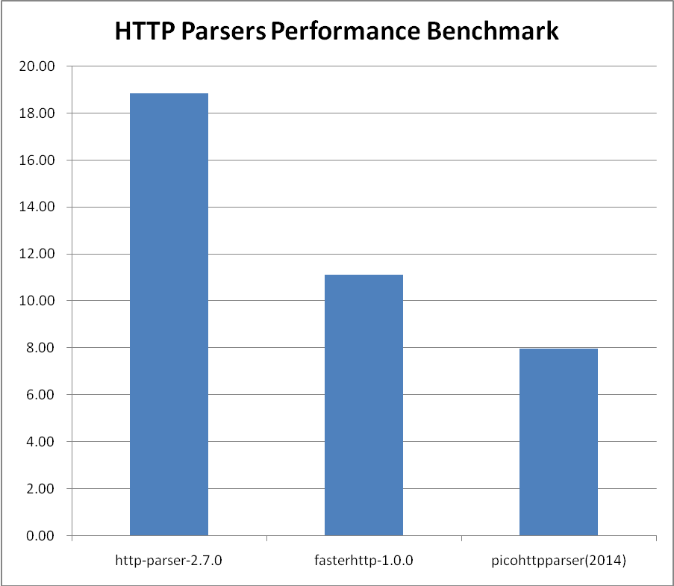
可以看出，功能性差不多的fasterhttp在性能上比http-parser快了近一倍，逼近功能不完整的picohttpparser的性能了（做的事少当然速度就快了，呵呵）。
恩，总体满意，以后有想法再继续优化吧。

压测代码
http-parser自带的bench.c修改统一了HTTP请求报文
/* Copyright Fedor Indutny. All rights reserved.
*
* Permission is hereby granted, free of charge, to any person obtaining a copy
* of this software and associated documentation files (the "Software"), to
* deal in the Software without restriction, including without limitation the
* rights to use, copy, modify, merge, publish, distribute, sublicense, and/or
* sell copies of the Software, and to permit persons to whom the Software is
* furnished to do so, subject to the following conditions:
*
* The above copyright notice and this permission notice shall be included in
* all copies or substantial portions of the Software.
*
* THE SOFTWARE IS PROVIDED "AS IS", WITHOUT WARRANTY OF ANY KIND, EXPRESS OR
* IMPLIED, INCLUDING BUT NOT LIMITED TO THE WARRANTIES OF MERCHANTABILITY,
* FITNESS FOR A PARTICULAR PURPOSE AND NONINFRINGEMENT. IN NO EVENT SHALL THE
* AUTHORS OR COPYRIGHT HOLDERS BE LIABLE FOR ANY CLAIM, DAMAGES OR OTHER
* LIABILITY, WHETHER IN AN ACTION OF CONTRACT, TORT OR OTHERWISE, ARISING
* FROM, OUT OF OR IN CONNECTION WITH THE SOFTWARE OR THE USE OR OTHER DEALINGS
* IN THE SOFTWARE.
*/
#include "http_parser.h"
#include <assert.h>
#include <stdio.h>
#include <string.h>
#include <stdlib.h>
#include <sys/time.h>

static const char data[] =
"GET /wp-content/uploads/2010/03/hello-kitty-darth-vader-pink.jpg HTTP/1.1\r\n" \
"Host: www.kittyhell.com\r\n" \
"User-Agent: Mozilla/5.0 (Macintosh; U; Intel Mac OS X 10.6; ja-JP-mac; rv:1.9.2.3) Gecko/20100401 Firefox/3.6.3 " \
"Pathtraq/0.9\r\n" \
"Accept: text/html,application/xhtml+xml,application/xml;q=0.9,*/*;q=0.8\r\n" \
"Accept-Language: ja,en-us;q=0.7,en;q=0.3\r\n" \
"Accept-Encoding: gzip,deflate\r\n" \
"Accept-Charset: Shift_JIS,utf-8;q=0.7,*;q=0.7\r\n" \
"Keep-Alive: 115\r\n" \
"Connection: keep-alive\r\n" \
"Cookie: wp_ozh_wsa_visits=2; wp_ozh_wsa_visit_lasttime=xxxxxxxxxx; " \
"__utma=xxxxxxxxx.xxxxxxxxxx.xxxxxxxxxx.xxxxxxxxxx.xxxxxxxxxx.x; " \
"__utmz=xxxxxxxxx.xxxxxxxxxx.x.x.utmccn=(referral)|utmcsr=reader.livedoor.com|utmcct=/reader/|utmcmd=referral\r\n" \
"\r\n" ;
static const size_t data_len = sizeof(data) - 1;

static int on_info(http_parser* p) {
return 0;
}

static int on_data(http_parser* p, const char *at, size_t length) {
return 0;
}

static http_parser_settings settings = {
.on_message_begin = on_info,
.on_headers_complete = on_info,
.on_message_complete = on_info,
.on_header_field = on_data,
.on_header_value = on_data,
.on_url = on_data,
.on_status = on_data,
.on_body = on_data
};

int bench(int iter_count, int silent) {
struct http_parser parser;
int i;
int err;
struct timeval start;
struct timeval end;
float rps;

if (!silent) {
err = gettimeofday(&start, NULL);
assert(err == 0);
}

for (i = 0; i < iter_count; i++) {
size_t parsed;
http_parser_init(&parser, HTTP_REQUEST);

parsed = http_parser_execute(&parser, &settings, data, data_len);
assert(parsed == data_len);
}

if (!silent) {
err = gettimeofday(&end, NULL);
assert(err == 0);

fprintf(stdout, "Benchmark result:\n");

rps = (float) (end.tv_sec - start.tv_sec) +
(end.tv_usec - start.tv_usec) * 1e-6f;
fprintf(stdout, "Took %f seconds to run\n", rps);

rps = (float) iter_count / rps;
fprintf(stdout, "%f req/sec\n", rps);
fflush(stdout);
}

return 0;
}

int main(int argc, char** argv) {
if (argc == 2 && strcmp(argv[1], "infinite") == 0) {
for (;;)
bench(5000000, 1);
return 0;
} else {
return bench(atoi(argv[1]), 0);
}
}

fasterhttp自带的压测代码，位于test/press.c
#include "fasterhttp.h"

#define REQ \
"GET /wp-content/uploads/2010/03/hello-kitty-darth-vader-pink.jpg HTTP/1.1\r\n" \
"Host: www.kittyhell.com\r\n" \
"User-Agent: Mozilla/5.0 (Macintosh; U; Intel Mac OS X 10.6; ja-JP-mac; rv:1.9.2.3) Gecko/20100401 Firefox/3.6.3 " \
"Pathtraq/0.9\r\n" \
"Accept: text/html,application/xhtml+xml,application/xml;q=0.9,*/*;q=0.8\r\n" \
"Accept-Language: ja,en-us;q=0.7,en;q=0.3\r\n" \
"Accept-Encoding: gzip,deflate\r\n" \
"Accept-Charset: Shift_JIS,utf-8;q=0.7,*;q=0.7\r\n" \
"Keep-Alive: 115\r\n" \
"Connection: keep-alive\r\n" \
"Cookie: wp_ozh_wsa_visits=2; wp_ozh_wsa_visit_lasttime=xxxxxxxxxx; " \
"__utma=xxxxxxxxx.xxxxxxxxxx.xxxxxxxxxx.xxxxxxxxxx.xxxxxxxxxx.x; " \
"__utmz=xxxxxxxxx.xxxxxxxxxx.x.x.utmccn=(referral)|utmcsr=reader.livedoor.com|utmcct=/reader/|utmcmd=referral\r\n" \
"\r\n"

static int press( int count )
{
struct HttpEnv *e = NULL ;
int i ;
struct HttpBuffer *b = NULL ;
int nret = 0 ;

e = CreateHttpEnv() ;
if( e == NULL )
{
printf( "CreateHttpEnv failed\n" );
return -1;
}

for( i = 0 ; i < count ; i++ )
{
ResetHttpEnv( e );

b = GetHttpRequestBuffer( e ) ;
SetHttpBufferPtr( b , REQ , sizeof(REQ) ) ;

nret = ParseHttpRequest( e ) ;
if( UNLIKELY(nret) )
{
printf( "ParseHttpRequest failed[%d]\n" , nret );
DestroyHttpEnv( e );
return -1;
}
}

DestroyHttpEnv( e );

return 0;
}

int main( int argc , char *argv[] )
{
if( argc == 1 + 1 )
{
return -press( atoi(argv[1]) );
}
else
{
printf( "USAGE : press count\n" );
exit(9);
}
}

picohttpparser自带的压测代码bench.c
/*
* Copyright (c) 2009-2014 Kazuho Oku, Tokuhiro Matsuno, Daisuke Murase,
* Shigeo Mitsunari
*
* The software is licensed under either the MIT License (below) or the Perl
* license.
*
* Permission is hereby granted, free of charge, to any person obtaining a copy
* of this software and associated documentation files (the "Software"), to
* deal in the Software without restriction, including without limitation the
* rights to use, copy, modify, merge, publish, distribute, sublicense, and/or
* sell copies of the Software, and to permit persons to whom the Software is
* furnished to do so, subject to the following conditions:
*
* The above copyright notice and this permission notice shall be included in
* all copies or substantial portions of the Software.
*
* THE SOFTWARE IS PROVIDED "AS IS", WITHOUT WARRANTY OF ANY KIND, EXPRESS OR
* IMPLIED, INCLUDING BUT NOT LIMITED TO THE WARRANTIES OF MERCHANTABILITY,
* FITNESS FOR A PARTICULAR PURPOSE AND NONINFRINGEMENT. IN NO EVENT SHALL THE
* AUTHORS OR COPYRIGHT HOLDERS BE LIABLE FOR ANY CLAIM, DAMAGES OR OTHER
* LIABILITY, WHETHER IN AN ACTION OF CONTRACT, TORT OR OTHERWISE, ARISING
* FROM, OUT OF OR IN CONNECTION WITH THE SOFTWARE OR THE USE OR OTHER DEALINGS
* IN THE SOFTWARE.
*/

#include <assert.h>
#include <stdio.h>
#include "picohttpparser.h"

#define REQ \
"GET /wp-content/uploads/2010/03/hello-kitty-darth-vader-pink.jpg HTTP/1.1\r\n" \
"Host: www.kittyhell.com\r\n" \
"User-Agent: Mozilla/5.0 (Macintosh; U; Intel Mac OS X 10.6; ja-JP-mac; rv:1.9.2.3) Gecko/20100401 Firefox/3.6.3 " \
"Pathtraq/0.9\r\n" \
"Accept: text/html,application/xhtml+xml,application/xml;q=0.9,*/*;q=0.8\r\n" \
"Accept-Language: ja,en-us;q=0.7,en;q=0.3\r\n" \
"Accept-Encoding: gzip,deflate\r\n" \
"Accept-Charset: Shift_JIS,utf-8;q=0.7,*;q=0.7\r\n" \
"Keep-Alive: 115\r\n" \
"Connection: keep-alive\r\n" \
"Cookie: wp_ozh_wsa_visits=2; wp_ozh_wsa_visit_lasttime=xxxxxxxxxx; " \
"__utma=xxxxxxxxx.xxxxxxxxxx.xxxxxxxxxx.xxxxxxxxxx.xxxxxxxxxx.x; " \
"__utmz=xxxxxxxxx.xxxxxxxxxx.x.x.utmccn=(referral)|utmcsr=reader.livedoor.com|utmcct=/reader/|utmcmd=referral\r\n" \
"\r\n"

int main(void)
{
const char *method;
size_t method_len;
const char *path;
size_t path_len;
int minor_version;
struct phr_header headers[32];
size_t num_headers;
int i, ret;

for (i = 0; i < 10000000; i++) {
num_headers = sizeof(headers) / sizeof(headers[0]);
ret = phr_parse_request(REQ, sizeof(REQ) - 1, &method, &method_len, &path, &path_len, &minor_version, headers, &num_headers,
0);
assert(ret == sizeof(REQ) - 1);
}

return 0;
}

开发参考

HTTP环境

环境

CreateHttpEnv
原型： | struct HttpEnv *CreateHttpEnv();
说明： | 创建HTTP环境
参数： | （无）
返回值： | HTTP环境结构

ResetHttpEnv
原型： | void ResetHttpEnv( struct HttpEnv *e );
说明： | 销毁HTTP环境重置HTTP环境
参数： | struct HttpEnv *e HTTP环境结构
返回值： | （无）

DestroyHttpEnv
原型： | void DestroyHttpEnv( struct HttpEnv *e );
说明： | 销毁HTTP环境
参数： | struct HttpEnv *e HTTP环境结构
返回值： | （无）

环境属性

SetHttpTimeout
原型： | void SetHttpTimeout( struct HttpEnv *e , long timeout );
说明： | 设置HTTP通讯接收超时时间。一个HTTP环境中只需设置一次，重置环境时同时重置为首次超时时间
参数： | struct HttpEnv *e HTTP环境结构  long timeout 通讯接收超时时间，单位：秒
返回值： | （无）

EnableHttpResponseCompressing
原型： | void EnableHttpResponseCompressing( struct HttpEnv *e , int enable_response_compressing );
说明： | 激活HTTP自动压缩解压。目前只对客户端接收HTTP响应，服务端接收 HTTP请求和发送HTTP响应时起作用
参数： | struct HttpEnv *e HTTP环境结构  int enable_response_compressing 0:禁用 1:启用
返回值： | （无）

SetParserCustomIntData
原型： | void SetParserCustomIntData( struct HttpEnv *e , int i );
说明： | 保存自定义数据到HTTP环境中
参数： | struct HttpEnv *e HTTP环境结构  int i 整型数据
返回值： | （无）

GetParserCustomIntData
原型： | int GetParserCustomIntData( struct HttpEnv *e );
说明： | 从HTTP环境中取出自定义数据
参数： | struct HttpEnv *e HTTP环境结构
返回值： | 整型数据

SetParserCustomPtrData
原型： | void SetParserCustomPtrData( struct HttpEnv *e , void *ptr );
说明： | 保存自定义数据到HTTP环境中
参数： | struct HttpEnv *e HTTP环境结构  char *ptr 指针型数据
返回值： | （无）

GetParserCustomPtrData
原型： | void *GetParserCustomPtrData( struct HttpEnv *e );
说明： | 从HTTP环境中取出自定义数据
参数： | struct HttpEnv *e HTTP环境结构
返回值： | 指针型数据

全局参数

ResetAllHttpStatus
原型： | void ResetAllHttpStatus();
说明： | 重置所有HTTP响应状态码及描述文本
参数： | （无）
返回值： | （无）

SetHttpStatus
原型： | void SetHttpStatus( int status_code , char *status_code_s , char *status_text );
说明： | 设置HTTP响应状态码及描述文本。用于自定义HTTP状态码及描述文本
参数： | int status_code HTTP状态码，如：404  char *status_code_s 字符串型HTTP状态码，如："404"  char *status_text 描述文本，如："Not Found"
返回值： | （无）

SetHttpStatus
原型： | void SetHttpStatus( int status_code , char *status_code_s , char *status_text );
说明： | 设置HTTP响应状态码及描述文本。用于自定义HTTP状态码及描述文本
参数： | int status_code HTTP状态码，如：404  char *status_code_s 字符串型HTTP状态码，如："404"  char *status_text 描述文本，如："Not Found"
返回值： | （无）

HTTP通讯与解析

HTTP客户端高层API

RequestHttp
原型： | int RequestHttp( SOCKET sock , SSL *ssl , struct HttpEnv *e );
说明： | 发送HTTP请求，以及接收、解析HTTP响应。请求前必须在请求缓冲区内组织好HTTP请求数据
参数： | SOCKET sock socket描述字，HTTP协议用  SSL *ssl ssl结构指针，HTTPS协议用  struct HttpEnv *e HTTP环境结构
返回值： | 0:成功  非0:失败

HTTP客户端低层API

SendHttpRequest
原型： | int SendHttpRequest( SOCKET sock , SSL *ssl , struct HttpEnv *e );
说明： | 发送HTTP请求。请求前必须在请求缓冲区内组织好HTTP请求数据
参数： | SOCKET sock socket描述字，HTTP协议用  SSL *ssl ssl结构指针，HTTPS协议用  struct HttpEnv *e HTTP环境结构
返回值： | 0:成功  非0:失败

ReceiveHttpResponse
原型： | int ReceiveHttpResponse( SOCKET sock , SSL *ssl , struct HttpEnv *e );
说明： | 接收、解析HTTP响应
参数： | SOCKET sock socket描述字，HTTP协议用  SSL *ssl ssl结构指针，HTTPS协议用  struct HttpEnv *e HTTP环境结构
返回值： | 0:成功  非0:失败

HTTP客户端低层API（非堵塞版本）

SendHttpRequestNonblock
原型： | int SendHttpRequestNonblock ( SOCKET sock , SSL *ssl , struct HttpEnv *e );
说明： | SendHttpRequest的非堵塞版本
参数： | SOCKET sock socket描述字，HTTP协议用  SSL *ssl ssl结构指针，HTTPS协议用  struct HttpEnv *e HTTP环境结构
返回值： | 0:成功  FASTERHTTP_INFO_TCP_SEND_WOULDBLOCK:缓冲区内还有数据等待发送  非0:失败

ReceiveHttpResponseNonblock
原型： | int ReceiveHttpResponseNonblock ( SOCKET sock , SSL *ssl , struct HttpEnv *e );
说明： | ReceiveHttpResponse的非堵塞版本
参数： | SOCKET sock socket描述字，HTTP协议用  SSL *ssl ssl结构指针，HTTPS协议用  struct HttpEnv *e HTTP环境结构
返回值： | 0:成功  FASTERHTTP_INFO_NEED_MORE_HTTP_BUFFER:缓冲区内数据不完整  非0:失败

HTTP服务端高层API

ResponseAllHttp
原型： | int ResponseAllHttp( SOCKET sock , SSL *ssl , struct HttpEnv *e , funcProcessHttpRequest *pfuncProcessHttpRequest , void *p );
说明： | 接收、解析HTTP请求，调用回调函数处理之，然后发送HTTP响应，如果客户端要求连接保持（Connection: Keep-Alive），则迭代之。  回调函数原型：typedef int funcProcessHttpRequest( struct HttpEnv *e , void *p );
参数： | SOCKET sock socket描述字，HTTP协议用  SSL *ssl ssl结构指针，HTTPS协议用  struct HttpEnv *e HTTP环境结构  funcProcessHttpRequest *pfuncProcessHttpRequest 回调函数指针  void *p 自定义数据，直接传递入回调函数
返回值： | 0:成功  非0:失败

HTTP服务端低层API

ReceiveHttpRequest
原型： | int ReceiveHttpRequest( SOCKET sock , SSL *ssl , struct HttpEnv *e );
说明： | 接收、解析HTTP请求
参数： | SOCKET sock socket描述字，HTTP协议用  SSL *ssl ssl结构指针，HTTPS协议用  struct HttpEnv *e HTTP环境结构
返回值： | 0:成功  FASTERHTTP_INFO_TCP_CLOSE:安全断开连接  非0:失败

FormatHttpResponseStartLine
原型： | int FormatHttpResponseStartLine( int status_code , struct HttpEnv *e , int fill_body_with_status_flag );
说明： | 在HTTP响应缓冲区中组织首行数据
参数： | int status_code HTTP响应状态码  struct HttpEnv *e HTTP环境结构  int fill_body_with_status_flag 1:同时组织HTTP体，当错误时使用 0:不组织HTTP体，默认
返回值： | 0:成功  非0:失败

SendHttpRequest
原型： | int SendHttpRequest( SOCKET sock , SSL *ssl , struct HttpEnv *e );
说明： | 发送HTTP响应
参数： | SOCKET sock socket描述字，HTTP协议用  SSL *ssl ssl结构指针，HTTPS协议用  struct HttpEnv *e HTTP环境结构
返回值： | 0:成功  非0:失败

CheckHttpKeepAlive
原型： | int CheckHttpKeepAlive( struct HttpEnv *e );
说明： | 检查本次请求是否需要保持连接
参数： | struct HttpEnv *e HTTP环境结构
返回值： | 0:不保持连接  1:需要保持连接

HTTP服务端低层API（非堵塞版本）

ReceiveHttpRequestNonblock
原型： | int ReceiveHttpRequestNonblock ( SOCKET sock , SSL *ssl , struct HttpEnv *e );
说明： | ReceiveHttpRequest的非堵塞版本
参数： | SOCKET sock socket描述字，HTTP协议用  SSL *ssl ssl结构指针，HTTPS协议用  struct HttpEnv *e HTTP环境结构
返回值： | 0:成功  FASTERHTTP_INFO_TCP_CLOSE:安全断开连接  FASTERHTTP_INFO_NEED_MORE_HTTP_BUFFER:缓冲区内数据不完整  非0:失败

SendHttpRequestNonblock
原型： | int SendHttpRequestNonblock ( SOCKET sock , SSL *ssl , struct HttpEnv *e );
说明： | SendHttpRequest的非堵塞版本
参数： | SOCKET sock socket描述字，HTTP协议用  SSL *ssl ssl结构指针，HTTPS协议用  struct HttpEnv *e HTTP环境结构
返回值： | 0:成功  FASTERHTTP_INFO_TCP_SEND_WOULDBLOCK:缓冲区内还有数据等待发送  非0:失败

HTTP头与体信息

HTTP首行头信息

GetHttpHeaderPtr_METHOD
原型： | char *GetHttpHeaderPtr_METHOD( struct HttpEnv *e , int *p_value_len );
说明： | 得到HTTP请求头首行METHOD值
参数： | struct HttpEnv *e HTTP环境结构  int *p_value_len 回传请求头首行头METHOD的值长度，如果置为NULL则不回传
返回值： | HTTP请求头首行METHOD值地址

GetHttpHeaderLen_METHOD
原型： | int GetHttpHeaderLen_METHOD( struct HttpEnv *e );
说明： | 得到HTTP请求头首行METHOD值长度
参数： | struct HttpEnv *e HTTP环境结构
返回值： | HTTP请求头首行METHOD值长度

GetHttpHeaderPtr_URI
原型： | char *GetHttpHeaderPtr_URI( struct HttpEnv *e , int *p_value_len );
说明： | 得到HTTP请求头首行URI值
参数： | struct HttpEnv *e HTTP环境结构  int *p_value_len 回传HTTP请求头首行URI的值长度，如果置为NULL则不回传
返回值： | HTTP请求头首行URI值地址

GetHttpHeaderLen_URI
原型： | int GetHttpHeaderLen_URI( struct HttpEnv *e );
说明： | 得到HTTP请求头首行URI值长度
参数： | struct HttpEnv *e HTTP环境结构
返回值： | HTTP请求头首行URI值长度

GetHttpHeaderPtr_VERSION
原型： | char *GetHttpHeaderPtr_VERSION( struct HttpEnv *e , int *p_value_len );
说明： | 得到HTTP请求头首行VERSION值
参数： | struct HttpEnv *e HTTP环境结构  int *p_value_len 回传HTTP请求头首行VERSION的值长度，如果置为NULL则不回传
返回值： | HTTP请求头首行VERSION值地址

GetHttpHeaderLen_VERSION
原型： | int GetHttpHeaderLen_VERSION( struct HttpEnv *e );
说明： | 得到HTTP首行请求请求头VERSION值长度
参数： | struct HttpEnv *e HTTP环境结构
返回值： | HTTP请求头首行VERSION值长度

GetHttpHeaderPtr_STATUSCODE
原型： | char *GetHttpHeaderPtr_STATUSCODE( struct HttpEnv *e , int *p_value_len );
说明： | 得到HTTP响应头首行STATUSCODE值
参数： | struct HttpEnv *e HTTP环境结构  int *p_value_len 回传HTTP响应头首行STATUSCODE的值长度，如果置为NULL则不回传
返回值： | HTTP响应头首行STATUSCODE值地址

GetHttpHeaderLen_STATUSCODE
原型： | int GetHttpHeaderLen_STATUSCODE( struct HttpEnv *e );
说明： | 得到HTTP响应头首行STATUSCODE值长度
参数： | struct HttpEnv *e HTTP环境结构
返回值： | HTTP响应头首行STATUSCODE值长度

GetHttpHeaderPtr_REASONPHRASE
原型： | char *GetHttpHeaderPtr_REASONPHRASE( struct HttpEnv *e , int *p_value_len );
说明： | 得到HTTP响应头首行REASONPHRASE值
参数： | struct HttpEnv *e HTTP环境结构  int *p_value_len 回传HTTP响应头首行REASONPHRASE的值长度，如果置为NULL则不回传
返回值： | HTTP响应头首行REASONPHRASE值地址

GetHttpHeaderLen_REASONPHRASE
原型： | int GetHttpHeaderLen_REASONPHRASE( struct HttpEnv *e );
说明： | 得到HTTP响应头首行REASONPHRASE值长度
参数： | struct HttpEnv *e HTTP环境结构
返回值： | 响应头首行REASONPHRASE值长度

HTTP头选项

QueryHttpHeaderPtr
原型： | char *QueryHttpHeaderPtr( struct HttpEnv *e , char *name , int *p_value_len );
说明： | 得到HTTP头选项的值
参数： | struct HttpEnv *e HTTP环境结构  char *name HTTP头选项名  int *p_value_len 回传头选项的值长度。如果置为NULL则不回传
返回值： | HTTP头选项的值地址

QueryHttpHeaderLen
原型： | int QueryHttpHeaderLen( struct HttpEnv *e , char *name );
说明： | 得到HTTP头选项的值长度
参数： | struct HttpEnv *e HTTP环境结构  char *name HTTP头选项名
返回值： | HTTP头选项的值长度

CountHttpHeaders
原型： | int CountHttpHeaders( struct HttpEnv *e );
说明： | 得到HTTP头选项的数量
参数： | struct HttpEnv *e HTTP环境结构
返回值： | HTTP头选项的数量

TravelHttpHeaderPtr
原型： | struct HttpHeader *TravelHttpHeaderPtr( struct HttpEnv *e , struct HttpHeader *p_header );
说明： | 遍历HTTP头选项
参数： | struct HttpEnv *e HTTP环境结构  struct HttpHeader *p_header 上一次遍历到的HTTP头选项结构。首次置为NULL
返回值： | NULL:没有HTTP头选项或遍历结束了  非NULL:本次遍历到HTTP头选项结构地址

GetHttpHeaderNamePtr
原型： | char *GetHttpHeaderNamePtr( struct HttpHeader *p_header , int *p_name_len );
说明： | 得到HTTP头选项结构中的名字
参数： | struct HttpEnv *e HTTP环境结构  int *p_name_len HTTP头选项结构中的名字长度。如果置为NULL则不回传
返回值： | HTTP头选项结构中的名字地址

GetHttpHeaderNameLen
原型： | int GetHttpHeaderNameLen( struct HttpHeader *p_header );
说明： | 得到HTTP头选项结构中的名字长度
参数： | struct HttpEnv *e HTTP环境结构
返回值： | HTTP头选项结构中的名字长度

GetHttpHeaderValuePtr
原型： | char *GetHttpHeaderValuePtr( struct HttpHeader *p_header , int *p_value_len );
说明： | 得到HTTP头选项结构中的值
参数： | struct HttpEnv *e HTTP环境结构  int *p_value_len HTTP头选项结构中的值长度。如果置为NULL则不回传
返回值： | HTTP头选项结构中的值地址

GetHttpHeaderValueLen
原型： | int GetHttpHeaderNameLen( struct HttpHeader *p_header );
说明： | 得到HTTP头选项结构中的值长度
参数： | struct HttpEnv *e HTTP环境结构
返回值： | HTTP头选项结构中的值长度

HTTP体

GetHttpBodyPtr
原型： | char *GetHttpBodyPtr( struct HttpEnv *e , int *p_body_len );
说明： | 得到HTTP体数据
参数： | struct HttpEnv *e HTTP环境结构  int *p_body_len HTTP体数据长度。如果置为NULL则不回传
返回值： | HTTP体数据地址

GetHttpBodyLen
原型： | int GetHttpBodyLen( struct HttpEnv *e );
说明： | 得到HTTP体数据长度
参数： | struct HttpEnv *e HTTP环境结构
返回值： | HTTP体数据长度

HTTP缓冲区

得到HTTP缓冲区结构

GetHttpRequestBuffer
原型： | struct HttpBuffer *GetHttpRequestBuffer( struct HttpEnv *e );
说明： | 得到HTTP请求缓冲区结构
参数： | struct HttpEnv *e HTTP环境结构
返回值： | HTTP请求缓冲区结构地址

GetHttpResponseBuffer
原型： | struct HttpBuffer *GetHttpResponseBuffer( struct HttpEnv *e );
说明： | 得到HTTP响应缓冲区结构
参数： | struct HttpEnv *e HTTP环境结构
返回值： | HTTP响应缓冲区结构地址

得到HTTP缓冲区结构内信息

GetHttpBufferBase
原型： | char *GetHttpBufferBase( struct HttpBuffer *b , int *p_data_len );
说明： | 得到HTTP缓冲区有效数据
参数： | struct HttpBuffer *b HTTP缓冲区结构  int *p_data_len HTTP缓冲区有效数据长度。如果置为NULL则不回传
返回值： | HTTP缓冲区有效数据地址

GetHttpBufferLength
原型： | int GetHttpBufferLength( struct HttpBuffer *b );
说明： | 得到HTTP缓冲区有效数据长度
参数： | struct HttpBuffer *b HTTP缓冲区结构
返回值： | HTTP缓冲区有效数据长度

组织HTTP缓冲区数据

StrcpyHttpBuffer
原型： | int StrcpyHttpBuffer( struct HttpBuffer *b , char *str );
说明： | 复制字符串覆盖到HTTP缓冲区
参数： | struct HttpBuffer *b HTTP缓冲区结构  char *str 字符串
返回值： | 0:成功  非0:失败

StrcpyfHttpBuffer
原型： | int StrcpyfHttpBuffer( struct HttpBuffer *b , char *format , ... );
说明： | 格式化字符串覆盖到HTTP缓冲区
参数： | struct HttpBuffer *b HTTP缓冲区结构  char *format 格式化串（参考sprintf）  ... 参数列表（参考sprintf）
返回值： | 0:成功  非0:失败

StrcpyvHttpBuffer
原型： | int StrcpyvHttpBuffer( struct HttpBuffer *b , char *format , va_list valist );
说明： | 格式化字符串覆盖到HTTP缓冲区
参数： | struct HttpBuffer *b HTTP缓冲区结构  char *format 格式化串（参考vsprintf）  va_list valist 参数列表（参考vsprintf）
返回值： | 0:成功  非0:失败

StrcatHttpBuffer
原型： | int StrcatHttpBuffer( struct HttpBuffer *b , char *str );
说明： | 复制字符串追加到HTTP缓冲区
参数： | struct HttpBuffer *b HTTP缓冲区结构  char *str 字符串
返回值： | 0:成功  非0:失败

StrcatfHttpBuffer
原型： | int StrcatfHttpBuffer( struct HttpBuffer *b , char *format , ... );
说明： | 格式化字符串追加到HTTP缓冲区
参数： | struct HttpBuffer *b HTTP缓冲区结构  char *format 格式化串（参考sprintf）  ... 参数列表（参考sprintf）
返回值： | 0:成功  非0:失败

StrcatvHttpBuffer
原型： | int StrcpyvHttpBuffer( struct HttpBuffer *b , char *format , va_list valist );
说明： | 格式化字符串追加到HTTP缓冲区
参数： | struct HttpBuffer *b HTTP缓冲区结构  char *format 格式化串（参考vsprintf）  va_list valist 参数列表（参考vsprintf）
返回值： | 0:成功  非0:失败

MemcatHttpBuffer
原型： | int MemcatHttpBuffer( struct HttpBuffer *b , char *base , int len );
说明： | 复制二进制数据追加到HTTP缓冲区
参数： | struct HttpBuffer *b HTTP缓冲区结构  char *base 源数据基地址（参考memcpy）  int len 源数据有效长度（参考memcpy）
返回值： | 0:成功  非0:失败

StrcatHttpBufferFromFile
原型： | int StrcatHttpBufferFromFile( struct HttpBuffer *b , char *pathfilename , int *p_filesize );
说明： | 复制文件数据追加到HTTP缓冲区
参数： | struct HttpBuffer *b HTTP缓冲区结构  char *pathfilename 带路径的文件名  int *p_filesize 文件数据截取长度。如果置为NULL则读取整个文件
返回值： | 0:成功  非0:失败

内部实现

客户端API内部调用关系
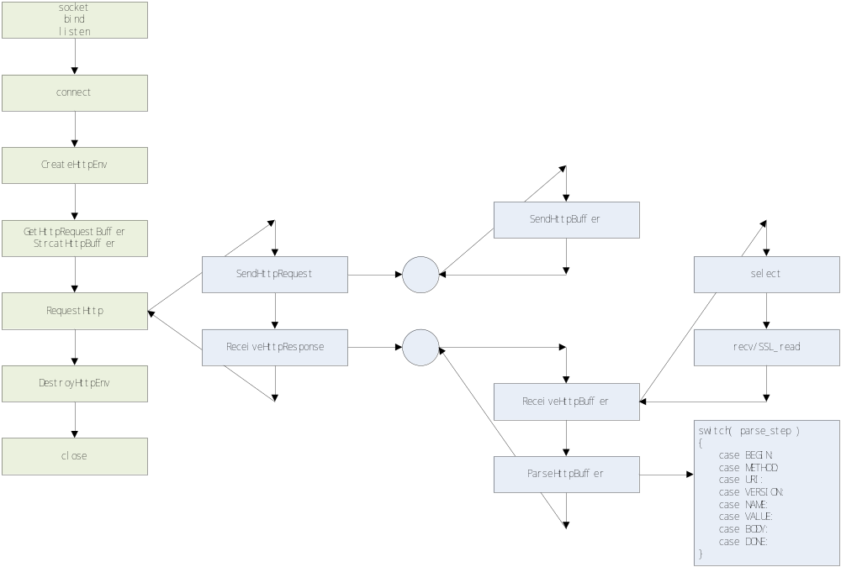
以上为客户端（堵塞模式）API内部调用关系图，土黄色为应用层流程，蓝色为fasterhttp内部流程。可见RequestHttp调用了SendHttpRequest发送HTTP请求，再调用了ReceiveHttpResponse接收、解析HTTP响应。SendHttpRequest调用了内部公共函数SendHttpBuffer发送缓冲区数据到TCP。ReceiveHttpResponse内部循环调用ReceiveHttpBuffer和ParseHttpBuffer，直到HTTP响应数据接收完整且解析完成。

服务端API内部调用关系
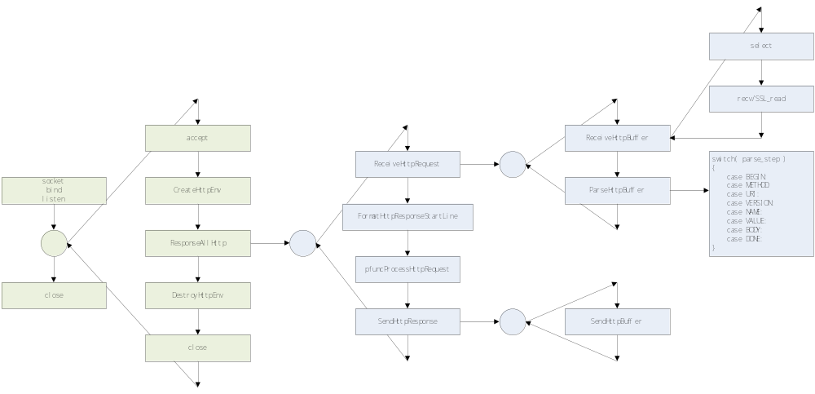
以上为服务端（堵塞模式）API内部调用关系，土黄色为应用层流程，蓝色为fasterhttp内部流程。可见ResponseAllHttp内部调用ReceiveHttpRequest接收、解析HTTP请求，再调用FormatHttpResponseStartLine默认组织响应首行，然后调用pfuncProcessHttpRequest处理HTTP请求、生成HTTP响应，如果出错则再次调用FormatHttpResponseStartLine组织带错误码的响应首行，最后调用SendHttpResponse发送HTTP响应，如果客户端要求连接保持则再原连接上迭代。ReceiveHttpRequest内部循环调用ReceiveHttpBuffer和ParseHttpBuffer，直到HTTP请求数据接收完整且解析完成。SendHttpResponse调用了内部公共函数SendHttpBuffer发送缓冲区数据到TCP。

