# **Test Document**

## **Report generation Test plan**

|  |  |  |  |
| --- | --- | --- | --- |
| **Test Case ID** | **Objective** | **Steps** | **Expected Result** |
| TC-01 | Verify that the report gets generated and populated with relevant data | * Prepare test data. * Generate report. * Verify report path is not null. * Check if file is created and not empty. | Report file should be created and contain data. |
| TC-01 | Verify that no report is generated when no data is available. | * Prepare empty lists. * Generate report. * Verify report path is null. * Check no file is created. | No report file should be created, and the returned path should be null. |
|  |  |  |  |

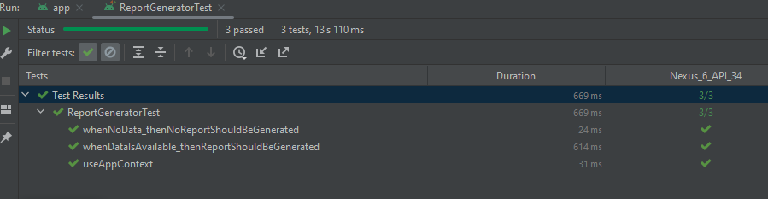

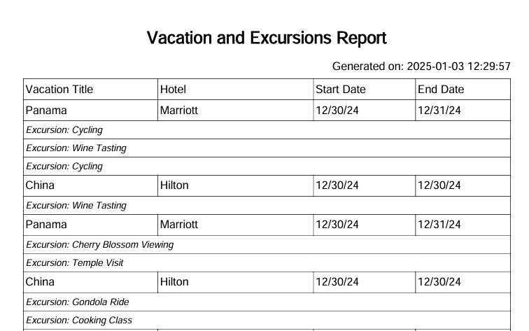

## **Search Functionality Test plan**

|  |  |  |  |
| --- | --- | --- | --- |
| **Test Case ID** | **Objective** | **Steps** | **Expected Result** |
| TC-03 | Verify user can successfully search for available vacation | Perform a search for an existing entry "China":   * Verify that the search text input is displayed. * Type "China". * Verify that a vacation with title “China” is displayed. | The search result for a vacation with title "China" should be displayed. |
| TC-01 | Search for Non-Existent Vacation | Perform a search for a non-existent entry "Nonexistent"   * Verify that the search text input is displayed. * Type "Nonexistent". * Verify that no results are found. | A message "No results found" should be displayed when no matching results are found. |
|  |  |  |  |

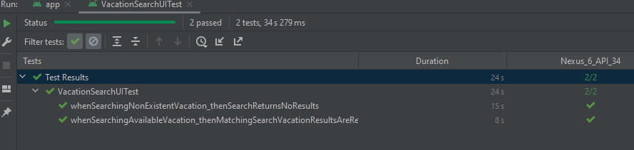

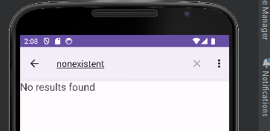

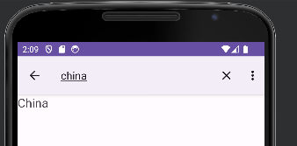

# **Sample app Run**

