Calvin Jay P. Bareja | OIC-NW

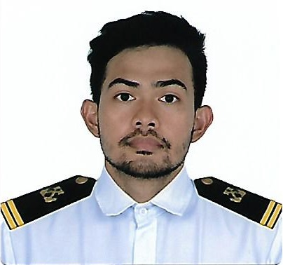

Location: Paranaque, Philippines

Contact No: +63977-634-85-02

E-mail: [calvinbareja89@gmail.com](mailto:calvinbareja89@gmail.com)

Professional Profile

Currently working under the company Unitra Maritime Manila Inc. (UMMI) and finished my contract as a Third Officer. Taking up Master’s Degree in Ship Management at Asian Institute for Maritime Studies. Planning to invest my knowledge in teaching the next generation about seafaring and learn to build my confidence. Looking forward to be a responsible Ship Captain in the future.

Core Qualifications

* Well versed in working on board a vessel.
* Excellent Driver (Vehicle, Crane and Ship)
* Welding, Rope works and rigging
* Security
* Computer Troubleshooting (Basic Networking)

Career Summary

December 2020 – September 2021 Interworld Shipping Corp (IWS) – Third Officer (Container 13,448 GRT

In charge of maintaining LSA (Life Saving Appliances) and FFA (Fire Fighting Apparatus) on board. Takes watch during navigation and during port stay. Receive instruction from Master and Chief Officer. Follows company policy and order given by management and executes it safely and without harm of person and environment.

December 2016 – August 2020 Unitra Maritime Manila Inc. (UMMI) – Third Officer (General Cargo 5,578 GRT)

20 July 2019 – 29 Aug 2020

Able Bodied Seafarer (Bulk Carrier)

January 2017 – December 2017 Grab PH - Driver

Worked part time which greatly helped my driving skills on the road and be a defensive driver.

December 2012 – October 2018 Hartmann Crewing Philippines - Able Bodied Seaman (Gen Cargo, Container)

(Formerly Associated Ship Ordinary Seaman (Bulk Carrier)

Management) Deck Cadet (Bulk Carrier)

Started my seafaring career in this company and build my confidence, skills and

knowledge as seafarer.

December 2011 – December 2012 Philippine Red Cross – Volunteer

Trained in First aid, Basic Life support and use of AED and eventually started volunteering which then gave me the opportunity to finish my OJT as a Data Encoder for my CCMTC vocational course. A regular blood donor to help with other people in need of blood.

Education and Trainings

IMO Model Course 3.12 National Maritime Polytechnic, Makati

(Assessor Training Course) December 2017

IMO Model Course 6.09 National Maritime Polytechnic, Makati

(Instructor Training Course) October 2017

OIC-NW COC Holder MARINA

Valid until 2019

Electric Arc & Gas Welding Course SETAMS

April 8, 13-15, 2019

Board Passer PRC, Manila

January 2014 (Average Score of 86.10%)

Pre-Sea Graduate Intership Navigation Training Center, Manila

August 2012

B.S. In Marine Transportation Philippine Maritime Institute, Manila

September 2013

Basic Computer Operations Caloocan City Manpower Training Center

November 2010

Engine Repair and Troubleshooting Lorraine Technical School, Caloocan City

Summer 2010

PC Networking and Informatics, Caloocan City

Troubleshooting June 2009

Hobbies and Interest

* Volunteer work
* Swimming
* Computer

References

Ma. Criselda D. Tique

Clerk 3 - Metropolitan Trial Court Branch 43 Quezon City

924-39-83

Urie Gabriel De Asis

Aircraft Mechanic A / Level 2 – Lufthansa Technik Philippines

0995-266-9626

Day Anne Judith L. Tenebro

Product Development Specialist – San Miguel Purefoods Company Magnolia Inc.

0999-993-6390