intro:

the focus of this assignment will be solving two minimisation optimisation problems using an evolutionary algorithm. The first problem function is  
where -10 ≤ x ≤ 10, d=20. The second problem function is   
where -500 ≤ x ≤ 500, d=20 and 31 refers to my student number (22010031). Evolutionary algorithms are particularly good for tasks like this because they gradually improve solutions across generations by mimicking natural selection. They are effective at exploring large, complex search spaces without needing derivative information. They iteratively improve solutions through selection, mutation and crossover expand, being particularly effective for optimisation problems like the two this report will be exploring. In order to implement and analyse an evolutionary algorithm to solve the two given problems, exploring how changes in parameters like mutation rate, mutation step size, population size and number of generations affect the performance, and comparing these results with other optimisation methods will be vital.

The algorithm starts by initialising a population of potential solutions within the parameter ranges of each function. The fitness of each individual is then evaluated, followed by applying mutation and crossover to generate new individuals. Selection and replacement are used to ensure that the best solutions are kept, leading to gradual improvement over generations.

The experimentation part of this report will focus on analysing how different algorithm parameters affect the performance of the algorithm for both problems, specifically evaluating aspects such as convergence speed, stability, and solution quality. The main parameters are the mutation rate, the mutation step size, population size and number of generations. These parameters control the behaviour of the algorithm and should have significant effects on the speed of the minimisation and the quality of the solutions. In the case of these two problems, the initialisation is relatively similar, with them both being initialised with 50 individuals, shown by the P value, and each individual being made up of 20 values in the ranges of [-10,10] and [-500,500] in the first and second problem respectively, shown by the N value. In both cases, the algorithm runs for 100 generations. the fitness of each individual in the population is calculated by plugging the individual into the test function, and in both cases, a lower value indicates a better solution. Each generation undergoes a cycle of mutation and crossover. For mutation, each gene has a probability defined by the mutation rate, shown by MUTRATE, with small random changes applied to it within the defined mutation step size, shown by MUTSTEP. Crossover happens between pairs of individuals in the population, where a random crossover point is chosen and their genes are swapped, creating two offspring. These offspring are then used in the next generation, with their fitness calculated like the individuals before them. Initially, both problems were tested with a MUTRATE of 1/N and a MUTSTEP of 0.1. These values were chosen to provide a balanced starting point, making it possible to observe the initial behaviour of the algorithm and establish a benchmark for further experimentation. The graphs below show the evolution of both problems fitness over 100 generations, with each having 6 graphs shown together to show how the algorithm initially works. The best fitness, along with average fitness, gradually improves in both cases, minimising towards 0. This suggests that the population is converging towards an optimal solution, but does not reach it efficiently with the baseline parameters. With further experimentation, parameters like MUTSTEP, MUTRATE, P, and the number of generations will be modified to find more optimal solutions. These changes are expected to affect how well the algorithm explores and refines solutions, helping us determine the best settings for these problems.

Figure 2: baseline graphs of function 2

The experiments that were conducted on the functions were done so to determine the best parameter values that would lead to best convergence and lowest fitness value. Each parameter is tested systematically while keeping all other parameters at their baseline value as shown above. This way of testing allowed a clearer understanding of how the individual parameters affected the performance of the evolutionary algorithm, which, along with finding the optimal solution, is the goal of this report. In the experiments, the mutation rate, or MUTRATE, was tested with 3 different values, a ‘low’ value of 0.01, a ‘medium’ value of 0.1, and a ‘high’ value of 0.5. this was in order to assess how the mutation rate affected the algorithm exploring the problem space. A low mutation rate was expected to limit exploration, potentially causing the algorithm to get stuck in local optima. A high mutation rate was expected to be mostly unstable and possibly jump in and out of local optima’s, but be more diverse as well. Mutation step size, or MUTSTEP, was tested with the same low, medium, and high values of 0.01, 0.1, and 0.5 respectively. In theory, a smaller step size meant more fine tuning of solutions, but possibly not being able to explore as well as a larger step size, whereas the high value might mean overshooting the target. In the case of the population size, values of 20, 50 and 100 were tested to explore their effect on diversity of the individuals and the speed of convergence. A smaller population was expected to have less diversity, but converge to 0 faster, with a faster program. A larger population was expected to maintain diversity for longer but take longer for the program to execute, which would be an issue in larger problems. Lastly, the number of generations was tested to see when the point of diminishing returns is in relation to computational power. Values of 50, 100 and 200 were tested, with the higher value of iterations expected to give the algorithm more opportunities to improve, but at the risk of converging early and wasting resources. Each experiment was repeated 5 times in order to account for the inherent randomness of evolutionary algorithms. When one parameter was being tested, the others were set to their baseline values of P = 50, MUTSTEP = 0.1, MUTRATE = 1/N, and Generations = 100.

Figure 1: baseline graphs of function 1

|  |  |  |  |  |
| --- | --- | --- | --- | --- |
| MUTRATE | Avg best fit | Avg avg fit | Avg best fit (g1) | Avg best fit (g50) |
| .01 | 21264.8563 | 156632.8046 | 552056.5853 | 77986.40599 |
| .1 | 26346.92031 | 143824.4822 | 526122.4506 | 82531.9001 |
| .5 | 20544.96131 | 134284.2079 | 424135.6688 | 73328.6592 |

In the case of the first function, it seems that individually, the mutation rate changing had a negligible effect on the fitness value, as seen in the table and graph. The difference between the highest best fitness value and the lowest best fitness value at the final generation is small, with a 0.5 mutation rate having the lowest best fitness value, of 20544.96. this number is a large value in terms of the fact that this is a minimisation function, which points to mutation rate not being a significant factor in isolation in exploring the problem space of function 1. Mutation rate primarily influences the exploration of the problem space, but other factors, such as the population size and the mutation step size also play a big role in that. This shows that in isolation, mutation rate for this functions’ impact is diminished, as it needs to be used in tandem with the other parameters to have a meaningful effect.

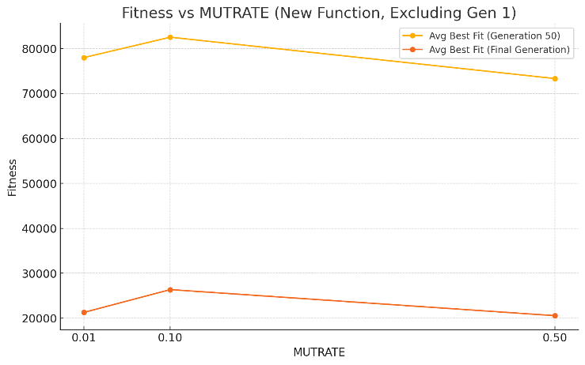

Figure 3: MUTRATE’s effect on the average of best fitness at final generation vs generation 50 over 6 runs on function 1

|  |  |  |  |  |
| --- | --- | --- | --- | --- |
| MUTRATE | Avg best fit | Avg avg fit | Avg best fit (g1) | Avg best fit (g50) |
| .01 | 2611.673870 | 3984.298874 | 6540.282387 | 3843.889209 |
| .1 | 2559.636893 | 3973.96899 | 6247.06323 | 3570.60501 |
| .5 | 2617.18480 | 4188.189568 | 6388.954277 | 4210.96644 |

This is also shown in function 2, where the difference between the best fitness is minute, with a 0.1 mutation rate slightly edging the others out. While small, the difference in the best fitness’ between results did show that a mutation rate of 0.1 did allow for a better level of balance between exploration and exploitation. A mutation rate of 0.01 being worse indicates that it resulted in premature convergence and not allowing for thorough exploration of the problem space, whereas a mutation rate of 0.5 introduced too much randomness within the results, not allowing the function to converge on an adequate solution. These results differ from those found with the first function, where a higher mutation rate performed better, which points to the first problem needing more aggressive exploration to find a good solution.

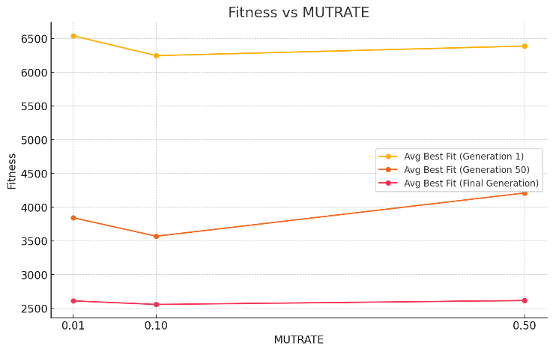

Figure 4: MUTRATE’s effect on the average of best fitness at final generation vs generation 50 vs generation 1 over 6 runs on function 2

Function 1

|  |  |  |  |  |
| --- | --- | --- | --- | --- |
| Population | Avg best fit | Avg avg fit | Avg best fit (g1) | Avg best fit (g50) |
| 20 | 49660.7226 | 54383.92901 | 542424.667 | 78197.3703 |
| 50 | 16790.85106 | 147464.4278 | 448035.2033 | 67042.72066 |
| 100 | 30327.0344 | 486908.4526 | 374050.3413 | 78091.09071 |

Function 2:

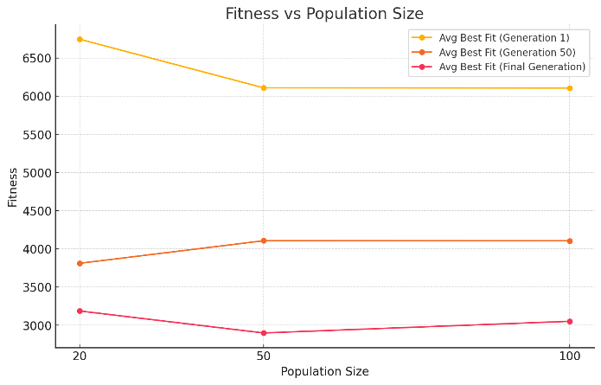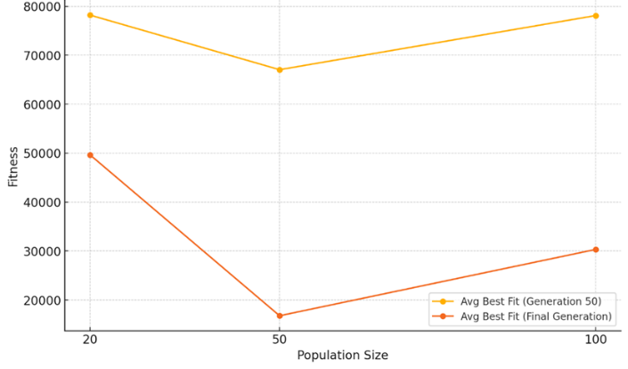

Figure 5: population sizes’ effect on the average of best fitness at final generation vs generation 50 over 6 runs on function 1

Figure 6: population sizes’ effect on the average of best fitness at final generation vs generation 50 vs generation 1 over 6 runs on function 2

|  |  |  |  |  |
| --- | --- | --- | --- | --- |
| Population | Avg best fit | Avg avg fit | Avg best fit (g1) | Avg best fit (g50) |
| 20 | 3187.02097 | 3306.647195 | 6744.822717 | 3811.218105 |
| 50 | 2899.151429 | 4184.148339 | 6108.737298 | 4106.405603 |
| 100 | 3051.893367 | 5664.128993 | 6106.39468 | 4105.939057 |

The population size on both functions had a similar result of a population size of 50 being the best. The population size is a significant parameter and works closely with the MUTRATE to balance exploration vs exploitation, and increasing it can increase diversity, but also computational costs. In function 1, the difference is quite large between the 3 values, with P=50 being significantly lower than the other 2, 20 especially. This shows that function 1 needed a moderate amount of diversity, but too much (P=100) didn’t lead to improvements at all and thus isn’t worth the extra time and effort for the increased diversity. On the other hand, function 2’s results were much closer, showing that for function 2, like MUTRATE, population size in isolation is also not a hugely significant parameter. This suggests that function 2 can be solved with a range of population sizes, and that a population size of 50 is the optimal balance between diversity and computational efficiency. Function 2 appears to be less dependent on diversity, pointing to a potentially simpler problem space than function 1.

|  |  |  |  |  |
| --- | --- | --- | --- | --- |
| MUTSTEP | Avg best fit | Avg avg fit | Avg best fit (g1) | Avg best fit (g50) |
| 0.01 | 31923.6636 | 200351.9021 | 619958.5653 | 108127.2212 |
| 0.1 | 36365.2746 | 187703.2227 | 465840.3275 | 69586.8715 |
| 0.5 | 12613.1524 | 114812.8570 | 328274.6386 | 60151.1525 |

The mutation step size significantly affects the convergence of the function in that it affects how big the changes are to individuals. A MUTSTEP of 0.5 provided the best results, majorly outperforming the other values. This allowed the algorithm to explore the complex problem space effectively and made sure it didn’t get stuck in local optima. The big jump between the best fitness at generation 1 vs generation 50 shows that a large mutation step size improves the solution heavily in the early stages. Both of the other values were too small to properly explore the problem space and couldn’t converge on a more effective solution, and possible got stuck in local optima. This highlights the complex problem space that function 1 has, and shows the significance of the mutation step size in comparison to mutation rate and population size.

Figure 7: MUTSTEP’s effect on the average of best fitness at final generation vs generation 50 over 6 runs on function 1

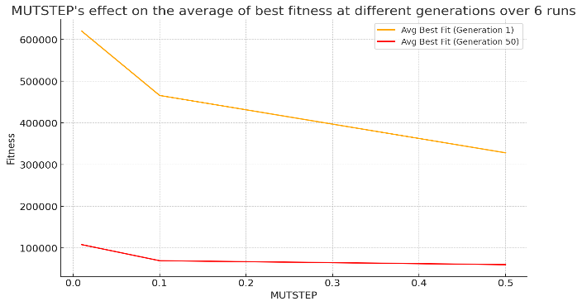

|  |  |  |  |  |
| --- | --- | --- | --- | --- |
| MUTSTEP | Avg best fit | Avg avg fit | Avg best fit (g1) | Avg best fit (g50) |
| 0.01 | 2895.557788 | 4486.601737 | 6231.841436 | 4058.25791 |
| 0.1 | 3096.852681 | 4248.999936 | 6321.957488 | 3906.868407 |
| 0.5 | 2549.463244 | 4231.548853 | 6269.265062 | 4069.403122 |

similarly, a mutation step size of 0.5 provided the best results for function 2, while not as large of a difference. It also had the worst best fitness result at generation 50, showing that for function 2, a large mutstep seemingly works better at a larger generation number. Although a mutation step size of 0.5 is the best result out of the experiments, it is still much higher than the optimal result of this function, showing that, like population size and mutation rate before it, mutation step size is not as significant on its own.

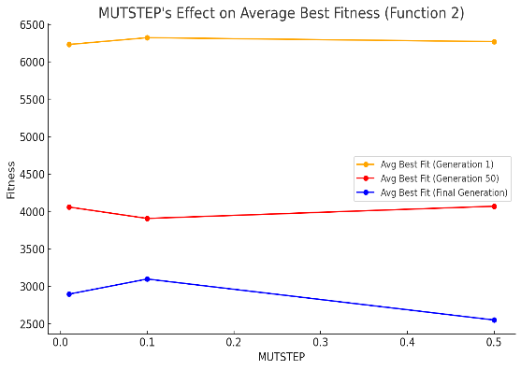

Figure 8: MUTSTEP’s’ effect on the average of best fitness at final generation vs generation 50 vs generation 1 over 6 runs on function 2

|  |  |  |  |  |
| --- | --- | --- | --- | --- |
| Generations | Avg best fit | Avg avg fit | Avg best fit (g1) | Avg best fit (g50) |
| 50 | 74080.58999 | 560620.7663 | 441454.5091 | 74080.58999 |
| 100 | 19041.3223 | 171873.3396 | 487803.1499 | 72928.55007 |
| 200 | 4176.854871 | 10431.69209 | 323651.2374 | 52376.92608 |

For function 1, the number of generations had a seemingly very significant effect on the fitness values. From 50 generations to 100 generations, there was a massive jump, from 74000 to 19000. From 100 to 200 generations, there was still a big jump, but definitely less impactful than the jump from 50 to 100, going from 19000 to 4000. Depending on the necessities of the person doing these experiments, a generations value of 100 may be good enough, seeing the huge jump, but for the purposes of this report, a generations value of 200 performed the best, and in isolation, had the most impact out of any of the parameters.

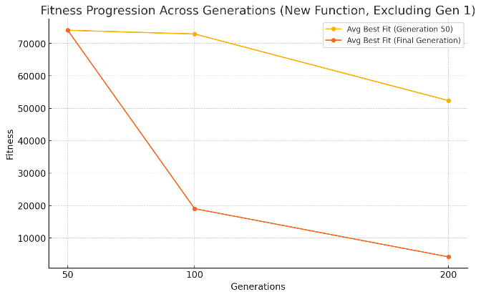

Figure 9: number of generations effect on the average of best fitness at final generation vs generation 50 over 6 runs on function 1

|  |  |  |  |  |
| --- | --- | --- | --- | --- |
| Generations | Avg best fit | Avg avg fit | Avg best fit (g1) | Avg best fit (g50) |
| 50 | 4023.184983 | 6001.50355 | 5907.735552 | 4023.184983 |
| 100 | 2876.696227 | 4340.742271 | 6212.578331 | 4186.121582 |
| 200 | 2052.312613 | 2458.469469 | 6638.755706 | 3991.246974 |

like function 1, function 2 also had the best result at generations = 200, but a slower improvement from 100 to 200, compared with 50-100. On the other hand, the ‘slower’ improvement was only slight, maybe suggesting that function 2 would have a better result to computational cost ratio at even higher generations. in the case of both of these functions, a higher number of generations inherently will increase the best fitness result, due to the fact that a higher number of generations only gives the function more chances to improve, but at a certain point, it is not worth the resources to do so. In the case of function 1, that point seems to be at around 200, potentially less with more testing, whereas in the case of function 2, it could potentially be higher.

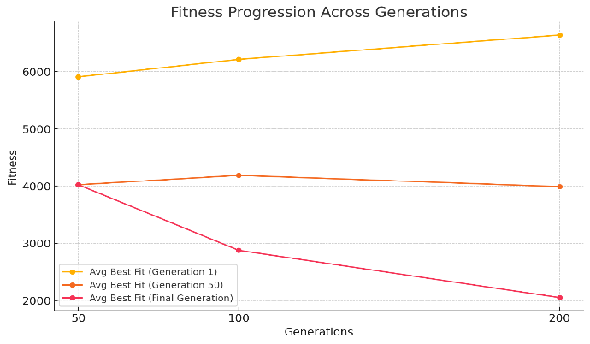

Figure 10: number of generations effect on the average of best fitness at final generation vs generation 50 vs generation 1 over 6 runs on function 2

After conducting individual experiments on each parameter, an optimal set of values was found for each function. In the case of function 1, the experiments found the best values that provided the best result, but for function 2, different values provided better results than what was predicted through the experimentation. In the initial experiments, the best performance for function 1 was seen with a mutation rate ranging from 0.1 to 0.5 providing relatively similar performances and a mutation step size of 0.5 giving the best average fitness, indicating that larger jumps were beneficial for exploration. A population size of 50 provided a good balance between diversity and convergence speed, compared to smaller and larger populations and increasing generations from 50 to 200 led to better convergence, but with diminishing returns. However, during combined parameter testing, it was found that the mutation rate of 0.5 and mutation step size of 0.5 performed the best when used together. This combination allowed both effective exploration and refined exploitation of the problem space. Additionally, while a population size of 50 was retained, the use of 200 generations provided enough evolutionary time for convergence without introducing significant inefficiencies or unnecessary computational costs. For function 2, a mutation rate of 0.5 was preferred, allowing sufficient exploration while maintaining some stability, with a mutation step size of 0.5 working well in isolation, balancing exploration and exploitation. A population size: of 50 was found to be optimal for balancing diversity and convergence and increasing to 200 generations produced the best results, but with diminishing return. however, combined testing showed that 250 generations and a slightly higher mutation step size of 0.7 performed better for function 2. the larger number of generations provided more opportunities for gradual improvement, while the higher mutation step size allowed for broader exploration, which appeared to be beneficial in this more rugged and extensive search space.