Task 1

1. **Simulating geometric Brownian motion**

Theoretical Expectation of S(3) = 52.6444934955

Theoretical Variance of S(3) = 623.09647233

By running the code in python, we can get a plot of 5 realisation of geometric Brownian motion.

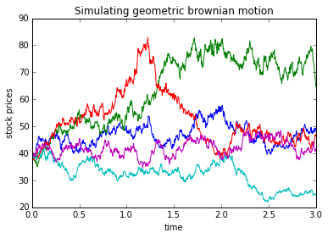

1. Expectation value of S(3)

- is calculated by using a numpy function, which is ‘np.mean’. We find the mean for all the values at time=3.

- the result we will get is E(s3)= 50.3992148652.

2. Variance of S(3)

- is calculated by using a numpy function, which is ‘np.var’. We find the variance for all the values at time=3.

- the result we will get is Var(s3)= 552.713735223

3. To calculate P[S(3) > 39]

- we find how much of the S(3) is larger than 39 and stored it in ‘count1’, then by using the ‘sum’ function, we calculate how many ‘ True’ is in the count1.

- the result is P(s3>39) = 0.645

- Then we divide the number of S(3)>39 with the total number of path to get the answer.

4. To calculate E[S(3) | S(3) > 39]

- we find the summation of S(3) that is larger than 39 by using ‘sum’ function

- then we divided it by the number of S(3) that are exceeded 39.

- E[s3 | s3 > 39] = 61.6987567358

#### (2) Simulating mean reversal process

By running the code in python, we can get a plot of 5 realisation of mean reversal process.

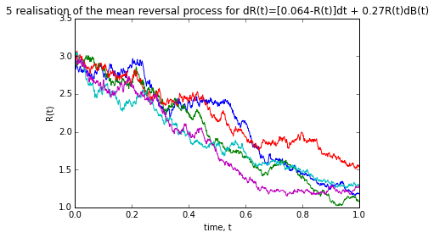

1. Expectation value of R(1)

- is calculated by using a numpy function, which is ‘np.mean’. We find the mean for all the values at time=1.

- The expected value of R(1) is 1.15359801189

2. P[R(1) > 2].

- We find how much R(1) are exceeded 2

- then we divide it with total number of paths to get P[R(1) > 2].

- the result is P[R(1)> 2 ]= 0.019

Task 2

1. There are 30 component stocks in the FTSE Bursa Malaysia KLCI Index. (Information is as at 22/6/2015.)

|  |  |  |  |  |  |
| --- | --- | --- | --- | --- | --- |
| **Stock Name** | **Stock Code** | **Stock sector** | **Weightage(%)** | **PE ratio** | **Net market capital(MYRb)** |
| AMMB Holdings | [1015](http://www.bursamalaysia.com/market/listed-companies/list-of-companies/plc-profile.html?stock_code=1015) | Bank | 2.38 | 8.82 | 16.97 |
| Astro Malaysia Holdings | [6399](http://www.bursamalaysia.com/market/listed-companies/list-of-companies/plc-profile.html?stock_code=6399) | broadcasting and entertainment | 1.22 | 28.06 | 15.761 |
| Axiata Group | [6888](http://www.bursamalaysia.com/market/listed-companies/list-of-companies/plc-profile.html?stock_code=6888) | Mobile telecommunication | 5.67 | 24.18 | 55.349 |
| British American Tobacco (Malaysia) | [4162](http://www.bursamalaysia.com/market/listed-companies/list-of-companies/plc-profile.html?stock_code=4162) | consumer | 1 | 20.06 | 18.445 |
| CIMB Group Holdings | [1023](http://www.bursamalaysia.com/market/listed-companies/list-of-companies/plc-profile.html?stock_code=1023) | bank | 5.96 | 17.52 | 46.694 |
| Digi.com | [6947](http://www.bursamalaysia.com/market/listed-companies/list-of-companies/plc-profile.html?stock_code=6947) | Mobile telecommunication | 4.04 | 21.02 | 41.83 |
| Genting | [3182](http://www.bursamalaysia.com/market/listed-companies/list-of-companies/plc-profile.html?stock_code=3182) | Travel & leisure | 3.68 | 19.3 | 30.748 |
| Genting Malaysia | [4715](http://www.bursamalaysia.com/market/listed-companies/list-of-companies/plc-profile.html?stock_code=4715) | Travel & leisure | 2.5 | 20.59 | 25.71 |
| Hong Leong Bank | [5819](http://www.bursamalaysia.com/market/listed-companies/list-of-companies/plc-profile.html?stock_code=5819) | banks | 1.67 | 11.19 | 24.572 |
| Hong Leong Financial | [1082](http://www.bursamalaysia.com/market/listed-companies/list-of-companies/plc-profile.html?stock_code=1082) | finance | 0.64 | 9.92 | 16.255 |
| IHH Healthcare | [5225](http://www.bursamalaysia.com/market/listed-companies/list-of-companies/plc-profile.html?stock_code=5225) | health care provider | 3.28 | 63.15 | 48.758 |
| IOI | [1961](http://www.bursamalaysia.com/market/listed-companies/list-of-companies/plc-profile.html?stock_code=1961) | plantation | 2.99 | 73.65 | 26.731 |
| KLCC Prop & Reits- stapled sec | 5235ss | tursts | 0.63 | 26.42 | 12.64 |
| Kuala Lumpur Kepong | [2445](http://www.bursamalaysia.com/market/listed-companies/list-of-companies/plc-profile.html?stock_code=2445) | plantation | 2.28 | 29.21 | 23.983 |
| Malayan Banking | [1155](http://www.bursamalaysia.com/market/listed-companies/list-of-companies/plc-profile.html?stock_code=1155) | bank | 9.32 | 12.45 | 88.041 |
| Maxis | [6012](http://www.bursamalaysia.com/market/listed-companies/list-of-companies/plc-profile.html?stock_code=6012) | Mobile telecommunication | 3.45 | 30.05 | 49.409 |
| MISC | [3816](http://www.bursamalaysia.com/market/listed-companies/list-of-companies/plc-profile.html?stock_code=3816) | marine transportation | 2.45 | 15.99 | 35.264 |
| PETRONAS Chemicals Group | [5183](http://www.bursamalaysia.com/market/listed-companies/list-of-companies/plc-profile.html?stock_code=5183) | chemicals | 3.68 | 21.83 | 50.64 |
| Petronas Dagangan | [5681](http://www.bursamalaysia.com/market/listed-companies/list-of-companies/plc-profile.html?stock_code=5681) | Oil & gas producers | 1.21 | 37.05 | 20.445 |
| Petronas Gas | [6033](http://www.bursamalaysia.com/market/listed-companies/list-of-companies/plc-profile.html?stock_code=6033) | Oil & gas producers | 3.4 | 22.79 | 42.741 |
| PPB Group | [4065](http://www.bursamalaysia.com/market/listed-companies/list-of-companies/plc-profile.html?stock_code=4065) | plantation | 1.8 | 18.13 | 18.233 |
| Public Bank | [1295](http://www.bursamalaysia.com/market/listed-companies/list-of-companies/plc-profile.html?stock_code=1295) | banks | 11.75 | 15.21 | 73.368 |
| RHB Capital | [1066](http://www.bursamalaysia.com/market/listed-companies/list-of-companies/plc-profile.html?stock_code=1066) | banks | 1.06 | 9.18 | 19.129 |
| SapuraKencana Petroleum | [5218](http://www.bursamalaysia.com/market/listed-companies/list-of-companies/plc-profile.html?stock_code=5218) | Oil & gas producers | 1.98 | 12.08 | 14.321 |
| Sime Darby | [4197](http://www.bursamalaysia.com/market/listed-companies/list-of-companies/plc-profile.html?stock_code=4197) | General industry | 5.56 | 21.89 | 52.671 |
| Telekom Malaysia | [4863](http://www.bursamalaysia.com/market/listed-companies/list-of-companies/plc-profile.html?stock_code=4863) | Mobile telecommunication | 2.96 | 32.34 | 24.915 |
| Tenaga Nasional | [5347](http://www.bursamalaysia.com/market/listed-companies/list-of-companies/plc-profile.html?stock_code=5347) | electricity | 9.28 | 9.15 | 69.304 |
| UMW Holdings | [4588](http://www.bursamalaysia.com/market/listed-companies/list-of-companies/plc-profile.html?stock_code=4588) | consumer | 1.37 | 20.41 | 11.987 |
| Westports holdings | 5246 | transportation services | 0.93 | 27.44 | 14.36 |
| YTL Corp | [4677](http://www.bursamalaysia.com/market/listed-companies/list-of-companies/plc-profile.html?stock_code=4677) | Oil & gas producers | 1.63 | 14.95 | 16.67 |

2. To obtain the 5-day moving average.

- I have chosen Malayan banking(1155), and the Maybank data is downloaded for time period 1/1/2012 to 1/1/2015.

- to find the 5-day moving average, we take the summation of the stock prices of Maybank for 5 days, then divide it by 5.

- we first define a function of moving_avg(values, days)

-then by taking only the closing price of maybank, we use function of *moving_avg* to get the 5-day moving average value.

The 5-day moving average plot is as follow:

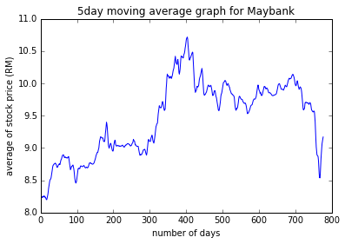

From running the code, we can obtain the correlation of Maybank and FTSEKLCI data, which is equal to 0.852908.