| **Interval (zile) de la data confirmarii)** | | ***(0,3]*** | ***(3,7]*** | ***(7,14]*** | ***(14,21]*** | ***(21,28]*** | ***(28,Inf]*** | ***Total*** |
| --- | --- | --- | --- | --- | --- | --- | --- | --- |
| *53 (4.7%)* | *218 (19.4%)* | *515 (45.9%)* | ***220 (19.6%)*** | *84 (7.5%)* | *31 (2.8%)* | *1121* |
| **RT - PCR** | **detectable** | 35 (81.4%) | 157 (82.6%) | 301 (67.6%) | **119 (56.7%)** | 47 (56.6%) | 16 (51.6%) | 675 (67.4%) |
| **negative** | 8 (18.6%) | 33 (17.4%) | 144 (32.4%) | 91 (43.3%) | 36 (43.4%) | 15 (48.4%) | 327 (32.6%) |
| **IgM** | **μ ±DS** | 3.15 ±9.72 | 1.85 ±3.97 | 4.65 ±12.7 | 8.58 ±20.7 | 3.15 ±4.3 | 4.74 ±4.39 | 4.14 ±11.9 |
| **Gμ ±DS** | 0.745 ±3.82 | 0.784 ±2.98 | 1.46 ±3.65 | **2.77 ±3.79** | 1.77 ±2.84 | 2.82 ±3.13 | 1.30 ±3.65 |
| **M (min:max)** | 0.41 (0.19:52.57) | 0.57 (0.17:26.56) | 1.14 (0.22:123.08) | **2.56 (0.33:124.84)** | 1.24 (0.49:20.32) | 4.03 (0.52:15.9) | 0.97 (0.17:124.84) |
| **M (IQR)** | 0.41 (0.34-1.38) | 0.57 (0.36-1.29) | 1.14 (0.53-2.6) | 2.56 (0.87-5.36) | 1.24 (0.71-3.74) | 4.03 (0.99-7.92) | 0.97 (0.47-**2.61**) |
| **IgG** | **μ ±DS** | 9.41 ±34.4 | 3.01 ±7.02 | 4.74 ±13.1 | 10.01 ±20.5 | 7.67 ±9.87 | 32.44 ±36.0 | 5.95 ±16.3 |
| **Gμ ±DS** | 1.17 ±4.06 | 1.12 ±2.89 | 1.58 ±3.23 | **3.29 ±4.07** | 3.75 ±3.47 | 12.81 ±5.65 | 1.67 ±3.65 |
| **M (min:max)** | 0.69 (0.5:178.19) | 0.72 (0.49:36.67) | 0.98 (0.52:130.36) | **2 (0.6:133.35)** | 3.8 (0.66:39.48) | 21.46 (0.66:110.17) | 0.9 (0.49:178.19) |
| **M (IQR)** | 0.69 (0.58-0.86) | 0.72 (0.63-0.98) | 0.98 (0.68-2.2) | 2 (1.01-8.41) | 3.8 (1.15-9.05) | 21.46 (2.03-37.66) | 0.9 (0.67-**2.9**) |
| μ ±DS: media, deviatia standard;  Gμ ±DS: media geometrica, deviatia standard  M (min:max): mediana, min, max  M (IQR): mediana, IQR | | | | | | | | |

# Methods

Am exclus pacientii: (n=21 / 493)

* la care nu am gasit data confirmarii sau data primului test
* care au avut mai mult de +/- 14 zile intre data confirmarii si data internarii
* care au avut mai mult de 14 zile intre data confirmarii si data primului test
* la care data primului test a fost inainte de data confirmarii
* duplicate (2 cazuri)

Avem o problema cu decesesle. Figureaza ca decedati doar pacientii care au decedat in SCBI. Baza de date include doar vreo 500 dintre toate cazurile de COVID, deci si doar cateva decese (11) dintre toate decesele reale. Deci, avem o mortalitate de 2.3% pe esantion, care este comparabila cu mortalitatea pe judet, deci cred ca selectia cazurilor a fost ok (pentru moment).

Un pacient a avut o forma asimpomatica de boala, dar a fost internat la ICU pentru altceva. Probabil mai sunt si altii care figureaza cu internare la ICU, dar pentru altceva.

Pe grafice, am unit formele asimptomatice si usoare, respectiv formele intermediare, severe si crititce). Graficele arata doar primele 30 zile de la data confirmarii, dar calculele sunt facute cu toate datele. Nu am separat internarile inainte si dupa 24 iunie, pentru ca oricum se separa de la sine daca nu au destule date.

# Results

For ease of analysis, we cummulated clinical forms into “mild” (asymptomatic to mild) and “severe” (intermediate to critical) clinical forms.

Both IgM and IgG showed an upwards trend with time since confirmation of the infection, more pronounced for IgG values and in patients with a more severe clinical form. Since patients showed a high degree of variability and because the date of confirmation was not a perfect replacement for the date of infection (especially during the beginning of the pandemic when tests were not readily available), our data requires aggressive aggregation to reveal any patterns. As the time-dependent increase in both IgG and IgM values remains visible after factoring in various variables (only clinical severity shown), we expect it be genuine. Both antibodies had higher average and higher variability in patients with more severe forms, suggesting that severity is linked to a higher immune reactivity, at least in a subset of patients. We decided to separate patients into high / low reactivity based on IgM and IgG values at a 75% quartile threshold: patients who had at least 1 antibody measurement above the 75% quartile of all measurements in the database (2.906 for IgG and 2.607 for IgM) were classified as “high reactivity” while the others were classified as “lower reactivity” for IgM and IgG, respectively.

## IgM by time and clinical form

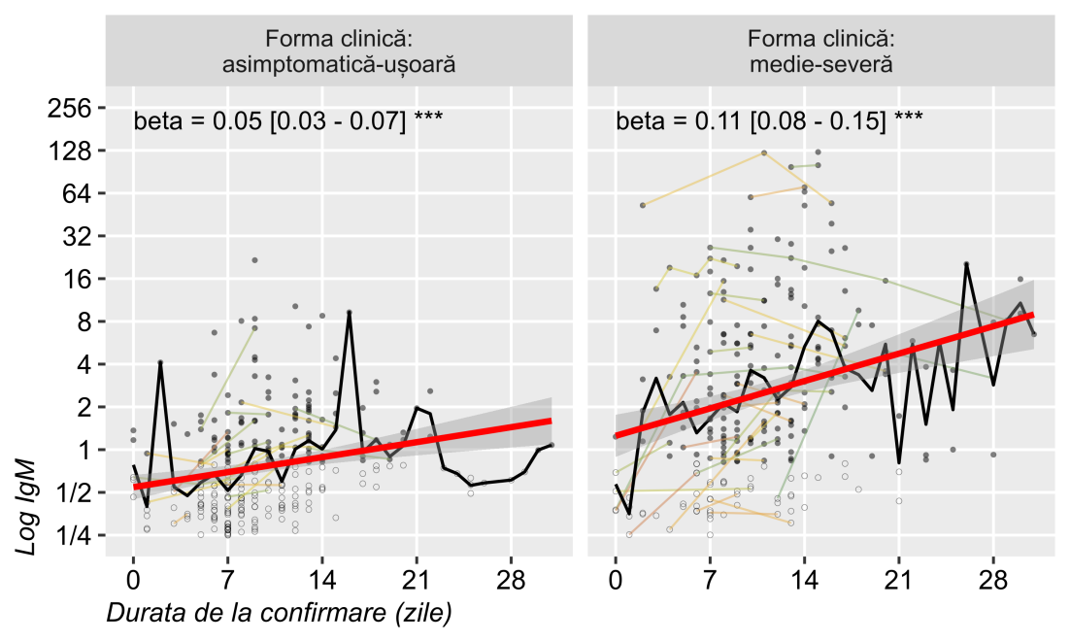

## IgG by time and clinical form

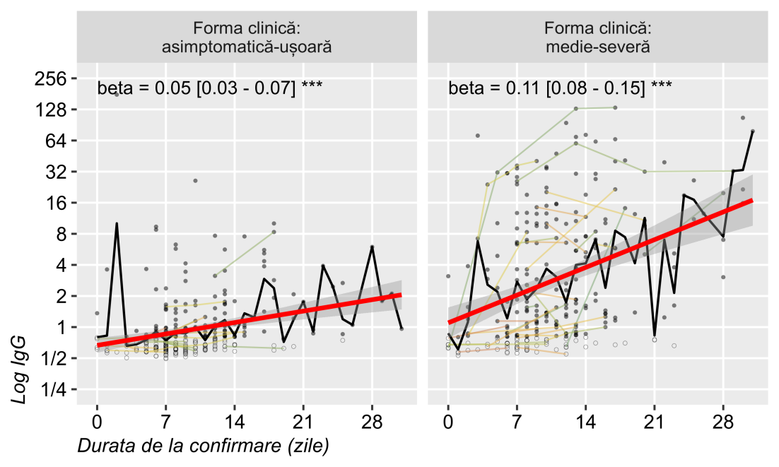

Figure 1: Averaged and plotted against time since confirmation date, both IgM and IgG values showed an upwoards linear trend, more pronounced in severe compared to milder forms, and in IgG compared to IgM. Log y axis; repeated measurements are joined by thin lines; linear regression line with SE; beta coefficient (log titre change per day).

## IgM positivity rate by time and clinical form

Both antibodies showed an upwards trend in positivity rate across time. In both cases, patients with a more severe form had relatively higher rate of positivity after 2-4 weeks as well as after the first few days since confirmation. IgM seem better correlated to severity than IgG. A smaller proportion of patients had detectable levels of IgM compared to IgM in milder cases, while IgG became positive after 1 month in almost all patients, regardless of severity. Similarly, RT-PCR positivity rate decreased faster among patients with milder forms.

The highest number of test were performed during the the first 2 weeks since confirmation. Few patients had follow-up longer then what is shown in the charts. Their data was still included in the calculations, but their effect on the overall results are negligible.

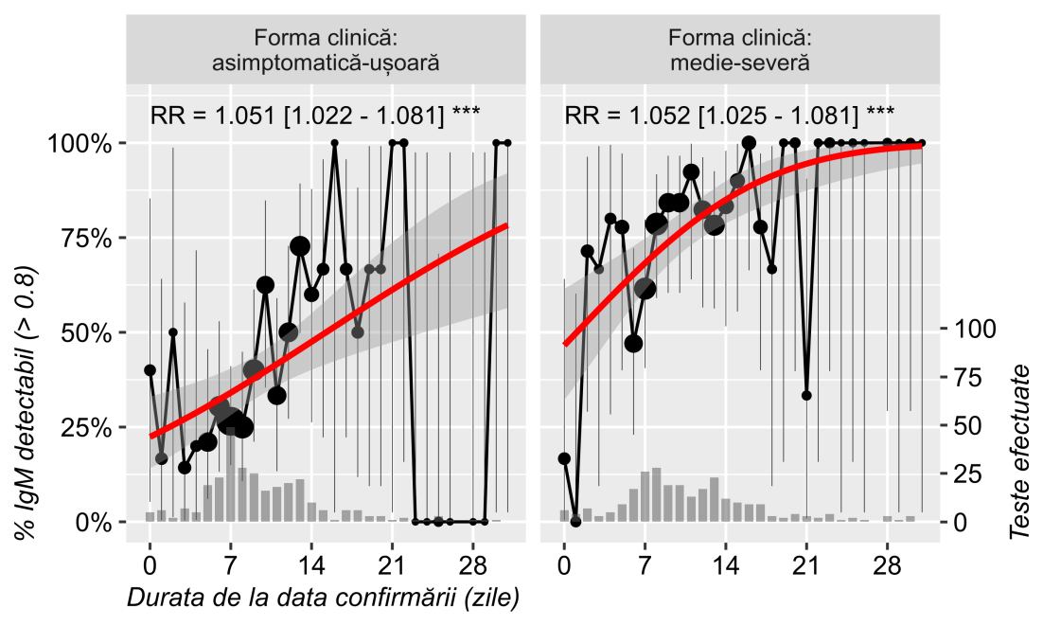

## IgG positivity rate by time and clinical form

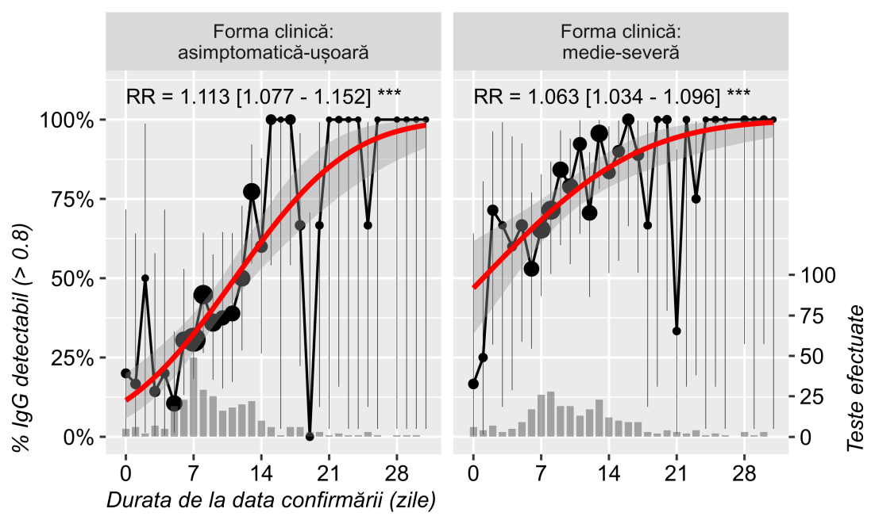

## PCR positivity rate by time and clinical form

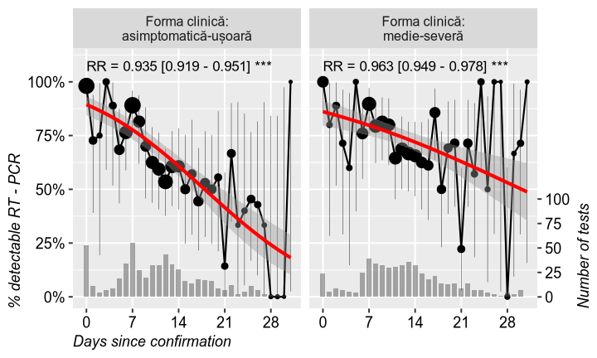

Figure 2: The proportion of patients found with detectable IgM (>0.8), IgG (>0.8) and RT-PCR results (uncertain results removed), by time since confirmation (first month) and clinical severity (mild: asymptomatic to mild; severe: intermediate to critical). Also shown: weighted probit regression line, risk-ratio change per day, number of tests performed (dot area and bottom histogram with right y-axis) and binomial 95% confidence interval around average proportion. ## Summary table by clinical form

## Severe vs mild

Table 1: Sample description by clinical severity (mild: asymptomatic to mild; severe: intermediate to critical).

| **Variable** | **Details** | **severe** | **mild** | **Total** | **Statistics** |
| --- | --- | --- | --- | --- | --- |
| **Clinical form** |  | **208 (44.3%)** | **261 (55.7%)** | **469** |  |
| **Age (years)** | **μ ±SD** | **54.46 ±17.8** | **32.02 ±18.9** | **42.03 ±21.5** | **MW: p<0.001** |
| **M (min:max)** | **54.5 (1:94)** | **32 (0:81)** | **43 (0:94)** |
| **M (IQR)** | **54.5 (43-67)** | **32 (16-46)** | **43 (28-57)** |
| **Sex** | **M** | **116 (55.8%)** | **110 (42.1%)** | **226 (48.2%)** | **OR=1.73 [1.20, 2.50] (p=0.004)** |
| **F** | **92 (44.2%)** | **151 (57.9%)** | **243 (51.8%)** |
| HCW | | 16 (8.2%) | 25 (10.6%) | 41 (9.5%) | OR=0.75 [0.39, 1.45] (p=0.415) |
| **Outcome** | **deceased** | **10 (4.9%)** | **0** | **10 (2.2%)** | **OR=27.98 [1.63, 480.42] (p<0.001)** |
| **alive** | **195 (95.1%)** | **260 (100%)** | **455 (97.8%)** |
| **ICU** | | **27 (13.1%)** | **1 (0.4%)** | **28 (6.0%)** | **OR=39.22 [5.28, 291.23] (p<0.001)** |
| **Transfer to COVID unit** | | **38 (18.4%)** | **16 (6.2%)** | **54 (11.6%)** | **OR=3.43 [1.85, 6.35] (p<0.001)** |
| **Hospitalization (days)** | **μ ±SD** | **17.38 ±12.3** | **12.44 ±7.67** | **14.66 ±10.3** | **MW: p<0.001** |
| **M (min:max)** | **14 (1:101)** | **10 (1:44)** | **12 (1:101)** |
| **M (IQR)** | **14 (11-20.25)** | **10 (8-15)** | **12 (9-17)** |
| Admission to confirmation | μ ±SD | -1.12 ±2.72 | -1.10 ±1.71 | -1.11 ±2.21 | MW: p=0.149 |
| M (min:max) | -1 (-20:5) | -1 (-11:1) | -1 (-20:5) |
| M (IQR) | -1 (-1-0) | -1 (-1-0) | -1 (-1-0) |
| **CT scan** | **crazy paving and/or ground-glass opacities** | **128 (62.4%)** | **6 (2.3%)** | **134 (28.8%)** | **OR=70.65 [29.97, 166.53] (p<0.001)** |
| **no significant changes** | **77 (37.6%)** | **255 (97.7%)** | **332 (71.2%)** |
| **CT - Lung damage** | **high area damage** | **68 (36.2%)** | **0** | **68 (15.2%)** | **OR=293.90 [18.05, 4 786.34] (p<0.001)** |
| **minimal or no lung damage** | **120 (63.8%)** | **258 (100%)** | **378 (84.8%)** |
| **Test 1 (days)** | **μ ±SD** | **7.39 ±4.37** | **6.01 ±4.21** | **6.61 ±4.34** | **MW: p<0.001** |
| **M (min:max)** | **7 (0:21)** | **7 (0:16)** | **7 (0:21)** |
| **M (IQR)** | **7 (5-10)** | **7 (2-9)** | **7 (3-9)** |
| RT - PCR 1 | detectable | 160 (84.7%) | 200 (84.0%) | 360 (84.3%) | OR=1.05 [0.62, 1.77] (p=0.894) |
| negative | 29 (15.3%) | 38 (16.0%) | 67 (15.7%) |
| **IgM 1** | **μ ±SD** | **3.37 ±6.6** | **0.919 ±1.29** | **1.99 ±4.6** | **MW: p<0.001** |
| **M (min:max)** | **1.25 (0.22:52.57)** | **0.47 (0.17:9.29)** | **0.68 (0.17:52.57)** |
| **M (IQR)** | **1.25 (0.55-2.95)** | **0.47 (0.33-0.97)** | **0.68 (0.37-1.61)** |
| **IgG 1** | **μ ±SD** | **4.80 ±9.73** | **2.28 ±14.5** | **3.37 ±12.7** | **MW: p<0.001** |
| **M (min:max)** | **1.14 (0.53:71.5)** | **0.7 (0.49:178.19)** | **0.78 (0.49:178.19)** |
| **M (IQR)** | **1.14 (0.76-3.25)** | **0.7 (0.61-0.86)** | **0.78 (0.64-1.41)** |
| **Test 2 (days)** | **μ ±SD** | **11.77 ±4.59** | **10.46 ±3.74** | **11.14 ±4.3** | **MW: p=0.008** |
| **M (min:max)** | **11 (1:30)** | **11 (1:21)** | **11 (1:30)** |
| **M (IQR)** | **11 (9-14)** | **11 (8-13)** | **11 (8-13.25)** |
| RT - PCR 2 | detectable | 101 (72.7%) | 84 (65.6%) | 185 (69.3%) | OR=1.39 [0.83, 2.35] (p=0.234) |
| negative | 38 (27.3%) | 44 (34.4%) | 82 (30.7%) |
| **IgM 2** | **μ ±SD** | **7.91 ±16.8** | **1.41 ±2.77** | **4.65 ±12.4** | **MW: p<0.001** |
| **M (min:max)** | **2.22 (0.3:123.08)** | **0.71 (0.22:21.63)** | **1.09 (0.22:123.08)** |
| **M (IQR)** | **2.22 (0.84-7.06)** | **0.71 (0.42-1.21)** | **1.09 (0.53-3.21)** |
| **IgG 2** | **μ ±SD** | **7.91 ±13.3** | **1.19 ±1.16** | **4.54 ±9.92** | **MW: p<0.001** |
| **M (min:max)** | **1.58 (0.55:69.39)** | **0.81 (0.52:7.68)** | **0.98 (0.52:69.39)** |
| **M (IQR)** | **1.58 (0.79-10.29)** | **0.81 (0.63-1.08)** | **0.98 (0.69-2.92)** |
| Test 3 (days) | μ ±SD | 16.03 ±6.12 | 14.54 ±4.52 | 15.25 ±5.43 | MW: p=0.127 |
| M (min:max) | 15 (3:37) | 14 (5:26) | 14 (3:37) |
| M (IQR) | 15 (12.25-18.75) | 14 (11-18) | 14 (12-18) |
| RT - PCR 3 | detectable | 56 (61.5%) | 42 (48.8%) | 98 (55.4%) | OR=1.68 [0.92, 3.05] (p=0.098) |
| negative | 35 (38.5%) | 44 (51.2%) | 79 (44.6%) |
| **IgM 3** | **μ ±SD** | **15.41 ±26.6** | **1.59 ±1.79** | **9.17 ±20.8** | **MW: p<0.001** |
| **M (min:max)** | **5.53 (0.24:124.84)** | **0.99 (0.31:8.08)** | **1.99 (0.24:124.84)** |
| **M (IQR)** | **5.53 (2.45-14.82)** | **0.99 (0.64-1.8)** | **1.99 (0.9-6.5)** |
| **IgG 3** | **μ ±SD** | **18.15 ±29.6** | **1.85 ±2.17** | **10.78 ±23.3** | **MW: p<0.001** |
| **M (min:max)** | **6.09 (0.64:130.36)** | **0.82 (0.58:8.34)** | **1.45 (0.58:130.36)** |
| **M (IQR)** | **6.09 (1.26-19.28)** | **0.82 (0.66-1.63)** | **1.45 (0.82-7.29)** |
| Test 4 (days) | μ ±SD | 20.08 ±7.54 | 18.35 ±5.35 | 19.18 ±6.56 | MW: p=0.436 |
| M (min:max) | 19 (7:44) | 18 (6:32) | 18 (6:44) |
| M (IQR) | 19 (14-23) | 18 (15-22) | 18 (14.5-22) |
| **RT - PCR 4** | **detectable** | **42 (65.6%)** | **29 (46.0%)** | **71 (55.9%)** | **OR=2.24 [1.09, 4.58] (p=0.032)** |
| **negative** | **22 (34.4%)** | **34 (54.0%)** | **56 (44.1%)** |
| **IgM 4** | **μ ±SD** | **14.25 ±24.9** | **1.12 ±0.796** | **8.95 ±20.0** | **MW: p<0.001** |
| **M (min:max)** | **5.97 (0.92:100.86)** | **0.78 (0.49:3)** | **2.8 (0.49:100.86)** |
| **M (IQR)** | **5.97 (2.89-10.82)** | **0.78 (0.57-1.26)** | **2.8 (1.01-6.42)** |
| **IgG 4** | **μ ±SD** | **35.47 ±38.3** | **2.54 ±2.74** | **22.04 ±33.4** | **MW: p<0.001** |
| **M (min:max)** | **21.46 (0.66:133.35)** | **1.76 (0.65:10.09)** | **6.94 (0.65:133.35)** |
| **M (IQR)** | **21.46 (8.08-42.7)** | **1.76 (0.87-2.67)** | **6.94 (1.37-25.16)** |
| Test 5 (days) | μ ±SD | 23.44 ±9.39 | 22.18 ±4.57 | 22.85 ±7.51 | MW: p=0.958 |
| M (min:max) | 22 (9:57) | 22 (13:31) | 22 (9:57) |
| M (IQR) | 22 (18-26.5) | 22 (19-26) | 22 (18-26) |
| RT - PCR 5 | detectable | 20 (48.8%) | 15 (40.5%) | 35 (44.9%) | OR=1.40 [0.57, 3.43] (p=0.501) |
| negative | 21 (51.2%) | 22 (59.5%) | 43 (55.1%) |
| IgM 5 | μ ±SD | 4.39 ±5.29 | 0.90 ±0.263 | 2.79 ±4.22 | MW: p=0.106 |
| M (min:max) | 3.58 (0.44:19.58) | 0.86 (0.55:1.31) | 0.98 (0.44:19.58) |
| M (IQR) | 3.58 (0.92-5.24) | 0.86 (0.66-1.08) | 0.98 (0.81-3.64) |
| IgG 5 | μ ±SD | 12.81 ±15.9 | 1.54 ±1.55 | 7.65 ±12.9 | MW: p=0.082 |
| M (min:max) | 3.8 (0.66:40.52) | 0.94 (0.6:5.99) | 1.52 (0.6:40.52) |
| M (IQR) | 3.8 (0.84-24.69) | 0.94 (0.82-1.6) | 1.52 (0.83-5.38) |
| **IgM at discharge** | **μ ±SD** | **5.71 ±7.91** | **0.993 ±0.396** | **3.91 ±6.6** | **MW: p=0.009** |
| **M (min:max)** | **1.97 (0.44:29.42)** | **0.94 (0.48:2.06)** | **1.08 (0.44:29.42)** |
| **M (IQR)** | **1.97 (0.86-7.63)** | **0.94 (0.71-1.09)** | **1.08 (0.77-3.03)** |
| **IgG at discharge** | **μ ±SD** | **20.12 ±31.0** | **1.49 ±1.32** | **13.08 ±26.0** | **MW: p=0.001** |
| **M (min:max)** | **6.63 (0.64:133.35)** | **0.88 (0.6:5.99)** | **2.12 (0.6:133.35)** |
| **M (IQR)** | **6.63 (1-24.99)** | **0.88 (0.78-2.08)** | **2.12 (0.8-10.49)** |
| **IgM >2.6** | | **90 (43.3%)** | **18 (6.9%)** | **108 (23.0%)** | **OR=10.30 [5.93, 17.88] (p<0.001)** |
| **IgG >2.9** | | **88 (42.3%)** | **22 (8.4%)** | **110 (23.5%)** | **OR=7.97 [4.75, 13.35] (p<0.001)** |
| **Hydroxychloroquine (days)** | **μ ±SD** | **10.35 ±4.47** | **3.28 ±3.84** | **6.43 ±5.42** | **MW: p<0.001** |
| **M (min:max)** | **10 (0:23)** | **0 (0:12)** | **7 (0:23)** |
| **M (IQR)** | **10 (8-12.75)** | **0 (0-7)** | **7 (0-10)** |
| **Anticoagulant** | | **160 (77.3%)** | **56 (21.6%)** | **216 (46.4%)** | **OR=12.34 [7.95, 19.15] (p<0.001)** |
| **Corticoid** | | **65 (31.6%)** | **8 (3.1%)** | **73 (15.7%)** | **OR=14.52 [6.77, 31.14] (p<0.001)** |
| Kaletra | | 100 (48.3%) | 122 (46.9%) | 222 (47.5%) | OR=1.06 [0.73, 1.52] (p=0.780) |
| **Daruna** | | **40 (19.4%)** | **5 (1.9%)** | **45 (9.7%)** | **OR=12.29 [4.75, 31.78] (p<0.001)** |
| Remdesivir | | 2 (4.7%) | 0 | 2 (1.9%) | OR=7.65 [0.36, 163.41] (p=0.162) |
| Favipiravir | | 3 (20.0%) | 3 (13.0%) | 6 (15.8%) | OR=1.67 [0.29, 9.62] (p=0.663) |
| **Tocilizumab** | | **4 (1.9%)** | **0** | **4 (0.9%)** | **OR=11.62 [0.62, 217.11] (p=0.037)** |
| *μ ±SD = Mean (standard deviation); Welch = Welch T-Test (not assuming equal variances); OR = odds-ratio [95% CI] and p value from Fisher test);* | | | | | |

## Summary table by IgM reactivity

Table 2: Sample description by IgM reactivity, defined as high if at least 1 measurement was above the 75% quartile af all IgM measurements in the database (2.607 for IgM).

| **Variable** | **Details** | **yes** | **no** | **Total** | **Statistics** |
| --- | --- | --- | --- | --- | --- |
| **IgM >2.6** |  | **110 (23.4%)** | **361 (76.6%)** | **471** |  |
| **Age (years)** | **μ ±SD** | **53.08 ±17.6** | **38.66 ±21.5** | **42.03 ±21.5** | **MW: p<0.001** |
| **M (min:max)** | **52.5 (5:93)** | **39 (0:94)** | **43 (0:94)** |
| Sex | M | 62 (56.4%) | 166 (46.0%) | 228 (48.4%) | OR=1.52 [0.99, 2.33] (p=0.064) |
| F | 48 (43.6%) | 195 (54.0%) | 243 (51.6%) |
| HCW | | 6 (5.8%) | 35 (10.7%) | 41 (9.5%) | OR=0.52 [0.21, 1.27] (p=0.179) |
| **Clinical form** | **severe** | **90 (83.3%)** | **118 (32.7%)** | **208 (44.3%)** | **OR=10.30 [5.93, 17.88] (p<0.001)** |
| **mild** | **18 (16.7%)** | **243 (67.3%)** | **261 (55.7%)** |
| **Outcome** | **deceased** | **6 (5.5%)** | **4 (1.1%)** | **10 (2.1%)** | **OR=5.09 [1.41, 18.38] (p=0.014)** |
| **alive** | **104 (94.5%)** | **353 (98.9%)** | **457 (97.9%)** |
| **ICU** | | **17 (15.6%)** | **12 (3.3%)** | **29 (6.2%)** | **OR=5.36 [2.47, 11.62] (p<0.001)** |
| **Transfer to COVID unit** | | **19 (17.3%)** | **35 (9.7%)** | **54 (11.5%)** | **OR=1.93 [1.06, 3.54] (p=0.040)** |
| **Hospitalization (days)** | **μ ±SD** | **19.63 ±13.1** | **13.15 ±8.75** | **14.66 ±10.3** | **MW: p<0.001** |
| **M (min:max)** | **16 (1:101)** | **11 (1:84)** | **12 (1:101)** |
| Admission to confirmation | μ ±SD | -1.18 ±2.97 | -1.09 ±1.93 | -1.11 ±2.21 | MW: p=0.179 |
| M (min:max) | -1 (-20:1) | -1 (-14:5) | -1 (-20:5) |
| **CT scan** | **crazy paving and/or ground-glass opacities** | **78 (71.6%)** | **58 (16.2%)** | **136 (29.1%)** | **OR=13.06 [7.90, 21.58] (p<0.001)** |
| **no significant changes** | **31 (28.4%)** | **301 (83.8%)** | **332 (70.9%)** |
| **CT - Lung damage** | **high area damage** | **51 (50.0%)** | **19 (5.5%)** | **70 (15.6%)** | **OR=17.21 [9.41, 31.48] (p<0.001)** |
| **minimal or no lung damage** | **51 (50.0%)** | **327 (94.5%)** | **378 (84.4%)** |
| Test 1 (days) | μ ±SD | 7.25 ±4.8 | 6.42 ±4.17 | 6.61 ±4.34 | MW: p=0.092 |
| M (min:max) | 8 (0:21) | 7 (0:19) | 7 (0:21) |
| RT - PCR 1 | detectable | 88 (86.3%) | 274 (83.8%) | 362 (84.4%) | OR=1.22 [0.64, 2.30] (p=0.640) |
| negative | 14 (13.7%) | 53 (16.2%) | 67 (15.6%) |
| **IgM 1** | **μ ±SD** | **7.46 ±8.95** | **0.787 ±0.602** | **1.99 ±4.6** | **MW: p<0.001** |
| **M (min:max)** | **4.6 (0.37:52.57)** | **0.54 (0.17:2.59)** | **0.68 (0.17:52.57)** |
| **IgG 1** | **μ ±SD** | **12.21 ±27.5** | **1.42 ±3.27** | **3.37 ±12.7** | **MW: p<0.001** |
| **M (min:max)** | **3.44 (0.62:178.19)** | **0.72 (0.49:35.57)** | **0.78 (0.49:178.19)** |
| **Test 2 (days)** | **μ ±SD** | **12.02 ±4.94** | **10.75 ±3.94** | **11.14 ±4.3** | **MW: p=0.031** |
| **M (min:max)** | **12 (1:30)** | **11 (1:23)** | **11 (1:30)** |
| RT - PCR 2 | detectable | 64 (72.7%) | 121 (67.6%) | 185 (69.3%) | OR=1.28 [0.73, 2.25] (p=0.481) |
| negative | 24 (27.3%) | 58 (32.4%) | 82 (30.7%) |
| **IgM 2** | **μ ±SD** | **13.58 ±20.2** | **0.894 ±0.57** | **4.65 ±12.4** | **MW: p<0.001** |
| **M (min:max)** | **7.06 (0.47:123.08)** | **0.71 (0.22:2.53)** | **1.09 (0.22:123.08)** |
| **IgG 2** | **μ ±SD** | **11.80 ±15.8** | **1.51 ±2.25** | **4.54 ±9.92** | **MW: p<0.001** |
| **M (min:max)** | **6.57 (0.57:69.39)** | **0.8 (0.52:15.66)** | **0.98 (0.52:69.39)** |
| Test 3 (days) | μ ±SD | 15.73 ±6.32 | 14.96 ±4.82 | 15.25 ±5.43 | MW: p=0.457 |
| M (min:max) | 15 (3:37) | 14 (5:33) | 14 (3:37) |
| RT - PCR 3 | detectable | 37 (54.4%) | 62 (56.4%) | 99 (55.6%) | OR=0.92 [0.50, 1.70] (p=0.877) |
| negative | 31 (45.6%) | 48 (43.6%) | 79 (44.4%) |
| **IgM 3** | **μ ±SD** | **18.42 ±27.9** | **1.10 ±0.643** | **9.17 ±20.8** | **MW: p<0.001** |
| **M (min:max)** | **7.52 (1.35:124.84)** | **0.91 (0.24:2.56)** | **1.99 (0.24:124.84)** |
| **IgG 3** | **μ ±SD** | **21.14 ±31.2** | **1.74 ±2.06** | **10.78 ±23.3** | **MW: p<0.001** |
| **M (min:max)** | **6.9 (0.72:130.36)** | **0.84 (0.58:8.34)** | **1.45 (0.58:130.36)** |
| Test 4 (days) | μ ±SD | 19.63 ±7.86 | 18.89 ±5.61 | 19.18 ±6.56 | MW: p=0.942 |
| M (min:max) | 18 (6:44) | 18 (6:37) | 18 (6:44) |
| RT - PCR 4 | detectable | 30 (60.0%) | 41 (52.6%) | 71 (55.5%) | OR=1.35 [0.66, 2.78] (p=0.468) |
| negative | 20 (40.0%) | 37 (47.4%) | 57 (44.5%) |
| **IgM 4** | **μ ±SD** | **15.96 ±25.8** | **1.05 ±0.542** | **8.95 ±20.0** | **MW: p<0.001** |
| **M (min:max)** | **6.32 (0.92:100.86)** | **1.01 (0.49:2.59)** | **2.8 (0.49:100.86)** |
| **IgG 4** | **μ ±SD** | **38.06 ±39.5** | **4.01 ±5.71** | **22.04 ±33.4** | **MW: p<0.001** |
| **M (min:max)** | **23.96 (1.24:133.35)** | **1.41 (0.65:21.36)** | **6.94 (0.65:133.35)** |
| Test 5 (days) | μ ±SD | 23.61 ±10.1 | 22.45 ±5.81 | 22.85 ±7.51 | MW: p=0.838 |
| M (min:max) | 22 (9:57) | 22 (9:44) | 22 (9:57) |
| RT - PCR 5 | detectable | 11 (40.7%) | 24 (47.1%) | 35 (44.9%) | OR=0.77 [0.30, 1.99] (p=0.639) |
| negative | 16 (59.3%) | 27 (52.9%) | 43 (55.1%) |
| **IgM 5** | **μ ±SD** | **7.49 ±5.62** | **0.855 ±0.253** | **2.79 ±4.22** | **MW: p<0.001** |
| **M (min:max)** | **5.24 (3.58:19.58)** | **0.86 (0.44:1.31)** | **0.98 (0.44:19.58)** |
| **IgG 5** | **μ ±SD** | **19.16 ±18.1** | **2.90 ±5.79** | **7.65 ±12.9** | **MW: p=0.011** |
| **M (min:max)** | **10.8 (0.7:40.52)** | **0.94 (0.6:24.69)** | **1.52 (0.6:40.52)** |
| **IgM at discharge** | **μ ±SD** | **10.15 ±9.01** | **0.978 ±0.414** | **3.91 ±6.6** | **MW: p<0.001** |
| **M (min:max)** | **7.63 (1.39:29.42)** | **0.87 (0.44:2.06)** | **1.08 (0.44:29.42)** |
| **IgG at discharge** | **μ ±SD** | **34.72 ±38.2** | **3.30 ±6.31** | **13.08 ±26.0** | **MW: p<0.001** |
| **M (min:max)** | **20.8 (3.05:133.35)** | **0.89 (0.6:27.23)** | **2.12 (0.6:133.35)** |
| **IgG >2.9** | | **76 (69.1%)** | **36 (10.0%)** | **112 (23.8%)** | **OR=20.18 [11.86, 34.32] (p<0.001)** |
| **Hydroxychloroquine (days)** | **μ ±SD** | **10.95 ±5.34** | **5.05 ±4.64** | **6.43 ±5.42** | **MW: p<0.001** |
| **M (min:max)** | **10 (0:22)** | **6 (0:23)** | **7 (0:23)** |
| **Anticoagulant** | | **89 (80.9%)** | **129 (36.0%)** | **218 (46.6%)** | **OR=7.52 [4.46, 12.68] (p<0.001)** |
| **Corticoid** | | **46 (42.2%)** | **29 (8.1%)** | **75 (16.0%)** | **OR=8.31 [4.86, 14.22] (p<0.001)** |
| Kaletra | | 46 (42.2%) | 177 (49.2%) | 223 (47.5%) | OR=0.75 [0.49, 1.16] (p=0.229) |
| **Daruna** | | **29 (26.6%)** | **16 (4.5%)** | **45 (9.6%)** | **OR=7.77 [4.03, 14.99] (p<0.001)** |
| **Remdesivir** | | **2 (14.3%)** | **1 (1.1%)** | **3 (2.8%)** | **OR=15.50 [1.31, 184.09] (p=0.044)** |
| Favipiravir | | 1 (25.0%) | 5 (14.3%) | 6 (15.4%) | OR=2.00 [0.17, 23.25] (p=0.502) |
| **Tocilizumab** | | **3 (2.8%)** | **1 (0.3%)** | **4 (0.9%)** | **OR=10.16 [1.05, 98.69] (p=0.041)** |
| **AgeCategory** | **>50** | **63 (57.3%)** | **110 (30.5%)** | **173 (36.7%)** | **OR=3.06 [1.97, 4.75] (p<0.001)** |
| **<50** | **47 (42.7%)** | **251 (69.5%)** | **298 (63.3%)** |
| *μ ±SD = Mean (standard deviation); Welch = Welch T-Test (not assuming equal variances); OR = odds-ratio [95% CI] and p value from Fisher test);* | | | | | |

## Summary table by IgG reactivity

Table 3: Sample description by IgG reactivity, defined as high if at least 1 measurement was above the 75% quartile af all IgG measurements in the database (2.906 for IgG).

| **Variable** | **Details** | **yes** | **no** | **Total** | **Statistics** |
| --- | --- | --- | --- | --- | --- |
| **IgG >2.9** |  | **112 (23.8%)** | **359 (76.2%)** | **471** |  |
| **Age (years)** | **μ ±SD** | **51.79 ±19.7** | **38.98 ±21.2** | **42.03 ±21.5** | **MW: p<0.001** |
| **M (min:max)** | **55 (1:93)** | **39 (0:94)** | **43 (0:94)** |
| Sex | M | 61 (54.5%) | 167 (46.5%) | 228 (48.4%) | OR=1.38 [0.90, 2.11] (p=0.159) |
| F | 51 (45.5%) | 192 (53.5%) | 243 (51.6%) |
| **HCW** | | **2 (1.9%)** | **39 (12.0%)** | **41 (9.5%)** | **OR=0.14 [0.03, 0.60] (p<0.001)** |
| **Clinical form** | **severe** | **88 (80.0%)** | **120 (33.4%)** | **208 (44.3%)** | **OR=7.97 [4.75, 13.35] (p<0.001)** |
| **mild** | **22 (20.0%)** | **239 (66.6%)** | **261 (55.7%)** |
| Outcome | deceased | 5 (4.5%) | 5 (1.4%) | 10 (2.1%) | OR=3.31 [0.94, 11.66] (p=0.062) |
| alive | 106 (95.5%) | 351 (98.6%) | 457 (97.9%) |
| **ICU** | | **14 (12.6%)** | **15 (4.2%)** | **29 (6.2%)** | **OR=3.30 [1.54, 7.07] (p=0.003)** |
| Transfer to COVID unit | | 17 (15.2%) | 37 (10.4%) | 54 (11.5%) | OR=1.55 [0.83, 2.87] (p=0.176) |
| **Hospitalization (days)** | **μ ±SD** | **20.57 ±14.8** | **12.82 ±7.52** | **14.66 ±10.3** | **MW: p<0.001** |
| **M (min:max)** | **16.5 (1:101)** | **11 (1:59)** | **12 (1:101)** |
| Admission to confirmation | μ ±SD | -1.18 ±2.91 | -1.09 ±1.94 | -1.11 ±2.21 | MW: p=0.257 |
| M (min:max) | -1 (-20:1) | -1 (-14:5) | -1 (-20:5) |
| **CT scan** | **crazy paving and/or ground-glass opacities** | **72 (65.5%)** | **64 (17.9%)** | **136 (29.1%)** | **OR=8.70 [5.40, 14.02] (p<0.001)** |
| **no significant changes** | **38 (34.5%)** | **294 (82.1%)** | **332 (70.9%)** |
| **CT - Lung damage** | **high area damage** | **49 (47.6%)** | **21 (6.1%)** | **70 (15.6%)** | **OR=14.00 [7.79, 25.17] (p<0.001)** |
| **minimal or no lung damage** | **54 (52.4%)** | **324 (93.9%)** | **378 (84.4%)** |
| **Test 1 (days)** | **μ ±SD** | **7.52 ±4.76** | **6.33 ±4.16** | **6.61 ±4.34** | **MW: p=0.007** |
| **M (min:max)** | **8 (0:21)** | **7 (0:19)** | **7 (0:21)** |
| RT - PCR 1 | detectable | 91 (86.7%) | 271 (83.6%) | 362 (84.4%) | OR=1.27 [0.67, 2.40] (p=0.537) |
| negative | 14 (13.3%) | 53 (16.4%) | 67 (15.6%) |
| **IgM 1** | **μ ±SD** | **5.35 ±6.4** | **1.25 ±3.73** | **1.99 ±4.6** | **MW: p<0.001** |
| **M (min:max)** | **3.13 (0.38:26.56)** | **0.54 (0.17:52.57)** | **0.68 (0.17:52.57)** |
| **IgG 1** | **μ ±SD** | **14.69 ±27.3** | **0.877 ±0.43** | **3.37 ±12.7** | **MW: p<0.001** |
| **M (min:max)** | **6.33 (0.62:178.19)** | **0.71 (0.49:2.86)** | **0.78 (0.49:178.19)** |
| **Test 2 (days)** | **μ ±SD** | **12.23 ±5.29** | **10.69 ±3.75** | **11.14 ±4.3** | **MW: p=0.011** |
| **M (min:max)** | **12 (1:30)** | **11 (1:21)** | **11 (1:30)** |
| RT - PCR 2 | detectable | 60 (76.9%) | 125 (66.1%) | 185 (69.3%) | OR=1.71 [0.93, 3.13] (p=0.108) |
| negative | 18 (23.1%) | 64 (33.9%) | 82 (30.7%) |
| **IgM 2** | **μ ±SD** | **10.09 ±13.5** | **2.55 ±11.3** | **4.65 ±12.4** | **MW: p<0.001** |
| **M (min:max)** | **4.32 (0.39:60.04)** | **0.81 (0.22:123.08)** | **1.09 (0.22:123.08)** |
| **IgG 2** | **μ ±SD** | **13.99 ±15.3** | **0.923 ±0.377** | **4.54 ±9.92** | **MW: p<0.001** |
| **M (min:max)** | **8.32 (0.57:69.39)** | **0.8 (0.52:2.1)** | **0.98 (0.52:69.39)** |
| **Test 3 (days)** | **μ ±SD** | **16.36 ±6.63** | **14.60 ±4.5** | **15.25 ±5.43** | **MW: p=0.046** |
| **M (min:max)** | **15.5 (3:37)** | **13 (5:33)** | **14 (3:37)** |
| RT - PCR 3 | detectable | 42 (60.9%) | 57 (52.3%) | 99 (55.6%) | OR=1.42 [0.77, 2.62] (p=0.282) |
| negative | 27 (39.1%) | 52 (47.7%) | 79 (44.4%) |
| **IgM 3** | **μ ±SD** | **16.32 ±28.2** | **3.58 ±9.43** | **9.17 ±20.8** | **MW: p<0.001** |
| **M (min:max)** | **6.4 (0.68:124.84)** | **1.05 (0.24:54.49)** | **1.99 (0.24:124.84)** |
| **IgG 3** | **μ ±SD** | **23.31 ±31.2** | **0.998 ±0.439** | **10.78 ±23.3** | **MW: p<0.001** |
| **M (min:max)** | **7.95 (1.12:130.36)** | **0.84 (0.58:2.65)** | **1.45 (0.58:130.36)** |
| Test 4 (days) | μ ±SD | 20.61 ±8.07 | 18.17 ±5.07 | 19.18 ±6.56 | MW: p=0.073 |
| M (min:max) | 20 (6:44) | 18 (6:32) | 18 (6:44) |
| RT - PCR 4 | detectable | 32 (60.4%) | 39 (52.0%) | 71 (55.5%) | OR=1.41 [0.69, 2.87] (p=0.372) |
| negative | 21 (39.6%) | 36 (48.0%) | 57 (44.5%) |
| **IgM 4** | **μ ±SD** | **14.10 ±25.0** | **1.58 ±1.44** | **8.95 ±20.0** | **MW: p=0.001** |
| **M (min:max)** | **5.35 (0.57:100.86)** | **1.15 (0.49:5.83)** | **2.8 (0.49:100.86)** |
| **IgG 4** | **μ ±SD** | **36.49 ±37.5** | **1.39 ±0.812** | **22.04 ±33.4** | **MW: p<0.001** |
| **M (min:max)** | **21.46 (5.85:133.35)** | **0.97 (0.65:2.85)** | **6.94 (0.65:133.35)** |
| Test 5 (days) | μ ±SD | 24.54 ±9.47 | 21.57 ±5.35 | 22.85 ±7.51 | MW: p=0.188 |
| M (min:max) | 22 (9:57) | 21.5 (9:35) | 22 (9:57) |
| RT - PCR 5 | detectable | 13 (38.2%) | 22 (50.0%) | 35 (44.9%) | OR=0.62 [0.25, 1.54] (p=0.362) |
| negative | 21 (61.8%) | 22 (50.0%) | 43 (55.1%) |
| **IgM 5** | **μ ±SD** | **5.61 ±5.93** | **1.10 ±0.951** | **2.79 ±4.22** | **MW: p=0.015** |
| **M (min:max)** | **3.83 (0.61:19.58)** | **0.86 (0.44:4.4)** | **0.98 (0.44:19.58)** |
| **IgG 5** | **μ ±SD** | **18.66 ±16.1** | **1.04 ±0.469** | **7.65 ±12.9** | **MW: p<0.001** |
| **M (min:max)** | **10.8 (3.05:40.52)** | **0.86 (0.6:2.12)** | **1.52 (0.6:40.52)** |
| **IgM at discharge** | **μ ±SD** | **7.87 ±8.73** | **0.967 ±0.399** | **3.91 ±6.6** | **MW: p<0.001** |
| **M (min:max)** | **3.74 (0.61:29.42)** | **0.86 (0.44:2.06)** | **1.08 (0.44:29.42)** |
| **IgG at discharge** | **μ ±SD** | **29.34 ±35.2** | **2.24 ±5.11** | **13.08 ±26.0** | **MW: p<0.001** |
| **M (min:max)** | **17.91 (3.05:133.35)** | **0.86 (0.6:27.23)** | **2.12 (0.6:133.35)** |
| **IgM >2.6** | | **76 (67.9%)** | **34 (9.5%)** | **110 (23.4%)** | **OR=20.18 [11.86, 34.32] (p<0.001)** |
| **Hydroxychloroquine (days)** | **μ ±SD** | **10.41 ±5.68** | **5.18 ±4.69** | **6.43 ±5.42** | **MW: p<0.001** |
| **M (min:max)** | **10 (0:21)** | **6 (0:23)** | **7 (0:23)** |
| **Anticoagulant** | | **86 (76.8%)** | **132 (37.1%)** | **218 (46.6%)** | **OR=5.61 [3.44, 9.15] (p<0.001)** |
| **Corticoid** | | **45 (40.5%)** | **30 (8.4%)** | **75 (16.0%)** | **OR=7.43 [4.36, 12.66] (p<0.001)** |
| Kaletra | | 46 (41.4%) | 177 (49.4%) | 223 (47.5%) | OR=0.72 [0.47, 1.11] (p=0.158) |
| **Daruna** | | **28 (25.2%)** | **17 (4.8%)** | **45 (9.6%)** | **OR=6.75 [3.53, 12.91] (p<0.001)** |
| Remdesivir | | 2 (10.0%) | 1 (1.1%) | 3 (2.8%) | OR=9.67 [0.83, 112.42] (p=0.087) |
| Favipiravir | | 0 | 6 (18.2%) | 6 (15.4%) | OR=0.33 [0.02, 6.54] (p=0.564) |
| **Tocilizumab** | | **3 (2.7%)** | **1 (0.3%)** | **4 (0.9%)** | **OR=9.92 [1.02, 96.31] (p=0.043)** |
| **AgeCategory** | **>50** | **66 (58.9%)** | **107 (29.8%)** | **173 (36.7%)** | **OR=3.38 [2.18, 5.24] (p<0.001)** |
| **<50** | **46 (41.1%)** | **252 (70.2%)** | **298 (63.3%)** |
| *μ ±SD = Mean (standard deviation); Welch = Welch T-Test (not assuming equal variances); OR = odds-ratio [95% CI] and p value from Fisher test);* | | | | | |

# Results: all

IgM and IgG values at all time intervals since confirmation date were consistently significantly correlated, irrespective of time since confirmation, date of confirmation or clinical form.

## IgM by time

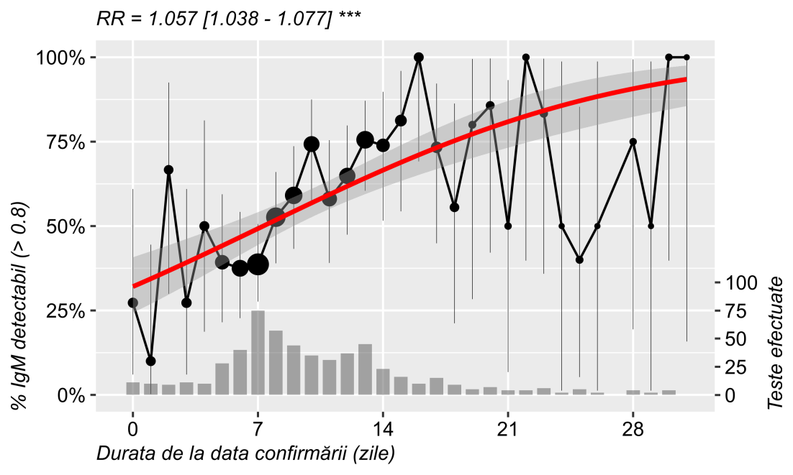

## IgG by time

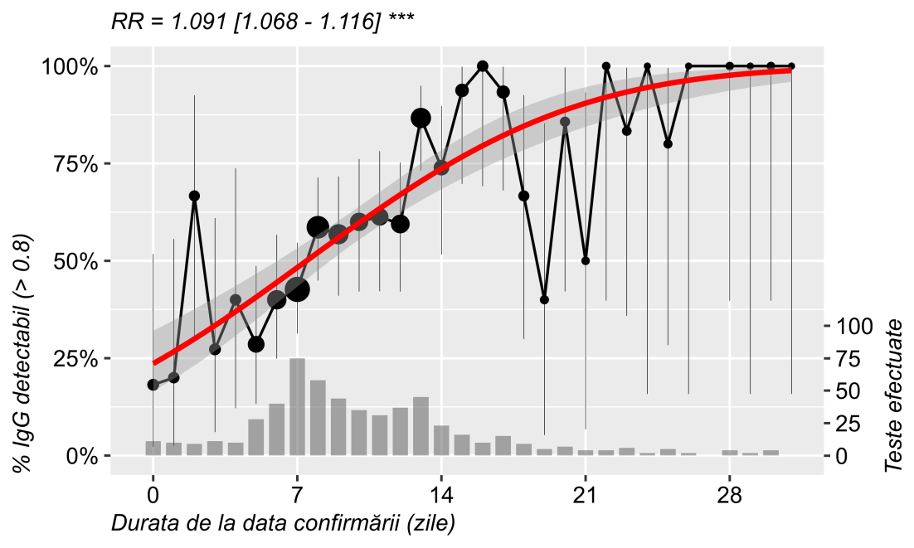

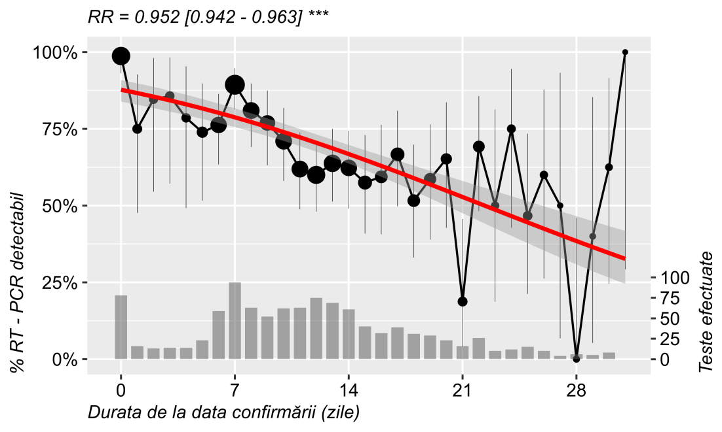

Figure 5: The proportion of patients found with detectable IgM (>0.8), IgG (>0.8) and RT-PCR results (uncertain results removed), by time since confirmation (first month) and clinical severity (mild: asymptomatic to mild; severe: intermediate to critical). Also shown: weighted probit regression line, number of tests performed (dot area and bottom histogram with right y-axis) and binomial 95% confidence interval around average proportion.

# KM plots

### PCR

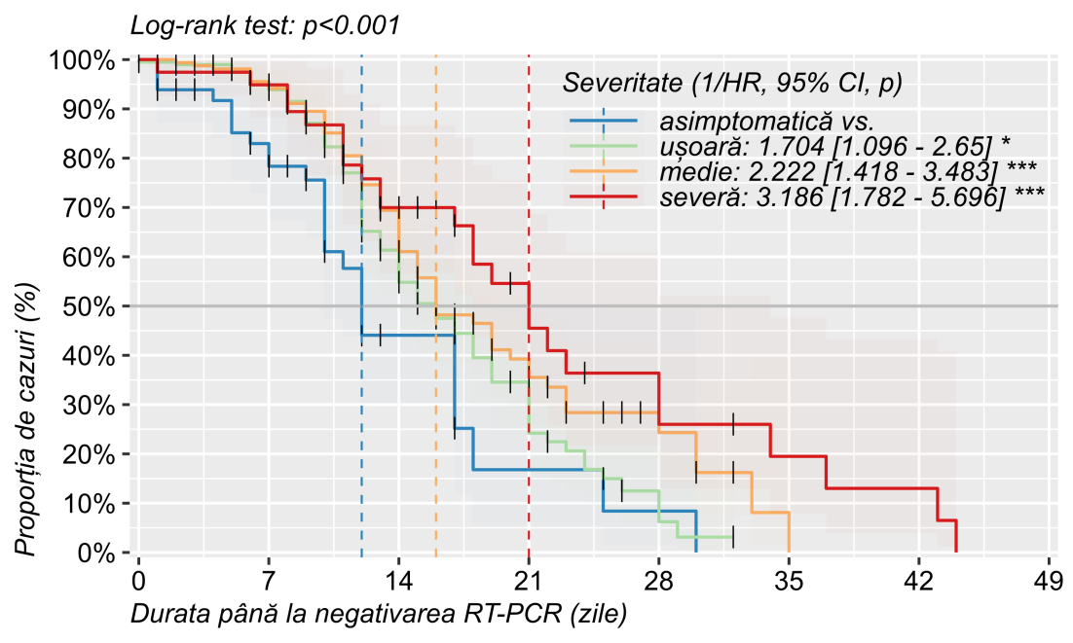

Figure 6: Reverse cummulative distribution (Kaplan Meier) plot of RT-PCR negativation rate by time since confirmation and severity. Dates were calculated to the first negative PCR result. Also shown: invese hazard-ratio comparing all severities to asymptomatic, with 95% CI and statistical signifficance; overall log-rank test.

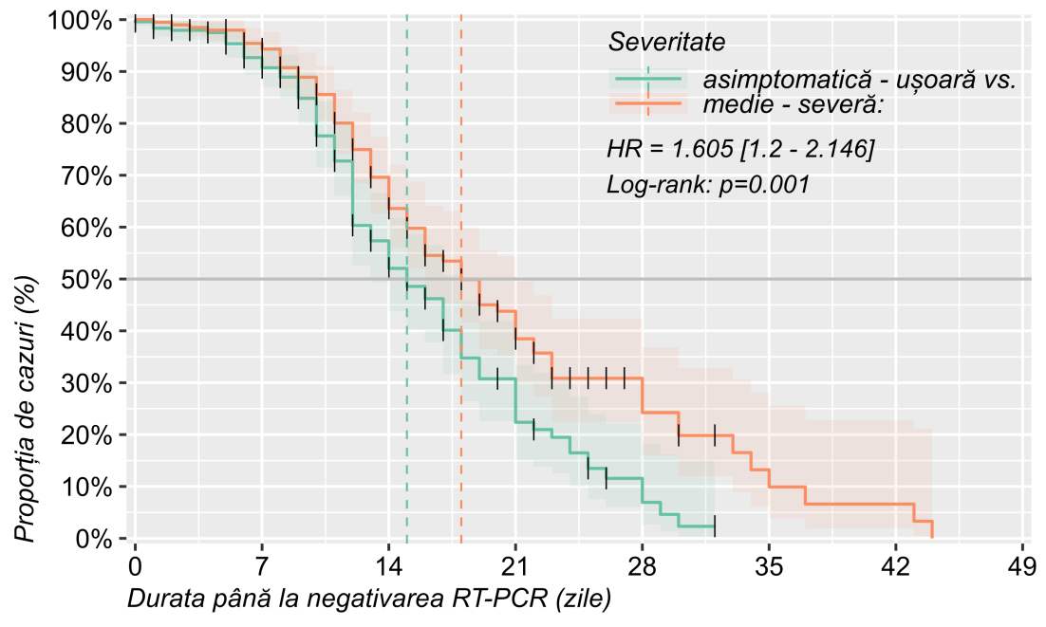

Figure 7: Reverse cummulative distribution (Kaplan Meier) plot of RT-PCR negativation rate by time since confirmation and severity. Dates were calculated to the first negative PCR result. Also shown: invese hazard-ratio comparing more severe forms to asymptomatic - mild, with 95% CI and log-rank test.

### IgM

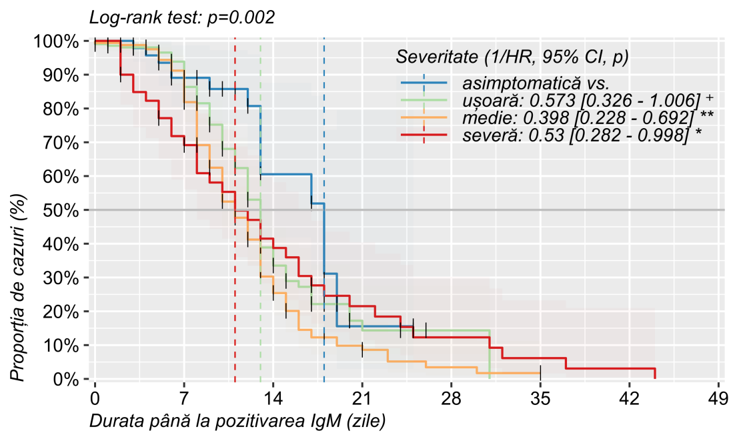

Figure 8: Reverse cummulative distribution (Kaplan Meier) plot of IgM positivation rate (first value > 0.8) by time since confirmation and severity. Dates were calculated to the first negative PCR result. Also shown: invese hazard-ratio comparing all severities to asymptomatic, with 95% CI and statistical signifficance; overall log-rank test.

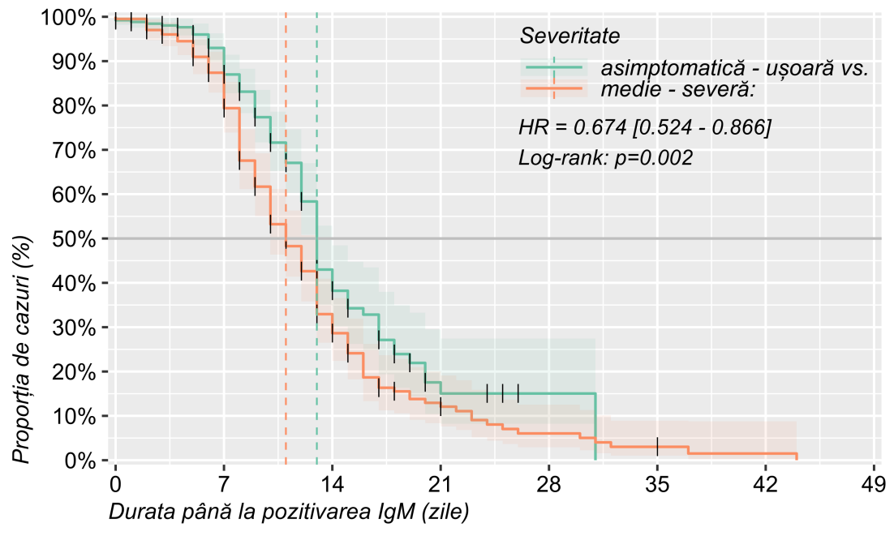

Figure 9: Reverse cummulative distribution (Kaplan Meier) plot of IgM positivation rate (first value > 0.8) by time since confirmation and severity. Dates were calculated to the first negative PCR result. Also shown: invese hazard-ratio comparing more severe forms to asymptomatic - mild, with 95% CI and log-rank test.

### IgG

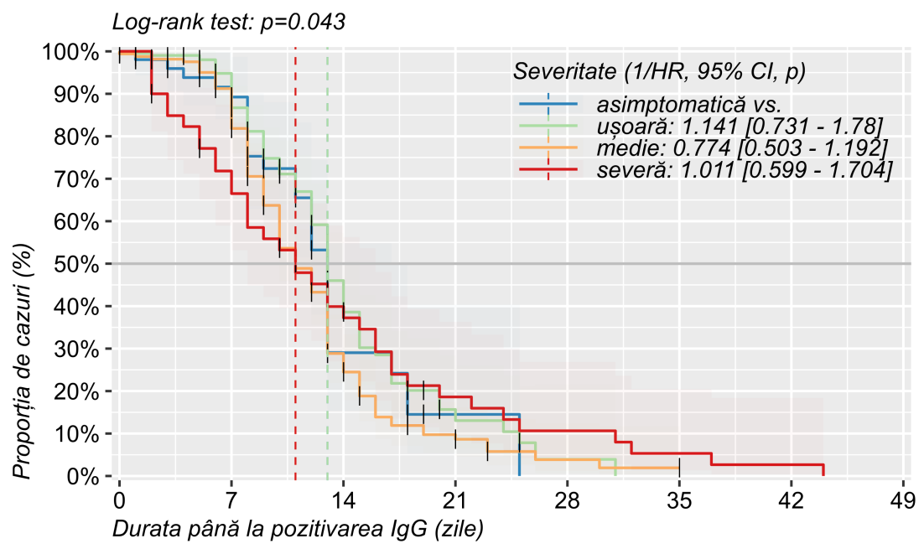

Figure 10: Reverse cummulative distribution (Kaplan Meier) plot of IgG positivation rate (first value > 0.8) by time since confirmation and severity. Dates were calculated to the first negative PCR result. Also shown: invese hazard-ratio comparing all severities to asymptomatic, with 95% CI and statistical signifficance; overall log-rank test.

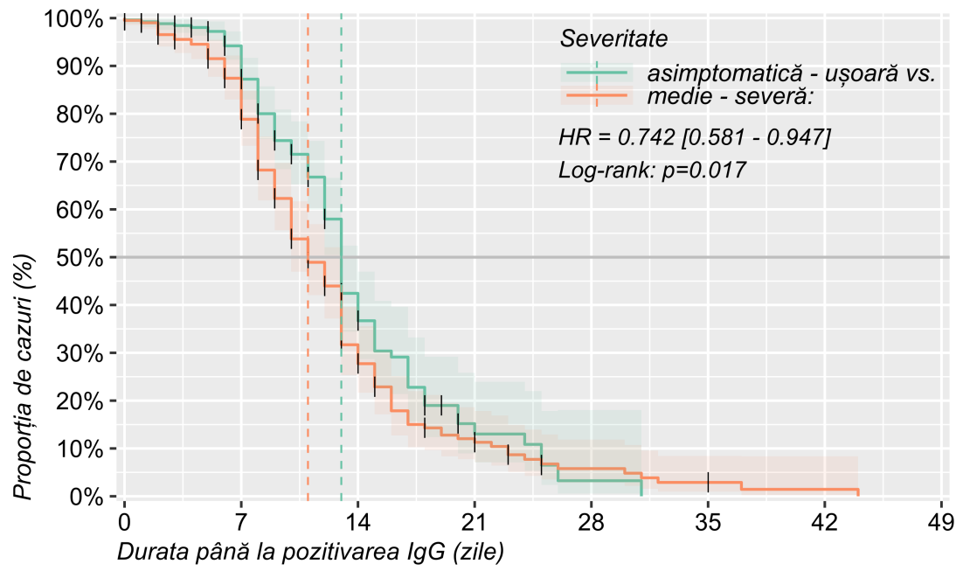

Figure 11: Reverse cummulative distribution (Kaplan Meier) plot of IgG positivation rate (first value > 0.8) by time since confirmation and severity. Dates were calculated to the first negative PCR result. Also shown: invese hazard-ratio comparing more severe forms to asymptomatic - mild, with 95% CI and log-rank test.

# References

1. R Core Team (2020). R: A language and environment for statistical computing. R Foundation for Statistical Computing, Vienna, Austria. URL <https://www.R-project.org/>.