Graduation Thesis

Graduation Thesis

Regine Besinger

Table of Contents

# General part

# Special part

## Introduction

### Objectives

## Methods

### Statisitcal analysis of the data

To describe the quantitative variables, we used histograms and we calculated the arithmetic means ±standard deviation (SD) [with 95% confidence interval (CI)], as well as the extreme and median values. For the qualitative variables, we used pie or bar charts and calculated the absolute and percentual frequencies of the formed categories.

To study the relationships between quantitative and qualitative variables, we used the T or Mann-Whitney (MW) tests if they were binary, respectively ANOVA or Kruskal-Wallis (KW) if they had more categories. We presented the p values generated by these tests as well as the means ±SD of the groups and the difference of the means with associated 95% CI. We graphically presented the results in the form of box plots. To study the relationships between the quantitative variables we used the Spearman correlation coefficient (R), with the associated p-value and graphically presented the relations as scatter plots, on which we added the regression line. To describe the relationships between the qualitative variables we used the Chi² or Fisher test and the Cramer phi or V and Odds-Ratio (OR) / Relative Risk (RR) indicators with 95% CI. We graphically presented the results in the form of pie or bar charts.

We used Microsoft Excel 2016 for database management. For all statistical analyzes and subsequent graphs we used R 3.6.2 [1]. We considered p <0.05 to be statistically significant and p <0.10 to show only a tendency towards statistical significance.

## Results

### Demographics

A total of 372 patients were includen din the study, of whom 60% were men. Age had values between 25 and 94 years old (median = 69) with a mean of 66.47 ±12.9 years old. Women were approximatively 5.36 years older on average than men (Mann-Whitney test: p<0.001).

Table 1: Demographic parameters of the sample.

| **Variable** | **Details** | **Total** |
| --- | --- | --- |
| **N=** |  | **372** |
| Age groups | ≤50 | 38 (10.2%) |
| 51-69 | 161 (43.4%) |
| ≥70 | 172 (46.4%) |
| Age (years) | μ ±SD | 66.47 ±12.9 |
| M (min:max) | 69 (25:94) |
| Sex | F | 151 (40.6%) |
| M | 221 (59.4%) |
| Height (cm) | μ ±SD | 168.70 ±13.6 |
| M (min:max) | 170 (70:193) |
| Weight (kg) | μ ±SD | 81.91 ±18.2 |
| M (min:max) | 80 (40:178) |
| *μ ±SD = Mean (standard deviation); M (min:max) = Median (min:max);* | | |

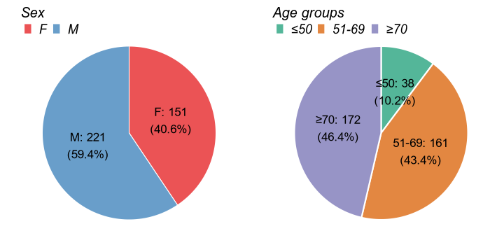

Figure 1: Sex and age groups distribution.

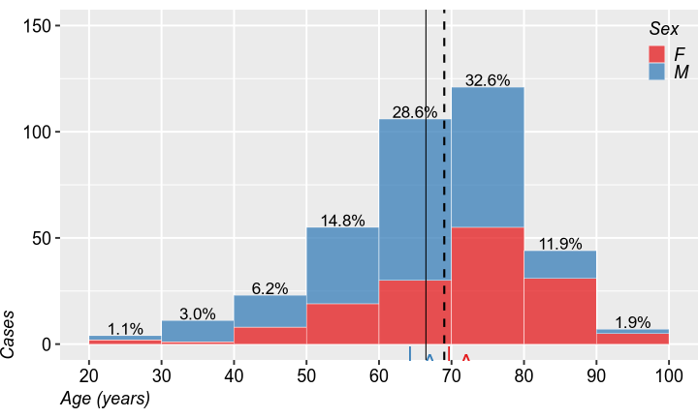

Figure 2: Age distribution, at admission, colored by sex. (| mean, ¦ median).

### Durations

Time onset - presentation (hours) (N=371) a avut valori între -0.133 și 3.95 (mediana: 1.617) cu o medie de 1.76 ±0.82.

Time onset - cerebral CT (hours) (N=370) a avut valori între 0 și 4.417 (mediana: 2.075) cu o medie de 2.15 ±0.83.

Time onset - analyses results (hours) (N=369) a avut valori între 0 și 4.55 (mediana: 2.317) cu o medie de 2.35 ±0.838.

Time onset - treatment start (hours) (N=371) a avut valori între 0 și 4.5 (mediana: 2.8) cu o medie de 2.76 ±0.824.

Time presentation - treatment start (hours) (N=371) a avut valori între 0.133 și 3.5 (mediana: 0.95) cu o medie de 1.02 ±0.479.

It took up to 4 hours after clinical onset for patients to present to the emergency unit, with a median of 1.6 hours. Then, it further took up to 3.5 hours to initiate fibrinolytic treatment (median=1 hour), for a total of up to 4.5 hours between onset to treatment (median=2.8 hours).

Only 5% of the patients started treatment after more than 2 hours after presentaion.

CT imaging and laboratory analyses took up to 4.5 hours to complete (medians of 2.3 and 2.1 hours).

Table 2: .

| **Variable** | **Details** | **Total** |
| --- | --- | --- |
| **N=** |  | **372** |
| Time onset - presentation (hours) | μ ±SD | 1.76 ±0.82 |
| M (min:max) | 1.62 (-0.13:3.95) |
| Time onset - cerebral CT (hours) | μ ±SD | 2.15 ±0.83 |
| M (min:max) | 2.08 (0:4.42) |
| Time onset - analyses results (hours) | μ ±SD | 2.35 ±0.838 |
| M (min:max) | 2.32 (0:4.55) |
| Time onset - treatment start (hours) | μ ±SD | 2.76 ±0.824 |
| M (min:max) | 2.8 (0:4.5) |
| Time presentation - treatment start (hours) | μ ±SD | 1.02 ±0.479 |
| M (min:max) | 0.95 (0.13:3.5) |
| Long interval: presentation - treatment start (other reasons) | | 17 (4.6%) |
| *μ ±SD = Mean (standard deviation); M (min:max) = Median (min:max);* | | |

Figure 3: .

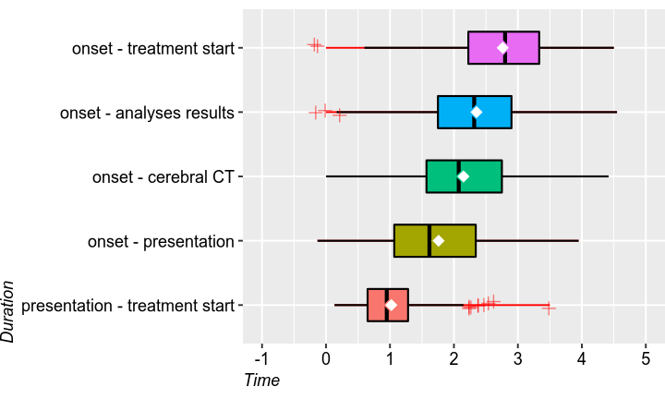

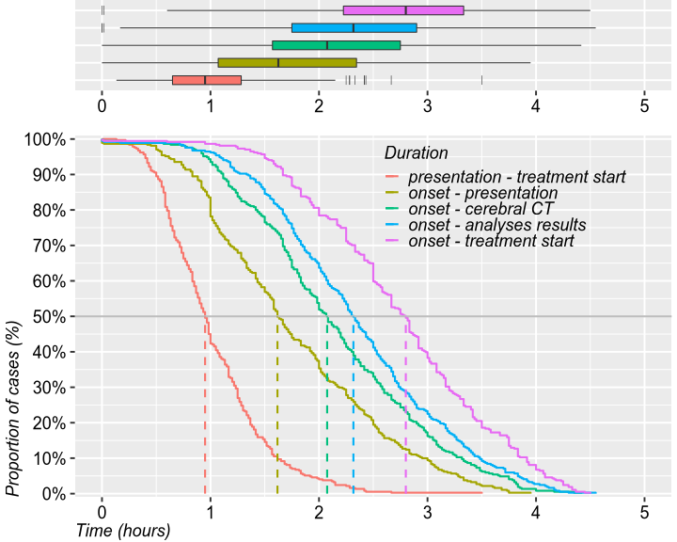

### Scores

Table 3: .

| **Variable** | **Details** | **Total** |
| --- | --- | --- |
| **N=** |  | **372** |
| NIHSS score at admission | μ ±SD | 11.77 ±5.7 |
| M (min:max) | 11 (0:31) |
| NIHSS score at 1 hour | μ ±SD | 10.11 ±6.54 |
| M (min:max) | 9 (0:38) |
| NIHSS score at 2 hours | μ ±SD | 9.37 ±6.84 |
| M (min:max) | 8 (0:48) |
| NIHSS score at 24 hours | μ ±SD | 8.48 ±7.67 |
| M (min:max) | 6 (0:48) |
| NIHSS score at 7 days | μ ±SD | 5.25 ±6.0 |
| M (min:max) | 3 (0:30) |
| *μ ±SD = Mean (standard deviation); M (min:max) = Median (min:max);* | | |

The average NIHSS score decreased within the first week after admission form approximatively 11.77 ±5.7 to about 5.25 ±6.0. At admission, half of the patients had NIHSS values 11 while after 7 days, the median dropped to 3. Meanwhile the distribution of NIHSS values evolves more concentrated towards 0, with fewer and fewer patients with high scores.

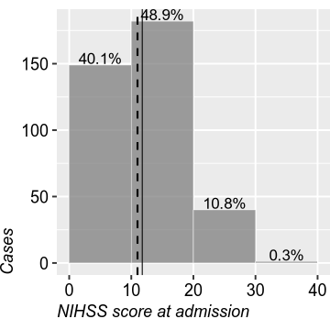

Figure 4:

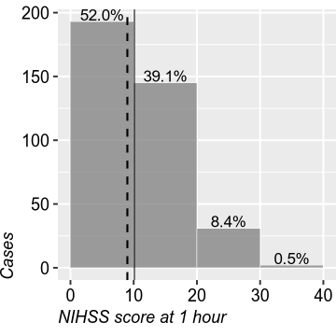

Figure 5:

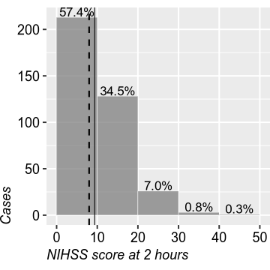

Figure 6:

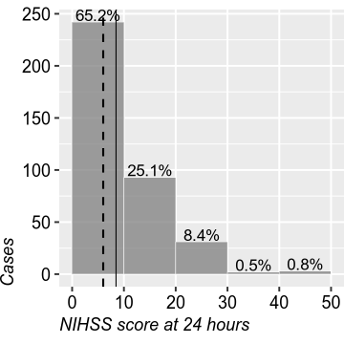

Figure 7:

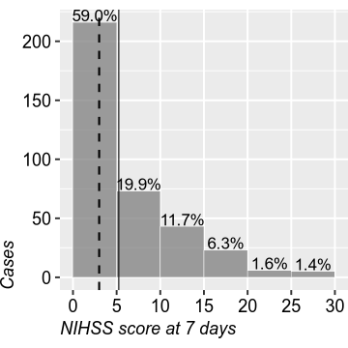

Figure 8:

Figure 9: .

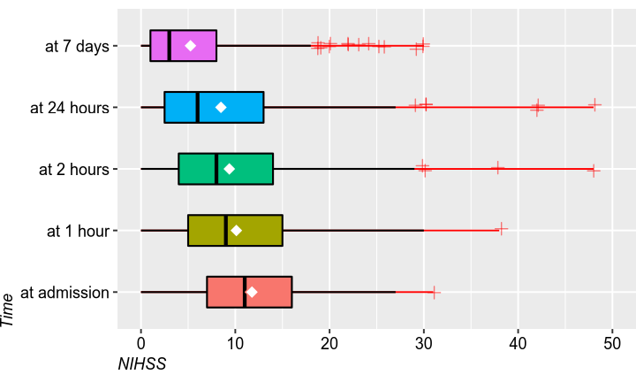

Table 4: .

| **Variable** | **Details** | **Total** |
| --- | --- | --- |
| **N=** |  | **372** |
| Rankin score at 3 months (deceased) | deceased after discharge | 1 (0.3%) |
| deceased in hospital | 46 (13.4%) |
| no | 296 (86.3%) |
| Rankin score at discharge | μ ±SD | 3.91 ±1.9 |
| M (min:max) | 4 (1:7) |
| Rankin score at 3 months | μ ±SD | 3.38 ±2.04 |
| M (min:max) | 3 (1:7) |
| Barthel Index at 3 months (deceased) | deceased after discharge | 36 (9.7%) |
| deceased in hospital | 46 (12.4%) |
| no | 289 (77.9%) |
| Barthel Index at 3 months | μ ±SD | 14.28 ±7.12 |
| M (min:max) | 18 (0:20) |
| *μ ±SD = Mean (standard deviation); M (min:max) = Median (min:max);* | | |

Between discharge and the follow-up at 3 months, the average Rankin score decreased from 3.91 ±1.9 to 3.38 ±2.04. At follow-up, the average Barthel index acheived an average value of 14.3 ±7.1, with more than 40% of the patients having the maximum value of 20.

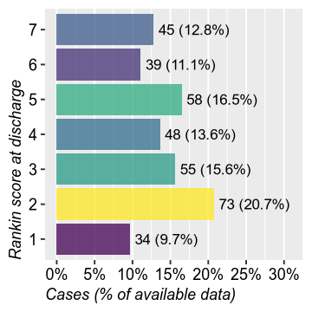

Figure 10:

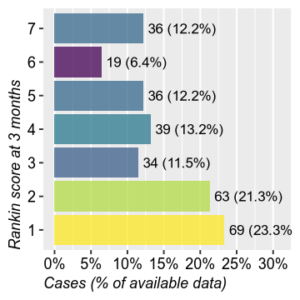

Figure 11:

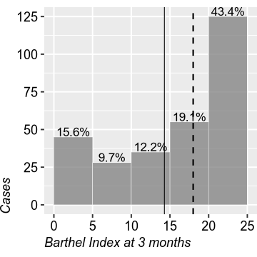

Figure 12: Barthel Index at 3 months

### Correls

Higher of average HIHSS scores were weakly correlated to the duration between the onset of symptoms until thrombolytic administration. Only at 2 and 24 hours was this correlation statistically significant (Spearman R = 0.11, p=0.032 and R=0.12, p=0.026, respectively). Similarly, neither Rankin score, nor Barthel index were signifficantly correlated to this duration, even after adjusting for age. Hemorrhagic transformation was not found significantly influenced by time between clnical onset and treatment (T-test: p=0.40).

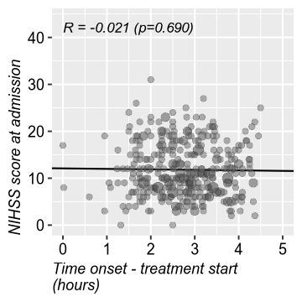

Figure 13:

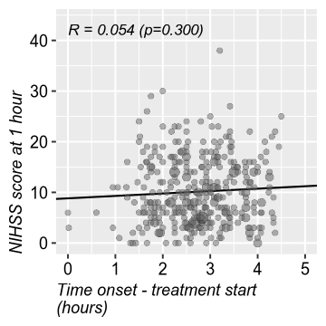

Figure 14:

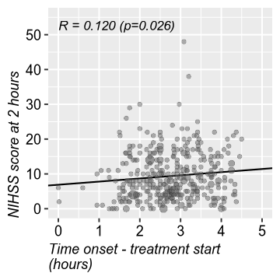

Figure 15:

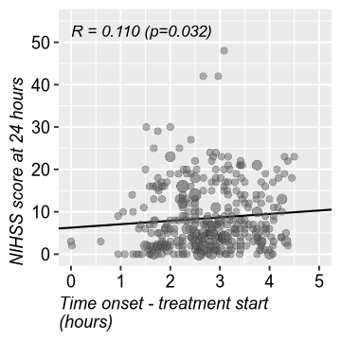

Figure 16:

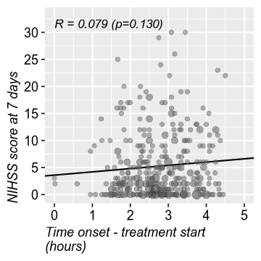

Figure 17:

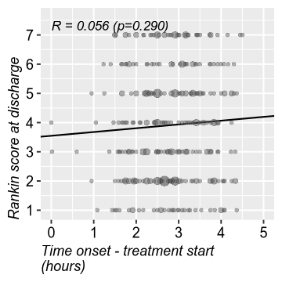

Figure 18:

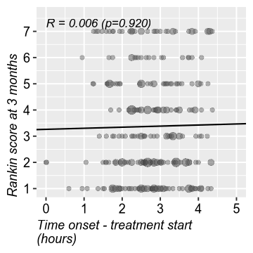

Figure 19:

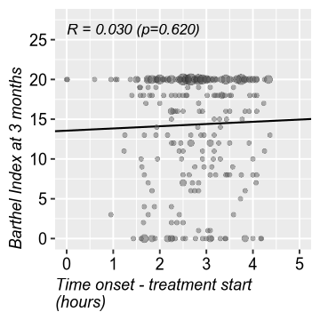

Figure 20:

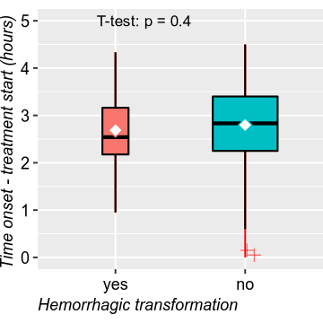

Figure 21:

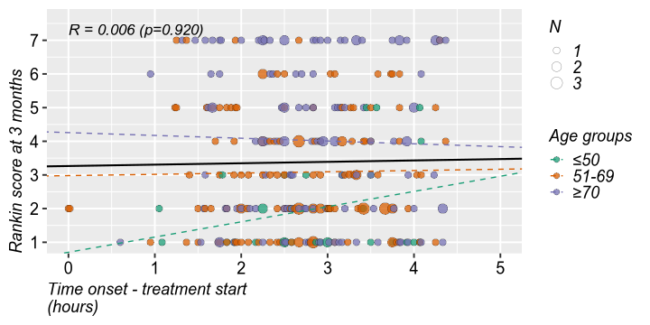

Figure 22:

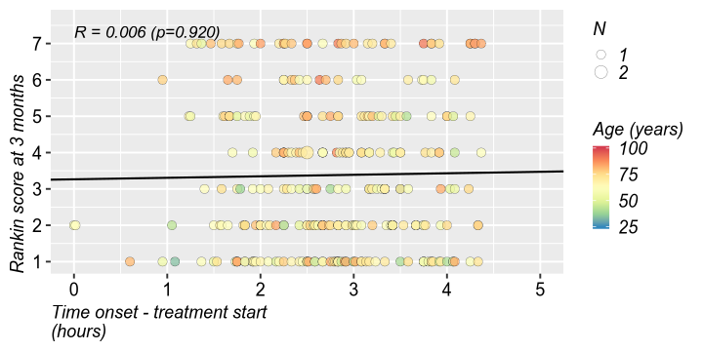

Figure 23:

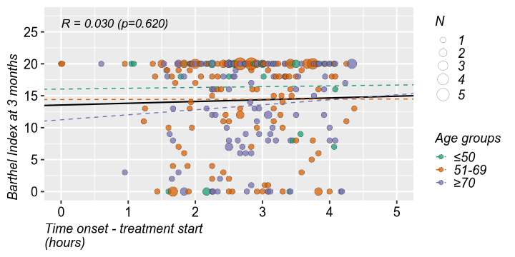

Figure 24:

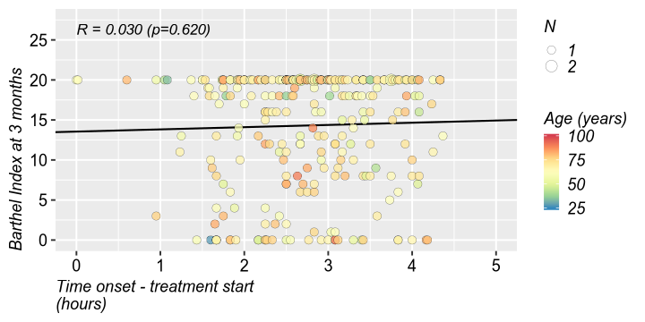

Figure 23:

# Demo

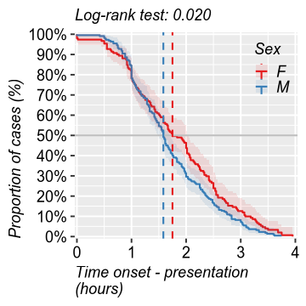

Figure 25:

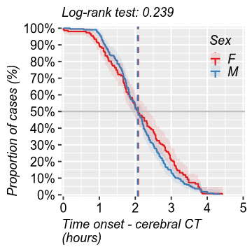

Figure 26:

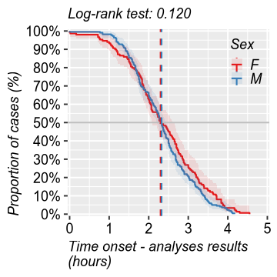

Figure 27:

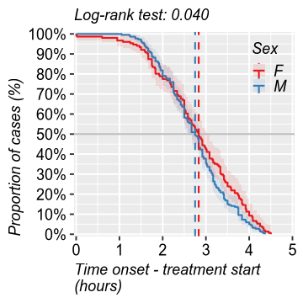

Figure 28:

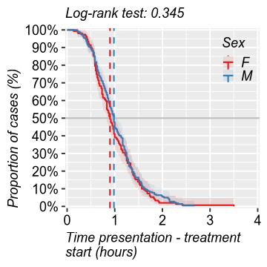

Figure 29:

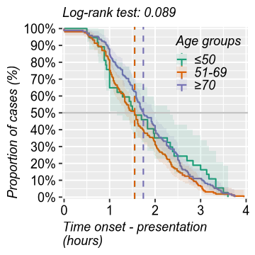

Figure 30:

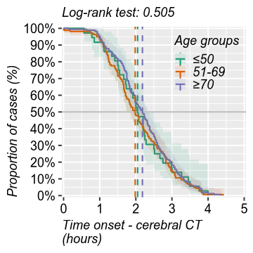

Figure 31:

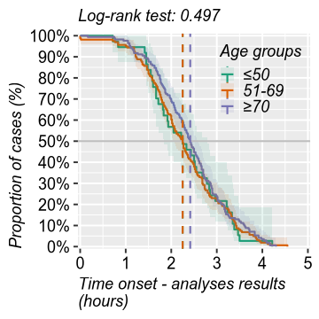

Figure 32:

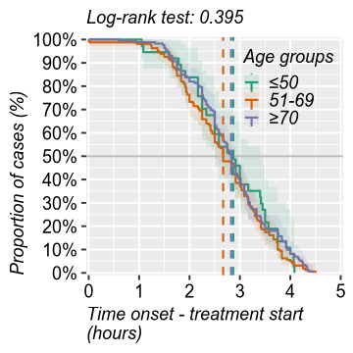

Figure 33:

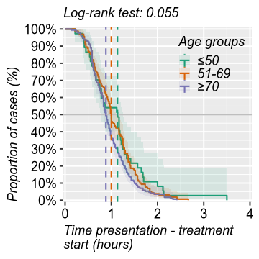

Figure 34:

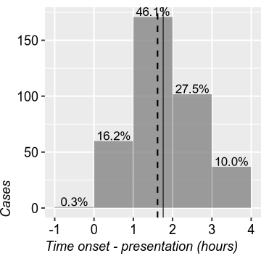

Figure 35:

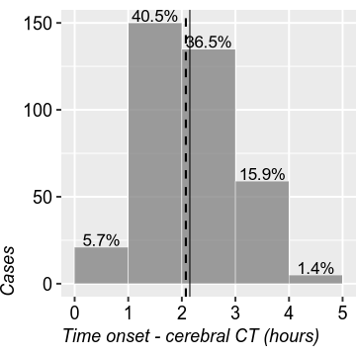

Figure 36:

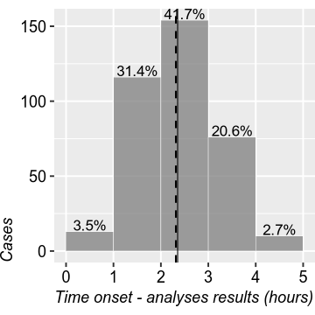

Figure 37:

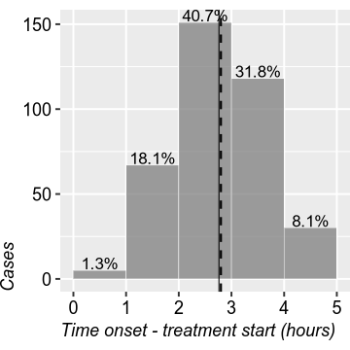

Figure 38:

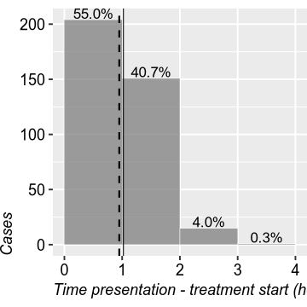

Figure 39:

$p 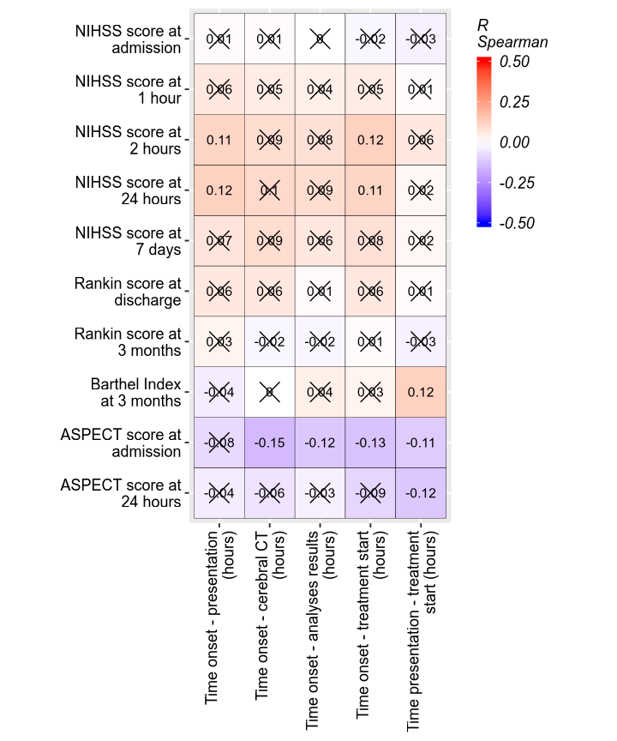 $t a flextable object. col_keys: VS. (Spearman R), Time onset - presentation (hours), Time onset - cerebral CT (hours), Time onset - analyses results (hours), Time onset - treatment start (hours), Time presentation - treatment start (hours) header has 1 row(s) body has 10 row(s) original dataset sample: VS. (Spearman R) Time onset - presentation (hours) 1 NIHSS score at admission 0.012(p=0.819) 2 NIHSS score at 1 hour 0.063(p=0.229) 3 NIHSS score at 2 hours 0.105(p=0.043) 4 NIHSS score at 24 hours 0.124(p=0.017) 5 NIHSS score at 7 days 0.073(p=0.161) Time onset - cerebral CT (hours) Time onset - analyses results (hours) 1 0.008(p=0.874) -0.002(p=0.962) 2 0.055(p=0.296) 0.043(p=0.406) 3 0.089(p=0.089) 0.077(p=0.142) 4 0.102(p=0.051) 0.089(p=0.089) 5 0.090(p=0.086) 0.062(p=0.242) Time onset - treatment start (hours) 1 -0.021(p=0.690) 2 0.054(p=0.301) 3 0.116(p=0.026) 4 0.111(p=0.032) 5 0.079(p=0.133) Time presentation - treatment start (hours) 1 -0.031(p=0.549) 2 0.011(p=0.832) 3 0.059(p=0.256) 4 0.019(p=0.715) 5 0.021(p=0.690)

Table 5: .

| **Variable** | **Details** | **yes** | **no** | **Total** | **Statistics** |
| --- | --- | --- | --- | --- | --- |
| **Hemorrhagic transformation** |  | **50 (14.0%)** | **308 (86.0%)** | **358** |  |
| Age (years) | μ ±SD | 68.72 ±13.1 | 66.29 ±12.8 | 66.47 ±12.9 | MW: p=0.128 |
| M (min:max) | 72.5 (37:91) | 68 (25:94) | 69 (25:94) |
| **Sex** | **F** | **27 (54.0%)** | **117 (38.0%)** | **144 (40.2%)** | **OR=1.92 [1.05, 3.50] (p=0.043)** |
| **M** | **23 (46.0%)** | **191 (62.0%)** | **214 (59.8%)** |
| **Height (cm)** | **μ ±SD** | **163.71 ±20.5** | **169.36 ±12.3** | **168.70 ±13.6** | **MW: p=0.014** |
| **M (min:max)** | **165 (70:183)** | **170 (70:193)** | **170 (70:193)** |
| Weight (kg) | μ ±SD | 84.54 ±26.5 | 81.23 ±16.4 | 81.91 ±18.2 | MW: p=0.813 |
| M (min:max) | 81 (40:176) | 80 (40:178) | 80 (40:178) |
| Time onset - presentation (hours) | μ ±SD | 1.66 ±0.777 | 1.79 ±0.819 | 1.76 ±0.82 | MW: p=0.275 |
| M (min:max) | 1.53 (0.45:3.75) | 1.67 (-0.13:3.95) | 1.62 (-0.13:3.95) |
| Time onset - cerebral CT (hours) | μ ±SD | 2.14 ±0.816 | 2.17 ±0.822 | 2.15 ±0.83 | MW: p=0.753 |
| M (min:max) | 2 (0.57:3.82) | 2.08 (0:4.42) | 2.08 (0:4.42) |
| Time onset - analyses results (hours) | μ ±SD | 2.31 ±0.836 | 2.39 ±0.825 | 2.35 ±0.838 | T-test: p=0.547 |
| M (min:max) | 2.28 (0.83:4.22) | 2.33 (0:4.55) | 2.32 (0:4.55) |
| Time onset - treatment start (hours) | μ ±SD | 2.69 ±0.842 | 2.80 ±0.814 | 2.76 ±0.824 | MW: p=0.279 |
| M (min:max) | 2.54 (0.95:4.33) | 2.83 (0:4.5) | 2.8 (0:4.5) |
| Time presentation - treatment start (hours) | μ ±SD | 1.02 ±0.449 | 1.03 ±0.484 | 1.02 ±0.479 | MW: p=0.978 |
| M (min:max) | 0.92 (0.28:2.15) | 0.98 (0.13:3.5) | 0.95 (0.13:3.5) |
| Long interval: presentation - treatment start (other reasons) | | 3 (6.0%) | 14 (4.5%) | 17 (4.7%) | OR=1.34 [0.37, 4.84] (p=0.717) |
| **NIHSS score at admission** | **μ ±SD** | **14.24 ±5.42** | **11.35 ±5.6** | **11.77 ±5.7** | **MW: p<0.001** |
| **M (min:max)** | **15 (0:26)** | **10 (2:31)** | **11 (0:31)** |
| **NIHSS score at 1 hour** | **μ ±SD** | **13.04 ±5.6** | **9.80 ±6.36** | **10.11 ±6.54** | **MW: p<0.001** |
| **M (min:max)** | **14 (2:26)** | **8 (0:38)** | **9 (0:38)** |
| **NIHSS score at 2 hours** | **μ ±SD** | **12.38 ±6.24** | **9.04 ±6.63** | **9.37 ±6.84** | **MW: p<0.001** |
| **M (min:max)** | **12.5 (1:30)** | **8 (0:48)** | **8 (0:48)** |
| **NIHSS score at 24 hours** | **μ ±SD** | **13.31 ±7.89** | **7.93 ±7.24** | **8.48 ±7.67** | **MW: p<0.001** |
| **M (min:max)** | **14 (0:42)** | **6 (0:48)** | **6 (0:48)** |
| **NIHSS score at 7 days** | **μ ±SD** | **7.45 ±7.07** | **5.03 ±5.62** | **5.25 ±6.0** | **MW: p=0.030** |
| **M (min:max)** | **6 (0:26)** | **3 (0:30)** | **3 (0:30)** |
| Vasculary teritory of the current stroke | 1 | 26 (53.1%) | 173 (56.5%) | 199 (56.1%) | V=0.03 (p=0.873) |
| 2 | 20 (40.8%) | 113 (36.9%) | 133 (37.5%) |
| 3 | 3 (6.1%) | 20 (6.5%) | 23 (6.5%) |
| **Repeated strokes** | | **5 (10.2%)** | **7 (2.3%)** | **12 (3.4%)** | **OR=4.74 [1.44, 15.59] (p=0.017)** |
| **Repeated strokes (after treatment)** | **1** | **3 (6.2%)** | **6 (2.1%)** | **9 (2.7%)** | **V=0.18 (p=0.014)** |
| **2** | **33 (68.8%)** | **246 (86.6%)** | **279 (84.0%)** |
| **deceased after discharge** | **0** | **1 (0.4%)** | **1 (0.3%)** |
| **deceased in hospital** | **12 (25.0%)** | **31 (10.9%)** | **43 (13.0%)** |
| SBP at presentation (mmHg) | μ ±SD | 156.72 ±26.6 | 156.38 ±26.1 | 155.83 ±28.5 | MW: p=0.898 |
| M (min:max) | 158 (112:220) | 154.5 (90:260) | 155.5 (0:260) |
| DBP at presentation (mmHg) | μ ±SD | 92.88 ±19.3 | 88.16 ±16.4 | 88.43 ±18.0 | MW: p=0.199 |
| M (min:max) | 89.5 (68:150) | 87 (50:156) | 86.5 (0:156) |
| **Rankin score at discharge** | **μ ±SD** | **5.02 ±1.64** | **3.71 ±1.87** | **3.91 ±1.9** | **MW: p<0.001** |
| **M (min:max)** | **5 (1:7)** | **3 (1:7)** | **4 (1:7)** |
| **Rankin score at 3 months** | **μ ±SD** | **4.29 ±1.98** | **3.20 ±1.98** | **3.38 ±2.04** | **MW: p=0.002** |
| **M (min:max)** | **4 (1:7)** | **3 (1:7)** | **3 (1:7)** |
| Hemorrhagic transformation type | 1 | 20 (42.6%) | 0 (NA) | 20 (42.6%) | V=NA (p>0.999) |
| 2 | 10 (21.3%) | 0 (NA) | 10 (21.3%) |
| 3 | 11 (23.4%) | 0 (NA) | 11 (23.4%) |
| 4 | 6 (12.8%) | 0 (NA) | 6 (12.8%) |
| Significant extracerebral hemorrhage | | 1 (2.0%) | 1 (0.3%) | 2 (0.6%) | OR=6.04 [0.37, 98.18] (p=0.268) |
| **Symptoms** | **0** | **0** | **27 (50.0%)** | **27 (26.5%)** | **V=0.64 (p<0.001)** |
| **1** | **14 (29.2%)** | **0** | **14 (13.7%)** |
| **2** | **34 (70.8%)** | **27 (50.0%)** | **61 (59.8%)** |
| Seizures | | 3 (6.0%) | 6 (2.0%) | 9 (2.6%) | OR=3.10 [0.75, 12.80] (p=0.126) |
| **Deceased while in hospital** | | **12 (24.5%)** | **31 (10.2%)** | **43 (12.1%)** | **OR=2.87 [1.35, 6.07] (p=0.008)** |
| Time of death (in hospital) | 2 | 1 (8.3%) | 3 (10.3%) | 4 (9.8%) | V=0.04 (p=0.971) |
| 3 | 1 (8.3%) | 2 (6.9%) | 3 (7.3%) |
| 4 | 10 (83.3%) | 24 (82.8%) | 34 (82.9%) |
| **Cause of death (in hospital)** | **1** | **5 (41.7%)** | **17 (58.6%)** | **22 (53.7%)** | **V=0.68 (p=0.002)** |
| **3** | **5 (41.7%)** | **0** | **5 (12.2%)** |
| **4** | **1 (8.3%)** | **0** | **1 (2.4%)** |
| **6** | **1 (8.3%)** | **2 (6.9%)** | **3 (7.3%)** |
| **7** | **0** | **5 (17.2%)** | **5 (12.2%)** |
| **8** | **0** | **5 (17.2%)** | **5 (12.2%)** |
| **Deceased after discharge** | **1** | **8 (16.7%)** | **25 (8.8%)** | **33 (9.9%)** | **V=0.20 (p=0.009)** |
| **2** | **28 (58.3%)** | **230 (80.7%)** | **258 (77.5%)** |
| **9** | **0** | **1 (0.4%)** | **1 (0.3%)** |
| **deceased after discharge** | **0** | **1 (0.4%)** | **1 (0.3%)** |
| **deceased in hospital** | **12 (25.0%)** | **28 (9.8%)** | **40 (12.0%)** |
| Cause of death (after discharge) | 1 | 2 (12.5%) | 4 (9.1%) | 6 (10.0%) | V=0.46 (p=0.247) |
| 2 | 1 (6.2%) | 0 | 1 (1.7%) |
| 3 | 2 (12.5%) | 1 (2.3%) | 3 (5.0%) |
| 4 | 1 (6.2%) | 7 (15.9%) | 8 (13.3%) |
| 5 | 1 (6.2%) | 0 | 1 (1.7%) |
| 6 | 0 | 1 (2.3%) | 1 (1.7%) |
| 7 | 0 | 5 (11.4%) | 5 (8.3%) |
| 8 | 0 | 1 (2.3%) | 1 (1.7%) |
| 9 | 1 (6.2%) | 6 (13.6%) | 7 (11.7%) |
| deceased after discharge | 8 (50.0%) | 18 (40.9%) | 26 (43.3%) |
| deceased in hospital | 0 | 1 (2.3%) | 1 (1.7%) |
| **ASPECT score at admission** | **μ ±SD** | **8.84 ±1.26** | **9.39 ±0.972** | **9.32 ±1.03** | **MW: p<0.001** |
| **M (min:max)** | **9 (5:10)** | **10 (5:10)** | **10 (5:10)** |
| **ASPECT score at 24 hours** | **μ ±SD** | **6.53 ±2.8** | **8.35 ±2.01** | **8.12 ±2.22** | **MW: p<0.001** |
| **M (min:max)** | **7 (1:10)** | **9 (1:10)** | **9 (1:10)** |
| **Rankin score at 3 months (deceased)** | **deceased after discharge** | **0** | **1 (0.3%)** | **1 (0.3%)** | **V=0.15 (p=0.019)** |
| **deceased in hospital** | **12 (25.5%)** | **31 (10.8%)** | **43 (12.9%)** |
| **no** | **35 (74.5%)** | **255 (88.9%)** | **290 (86.8%)** |
| **Barthel Index at 3 months** | **μ ±SD** | **12.16 ±7.62** | **14.81 ±6.81** | **14.28 ±7.12** | **MW: p=0.038** |
| **M (min:max)** | **15 (0:20)** | **18 (0:20)** | **18 (0:20)** |
| **Barthel Index at 3 months (deceased)** | **deceased after discharge** | **6 (12.2%)** | **26 (8.4%)** | **32 (9.0%)** | **V=0.17 (p=0.008)** |
| **deceased in hospital** | **12 (24.5%)** | **31 (10.1%)** | **43 (12.0%)** |
| **no** | **31 (63.3%)** | **251 (81.5%)** | **282 (79.0%)** |
| Type of death (in hospital) | 1 | 2 (15.4%) | 5 (16.7%) | 7 (16.3%) | V=0.27 (p=0.528) |
| 2 | 1 (7.7%) | 0 | 1 (2.3%) |
| 3 | 0 | 1 (3.3%) | 1 (2.3%) |
| deceased after discharge | 0 | 1 (3.3%) | 1 (2.3%) |
| deceased in hospital | 10 (76.9%) | 23 (76.7%) | 33 (76.7%) |
| Age groups | ≤50 | 6 (12.0%) | 29 (9.4%) | 35 (9.8%) | V=0.11 (p=0.109) |
| 51-69 | 15 (30.0%) | 141 (45.9%) | 156 (43.7%) |
| ≥70 | 29 (58.0%) | 137 (44.6%) | 166 (46.5%) |
| *μ ±SD = Mean (standard deviation); M (min:max) = Median (min:max); MW = Mann-Whitney Test; Welch = Welch T-Test (not assuming equal variances); OR/RR = odds-ratio / risk-ratio [95% CI] and p value from Fisher test); V = Cramér V (p value from Chi² test);* | | | | | |

# References

1. R Core Team (2020). R: A language and environment for statistical computing. R Foundation for Statistical Computing, Vienna, Austria. URL <https://www.R-project.org/>.