|  |  |
| --- | --- |
| **Lucrare de licenţă** | |
| **R Notebook** | |
| ***Îndrumător:*** | ***Absolvent:*** |
| **Prof. Dr.** | **Alex Istrate** |

Table of Contents

II. Intro 3

III. Rezultate 4

III.1 Demografie 5

III.2 AUDIT 7

III.3 AUDIT - total 9

III.4 BIS 12

III.5 BIS - total 14

III.6 BIS - profil 17

III.7 BIS ~ AUDIT 19

III.8 BIS-atentionala 24

III.9 BIS-comportamentala 28

III.10 BIS-non-planning 33

# Intro

Classes 'tbl_df', 'tbl' and 'data.frame':

# Rezultate

## Demografie

Varsta pacientilor

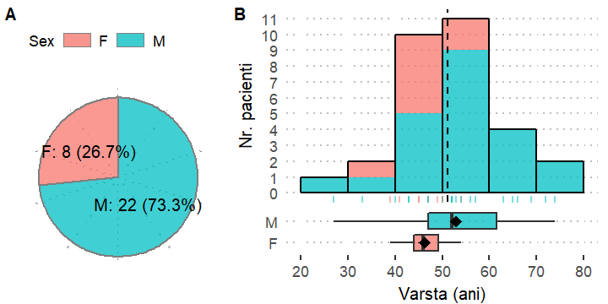

Figura. 1: Distrbutia parametrilor demografici studiati.

Parametrii statistici ai corelatiilor dintre scoul AUDIT si varsta.

|  |  |  |
| --- | --- | --- |
| AUDIT: | Pearson R | Spearman R |
| Total | 0.34 (p=0.062) | 0.40 (p=0.030) |
| risc moderat | 0.57 (p=0.143) | 0.66 (p=0.074) |
| risc crescut | 0.14 (p=0.547) | 0.07 (p=0.757) |

Valoarea scorului AUDIT creste proportinal cu cresterea valorilor pentru Varsta (ani). Aceasta corelatie moderata tinde spre a fi semnificativa statistic (R=0.34, p=0.062) conform coefcientului de corelatie Pearson.