So I found out that Google pretty much has the functionality covered (faster, cleaner, and better). In any case this was a fun exercise to keep me occupied, as well as familiarize myself with Python a bit. I work with Matlab for a living :) and am by no means a SW guy.

So here's the official unoffical how-to run the code.

Python version: 3
Packages used: sys, html, requests

How to run :
- Setup the environment. Copy the python file (ToyotaSearch.py) and setup text file (setupToySearch.txt) to some folder on your PC. ToyotaSearch.py is the actual python script. You don't need to worry about it unless you want to look under the hood and modify it. setupToySearch.txt is a text file that will be populated in step 2. This is temporary and I think it's more user friendly than asking the user to write extra lines into the command line.
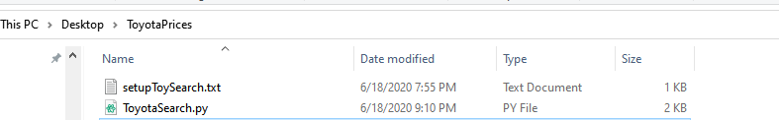
- Navigate to the top level parts website that you are interested in. Copy the URL at the top of the page to setupToySearch.txt.
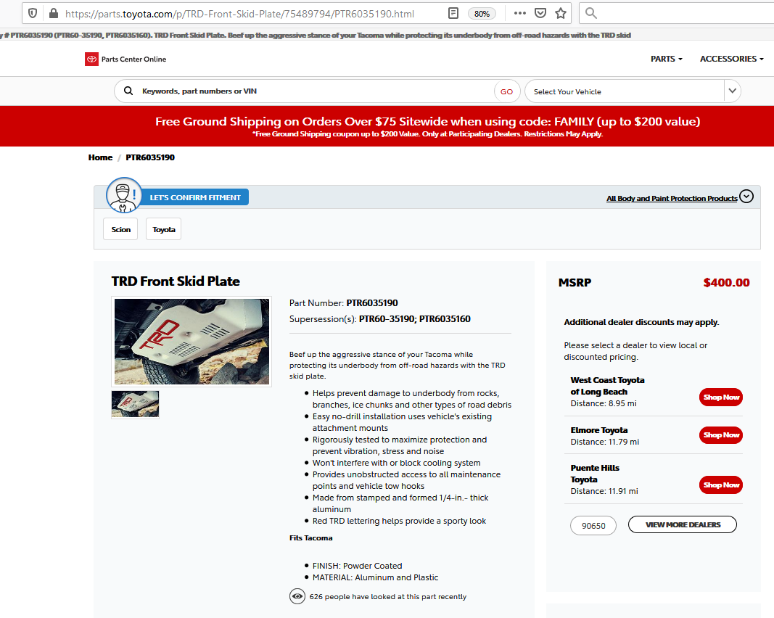
SetupToySearch.txt should look something like this:
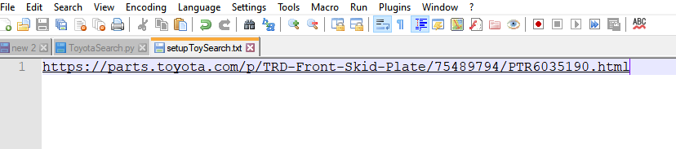
Warning: Make sure there's only one line in the text file. Otherwise, the code will look for “\n.” oops!
- Open open window. Hit windows key and type “cmd” and navigate to the folder where the script is located.
- To run the python script simply use the following command:
python ToyotaSearch.py
The program defaults to zip code 90650. This can be configured for any zip code by running the following
python ToyotaSearch.py 90210
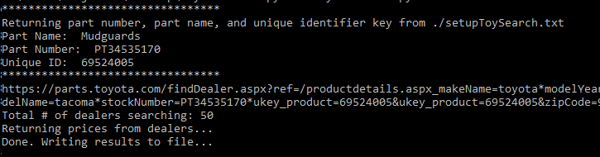
- The program writes and creates a .csv file named results_toyota_shop.csv. You can open this with excel and sort as necessary.
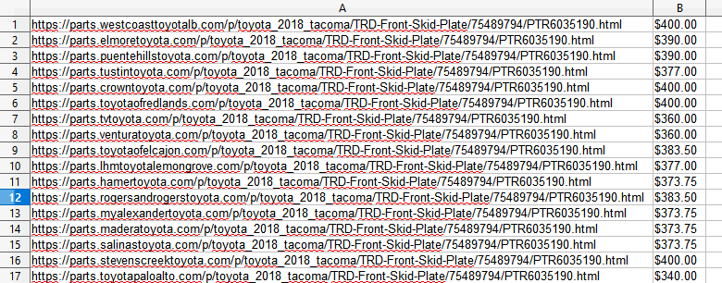
But hey!! Palo Alto has the cheapest skid plate!!! WUT WUT!!

You can do the sorting in excel or modify the price list in the code by using the sort function. I'll leave that as an exercise for the use :)

