Daddy Forgets My Name
By Bruce Lansky

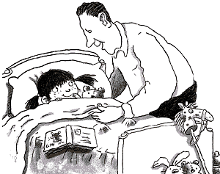
My daddy calls me sweetie pie.
He calls me honey bunny.
He also calls me poopsie,
which I think is kind of funny.
My daddy calls me sugarplum,
and also sleepyhead.
My silly dad forgets my name
when he tucks me into bed.

