Software Requirements Specification
for
Student-Adviser Tracker
Version 1.0
In partial fulfillment of the requirements of CMSC 128
Prepared by John Joseph R. Sinang
CMSC 128 AB-5L
March 11, 2015
Table of Contents
Table of Contents ii
Revision History ii
1. Introduction 1
1.1 Purpose 1
1.2 Document Conventions 1
1.3 Intended Audience and Reading Suggestions 1
1.4 Product Scope 1
1.5 References 1
2. Overall Description 2
2.1 Product Perspective 2
2.2 Product Functions 2
2.3 User Classes and Characteristics 2
2.4 Operating Environment 2
2.5 Design and Implementation Constraints 2
2.6 User Documentation 2
2.7 Assumptions and Dependencies 3
3. External Interface Requirements 3
3.1 User Interfaces 3
3.2 Hardware Interfaces 3
3.3 Software Interfaces 3
3.4 Communications Interfaces 3
4. System Features 4
4.1 User Authentication 4
4.2 Announcements 5
4.3 Advisers List 5
4.4 Request Change of Adviser 5
4.5 Private Messaging 5
4.6 Admin Online Monior 5
5. Other Nonfunctional Requirements 6
5.1 Performance Requirements 6
5.2 Safety Requirements 6
5.3 Security Requirements 6
5.4 Software Quality Attributes 6
5.5 Business Rules 6
6. Other Requirements 5
Appendix A: Glossary 5
Appendix B: Analysis Models 7
Appendix C: To Be Determined List 7

Revision History
Name | Date | Reason For Changes | Version
John Joseph Sinang | March 17, 2015 | Initial version | 1

Introduction

Purpose
The project that this software requirement document detailed is the Student-Adviser Tracker version 1 made for the Institute of Computer Science. This project aims to simplify tracking of student-adviser pairing. The Institute of Computer Science currently relies on hard copies of documents. It also aims to be a general-purpose system to help students access information about the institute.

Document Conventions
The title page of this software requirements specification is written in Arial font, sizes 32 and 20 for the title, and 14 for the subtitles. Headers are written in bold Times New Roman, size 18 for section headers and size 14 for sub-headers. Since the project is simple there is no need for complicated document formatting for each requirement.

Intended Audience and Reading Suggestions
This document is intended for the project developers (manager, leaders, members, and the instructor) and users (students, ICS admin, ICS faculty). It is suggested that the reader at least skim through the document from top to bottom, and not merely skip to further parts. For readers with extensive knowledge of the system, he/she may skip as desired.

Product Scope
The project originally aims to provide a means of information access regarding advisers and their advisees, particularly information on number of students an adviser has as his/her advisees. Potential has been seen in this system, so features are added in such a way that it makes the system a general purpose one, and may seek to not only provide information but make processes more convenient.

References
This document was based on a template downloaded at. Copyright to Karl E. Wiegers, but permission was given to access, edit, and copy the material, as stated in the title page of this document

Overall Description

Product Perspective
This system is the idea of ICS faculties Mini May Markie Sandoval and Marie Yvette De Robles for information regarding advisers and their advisees. This system was selected and assigned to CMSC 128 AB5L by Reginald Recario. Since the initial scope of the project was too small in the context of CMSC 128, the assigned project manager and Prof. Sandoval agreed to add functionalities and features.

Product Functions
The system will include:
- Allows user authentication
- Allows the user to see how many advisees an adviser has
- Allows the user to see how many students have graduated under an adviser
- Allows admin to change records, such as change of adviser
- Allows download and printing of forms and other information
- Allows posting and viewing of announcements
- Informs teachers that a student wants to be an advisee
- Informs students that a teacher has approved/disapproved being an adviser
- Allows admin to see who is online and where
- Sends notifications both in the system and via email
- Allows students to view teacher schedule
- Allows private messaging

User Classes and Characteristics
Users are classified into three: administrators who have complete access to system functionalities; teachers who can only view information and approve/disapprove a student request to being an adviser; and students who can only view information and send requests to potential advisers.

Operating Environment
The system back-end is stand-alone and can run in any environment with Java 1.7 installed. The front-end is also stand-alone and will require client environment to have a browser capable of handling Javascript.

Design and Implementation Constraints
Design and implementation of the system is time limited only because it is n academic requirement for CMSC 128. The developers will have minimal time in implementation of security and session. The availability of each member of the group also affects the productivity of the team, thus the project timeline. The team will not be responsible for system deployment and maintenance.

User Documentation
There is currently no user manual available for the system

Assumptions and Dependencies
It is assumed and later agreed upon that the system must be web-based. The system will be deployed in the ICS servers and can be accessed locally, with plans to have it available on the Internet. ICS servers run on UNIX systems (Linux) and are assumed that they can run Java 1.7, can handle file upload and downloads, and can handle multiple user sessions.

External Interface Requirements

User Interfaces
The user interface will be minimalistic. UI elements will be presented in a simple, non-cluttered fashion. It will use the default blue theme of ExtJS5.

Hardware Interfaces
The back-end and database components are deployed in a server. Through a network and a standard bowser, client computers access the system. The communication between server and client is done in JSON format.

Software Interfaces
The database used in this project is MySQL. It uses a driver from MySQL and Java persistence annotation API’s to communicate with Java. The server used for development is Tomcat 8. The Java back-end communicates with the Javascript-based ExtJS5 via JSON. The front-end and back-end components are both stand-alone, which means they can interact with other systems.

Communications Interfaces
Email functionalities in Java will use Javamail libraries. Standard HTTP protocol will be used. There are no plans for security and encryption, since both are not in the scope of this project.

System Features

User Authentication
4.1.1 Description and Priority
This feature provides basic user login and logout functionalities. High priority.

4.1.2 Stimulus/Response Sequences
- User enters credentials
- User clicks login button

- User clicks his name in the screen
- User clicks the logout button
4.1.3 Functional Requirements
- There must be form validation
- Display messages must appear and inform the user if login/logout is unsuccessful

Announcements
4.2.1 Description and Priority
This feature allows the viewing and creation of announcements, depending on user type. High priority.
4.2.2 Stimulus/Response Sequences
- User can see announcement upon login
- User can click button to open a file with details

- Admin clicks add announcement button
- Admin enters info, and has option to upload file
4.2.3 Functional Requirements
- File upload and download must work properly
- Display messages must appear and inform the user if upload is unsuccessful

Advisers List
4.2.1 Description and Priority
This feature allows viewing of advisers with the number of their advisees, along with other information. The name of the teacher can be clicked to view more details, and list of advisees with names and/or student numbers. Also has button to print to PDF. High priority.
4.2.2 Stimulus/Response Sequences
- TBA

4.2.3 Functional Requirements
- PDF will be generated using Java report tools (BIRT)
- PDF will be opened in a new browser tab so user can access built in PDF options

Request Change of Adviser
4.2.1 Description and Priority
This feature allows students to inform a teacher that he/she intends to change advisers and become an advisee. The Teacher is notified via system notifications and email. The teacher can then accept and set an appointment or decline. The student is notified when a decision is made. High priority.
4.2.2 Stimulus/Response Sequences
- TBA

4.2.3 Functional Requirements
- Automatic email must be implemented
- Notifications will be implemented using push notifications

Private Messaging
4.2.1 Description and Priority
This feature allows users to send other users a message. Medium priority.
4.2.2 Stimulus/Response Sequences
- TBA

4.2.3 Functional Requirements
- Must work like standard messaging

Admin Online Monitor
4.2.1 Description and Priority
This feature allows administrators to see users that are logged in on the system, as well as their IP addresses. Admin can also invalidate user session. Low priority.
4.2.2 Stimulus/Response Sequences
- TBA

4.2.3 Functional Requirements
- Sessions must be implemented properly for this to work

Other Nonfunctional Requirements

Performance Requirements
The system must be available for access both in the local network and through the Internet. It must also perform tasks with correct and quick results, reflective of real data.

Safety Requirements
No safety requirements are specified.

Security Requirements
Security is implemented using user authentication. Advanced security and encryption, however, are not implemented because they are not included in the project scope.

Software Quality Attributes
The most important attributes for this system are: availability, correctness, and usability. However, we also have added emphasis on maintainability – the source code must be well documented so that people who will maintain will have an easier time.

Business Rules
Admin can post announcements, send messages, and refer to real documents to update information. Students can edit their own information; can view other students’ and teachers’ basic information; can send change of adviser requests to desired advisers; can view announcements, and send messages. Teachers can accept or decline change of adviser requests, edit their own information, send messages, and view announcements. Change of adviser paperwork still remains.

Other Requirements
There are no other requirements that need to be specified.
Appendix A: Glossary
- ICS – Institute of Computer Science
- Admin – administrator from ICS
- Student – a BS Computer Science student of UP Los Baños. Is an advisee
- Teacher – faculty under ICS. Can be an adviser
Appendix B: Analysis Models
Entity Relationship Diagram
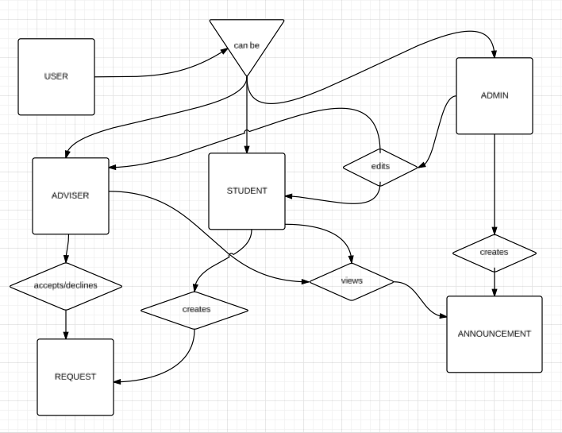

Appendix C: To Be Determined List
- An optional functionality to track teachers using GPS of their mobile phones
- System security implementation
- Interface to REGIST so database can be synchronized

