Top of Form
CAMAGA
Carnatic Music Association of Georgia
Concerts
=================================================================================================
March 26 - Saturday 3:30 P. M. -
Hindu Temple of Atlanta Auditorium
Shashank – Flute
Sandhya Srinath -- Violin
P. Satish Kumar - Mridangam,
Parupalli Phalgun - Khanjira,
Sukanya Ramgopal - Ghatam
Shirisha on Tanpura

Ramana Sat Sangh
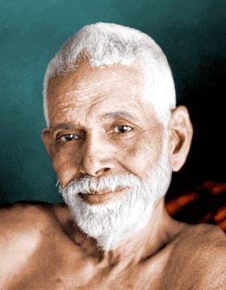
125th JAYANTHI CELEBRATIONS OF BHAGAWAN SRI RAMANA MAHARSHI

MUSIC CONCERT

SATURDAY, MARCH 19, 2005 – 4 PM – 6PM

HINDU TEMPLE OF ATLANTA AUDITORIUM

SMT. USHA BALAKRISHNAN – VOCAL
SRI DEEPAK MURTHY – VIOLIN
DR. RAM SRIRAM – MRIDANGAM

-NO ENTRANCE FEE- -ALL ARE WELCOME-
For more information please visit http://www.ramana-maharshi.org/
If you have any questions please contact The Georgia Chapter of Arunachala Ashrama at (678) 423-7324
==============================================================================================
Indian Classical Music Society
of Greater Atlanta

The Masters of Santoor and Tabla

Pandit Shiv Kumar Sharma & Ustad Zakir Hussain

Sunday, April 10, 2005, 6:30 PM
Glenn Memorial Auditorium
Pandit Shiv Kumar Sharma (Santoor)
Ustad Zakir Hussain (Tabla)
This is a presentation in collaboration with
Emory Asian Studies Department
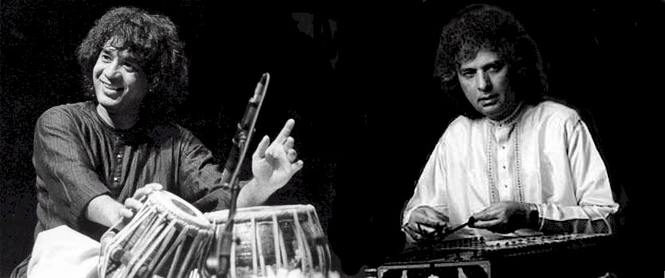
General Admission: $100, $75, $50, $35, $25
Student Tickets: $10 (Valid Student ID required at Gate)
ICMS members: FREE. Click here for more details.
Sponsorship Opportunities available
Call: 770-569-7472 or 763-443-6941
Email: sponsorship@icmsatlanta.org

For Membership call Sumati Mahajan at 770-446-1772
or email membership@icmsatlanta.org
For tickets
Contact ICMS at tickets@icmsatlanta.org or call
 | Usha Balakrishnan  Shubhangi Joshi  Sham Navathe  Raktim Sen  Shekhar Pendalwar  Sumati Mahajan | 770-649-7137  770 569 7472  770-416-8901  770-789-2311  770-962-4218  770-446-1772
Contact Aarohi (Georgia Tech) at gatech@icmsatlanta.org or call
 | Divya Mangotra  Abhiruchi Agarwal  Shayan Srinivasa | 404-543-1891  404-786-7374  404-510-0618
Contact Emory University (Asian Studies Program) at emory@icmsatlanta.org or call
 | Martha Shockey | 404-727-6280
 | Udita Adurkar | 404-384-4171 | (Ga Tech at Emory)
Contact Surabhi (Clemson University, SC) clemson@icmsatlanta.org or call
 | Sourabh Pansare | 864-650-5557
=========================================================================================

Visit our website: www.camaga.org
If you wish to be removed from this mailing, send an email to: camaga@bellsouth.
net
==================================================================================================
Sender: Ram S. Sriram
Organization: CAMAGA

Bottom of Form

