MovieGrade Installation Instructions

1. Download XAMPP using the following link: <https://www.apachefriends.org/xampp-files/7.1.16/xampp-win32-7.1.16-0-VC14-installer.exe>
   1. Install XAMPP using default configuration.
   2. Once complete, if not automatically opened, open the XAMPP Control Panel
   3. The control panel looks like this: 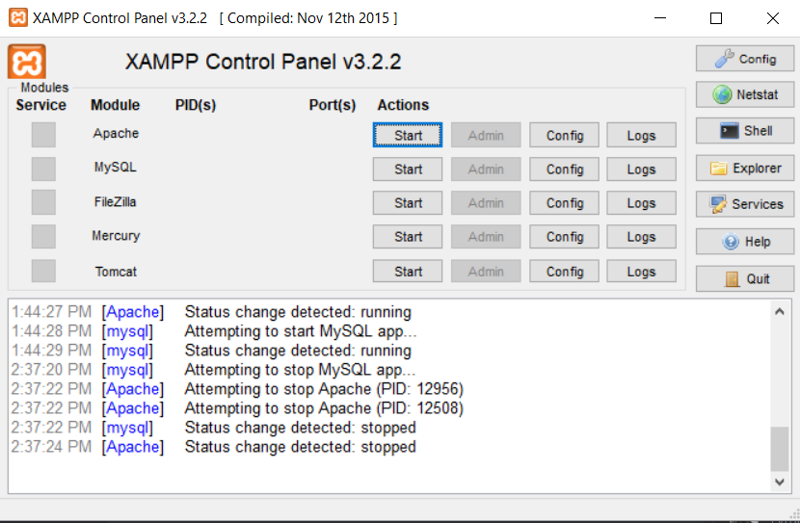
2. Click “Start” next to Apache in the control panel.
3. Click “Start” next to MYSQL in the control panel.
   1. Success will look like the following image

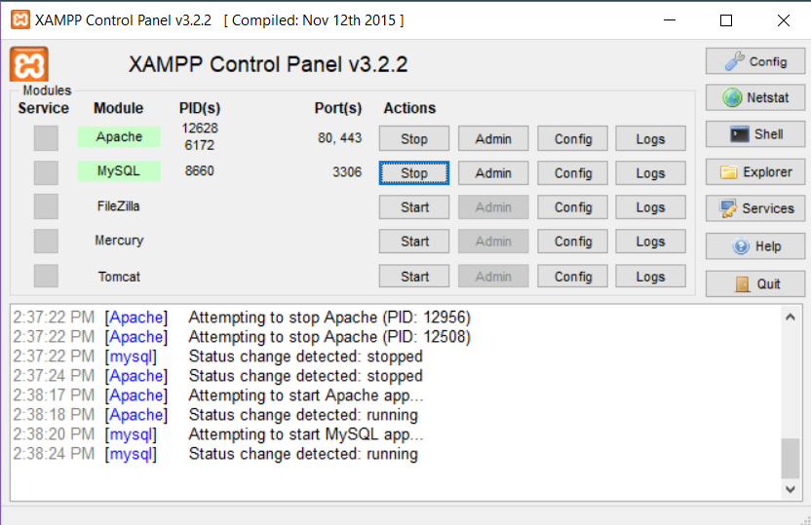

1. Assuming you used the default configuration, you should have a folder in your root (C:/) drive named “Xampp”
   1. Within “Xampp” is a directory named “htdocs”
      1. Htdocs is where the github repository will be cloned into.
2. Using Git Bash or your favorite git utility, navigate to c:/xampp/htdocs
3. Clone the MovieGrade repository into htdocs using the following link: <https://github.com/camarsh7/moviegrade.git>
4. Verify that you can access the webapp properly by opening a web browser and navigating to <http://localhost/moviegrade>
   1. If this does not work, you may be using a different port for apache, which will be specified in the configuration window.
      1. If using a different port, for example port 8080, navigate to <http://localhost:8080/moviegrade> instead
   2. You may see errors upon initially loading the web application, as you have not yet imported the database.
5. After you can navigate to the webpage successfully, visit <http://localhost/phpmyadmin> in order to begin importing the database.
6. When you first navigate to phpmyadmin, you will see a window that looks like the following (but with less or no databases yet): 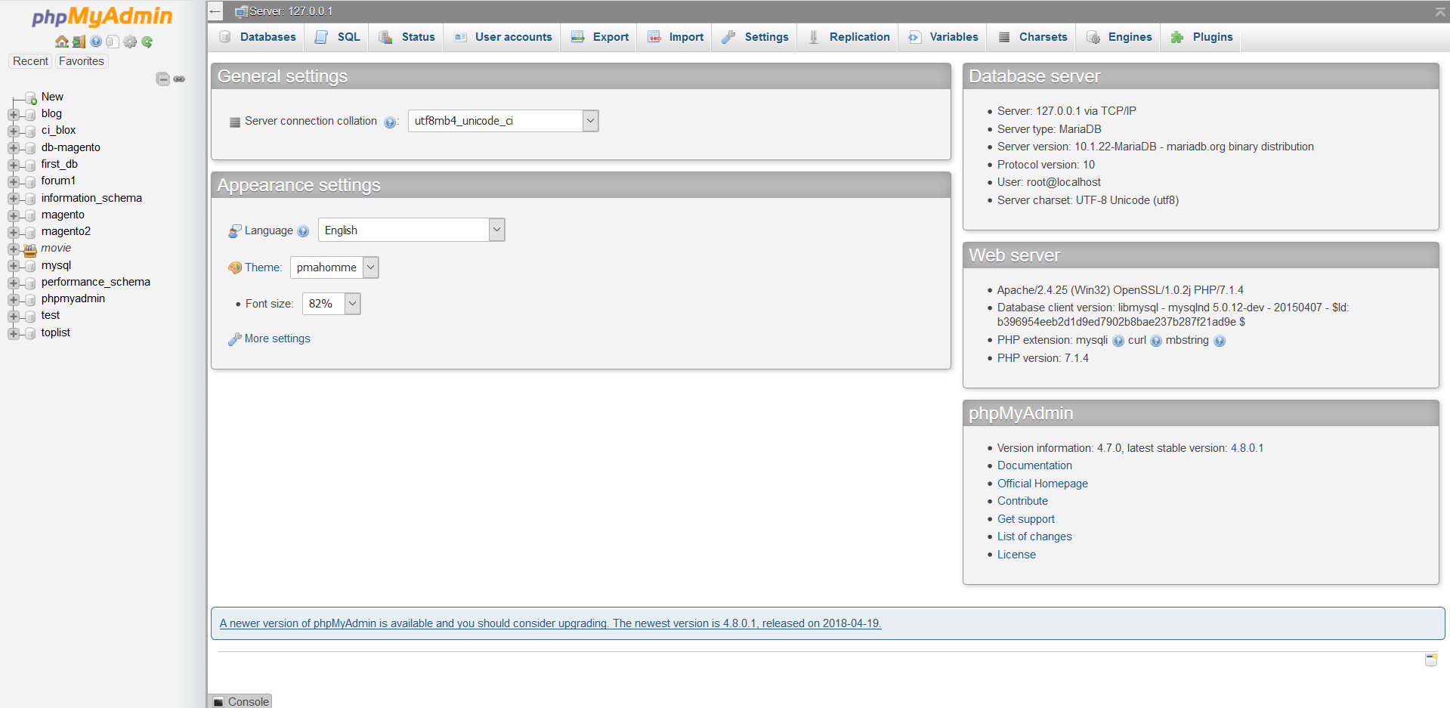
7. The next step is to click “New” at the top of the left sidebar.
8. This will take you to the page where you create new databases.
   1. You should see the following at the top:

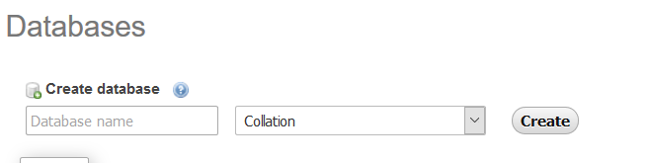

* 1. Insert “movie_grade” into the Database Name field, and hit create.

1. Select the newly created database on the left sidebar, and then click import as seen in the top of the following picture: 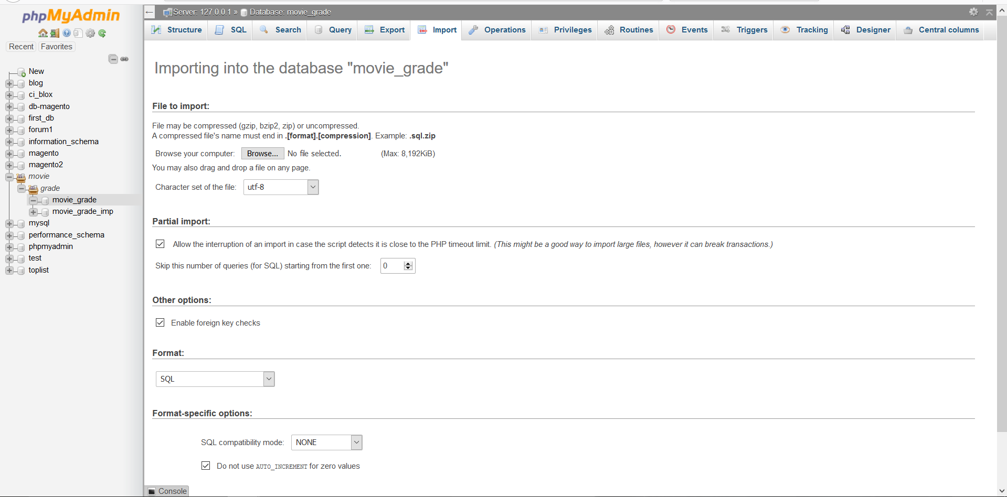
2. Click “Browse” under the “File to import:” section, and navigate to your moviegrade directory in htdocs.
   1. Select the movie_grade_populated.sql file, and hit “go” at the very bottom of the import page.
3. You should see a screen with a ton of success messages afterwards.
4. After you have imported the database, refresh your MovieGrade browser window, and ensure the errors disappeared. From here, you will be able to test the web application.