Mobile Doppler Application with Semantic Web Tecnologies
İhsan YİĞİTBAŞI
ihsanyigitbasi@gmail.com , Istanbul Aydin University , Turkey

Abstract
Mobil Doppler Application will be designed for checking health of fetus and expectant mother . In that project , Mobil doppler application serves commentary and forecast about instant status of fetus on FHR(Fetal Heart Rate). Instant Status of fetus varies on rates of diabetes , cholesterol , number of pregnancy , number of cesarian pregnancy and emotional changes of expectant mother . Especially project is planned for patient who has risk pregnancy . Mobil Doppler Application will be able to use by patient individually without need for going hospital . Needing smart personal e-health systems for checking instant status of health of fetus . Advanced data management technology and smart e-personal health systems serve recommendations for health of fetus . Mobile Doppler Application is developed with Semantic web technologies for taking commentary and forecast about instant status of fetus on FHR(Fetal Heart Rate) .
1 . Introduction
Information is getting important with impact of globalization and common ısing of technology . With increasing use of technology in health area , needing for correct information is increased . In 2001 , Tim Berners – Lee and his staff created new solution for using machine learning in web . They create new vision for classic web. That vision is named as a Semantic Web (Web 3.0)[1] . Semantic Web makes traditional style data to data that is understandable by machine and also with Web 3.0 , machines learns relations between data. In MDAP (Mobil Doppler Application Project) , data that comes from databases and doppler devices , is taking into ontology and making inferences about fetus’ and expectant mother’s health . MDAP system will work with home type doppler devices . Fetal heart rate of Fetus in expectant mother’s venter will be collected then it will save our ontology with additional informations . System will make inferences by using artifical intelligence side of our system (Semantic Web side , SWRL rules ) . Then System will create graph and warn expectant mother about possible doubts , paterns .
2 . Ontology Details
MDAP (Mobil Doppler Application) Ontology represents model of abstract health literature of concepts and informations about fetus and pregnancy . In other words , MDAP ontology stores these informations as a ontology that is understandable by machine : information about pregnancy and history of fetus and expectant mother , fetal heart rates , bazal heart rates and concepts about risks of pregnancy like acceleration , deceleration , tachycardia , bradycardia and their properties , their relations etc.
MDAP Ontology includes :
- Concepts about history and pregnancy of expectant mother
- Concepts about Fetus Heart Rates
- Concepts about risks and paterns of pregnancy
- Acceleration rates , deceleration rates , average heart beats , bazal and fetal heart rates , contraction rates , rates about history of pregnancy
Semantic rules of MDAP ontology are coded with SWRL (Semantic Web Rule Language) on Protege Editor . All structure of MDAP ontology is coded with OWL 2.0 on Protege Editor . Semantic relations of MDAP ontology is created by using tags like <owl:class>, <rdfs:subClassOf>, <owl:DatatypeProperty>, <owl:ObjectProperty>.
In Table 1 , a part of project is shown : “FETUS_HEART_VALUE” class , an individual of that class named as a “FH0001” , data properties of that individual named as “hasBazalRate” "hasAverageHeartBeatper5Min" “hasAverageHeartBeatper10Min" "hasAverageHeartBeat” .
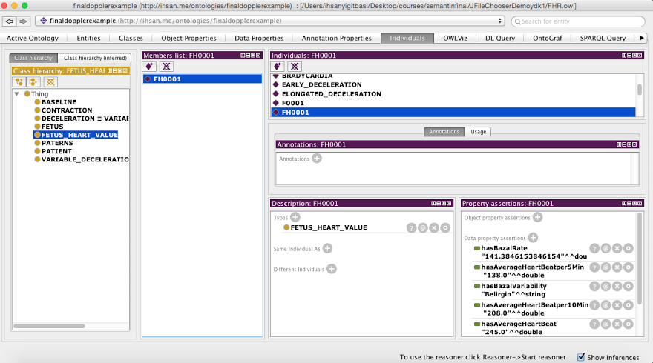
Table 1 : MDAP ontology screenshot

<ClassAtom>
<Class IRI="#FETUS"/>
<Variable IRI="urn:swrl#F"/>
</ClassAtom>
<ClassAtom>
<Class IRI="#FETUS_HEART_VALUE"/>
<Variable IRI="urn:swrl#FH"/>
</ClassAtom>
<ClassAtom>
<Class IRI="#PATIENT"/>
<Variable IRI="urn:swrl#P"/>
</ClassAtom>
<DataPropertyAtom>
<DataProperty IRI="#hasAccelerationEndingPoint"/>
<Variable IRI="urn:swrl#FH"/>
<Variable IRI="urn:swrl#A1"/>
</DataPropertyAtom>
<DataPropertyAtom>
<DataProperty IRI="#hasAccelerationStartingPoint"/>
<Variable IRI="urn:swrl#FH"/>
<Variable IRI="urn:swrl#A"/>
</DataPropertyAtom>
<DataPropertyAtom>
<DataProperty IRI="#hasContraction"/>
<Variable IRI="urn:swrl#P"/>
<Variable IRI="urn:swrl#CO"/>
</DataPropertyAtom>
Schema 1 : A Code Part of MDAP Ontology
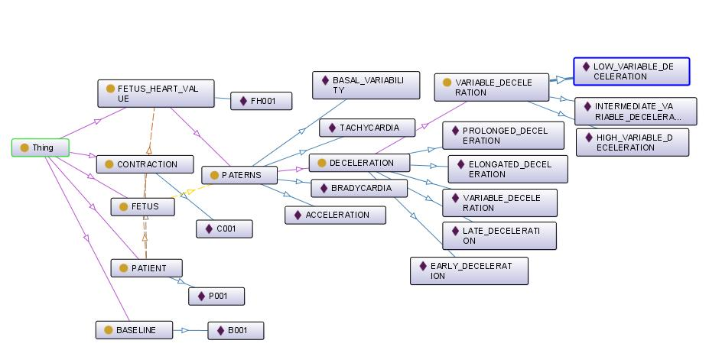
Schema 2 : A Ontograph View of MDAP Ontology

3 . SWRL Rules Explanation
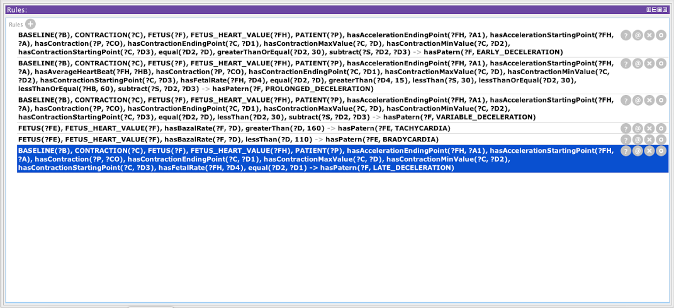
Schema 3 : A Rule View of MDAP Ontology
Rule 1 :
BASELINE(?B), CONTRACTION(?C), FETUS(?F), FETUS_HEART_VALUE(?FH), PATIENT(?P), hasAccelerationEndingPoint(?FH, ?A1), hasAccelerationStartingPoint(?FH, ?A), hasContraction(?P, ?CO), hasContractionEndingPoint(?C, ?D1), hasContractionMaxValue(?C, ?D), hasContractionMinValue(?C, ?D2), hasContractionStartingPoint(?C, ?D3), equal(?D2, ?D), greaterThanOrEqual(?D2, 30), subtract(?S, ?D2, ?D3) -> hasPatern(?F, EARLY_DECELERATION)
In that rule , when Expectant mother's minimum value of contraction and maximum value of contraction are equal and minimum value of contraction is greater than 30 , early deceleration suspicion is stated .
Rule 2 :
BASELINE(?B), CONTRACTION(?C), FETUS(?F), FETUS_HEART_VALUE(?FH), PATIENT(?P), hasAccelerationEndingPoint(?FH, ?A1), hasAccelerationStartingPoint(?FH, ?A), hasAverageHeartBeat(?FH, ?HB), hasContraction(?P, ?CO), hasContractionEndingPoint(?C, ?D1), hasContractionMaxValue(?C, ?D), hasContractionMinValue(?C, ?D2), hasContractionStartingPoint(?C, ?D3), hasFetalRate(?FH, ?D4), equal(?D2, ?D), greaterThan(?D4, 15), lessThan(?S, 30), lessThanOrEqual(?D2, 30), lessThanOrEqual(?HB, 60), subtract(?S, ?D2, ?D3) -> hasPatern(?F, PROLONGED_DECELERATION)
In that rule , when Expectant mother's minimum value of contraction and maximum value of contraction are equal , fetal rate value is greater than 15 , subtraction value between first value and minimum value is less than or equal 30 , average heartbeat value is less than or equal 60 , prolonged deceleration suspicion is stated .
Rule 3 :
BASELINE(?B), CONTRACTION(?C), FETUS(?F), FETUS_HEART_VALUE(?FH), PATIENT(?P), hasAccelerationEndingPoint(?FH, ?A1), hasAccelerationStartingPoint(?FH, ?A), hasContraction(?P, ?CO), hasContractionEndingPoint(?C, ?D1), hasContractionMaxValue(?C, ?D), hasContractionMinValue(?C, ?D2), hasContractionStartingPoint(?C, ?D3), equal(?D2, ?D), lessThan(?D2, 30), subtract(?S, ?D2, ?D3) -> hasPatern(?F, VARIABLE_DECELERATION)
In that rule , when Expectant mother's minimum value of contraction and maximum value of contraction are equal and minimum value of contraction is less than 30 , variable deceleration suspicion is stated .
Rule 4 :
BASELINE(?B), CONTRACTION(?C), FETUS(?F), FETUS_HEART_VALUE(?FH), PATIENT(?P), hasAccelerationEndingPoint(?FH, ?A1), hasAccelerationStartingPoint(?FH, ?A), hasContraction(?P, ?CO), hasContractionEndingPoint(?C, ?D1), hasContractionMaxValue(?C, ?D), hasContractionMinValue(?C, ?D2), hasContractionStartingPoint(?C, ?D3), hasFetalRate(?FH, ?D4), equal(?D2, ?D1) -> hasPatern(?F, LATE_DECELERATION)
In that rule , when Expectant mother's minimum value of contraction and maximum value of contraction are equal , late deceleration suspicion is stated .
Rule 5 :
FETUS(?FE), FETUS_HEART_VALUE(?F), hasBazalRate(?F, ?D), greaterThan(?D, 160) -> hasPatern(?FE, TACHYCARDIA)
In that rule , when Fetus' bazal heart rate is greater than 160 , tachycardia suspicion is stated .
Rule 6 :
FETUS(?FE), FETUS_HEART_VALUE(?F), hasBazalRate(?F, ?D), lessThan(?D, 110) -> hasPatern(?FE, BRADYCARDIA)
In that rule , when Fetus' bazal heart rate is less than 110 , bradycardia suspicion is stated .
4 . Pseudocode
The following lines will describe of the programme working process :

Design Description for Program mobile_doppler_application_with_semantic_web_technologies
read(measurements.csv)
initialized to dataList from measuremen1 variables
go to ProtegeAdapter:
go to Baseline:
initialize baseline from Baseline Class
initialize basalVariable from Baseline Class
go to FHRAvarages:
CalculatePerFiveMinutes, CalculatePerTenMinutes, CalculatePerTwentyMinutes
return to ProtegeAdapter
initialized fhrFivePerMinutes, fhrTenPerMinutes,fhrTwentyPerMinutes from FHRAvarages
go to Acceleration:
getAcceleration()
return to ProtegeAdapter
initialize accelerationValue from Acceleration
go to DataProperty:
SaveDTPInteger()
SaveDTPDouble()
SaveDTPString()
return to ProtegeAdapter
initialized individuals protege and execute SaveDTPInteger() SaveDTPDouble() SaveDTPString()
Graph-Show-button-clicked
go to Chart:
createGraph()
return Graph
showGraph
end

Patient-open-button-clicked
read(patient informations)
go to DataProperty:
SaveDTPInteger()
SaveDTPDouble()
SaveDTPString()
return to PatientWindow

go to ObjectProperty:
getAnObjectProperty();
go to NotificationWindow:
showMessages()
return to ObjectProperty
return to PatientWindow
initialized individuals protege and execute SaveDTPInteger() SaveDTPDouble() SaveDTPString()
end

5 . Literature Survey
MDAP take as reference 3 articles and we gave the article names as reference in the references part of the article. In the calculation part we used Prof Nadir COMERT’s article which for calculating deceleration,acceleration,baseline and baseline variabilities.[2](Table 2).

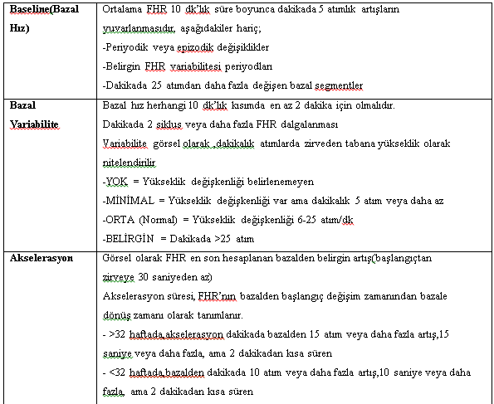
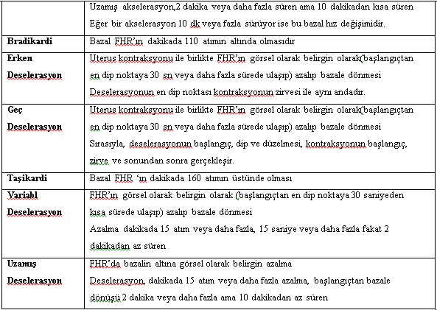
Table 2: Article Table referenced for calculating variables.

Has a normal heart rate patterns in the study. These Ones;
• Basal frequency 110-160 / min
• baseline variability (beat to beat) 5-15 beats / min.
• The presence of acceleration (15 mm or greater increase in BPM for longer than 15 seconds)
• The absence of obvious decelerations
• Early decelerations and typical light variable decelerations
• variability of normal basal rate of between 100-120.
Pathological cardiotocographic Patterns:
• Tachycardia
• 30 min. be seen in more than 50% of contractions during the late decelerations
• 30 to determine the longer time variability decreased from min (<5 beats / min)
• Persistent severe variable decelerations in which (at least 60 seconds. The time and <60 / min., Which is the number of hits) or persistent presence of atypical variable decelerations
• A bradycardia (less than 2 min. During the number of hits continued <100 / min. No)
Article 2: Quantitative Evaluation of Fetal Heart Rate
Name of Article : Application of fuzzy inference systems forclassification of fetal heart rate tracings in relation to neonatal outcome Czabański Robert, Jeżewski Janusz, Wróbel Janusz, Sikora Jerzy ve Jeżewski Michał 2013[3]
Part of that article is used for creating SWRL rules , in that article scientist wrote about their researchs about figo criterias and fetal conditions (Table 3 ) .
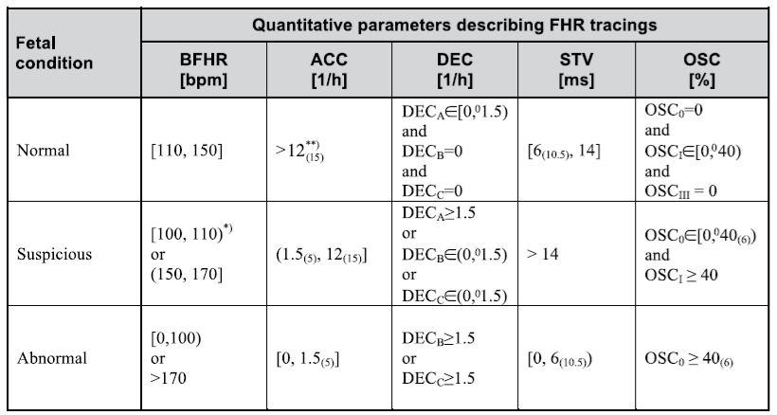
Table 3 : Quantitative parameters describing FHR tracings

6 . Results
When fetus is deceased in expectant mother's venter , immediately expectant mother has to birth .When fetus is deceased in expectant mother's venter , it's abortion , it's not birth deadly . Reporting deceasing , abortion , their reasons are very important for research and statistics . When we consider these situations , our Mobile Doppler Application is solution of a big problem . Results that are given by Mobile Doppler Application prevents fetus and expectant mothers worst cases .

References:
- [1] Berners-Lee, T., Hendler, J., and Lassila.,O. (2001).The Semantic Web, Scientific American, 284(5) 34-43.
- Dr. Nadir COMART (İstanbul, 2006) Elektronik Fetal Kalp Hızı Monitörizasyonu:Normal Monitör, Fetal Stres, Fetal Distres İle İlişkili Erken Neonatal Sonuçlar ( Uzmanlık Tezi ) ,
- Czabański Robert1, Jeżewski Janusz2, Wróbel Janusz2,Sikora Jerzy3, Jeżewski Michał1 (2013). Application of fuzzy inference systems for classification of fetal heart rate tracings in relation to neonatal outcome

