Expand this cell to see the code

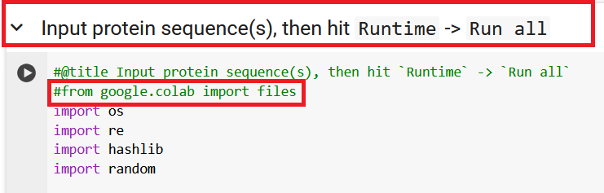
Comment this line out

