NanoOrch
Agent Platform
User Manual
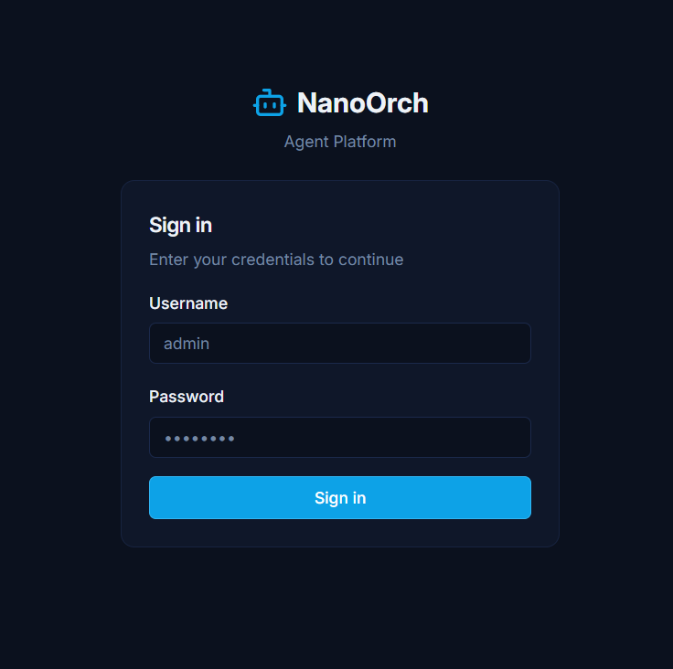
NanoOrch login screen

1. Introduction
Welcome to NanoOrch — a self-hosted AI agent orchestration platform. This manual is written for everyday users. No technical background is required.
NanoOrch lets you talk to AI agents from a web browser or from Slack/Teams. Depending on how your administrator has configured the system, agents can answer questions, search documents, run calculations, manage Jira issues, query cloud infrastructure, and much more.

2. Logging In
Go to the URL your administrator gave you (e.g. http://your-company-nanoorch.com) and sign in with your username and password.

Sign-in screen — enter your username and password and click Sign In
ℹ If you have not received credentials, contact your administrator. There is no self-service sign-up or password reset.
After login you will be taken to your workspace list. Global admins and workspace admins see the full admin UI; regular members see a clean chat-only interface.

3. Your Workspace List
A workspace is an isolated environment for a team or project. Everything — agents, tasks, integrations, schedules — lives inside a workspace. You can only see workspaces your administrator has added you to.
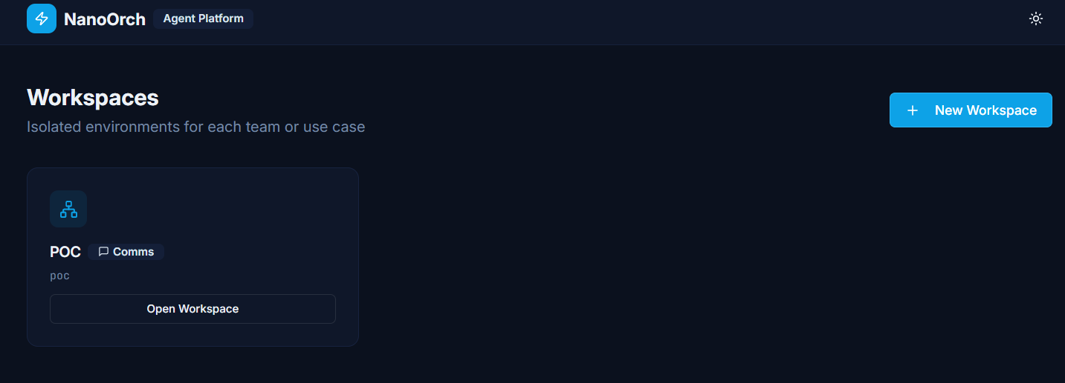
Workspace list — the Comms badge shows this workspace has two-way Slack/Teams enabled
Click Open Workspace to enter. If a workspace you expect is missing, ask your administrator to add you.
ℹ A workspace marked with a Comms badge supports two-way messaging — you can interact with agents directly from Slack or Microsoft Teams.

4. The Chat Interface
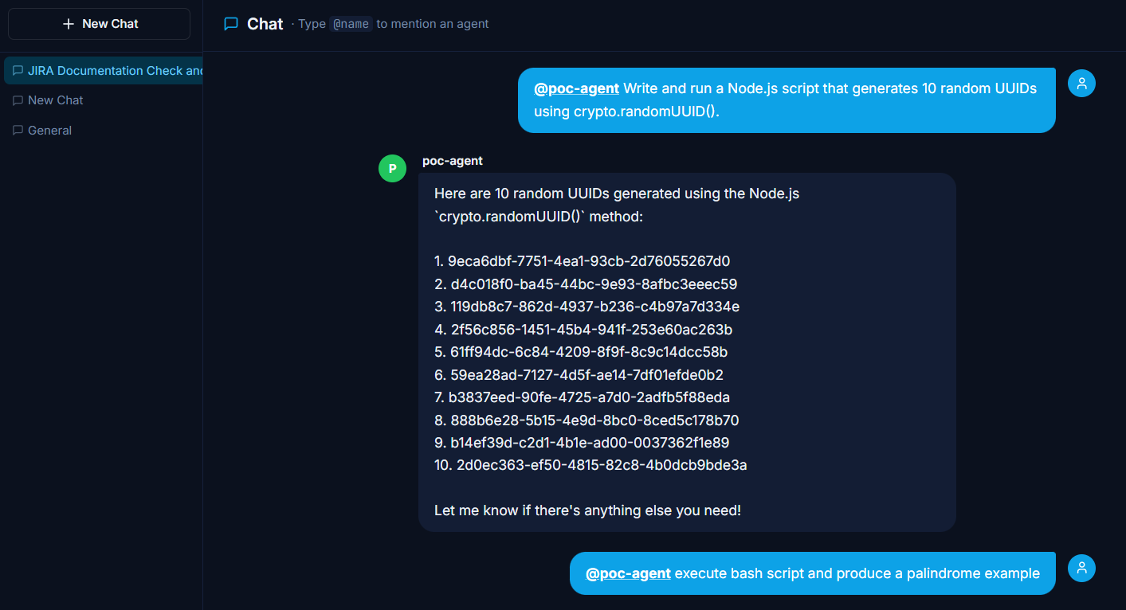
Chat interface — sidebar lists conversations; type @agent-name to address an agent
Once you open a workspace, the chat interface loads. Previous conversations are listed in the left sidebar. Start a new conversation with the + New Chat button at the top.

Addressing an agent
Type @ followed by the agent name. A dropdown appears with matching agents:
- Use ↑ and ↓ arrow keys to navigate the list
- Press Enter or Tab to select
- Press Escape to close the dropdown without selecting
@poc-agent what is the status of our latest deployment?
ℹ Always start your message with @agent-name. Without it, the platform does not know which agent to route your message to.

Conversation history
Your previous conversations appear in the left sidebar. Click any conversation to continue it. The agent remembers the context of each individual conversation — ask follow-up questions naturally without repeating yourself.

5. Types of Responses

Conversational answer
For questions, explanations, and summaries the agent replies directly in the chat. Text streams in word by word as it is generated.

Code execution
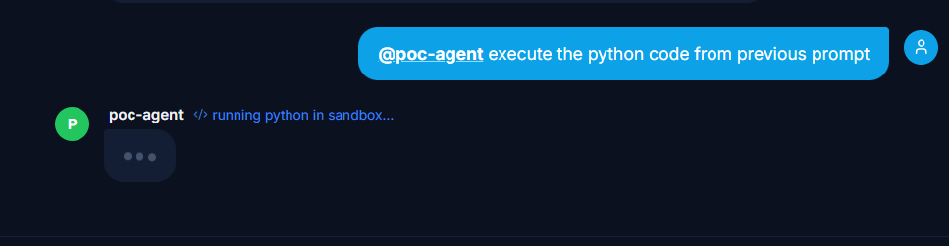
"running python in sandbox…" — the agent is executing code in the secure sandbox
If your question requires computation, the agent writes a program and runs it inside a locked-down container. You will see a "</> running … in sandbox…" indicator while it executes. The result streams back when the container finishes.
The sandbox supports Python and Node.js (JavaScript). It has no internet access, no access to your files, and nothing persists after the run.

Action response
If your request requires fetching live data or performing an operation (Jira, GitHub, GitLab, AWS, GCP, Azure), the agent calls the relevant service and returns the real result.

6. Approving Actions
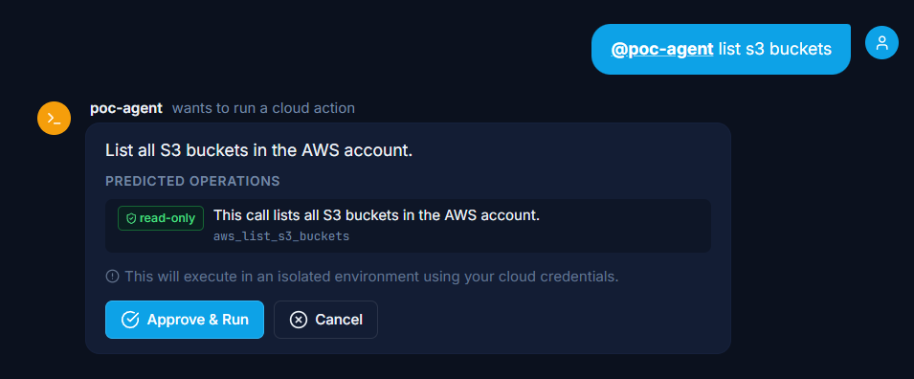
Approval gate — shows the proposed action, tool name, read-only badge, and Approve & Run / Cancel buttons
When an agent wants to call a cloud or developer tool it pauses and shows a confirmation card. The card includes:
- A description of what the agent wants to do
- A PREDICTED OPERATIONS panel showing the exact tool call name
- A read-only or write badge — green "read-only" for safe listing operations, amber/red for write operations
- Approve & Run — confirms the action; it runs immediately in an isolated environment
- Cancel — nothing happens; you can rephrase or ask something different
ℹ Read-only operations (listing resources, searching issues) are safe to approve freely. Write operations (creating, updating, deleting resources) have real effects — review carefully before approving.
Workspace admins can also review pending approvals in the Approvals section of the sidebar, where a badge shows how many are waiting.

7. The Tasks View
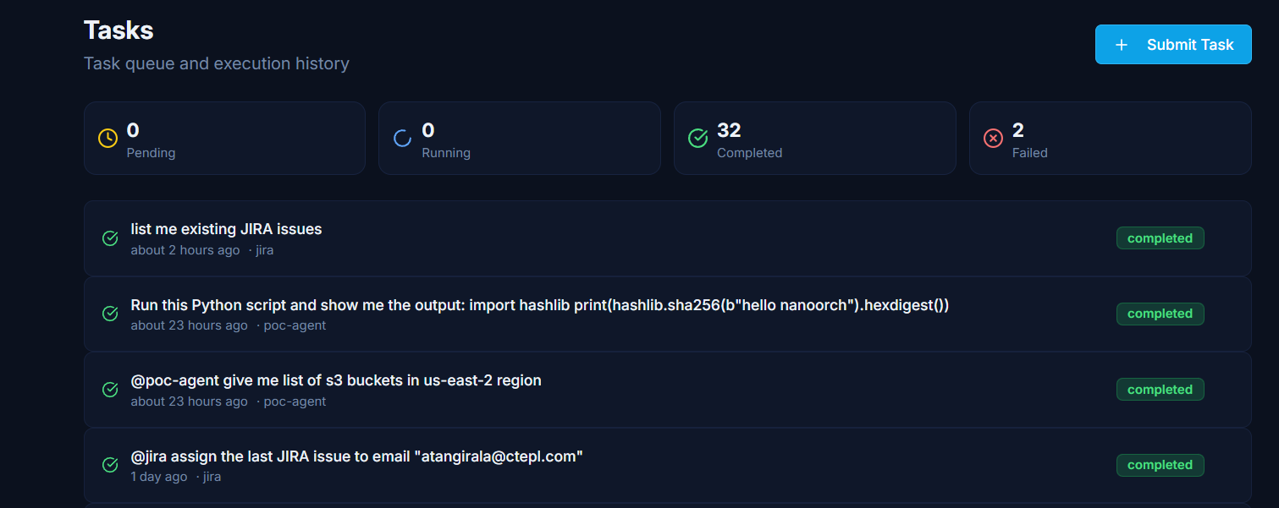
Tasks view — counter cards at the top, scrollable task list below with status badges
Every message you send that triggers an agent creates a task. The Tasks view (visible to workspace admins and global admins) shows:
- Summary counters: Pending, Running, Completed, Failed
- A scrollable list of tasks with their status badge, agent name, and relative timestamp
Click any task to open its detail view, which shows the full input, output, step-by-step agent reasoning, tool calls, and a real-time log stream while the task is running.

8. What Agents Can Do
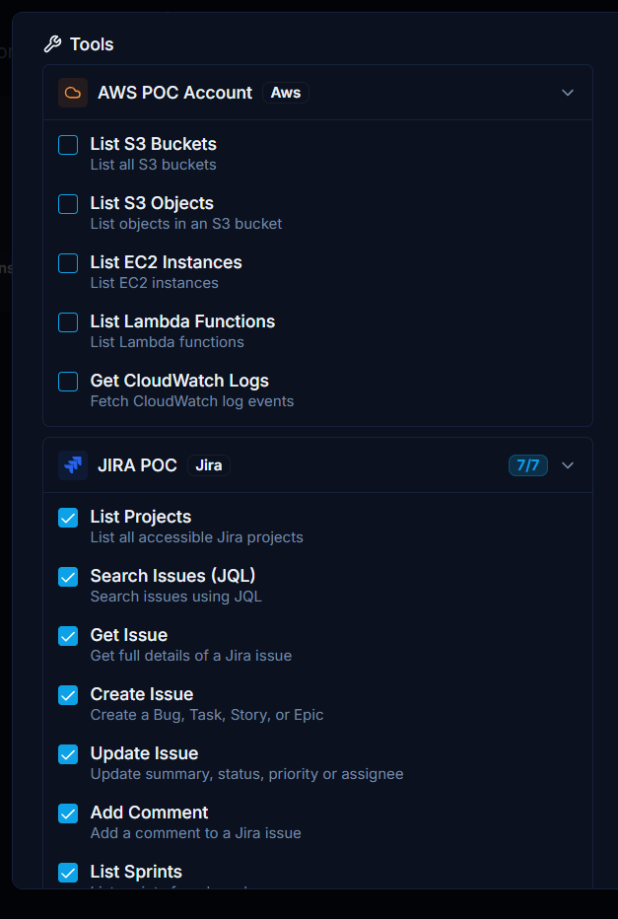
Agent tool panel — AWS and Jira tools selectable via checkboxes, grouped by integration
Depending on which integrations your administrator has configured, agents can:

Cloud infrastructure (AWS, GCP, Azure)
@infra-bot list all running EC2 instances in us-east-1
@infra-bot how many S3 buckets do we have?
@infra-bot show me the last 50 CloudWatch error logs

Jira
@jira-bot show all open P1 bugs in project CORE
@jira-bot create a bug: "Payment timeout on checkout" — priority High
@jira-bot list all active sprints on the engineering board
@jira-bot add a comment to INFRA-77: "Confirmed — investigating"

GitHub / GitLab
@devbot list all open PRs in the backend repo
@devbot create an issue: "Fix login redirect loop" in my-org/backend
@devbot list all failed pipelines on the release branch

Code execution (Python and Node.js)
@agent write a Python script to calculate compound interest on $50,000 at 4.5% for 10 years and run it
@agent write and run a Node.js script that generates 10 random UUIDs using crypto.randomUUID()

9. Integrations
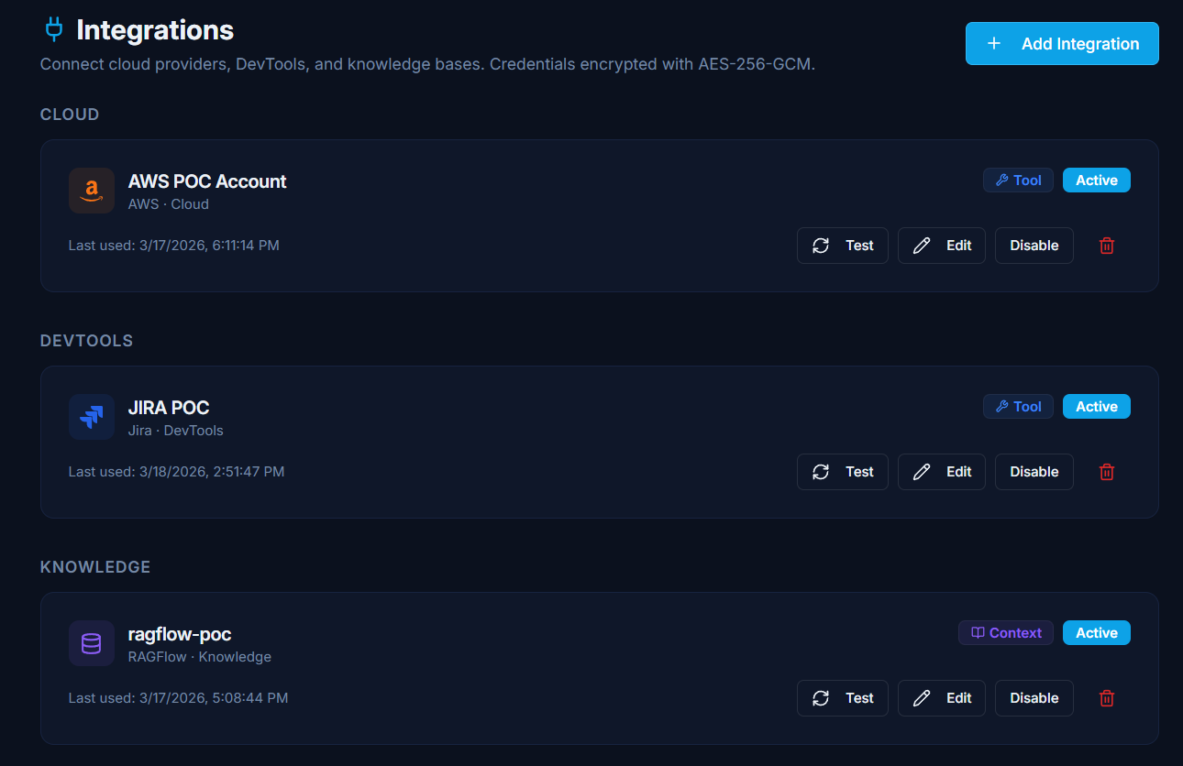
Integrations page — grouped by CLOUD, DEVTOOLS, and KNOWLEDGE with Test/Edit/Disable controls
Integrations connect NanoOrch to external services. They are grouped into three categories:
Item | Description
CLOUD | AWS, GCP, Azure — infrastructure tools (list resources, fetch logs)
DEVTOOLS | Jira, GitHub, GitLab — issue tracking, code repositories, CI/CD
KNOWLEDGE | RAGFlow — knowledge base for automatic document retrieval (Context mode)

Each integration card shows the provider type, last-used timestamp, and integration mode badge (Tool or Context). Use the Test button to verify connectivity without running a real task.

10. Knowledge Base (RAGFlow)
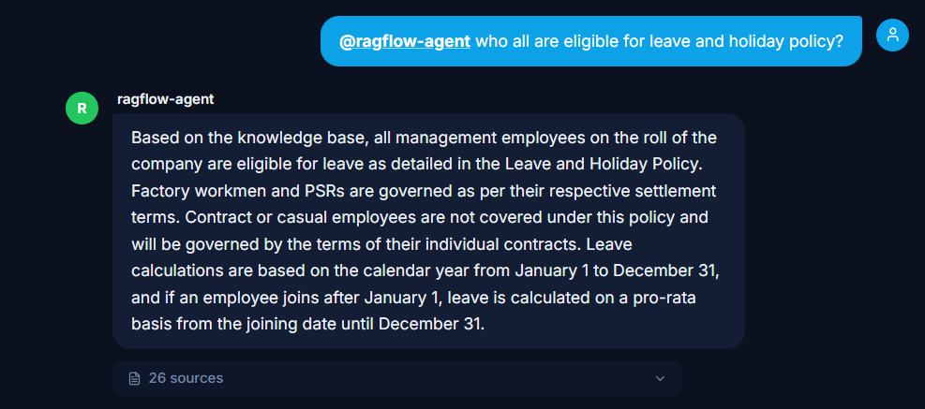
Agent answering a question using the RAGFlow knowledge base — 26 sources retrieved
If your administrator has connected a RAGFlow knowledge base, the agent automatically searches it before every response. You do not need to ask it to.
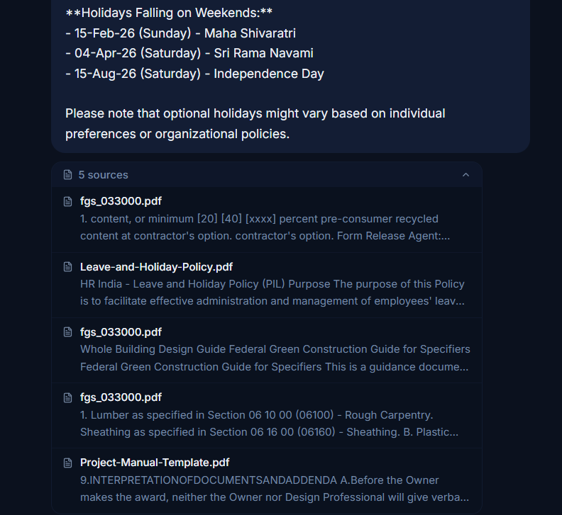
Expanded sources panel — document titles and excerpts used to form the answer
A Sources badge below the agent reply shows how many document chunks were retrieved (e.g. "26 sources"). Click it to expand and read each source excerpt. This lets you:
- Verify that the answer is grounded in real documents
- See which documents were referenced
- Find the original document if you need the full context
ℹ The number of sources shown (e.g. 26) reflects the number of document chunks retrieved. Multiple chunks may come from the same document.

11. Observability Dashboard
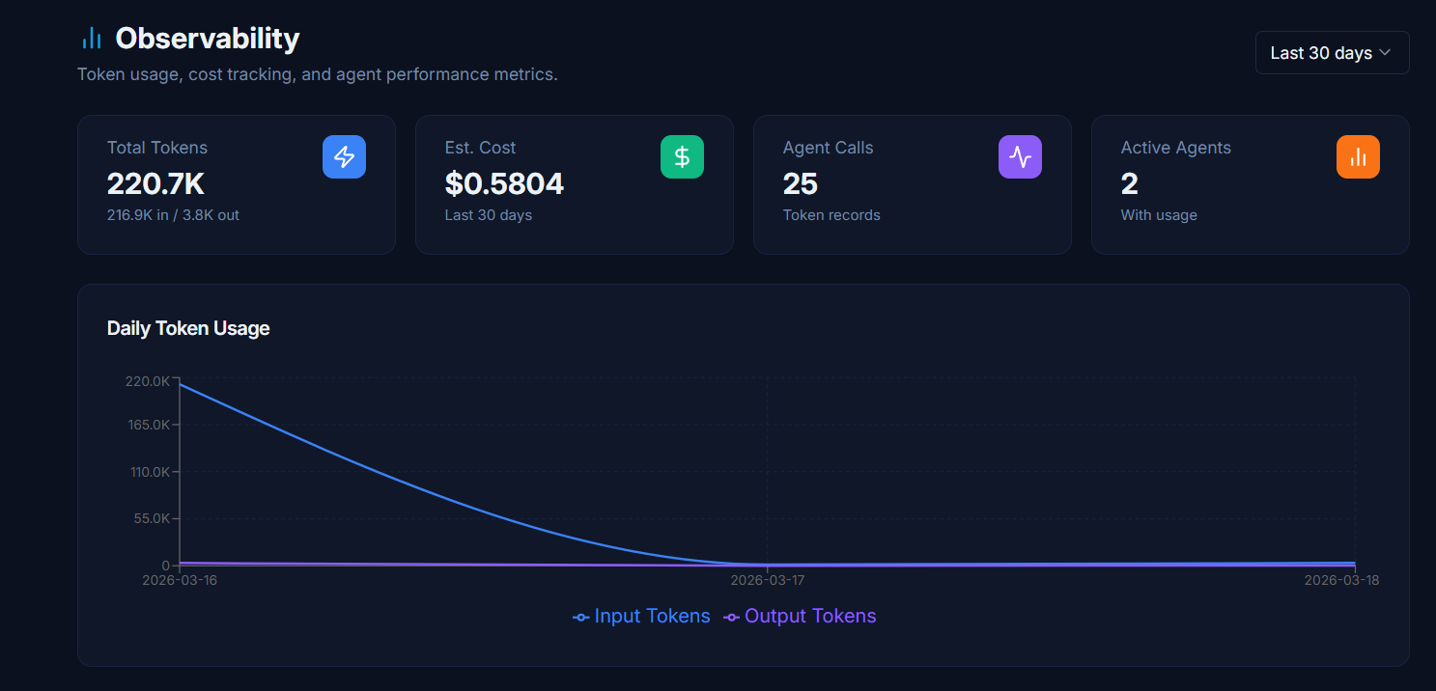
Observability — four summary cards and a daily token usage line chart
Workspace admins can view token usage and estimated costs in the Observability section of the sidebar.
The four summary cards at the top show:
Item | Description
Total Tokens | Combined input + output tokens for the selected period (e.g. 220.7K = 216.9K in + 3.8K out)
Est. Cost | Estimated USD cost based on per-token pricing for the period (e.g. $0.5804 for 30 days)
Agent Calls | Number of task invocations that used tokens (e.g. 25)
Active Agents | Number of distinct agents with at least one token record (e.g. 2)

The Daily Token Usage chart shows input and output token consumption day by day. Use the period selector (top right) to change the window (e.g. Last 7 days, Last 30 days).

12. Scheduled Jobs
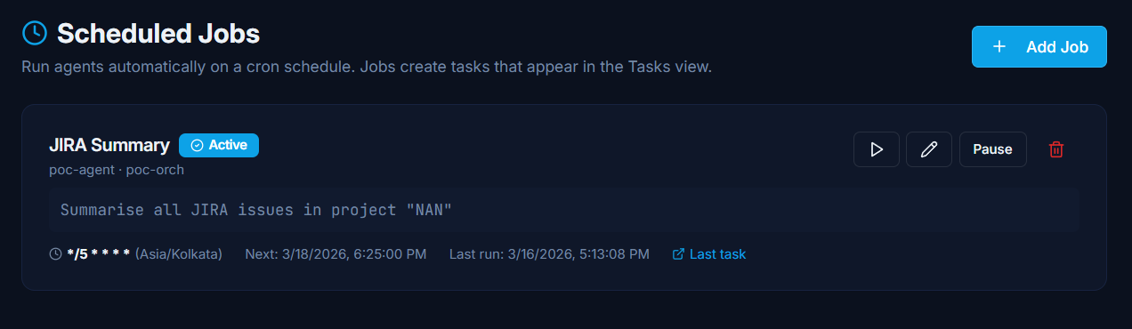
Scheduled Jobs — JIRA Summary job with Active badge, cron expression, and next/last-run timestamps
Scheduled jobs run agents automatically on a repeating cron schedule. As a user, you will receive the results of scheduled jobs as chat messages or Slack/Teams notifications — you do not need to do anything.
Each job card shows:
- Job name and Active / Paused badge
- The orchestrator and agent that runs the job
- The prompt sent to the agent on each run
- Cron expression and timezone (e.g. */5 * * * * · Asia/Kolkata = every 5 minutes)
- Next scheduled run time and last run time
- Last task link — click to open the most recent task log
Administrators can pause, resume, run immediately (Run Now), edit, or delete any job.

13. Pipelines
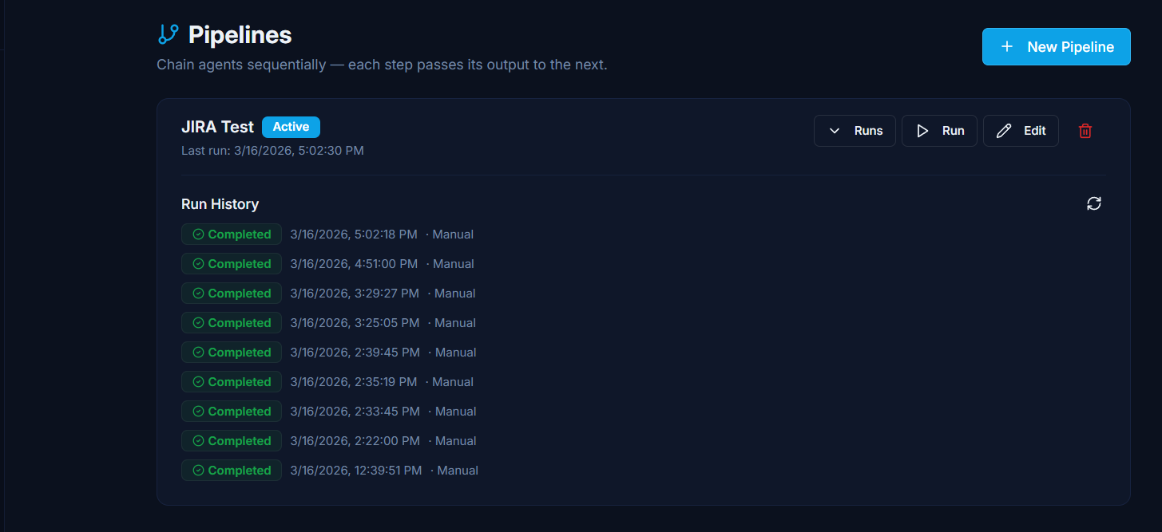
Pipelines — JIRA Test pipeline with run history showing completed runs and timestamps
A pipeline chains several agents together — the output of each step is passed automatically as context to the next. For example: one agent fetches Jira data → a second summarises it → a third creates a ticket.
As a user, you will not normally interact with pipelines directly. If you want a multi-step automated workflow, ask your administrator to set one up.
Each pipeline card shows:
- Pipeline name and Active badge
- Last run timestamp
- Run History — a collapsible list of completed runs with status, trigger (Manual / Scheduled), and timestamp
- Run Now button to trigger the pipeline manually

14. Using Agents via Slack or Teams
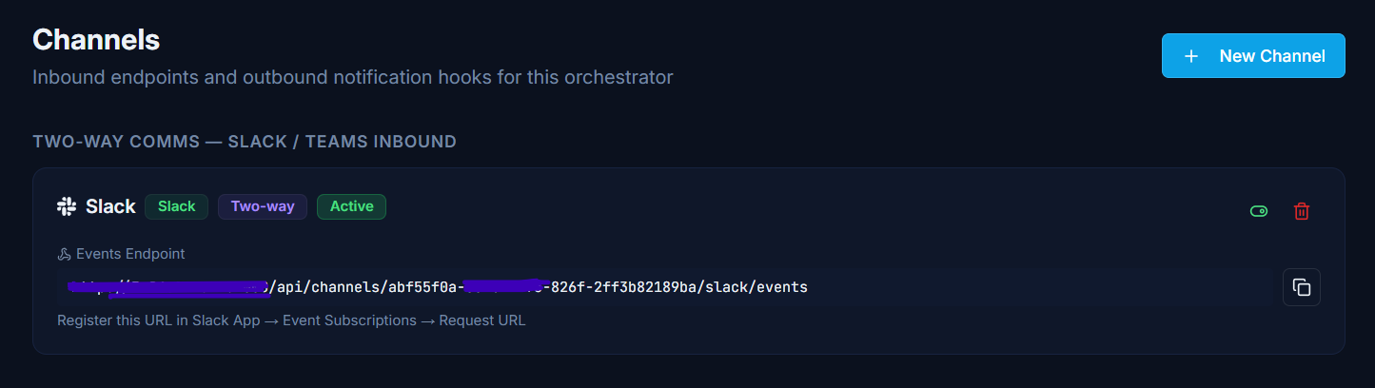
Channels page — Slack inbound channel with Two-way and Active badges, Events Endpoint URL
If your workspace is a Comms Workspace (look for the Comms badge on the workspace card), you can talk to NanoOrch agents directly from Slack or Microsoft Teams.

Slack
Mention the bot in any channel it has been invited to:
@NanoOrchBot what is the status of our deployment?
The agent will process your message and reply in the same thread, usually within a few seconds.
To address a specific agent, prefix your message with use agent-name:
@NanoOrchBot use devops-agent: check CloudWatch for any errors in the last hour
Without that prefix, your message goes to the default agent configured by your administrator. Direct messages (DMs) to the bot work the same way.

Microsoft Teams
Send a message to the Teams channel where the bot is installed:
use devops-agent: check CloudWatch for errors in the last hour
Or just type your prompt directly — the default agent will reply.

What agents can do from Slack / Teams
Everything they can do from the web chat — run code, query Jira, search GitHub, call AWS/GCP/Azure tools, retrieve from RAGFlow knowledge bases, and more. If an action requires approval, the agent will tell you in the reply; your administrator can approve it from the NanoOrch web UI.

Limitations
- One message = one task. Long-running tasks may take a minute or two before you see a reply.
- Context is shared within the same Slack thread or Teams conversation. Starting a new thread starts a fresh conversation.
- The agent sends text replies only — no file attachments.

15. Tips for Better Results

Be specific
The more context you give, the better the response.
Less specific: @jira-bot show issues
More specific: @jira-bot show all open P1 and P2 bugs in project CORE assigned to the backend team

Address the right agent
Use specialist agents for best results — one for cloud infrastructure, one for Jira, one for knowledge base search.

Ask follow-up questions
Context is remembered within the current conversation:
@jira-bot list my open issues
@jira-bot which of those are P1?
@jira-bot add a comment to the first one: "Investigating now"

Paste data inline
If you have JSON, CSV, or numbers you want the agent to process, paste them directly into your message.

If the response is cut off
@agent continue

16. Troubleshooting
The agent is not responding / spinner keeps going
- Wait up to 30 seconds — API calls to Jira, GitHub, or cloud services take longer than conversational answers.
- If it has been more than a minute, refresh the page and resend your message.
"No agents available" in the dropdown
- Your workspace has no agents configured. Ask your administrator to create one.
The agent says it cannot run code
- The sandbox Docker image may not have been built on the server. Ask your administrator.
The agent paused and is waiting for approval
- A workspace admin must approve the action in the Approvals sidebar section. If you are a workspace admin, open Approvals now. Otherwise, let your administrator know.
The action ran but something went wrong
- Open the task that was created and check the detailed log. Share the task ID with your administrator.
I cannot see a workspace I should have access to
- Ask your administrator to add you to that workspace from the Members section.
I forgot my password
- Ask your administrator to reset it. There is no self-service password reset.

Quick Reference
Goal | How
Talk to an agent | @agent-name your message → press Enter
Pick agent from dropdown | Type @, use ↑↓ arrows, press Enter or Tab
Cancel agent selection | Press Escape
Approve a pending action | Click Approve & Run on the confirmation card (or via Approvals in sidebar for admins)
See document sources (RAGFlow) | Click Sources badge below the agent reply
Ask a follow-up | Keep typing — context is remembered per conversation
Route to specific agent (Slack) | @NanoOrchBot use agent-name: your prompt
Run code from chat | Ask naturally — e.g. "@agent what is the SHA-256 of hello world?"
Switch workspace | Go to home screen (top-left logo or /member)
View task log | Click any task in the Tasks view

