1. What is a Container?

Containers are lightweight, executable packages that include everything needed to run a piece of software. This includes the code, runtime, libraries, and system tools.

Containers run on any system, ensuring consistency across environments.

2. What is an Image?

Images are the read-only templates used to create containers. They are the blueprint for containers.

An image could be the code you want to run, and Docker will create containers based on it.

3. What is Docker Compose?

Docker Compose is a tool to define and run multi-container Docker applications. Using a Compose file, you can set up multiple containers, networks, and volumes for a single application.

Ideal for managing complex applications with multiple services.

Run Containers and Expose Ports
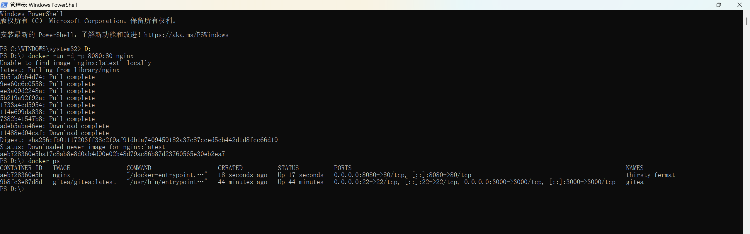

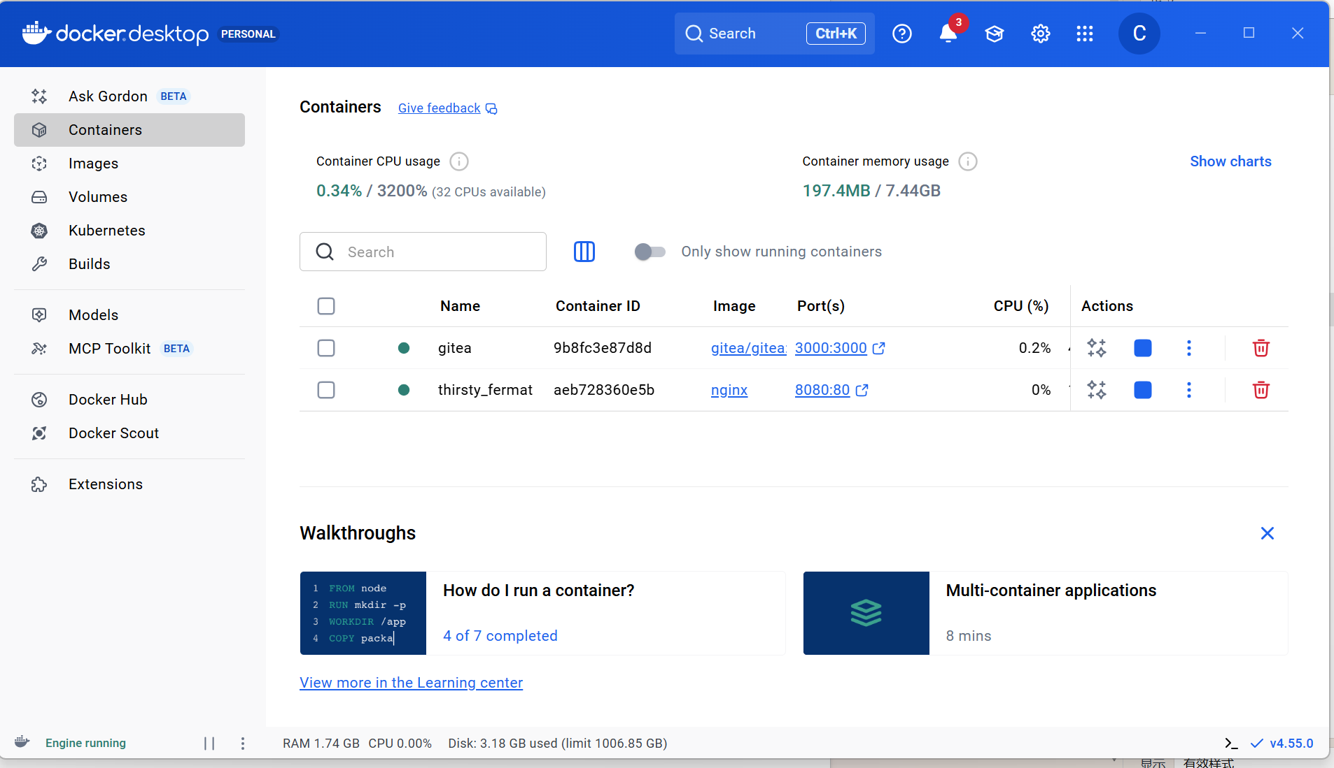

Persist Data and Share Files
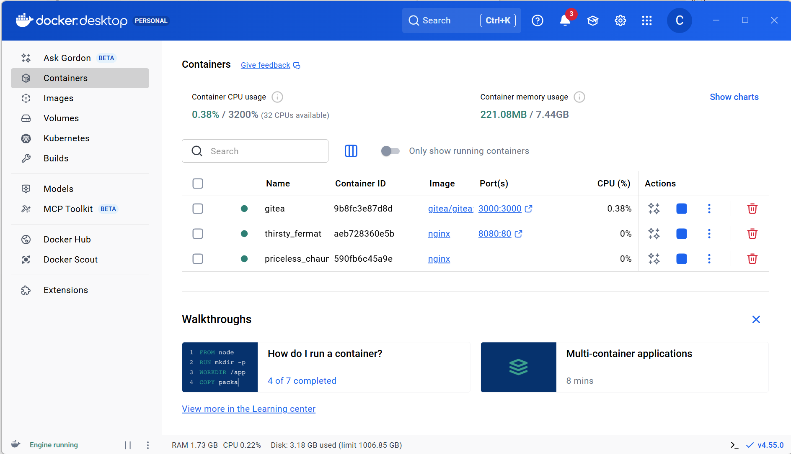
Sharing Local Files
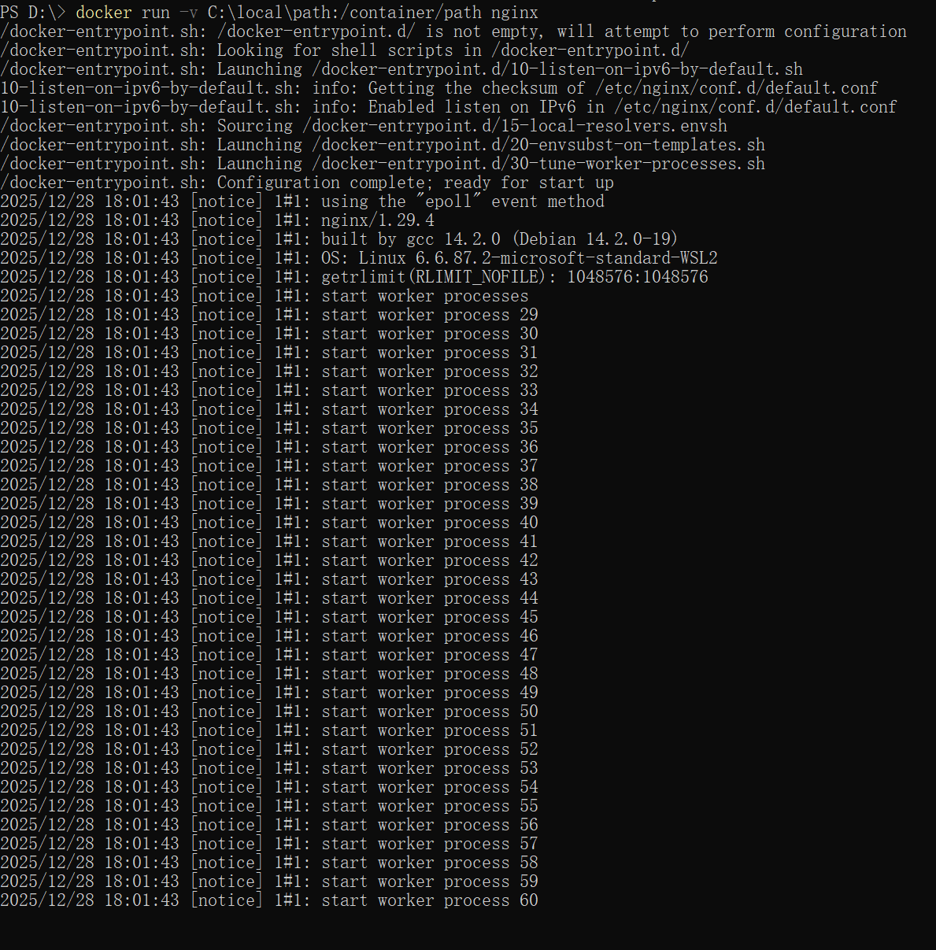
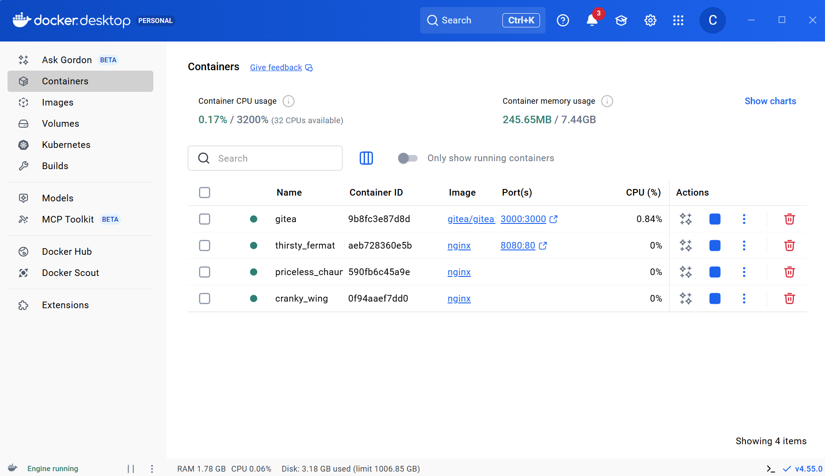
Multi-Container Applications
