Figure 2. Use of methods that do not require a healthcare provider, by age\* and age at first birth. National Survey of Family Growth (NSFG) 2011-2015.

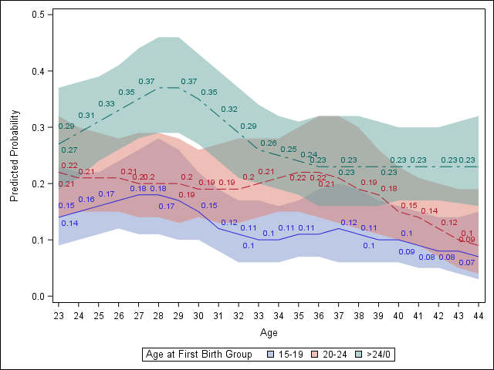

\*Adjusted for education, race, household income, age at first birth, parity, marital status, and current health insurance status. Predicted probabilities are calculated by setting covariates to the average effect across groups for each variable.