CSC212 Exercise on Stacks Keith Thomson

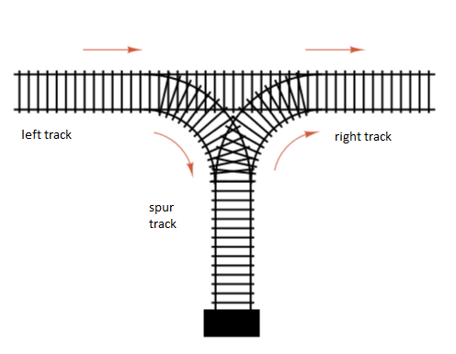

Consider a stack data structure that can process elements in a LIFO fashion.

If the numbers are coming into the left track in the order of 1,2,3, is there a sequence of push – pop instructions that can yield the trains to be lined up in the order of 3, 2, 1 on the right?

The answer is YES.

The sequence is push (1)

push (2)

push (3)

pop

pop

pop

Note: an impossible sequence is 3, 1, 2.

Given this stack data structure and letters A through J coming in the left track in alphabetical order, is it possible to generate the following sequences? Support your answer by showing the push – pop sequence for the possible sequences.

1. C B A D E F G H I J
2. A C B D E F G H I J
3. B A C D F H J G I E
4. C D E F H B J I G A

**1. C B A D E F G H I J** – P**ossible**

**push a, push b, push c, pop c, pop b, pop a, push d, pop d, push e, pop e, push f, pop f, push g, pop g, push h, pop h, push i, pop i, push j, pop j**

**2. A C B D E F G H I J** – p**ossible**

**push a, pop a, push b, push c, pop c, pop b, push d, pop d, push e, pop e, push f, pop f, push g, pop g, push h, pop h, push i, pop i, push j, pop j**

**3. B A C D F H J G I E** – i**mpossible**

**4. C D E F H B J I G A** – i**mpossible**